Name: Hasini Akkireddy
Role: AI/ML Intern
Date:01-06-202

Member 2 : Body Segmentation and Pose Detection

Task 1 — Body Segmentation Implementation
- Body segmentation is the process of separating the person from the background in an image
- The output is a mask where white pixels represent the person and black pixels represent the background
- This is an important step in virtual try-on as the system needs to know exactly where the person is in the image
What I Did
- The model takes a person image as input and outputs a segmentation mask
- Applied the mask on the original image to separate the person from the background
- Tested on multiple images with different backgrounds and lighting conditions
What I Observed
- Segmentation worked accurately on images with plain backgrounds
- Person region was correctly identified and separated
- Hair and arm edges were detected with good accuracy
- Slightly less accurate on images with complex backgrounds or similar colors to clothing
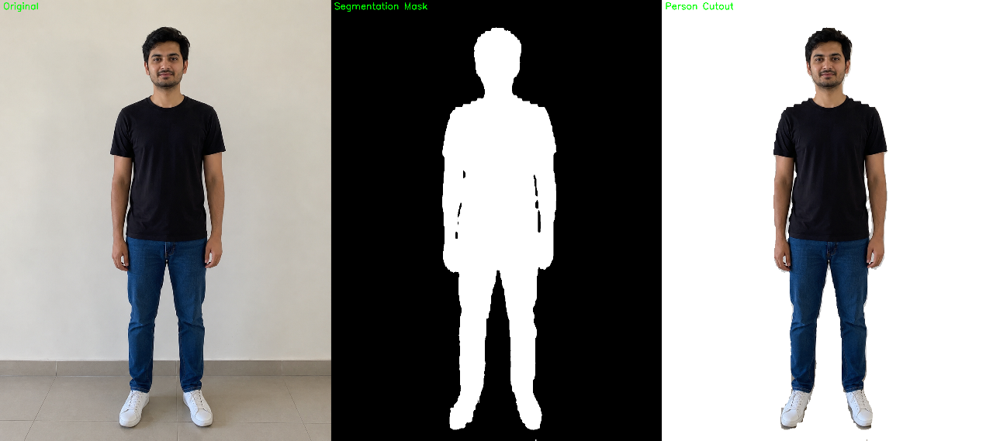

Task 2 — Pose Detection Testing
- Pose detection identifies the position of body joints in an image
- It draws a skeleton on the person showing connections between joints
- Used to understand body position and alignment for clothing placement
What I Did
- Implemented pose detection using MediaPipe Pose
- Tested on multiple static images loaded from local files
- Drew skeleton with all body landmarks on each image
- Saved output images showing detected pose
Models Tested
- MediaPipe Pose — detected 33 landmarks in real time, very fast and accurate on clear images
- MediaPipe Selfie Segmentation — separated person from background accurately
- Detectron2 — more powerful model supporting both pose and segmentation, higher accuracy on complex poses
What I Observed
- MediaPipe detected pose correctly on straight standing images
- Skeleton was drawn connecting shoulders, elbows, wrists, hips, knees and ankles
- Detection was accurate when full body was visible in the image
- Partial body or cropped images reduced detection accuracy
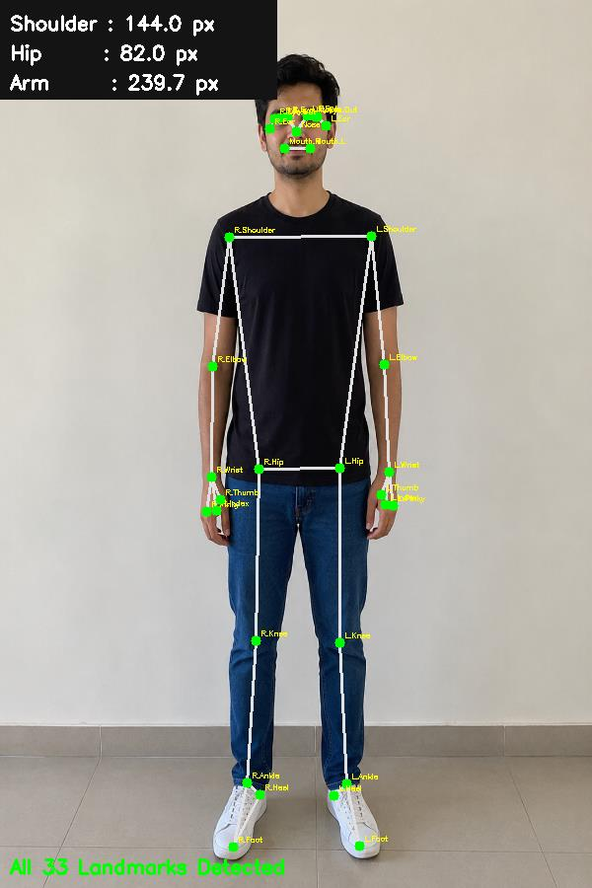
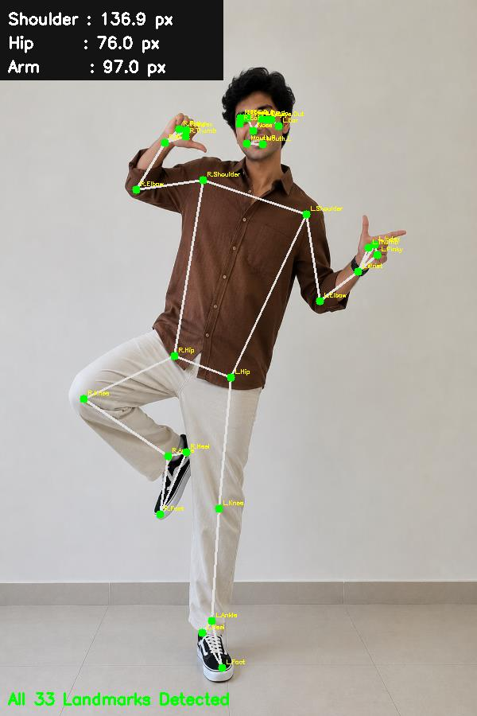

Task 3 — Accuracy Evaluation on Different Images
Testing on Different Images
I tested pose detection on multiple images with different conditions to evaluate accuracy.
- Straight standing pose — all landmarks detected correctly, skeleton drawn accurately
- Slightly tilted pose — most landmarks detected, minor shifts in elbow and wrist positions
- Arms crossed pose — shoulder landmarks correct but arm landmarks slightly off due to occlusion
- Side profile pose — only visible side landmarks detected correctly, hidden side landmarks missed
Effect of Lighting
- Good front lighting gave best results with all landmarks detected
- Poor lighting caused some landmarks to be missed or placed wrongly
- Strong shadows on one side reduced accuracy of that side landmarks
Effect of Clothing Color
- Dark clothing on dark background reduced segmentation accuracy
- Light clothing on light background caused similar issues
- Best results with clothing color clearly different from background

Pose Type | Landmarks Detected |  | Accuracy
Straight standing | All 33 |  | High
Arms slightly raised | 30 out of 33 |  | Good
Arms crossed | 28 out of 33 |  | Medium
Side profile | 20 out of 33 |  | Low
Sitting pose | 25 out of 33 |  | Medium
Key Findings
- Straight standing front facing poses give best accuracy
- Occlusion where one body part hides another reduces accuracy
- MediaPipe works best for simple poses and real time use
- Detectron2 handles complex poses better but needs more computing power
- For virtual try-on straight standing front facing images are recommended for best result

