Name: A.Hasini
Role: AI/ML Intern
Date: 4-06-2026

Body Landmark Detection & Measurement Analysis

Virtual try-on systems need to understand the human body's shape and proportions before placing clothing onto it. Body landmark detection is the process of identifying key points on the human body — such as shoulders, hips, and ankles — using machine learning. These points are then used to estimate real body measurements like shoulder width, height, and waist position, which help make virtual try-on results more accurate and realistic.

2. MediaPipe Pose
MediaPipe is an open-source framework by Google used for real-time body tracking. The MediaPipe Pose model detects 33 landmarks across the human body from a single image or video frame. Each landmark gives:
- X, Y coordinates — position in the image
- Z value — approximate depth
- Visibility score — confidence that the point is correctly detected
Key landmarks used for measurement include the shoulders (11, 12), hips (23, 24), and ankles (27, 28).

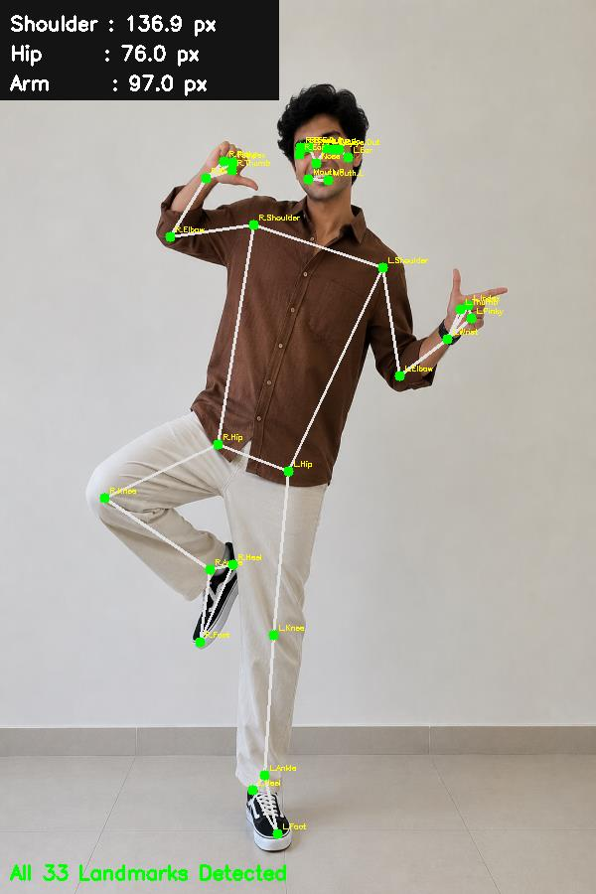
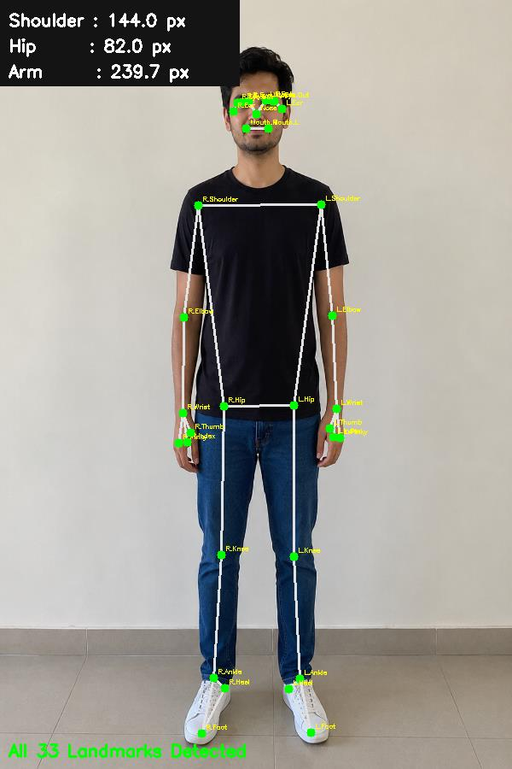

3. Body Measurements from Landmarks

Shoulder Width
Calculated as the straight-line distance between the left and right shoulder landmarks. This is used to scale the width of garments correctly.

Height Estimation
Estimated as the vertical distance from the nose (or top of head) down to the ankles. This helps scale garment length to match the person's actual height.

Waist Position
The waist is not directly detected, so it is approximated as the midpoint between the shoulders and the hips. This anchors waistbands of skirts, trousers, and dresses.

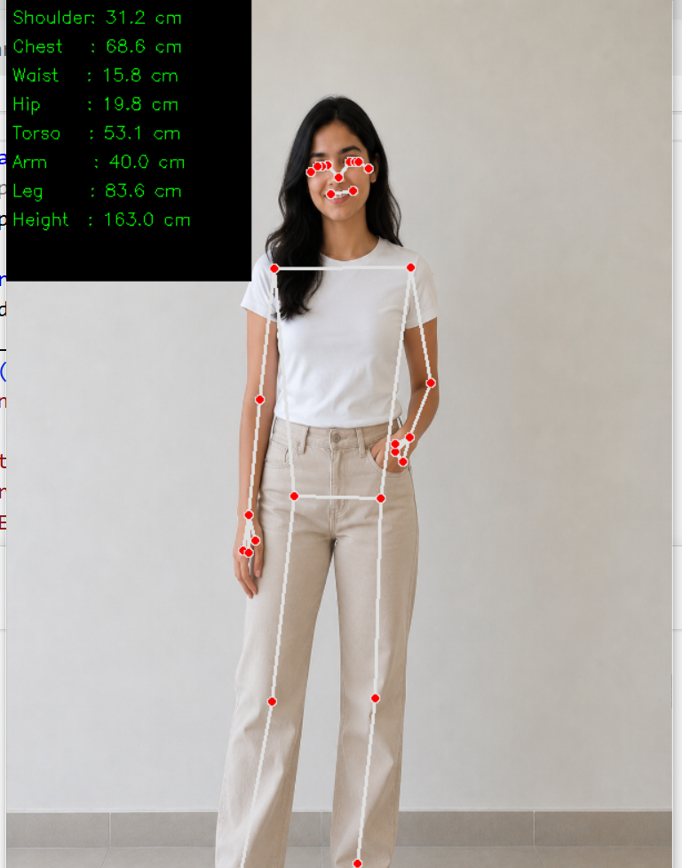

4. Factors Affecting Accuracy
- Lighting — Poor lighting reduces detection quality
- Pose — Frontal poses give the best results; side or twisted poses reduce accuracy
- Clothing — Baggy clothes may hide true joint positions
- Occlusion — If a body part is hidden or cut off, that landmark will have a low visibility score and should not be used in calculations

5. How Measurements Improve Virtual Try-On
Measurement | How It Helps
Shoulder Width | Aligns sleeve seams and chest area of tops
Height | Scales garment length to the person's body
Waist Position | Anchors waistbands of bottoms and tucked tops
Hip Position | Positions skirts, trousers, and dresses correctly
Without these measurements, garments appear stretched, misaligned, or incorrectly sized. With them, the overlay is proportional and realistic.

6. Tools Used
- MediaPipe — Body landmark detection
- OpenCV — Image processing and visualization
- Python — Scripting and calculations
- NumPy — Distance and measurement formulas

