Agentic AI Framework for Network Anomaly Detection, Root Cause Analysis and Remediation Recommendation
A project report submitted in partial fulfilment
of the requirements for the degree of
Bachelor of Technology
in
Electronics and Computer Engineering
by
Dharhshini V J
23BLC1080
Hasith Anton M A
23BLC1311
Harish J
23BLC1104


School of Electronics Engineering
Vellore Institute of Technology, Chennai
Vandalur - Kelambakkam Road
Chennai – 600127, India
October 2026

School of Electronics Engineering

Declaration
We hereby declare that the report titled Agentic AI Framework for Network Anomaly Detection, Root Cause Analysis and Remediation Recommendation submitted by us to the School of Electronics Engineering, Vellore Institute of Technology, Chennai, in partial fulfilment of the requirements for the award of Bachelor of Technology in Electronics and Computer Engineering, is a bonafide record of the work carried out by us under the supervision of Dr Papanasam E.
We further declare that the work reported in this report has not been submitted and will not be submitted, either in part or in full, for the award of any other degree or diploma of this institute or of any other institute or university.

Signature: ................  Dharhshini V J  23BLC1080  Date: ................ | Signature: ................  Hasith Anton M A  23BLC1311  Date: ................ | Signature: ................  Harish J  23BLC1104  Date: ................
School of Electronics Engineering

Certificate
This is to certify that the project report titled Agentic AI Framework for Network Anomaly Detection, Root Cause Analysis and Remediation Recommendation submitted by Dharhshini V J (23BLC1080), Hasith Anton M A (23BLC1311) and Harish J (23BLC1104) to Vellore Institute of Technology, Chennai, in partial fulfilment of the requirement for the award of the degree of Bachelor of Technology in Electronics and Computer Engineering is a bonafide work carried out under my supervision. The project report fulfils the requirements as per the regulations of this University and, in my opinion, meets the necessary standards for submission. The contents of this report have not been submitted and will not be submitted either in part or in full, for the award of any other degree or diploma and the same is certified.

Supervisor  Signature: ......................  Name: Dr Papanasam E  Date: ...................... | Head of the Department  Signature: ......................  Name: Dr Vijayakumar P  Date: ......................
Examiner 1  Signature: ......................  Name: ......................  Date: ...................... | Examiner 2  Signature: ......................  Name: ......................  Date: ......................
(Seal of the School)

Abstract
This project presents an AIOps framework that detects network faults, corroborates anomalous behaviour and generates evidence-grounded root-cause analysis (RCA) reports. It combines a supervised Random Forest detector, a temporal LSTM autoencoder and a LangGraph ReAct agent with a Streamlit operations dashboard.
The implementation uses synthetic SNMP-style telemetry for broad fault coverage and a Mininet/Open vSwitch spine-leaf emulation for kernel-level validation. The classifier detects known signatures, while the LSTM autoencoder evaluates 10-step, interface-isolated histories. For a high-confidence known fault, Tier 1 routes the alert directly to the agent; otherwise, Tier 2 identifies novel temporal anomalies. The agent queries live metrics, syslogs, topology, paths, routes and anomaly scores before returning a structured RCA report and remediation recommendation.
On the final augmented Mininet benchmark dataset of 73,240 records, evaluated on a held-out test split of 14,650 records, the fine-tuned Random Forest achieved ROC-AUC 0.9965, PR-AUC 0.9927, precision 0.9977, recall 0.9492 and F1 0.9728. The LSTM autoencoder achieved ROC-AUC 0.9812, PR-AUC 0.9284, precision 0.8970, recall 0.7093 and F1 0.7922. Across the retained 25-case agent benchmark, the agent produced 22 correct verdicts (88.0%), averaged 12.24 tool calls and completed an investigation in 12.17 seconds on average.
Keywords: network anomaly detection, root cause analysis, LSTM autoencoder, Random Forest, ReAct agent, LangGraph, Mininet.

Acknowledgements
We wish to express our sincere thanks and deep sense of gratitude to our project guide, Dr Papanasam E, School of Electronics Engineering (SENSE), for the consistent encouragement and valuable guidance offered to us throughout the course of the project work.
We sincerely express our gratitude to Dr. Ravi Sankar A, Dean, SENSE; Dr. Mohanaprasad K, Associate Dean (Academics), SENSE; and Dr. Chitra K, Associate Dean (Research), SENSE, for providing the necessary facilities and for their constant encouragement and support throughout our project.
We also extend our heartfelt thanks to Dr. Vijayakumar P, Head of the Department, for his continuous guidance and support during the course of this project.
We also take this opportunity to thank all the faculty of the School for their support and the knowledge imparted to us throughout the course.
We thank our parents, family and friends for bearing with us throughout the course of our project and for the opportunity they provided us in undergoing this course in such a prestigious institution.

Codes and Standards
The following standards and specifications guide the data model and the design of this project. Where a standard is used only as a design reference, this is stated in the body of the report.
1. Network Management and Telemetry
- RFC 3410: Introduction and Applicability Statements for the Internet-Standard Management Framework. Background for the SNMP-style polling model used in the simulator.
- RFC 2863: The Interfaces Group MIB. Defines interface variables such as ifOperStatus, ifInOctets, ifOutOctets, ifInDiscards and ifInErrors, which are the basis of the telemetry columns.
- RFC 5424: The Syslog Protocol. Reference for the format of the device log events that the agent can query.
- RFC 1191: Path MTU Discovery. Reference for the MTU-mismatch fault.
2. Network Interfaces
- IEEE 802.3: Ethernet. Reference for the standard 1500-byte payload against which the reduced MTU of 500 bytes in the mtu_mismatch fault is defined.
3. Information Security and Software Practice
- RFC 8259: The JavaScript Object Notation (JSON) Data Interchange Format. Format of the state file shared by the pipeline and the dashboard.
- ISO/IEC 27001: Information Security Management. Reference for the handling of credentials: API keys are kept in an environment file outside version control.

Mapping of Sustainable Development Goals (SDGs)
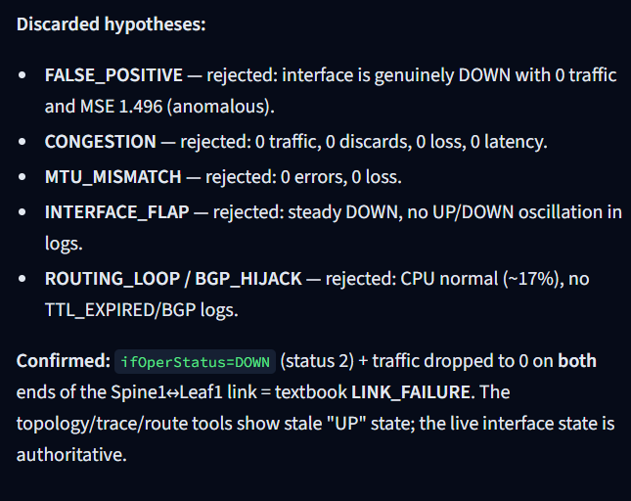 | Mapped SDGs | Justification | Example Impact
Agentic AI Framework for Network Anomaly Detection, Root Cause Analysis and Remediation Recommendation | SDG 9: Industry, Innovation and Infrastructure | Automates fault detection and diagnosis in network infrastructure, supporting reliable digital infrastructure and AI-based innovation in network operations. | Faults are investigated in under 30 seconds instead of 15 to 45 minutes, which shortens service degradation.
 | SDG 8: Decent Work and Economic Growth | Raises the productivity of network operations through technological upgrading (target 8.2) by automating repetitive triage and report writing. | Fewer false alerts and less alert fatigue; engineers can concentrate on higher-value tasks.

Table of Contents
Declaration i
Certificate ii
Abstract iii
Acknowledgements iv
Codes and Standards v
Mapping of Sustainable Development Goals (SDGs) vi
List of Figures ix
List of Tables x
List of Listings xi
List of Acronyms xii
1 Introduction 1
1.1 Background 1
1.2 Problem Statement 1
1.3 Objectives 2
1.4 Scope 2
1.5 Organisation of the Report 3
2 Literature Survey 4
2.1 Network Anomaly Detection 4
2.2 Log-Based Anomaly Detection 4
2.3 Root Cause Analysis in Networks 5
2.4 LLM Agents for Operations 5
2.5 Emulation and Domain Adaptation 5
2.6 Summary of the Studies Reviewed 6
2.7 Gaps Identified 7
3 Methodology 8
3.1 System Overview 8
3.2 Data Sources 9
3.2.1 Python WAN simulator (training data) 9
3.2.2 Mininet emulation (adaptation and validation data) 10
3.3 Feature Engineering 13
3.4 Tier 1: Random Forest Classifier 15
3.5 Tier 2: LSTM Autoencoder with Temporal Attention 16
3.6 Cascade Decision Logic 17
3.7 Domain Adaptation to Mininet Data 17
3.8 Tier 3: LangGraph ReAct Agent 18
3.9 Live Pipeline and Dashboard 19
3.10 Implementation Environment 20
3.11 Evaluation Metrics 20
4 Results and Discussion 21
4.1 Experimental Setup 21
4.2 Detection Results on Simulated Data 21
4.3 Improvement of the LSTM Autoencoder 23
4.4 False-Positive Suppression by the Cascade 25
4.5 Evaluation on Mininet Data 26
4.6 Evaluation of the ReAct Agent 27
4.6.1 Example of the ReAct loop 27
4.6.2 RCA accuracy and response time 28
4.7 Complex Scenarios 29
4.8 Dashboard Demonstration 29
4.9 Summary of Results 31
4.10 Discussion 32
5 Conclusion and Future Work 34
5.1 Conclusion 34
5.2 Limitations 34
5.3 Future Work 35
Appendix 1: Code Listings 36
Appendix 2: Pipeline State and Configuration 38
Appendix 3: Dashboard and Evaluation Evidence 39
Bibliography 47

List of Figures
Figure 3.1: System architecture: detection (Tiers 1 and 2) gating investigation (Tier 3) 8
Figure 3.2: Mininet Real-Data Lab dashboard showing augmented-dataset overview 13
Figure 3.3: Live Monitor dashboard in replay-mode idle state 19
Figure 4.1: Simulated-data detector evaluation output 22
Figure 4.2: Dashboard confusion-matrix view for detector evaluation 22
Figure 4.3: Dashboard receiver-operating-characteristic curves 23
Figure 4.4: Reconstruction-error distribution from diagnostic evaluation 24
Figure 4.5: Mininet Lab view of per-fault performance and probe-signal distributions 26
Figure 4.6: Root-cause analysis incident summary in the dashboard 27
Figure 4.7: Dashboard Live Monitor before a replay fault request 29
Figure 4.8: Dashboard after a replay fault request and detector evaluation 29
Figure 4.9: Dashboard root-cause evidence chain 30
Figure 4.10: Dashboard root-cause classification and remediation view 31
Figure A3.1: Root-cause evidence chain continuation...........................................39
Figure A3.2: Root-cause remediation recommendations...........................................39
Figure A3.3: Root-cause long-term remediation recommendations.................................40
Figure A3.4: Root-cause confidence assessment.................................................41
Figure A3.5: Root-cause tool-evidence analysis panel..........................................42
Figure A3.6: Root-cause discarded-hypotheses panel............................................43
Figure A3.7: Telemetry Analytics dashboard overview...........................................43
Figure A3.8: Telemetry Analytics fault-distribution and metric panels.........................44
Figure A3.9: Telemetry Analytics anomaly and feature views....................................44
Figure A3.10: Benchmark dashboard summary cards...............................................44
Figure A3.11: Benchmark dashboard detailed scenario table.....................................45
Figure A3.12: Results-folder confusion matrices...............................................45
Figure A3.13: Results-folder ROC and precision-recall curves..................................45
Figure A3.14: Results-folder threshold-sweep diagnostic.......................................46

List of Tables
Table 2.1: Summary of the fifteen studies reviewed 6
Table 3.1: Telemetry schema of the simulator 10
Table 3.1a: Engineered feature interpretation 14
Table 3.2: Target fault types and their injection in Mininet 12
Table 3.3: Decision logic of the three-tier cascade 17
Table 3.4: Diagnostic tools available to the agent 18
Table 3.5: Software stack 20
Table 3.6: Summary of the configuration of the three tiers 20
Table 4.1: Datasets used in the experiments 21
Table 4.2: Test-set metrics on the simulated data 21
Table 4.3: Effect of the refinements on the LSTM autoencoder 25
Table 4.4: Counters of the detection funnel in a test run 25
Table 4.5: Detection metrics on the Mininet test split before and after fine-tuning 26
Table 4.6: RCA accuracy and response time of the agent per fault type 28
Table 4.7: Multi-fault test scenarios 29
Table 4.8: Summary of test scenarios and results 31
Table 4.9: Comparison of existing approaches and this project 32

List of Listings
Listing 3.1: Telemetry generator (dataset generation) 9
Listing 3.2: Anomaly injector 9
Listing 3.3: Random Forest training and threshold tuning 12
Listing 3.4: LSTM autoencoder with temporal attention 13
Listing 3.5: ReAct agent graph and tool registry 15
Listing A.1: Dataset generation (network/telemetry_generator.py) 29
Listing A.2: Anomaly injection (network/anomaly_injector.py) 29
Listing A.3: Random Forest detector (detection/baseline_models.py) 29
Listing A.4: LSTM autoencoder (detection/lstm_autoencoder.py) 29
Listing A.5: ReAct agent (agent/react_agent.py) 30
Listing A.6: Mininet topology and fault injection (emulation/mininet_topo.py) 30
Listing A.7: Live pipeline (demo/live_pipeline.py) 30

List of Acronyms
Acronym | Full Form
AE | Autoencoder
AI | Artificial Intelligence
AIOps | Artificial Intelligence for IT Operations
API | Application Programming Interface
AUC | Area Under the Curve
CPU | Central Processing Unit
CSV | Comma-Separated Values
ECMP | Equal-Cost Multi-Path
GNN | Graph Neural Network
JSON | JavaScript Object Notation
KPI | Key Performance Indicator
LLM | Large Language Model
LSTM | Long Short-Term Memory
MIB | Management Information Base
ML | Machine Learning
MSE | Mean Squared Error
MTU | Maximum Transmission Unit
NOC | Network Operations Centre
OVS | Open vSwitch
PR-AUC | Area under the Precision-Recall curve
QoS | Quality of Service
RCA | Root Cause Analysis
ReAct | Reasoning and Acting
RF | Random Forest
ROC-AUC | Area under the Receiver Operating Characteristic curve
SDG | Sustainable Development Goal
SMOTE | Synthetic Minority Over-sampling Technique
SNMP | Simple Network Management Protocol
tc | Traffic Control (Linux)
UI | User Interface
WAN | Wide Area Network

CHAPTER 1

Introduction

1.1 Background
Modern enterprise and service-provider networks are watched through telemetry. Routers and switches expose interface counters, operational status, latency and loss measurements, and they write syslog messages. A single wide-area network can produce millions of telemetry rows per day, and the few rows that belong to a real fault are buried among them. Operations teams normally set thresholds in a monitoring tool. When a threshold trips, an engineer pulls metrics, reads syslogs, checks the topology and decides on a fix. This manual triage takes about 15 to 45 minutes per incident, and the service stays degraded for that time.
Machine learning can find anomalies in telemetry faster than a person, and large language models (LLMs) can reason over evidence and write clear explanations. In most existing work, however, detection and diagnosis are treated as separate problems. Detection models flag a row but do not say why it is abnormal, and root cause analysis (RCA) methods usually follow fixed rules or a fixed model architecture [1], [9]. False alerts add to the load, because an operator who sees too many of them stops trusting the monitor, a problem known as alert fatigue.
This project builds a single framework that goes from raw telemetry to a written incident report. The framework is a three-tier cascade. A Random Forest classifier recognises known fault signatures. An LSTM autoencoder with temporal attention then confirms or rejects each flag using the recent history of the device. Only anomalies on which both tiers agree are passed to a LangGraph ReAct agent, which uses a Google Gemini model to choose diagnostic tools, collect evidence and write a root cause analysis with remediation recommendations. A live dashboard shows each stage as it runs.

1.2 Problem Statement
Network operations centres face four connected problems.
- Volume. Telemetry arrives faster than engineers can read it, and faults are rare compared with normal rows.
- Alert fatigue. Threshold monitors raise many false alerts, so real faults are easily missed or ignored.
- Detection without diagnosis. A monitor says that something is wrong but not what is wrong, where it started, or what to do. Engineers must still correlate metrics, logs and topology by hand.
- Static analysis. Existing automated RCA methods rely on predefined rules, workflows or fixed models, and they cannot decide at run time which diagnostic check is needed for a given fault [1], [9].
The problem addressed in this report is therefore: how can a network be monitored so that real faults, including previously unseen ones, are detected with few false alarms, and each confirmed fault is automatically investigated and explained with evidence and a recommended remediation, in well under a minute?

1.3 Objectives
The objectives of the project are:
- to detect known and unseen (zero-day) network faults from telemetry;
- to filter false positives before any investigation is started;
- to use an LLM agent that chooses diagnostic tools dynamically to find the root cause of a confirmed anomaly;
- to generate an evidence-grounded incident report with remediation recommendations in under 30 seconds;
- to validate the approach on emulated (Mininet) data and not only on simulation; and
- to present the whole pipeline on a live dashboard with controls for injecting faults.

1.4 Scope
The work covers a Python simulator, a Mininet/Open vSwitch spine-leaf emulation, feature engineering, a Random Forest detector, an LSTM autoencoder, a LangGraph RCA agent and a Streamlit dashboard. The demonstration supports five injected operational fault classes—link failure, congestion, interface flap, MTU mismatch and packet loss—while the simulator also contains routing-loop benchmark scenarios. The agent recommends remediation; it does not make configuration changes on network devices.
The report evaluates the implemented single-fault workflow and clearly separates measured results from the planned compound-fault evaluation described in the limitations and future-work sections.

1.5 Organisation of the Report
Chapter 2 reviews the literature on network anomaly detection, log analysis, root cause analysis and LLM agents, and lists the gaps that this project addresses. Chapter 3 describes the data sources, the three tiers, the domain adaptation procedure, the live pipeline and the dashboard. Chapter 4 presents the results and discusses them. Chapter 5 concludes the report, states the limitations and proposes future work. The appendices collect the code listings and the pipeline state structure, followed by the bibliography.
CHAPTER 2

Literature Survey
This chapter reviews fifteen recent studies grouped by theme: network anomaly detection, log-based anomaly detection, root cause analysis, and the use of LLM agents for operations tasks. It then summarises the studies in one table and lists the gaps that this project is designed to fill.

2.1 Network Anomaly Detection
Anomaly detection in networks is usually treated as a classification or reconstruction problem on traffic and telemetry features [16]. Kamamura et al. analyse IP traffic at variable granularity so that large-scale anomalies can be found without fixing one time scale in advance [11]. Williams et al. model several seasonal patterns at once with a multi-seasonal SARIMA approach and flag points that break all of them [12]. Zhong et al. combine heterogeneous ensemble learning with a deep kNN to detect both known and unknown traffic anomalies at a fine granularity [13]. Kim et al. use an autoencoder that is trained on normal traffic and flags traffic it cannot reconstruct well, which allows unseen anomalies to be found in a blockchain network [14]. All four studies stop at detection. They tell the operator that a row or a flow is abnormal, but they do not explain the cause.
Two model families are used in this project. Random Forests [17] are fast, handle mixed numerical and binary features, and perform well when labelled examples of the fault are available. Recurrent networks with long short-term memory (LSTM) cells [18] model sequences, and an LSTM autoencoder trained only on normal data can detect faults it has never seen, because they reconstruct poorly [19]. Attention [20] lets such a model weight the most informative time steps in a window instead of treating them equally. The cascade in this project uses both families so that each covers the weakness of the other.

2.2 Log-Based Anomaly Detection
A second line of work detects faults in system logs. LogFiT fine-tunes a BERT-style language model in a self-supervised way on normal logs and flags sequences that the model finds unlikely [2]. LogEncoder learns log representations by contrastive learning, which improves unsupervised detection [3]. Han et al. use BERT with matching networks to detect anomalies from only a few labelled examples [4], and ContexLog represents logs without parsing, so that unseen log formats do not break it [5]. Bagora et al. apply active learning to label fault data from cloud metrics with less manual effort [6]. These methods work well on logs, but each uses one data source. None of them combines logs with interface telemetry and topology to explain a network fault.

2.3 Root Cause Analysis in Networks
Root cause analysis methods try to explain a fault once it is detected. Wankvar and Witayangkurn classify faults in an IP/MPLS network from SNMP and syslog data and then use case-based reasoning to retrieve a matching past case [1]. Guo et al. combine TextCNN and BERT on control-plane and data-plane information to detect failures in service function chains [7]. Mata et al. use a spatial graph convolutional network so that the topology of a mobile network guides the RCA [8]. Zhang combines CNN, LSTM and fuzzy reasoning to handle spatial-temporal fault data [9], Riaz et al. combine CNN and XGBoost to diagnose several faults from sparse drive-test reports in cellular networks [10], and Yen et al. learn dependencies between KPIs with a graph neural network [15].
These methods are effective in their own domains, but they are static. The set of checks that is run does not depend on the fault being investigated, and most of them are tied to one network type such as 4G/5G, service function chains or IP/MPLS. An engineer, in contrast, chooses the next check from what the previous one showed. That behaviour is what the agent tier of this project is designed to imitate.

2.4 LLM Agents for Operations
ReAct is a prompting pattern in which a language model alternates between reasoning steps and actions such as tool calls, and uses the result of each action in its next reasoning step [21]. Because every conclusion must follow from a tool result, the answer is grounded in retrieved evidence instead of being produced in a single unverified pass. LangGraph represents such an agent as a stateful graph of model and tool nodes with a bounded number of steps [22], and the Gemini API can be reached through an OpenAI-compatible interface [23], which keeps the choice of model replaceable. Few published network RCA systems use an LLM agent in this way, which is the opportunity this project takes.

2.5 Emulation and Domain Adaptation
Models trained on synthetic data are often evaluated on the same synthetic generator, which makes the results look better than they would be on real equipment. Mininet creates real Linux network namespaces, virtual Ethernet links and Open vSwitch instances on one machine [24], [25], so that faults injected with standard kernel tools produce real kernel behaviour. Transfer learning reuses what a model has learned in a source domain and adapts it to a target domain [26], and oversampling methods such as SMOTE [27] help when fault examples are rare. This project uses the simulator for large-scale training and Mininet for adaptation and validation.

2.6 Summary of the Studies Reviewed
Table 2.1: Summary of the fifteen studies reviewed
No. | Author(s), year | Method / approach | Finding and research gap
1 | Wankvar & Witayangkurn, 2025 | ML classification and case-based reasoning on SNMP and syslog data | Effective automated RCA, but uses predefined workflows with no dynamic agent-based investigation
2 | Almodovar et al., 2024 | LogFiT: BERT-based, self-supervised log anomaly detection | Strong log detection; does not combine logs with telemetry or topology for RCA
3 | Qi et al., 2023 | LogEncoder: contrastive learning with semantic log representations | Improves unsupervised detection; limited to log-level analysis
4 | Han et al., 2024 | BERT with matching networks for few-shot log anomaly detection | Handles limited labels; no multi-source RCA
5 | Xiao et al., 2024 | ContexLog: transformer-based contextual log representation without parsing | Robust to unseen log formats; lacks network-level diagnosis
6 | Bagora et al., 2024 | Active learning for automated labelling of cloud fault data | Reduces labelling effort; focused on cloud metrics, not RCA
7 | Guo et al., 2022 | FullSight: TextCNN and BERT on control and data plane information | High detection accuracy; limited to service function chains
8 | Mata et al., 2024 | Spatial graph convolutional network for topology-aware RCA | Effective topology-based RCA; specific to mobile networks
9 | Zhang, 2023 | CNN, LSTM and fuzzy reasoning (deep fuzzy neural network) | Handles spatial-temporal fault data; fixed diagnostic architecture
10 | Riaz et al., 2022 | HYDRA: CNN and XGBoost for multifault diagnosis from sparse MDT reports | Effective with sparse data; focused on cellular networks
11 | Kamamura et al., 2023 | IP traffic analysis with variable granularity | Detects large-scale traffic anomalies; no RCA
12 | Williams et al., 2023 | Multi-SARIMA time-series anomaly detection | Models several temporal patterns; no network-specific RCA
13 | Zhong et al., 2024 | RFG-HELAD: heterogeneous ensemble learning with deep kNN | Addresses unseen anomalies; no downstream root-cause reasoning
14 | Kim et al., 2022 | Autoencoder-based semi-supervised traffic anomaly detection | Detects unseen traffic anomalies; designed for blockchain networks
15 | Yen et al., 2022 | GNN with graph structure learning on multivariate KPIs | Learns network dependencies; no logs and no dynamic LLM-based diagnosis

2.7 Gaps Identified
The review shows the following gaps.
- Static RCA. Existing approaches rely on predefined rules, workflows or fixed models.
- Single-source analysis. Most methods use only KPIs, only logs or only alarms, and do not combine several network signals.
- Limited generalisation. Many solutions are designed for one domain such as 4G/5G, service function chains or IP/MPLS.
- Detection is not diagnosis. Fault detection and root-cause investigation are usually separate stages.
- No dynamic investigation. The models cannot choose diagnostic tools according to the fault.
- Limited LLM integration. Few approaches use an LLM agent for evidence-based, tool-driven RCA.
- Evaluation gap. Validation on realistic or emulated network environments is limited.
This project addresses these gaps with a detection cascade that gates an LLM agent, an agent that selects its own diagnostic tools and writes an evidence-based report, and a validation step on Mininet-emulated faults.
CHAPTER 3

Methodology

3.1 System Overview
The framework contains three implemented stages: a Random Forest classifier, an LSTM autoencoder and a LangGraph RCA agent. The reusable TieredTriagePipeline component sends an anomalous Random Forest prediction with probability greater than 0.85 directly to the agent; otherwise it evaluates the LSTM and escalates only an LSTM anomaly. The demonstration backend in demo/live_pipeline.py is deliberately more conservative: it displays both detector outputs for a requested replay scenario and invokes the agent only when the LSTM score crosses its stored threshold. These are two code paths in the repository and are described separately to avoid overstating a single routing rule.
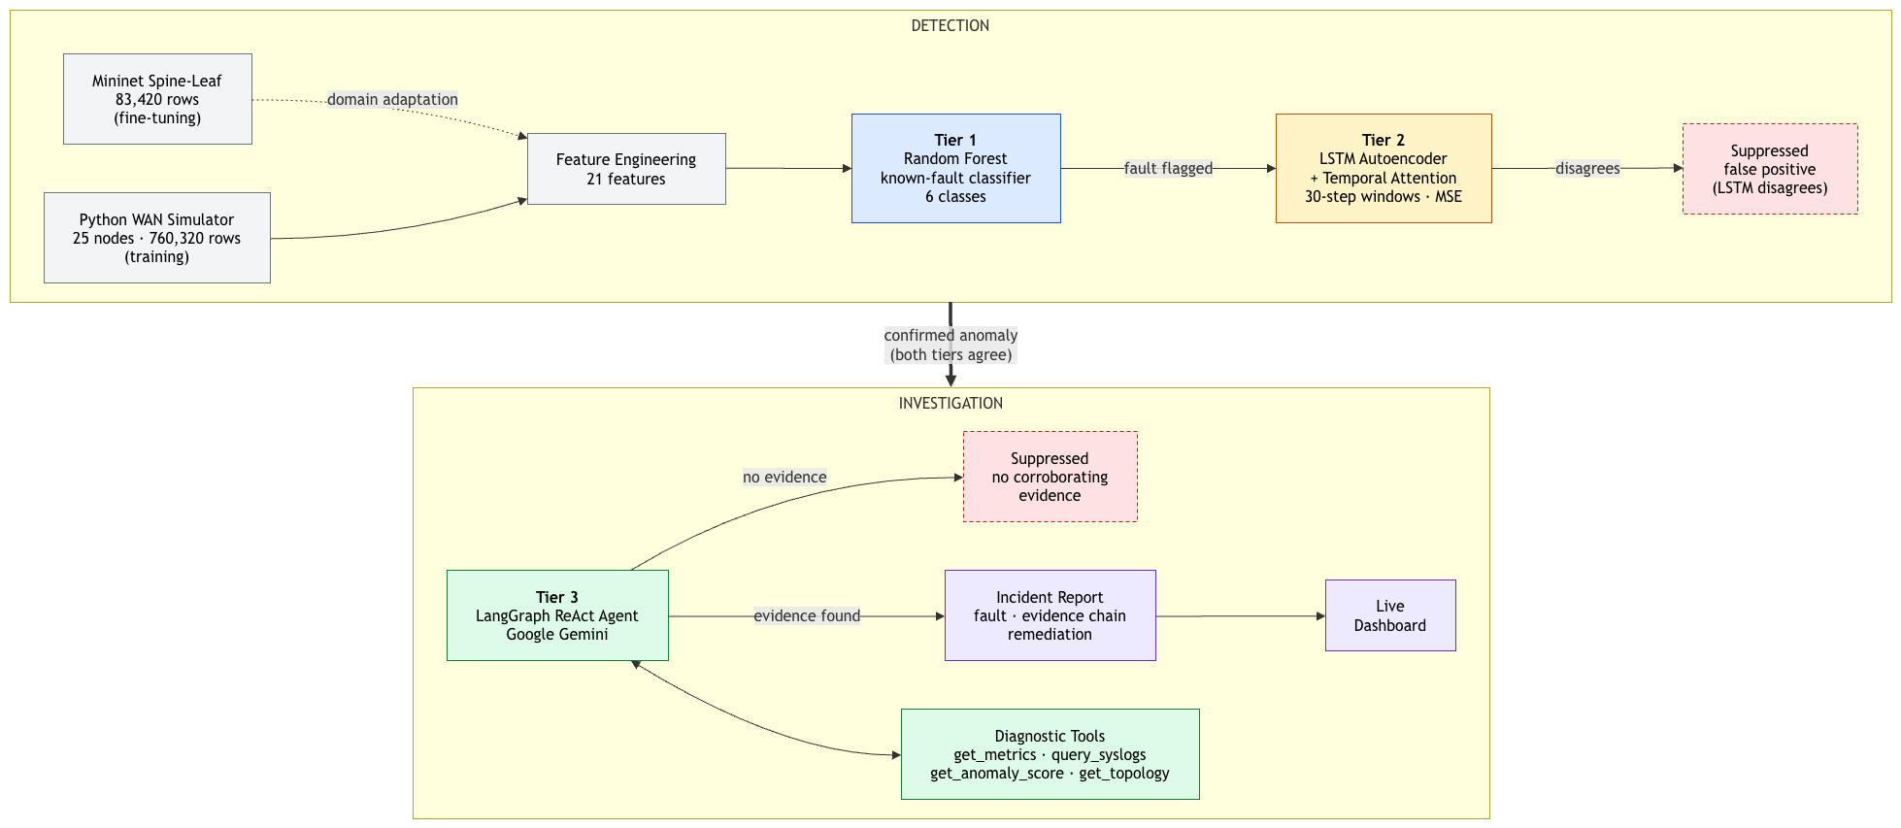
Figure 3.1: System architecture: detection (Tiers 1 and 2) gating investigation (Tier 3)
The cascade separates rapid recognition of known faults from temporal novelty detection. The Random Forest can classify incoming rows efficiently, while the autoencoder examines recent history and provides a route for unseen fault behaviour. The agent is invoked only after a detector raises an actionable alert, then independently checks the evidence before forming an RCA conclusion. This limits unnecessary LLM calls and allows the agent to suppress alerts that are contradicted by metrics, logs or topology.

3.2 Data Sources

3.2.1 Python WAN simulator (training data)
The primary training source is a Python SNMP-style telemetry simulator that produces one directed interface record per polling interval. For every physical topology link, the simulator emits a record for each direction so that the receiving and transmitting behaviour of both endpoints can be analysed separately. Normal traffic follows a daily load pattern with bounded Ornstein–Uhlenbeck noise, preventing every record from looking identical. The simulator stores telemetry, RFC 5424-style syslogs and sampled NetFlow-like flow records, allowing the agent to corroborate a detector alert with more than one data source.
A telemetry row is therefore an observation of one local interface at one moment in time, not a complete device summary. The same interface appears repeatedly across the dataset, and its ordered records form the history from which rates, rolling statistics and LSTM sequences are computed. The 760,320-record simulator corpus uses 15-second polling. Mininet uses a faster collector and produces a CSV with the same core schema so that the same pipeline can operate across the two sources.
A typical Mininet CSV record has the following form. The values shown are representative of the stored dataset and illustrate why raw counters are converted into differences before modelling:
timestamp=2026-10-24T13:10:37Z | device_id=l1 | interface_id=l1-eth2 | ifOperStatus=1 | ifInOctets=6273546650 | ifOutOctets=3357845116 | ifInDiscards=28855280 | ifOutDiscards=23494109 | ifInErrors=0 | latency_ms=0.28 | packet_loss_rate=0.0016 | cpu_utilization=0.0 | is_anomaly=0 | anomaly_type=none
The large octet and discard values are cumulative kernel counters, so a value is meaningful only in relation to earlier values from the same interface. For example, the pipeline computes delta_ifInOctets(t) = ifInOctets(t) − ifInOctets(t−1). This turns a cumulative byte counter into bytes observed during one polling interval and makes sudden drops, bursts and sustained utilisation measurable.
# network/telemetry_generator.py
engine = TelemetryEngine(topology)
snmp, syslogs, flow = engine.generate_telemetry_window(
start_time=phase_time, duration_seconds=259200,
interval_seconds=15, anomalies=anomalies
)
final_snmp.to_parquet("data/snmp_telemetry.parquet")

Listing 3.1: Telemetry generator (dataset generation)
# network/anomaly_injector.py
def create_congestion(self, link, start_time, duration_minutes):
return self._create_base_anomaly(
anomaly_type="congestion", link=link,
start_time=start_time, duration_minutes=duration_minutes,
severity="major",
description=f"High congestion detected on {link}."
)

Listing 3.2: Anomaly injector
Table 3.1: Telemetry schema of the simulator
Field | Meaning and use
timestamp | UTC time at which the polling record was produced. It orders each interface history and defines the temporal window.
device_id | Switch, router or simulated device that emitted the record, for example l1 or Spine1.
interface_id | Local monitored interface, for example l1-eth2. Each device/interface pair is treated as an independent time series.
peer_device_id | Remote endpoint of the directed simulated link. This field is available in the simulator topology; the Mininet CSV identifies the local port.
ifOperStatus | Operational interface state. The project uses 1 for UP and 2 for DOWN, following the IF-MIB convention.
ifInOctets | Bytes received at the interface. It is a raw counter in Mininet; changes between polls are more informative than the absolute value.
ifOutOctets | Bytes transmitted at the interface. Sustained high change rate indicates high utilisation; a sudden fall can indicate a failed link.
ifInDiscards | Received packets discarded without a receive error. Increases can indicate buffer pressure or fragmentation-related drops.
ifOutDiscards | Transmitted packets discarded, often due to queue overflow. It is a primary congestion signal.
ifInErrors | Received packets with errors, such as malformed or fragmented traffic. It is a strong MTU-mismatch signal.
latency_ms | Probe-derived delay in milliseconds. In the Mininet collector it is based on the dedicated UDP iperf3 probe jitter; it is a performance indicator, not an SNMP IF-MIB counter.
packet_loss_rate | Fraction of probe packets lost, in the range 0–1. A value of 0.40 means approximately 40% packet loss.
cpu_utilization | Host/switch CPU utilisation. In Mininet it is a host-level signal and is treated cautiously because it is not a true per-interface counter.
is_anomaly | Ground-truth binary label used for supervised training and evaluation: 0 normal, 1 fault interval. It is never supplied as a model input.
anomaly_type | Ground-truth fault label, such as link_failure or congestion. It is used for evaluation, replay selection and dashboard presentation, not as a prediction feature.
delta_ifInOctets / delta_ifOutOctets | Per-interface difference between successive counter readings. These derived values approximate traffic during the polling interval.
delta_ifInDiscards | Difference in receive discards between polls. It reveals new drops even when the raw counter is already large.

3.2.2 Mininet emulation (adaptation and validation data)
To obtain telemetry affected by real Linux networking behaviour, the project uses a Mininet/Open vSwitch spine-leaf topology with two spine switches, four leaf switches and four hosts. The TelemetryCollector visits each switch interface once per polling cycle. It reads rx_bytes, tx_bytes, rx_dropped, tx_dropped and rx_errors from /sys/class/net/<interface>/statistics, reads operational state from /sys/class/net/<interface>/operstate, and records host CPU utilisation from /proc/stat. A dedicated UDP iperf3 probe runs in parallel and supplies jitter-derived latency and packet-loss values. Every collected record is labelled with the active injection type only for controlled training and evaluation.
The collector flushes new records to mininet_telemetry_live.csv every five seconds, so the live pipeline can process newly arriving data without waiting for the full experiment to end. When an experiment is saved, it also derives delta_ifInOctets, delta_ifOutOctets and delta_ifInDiscards per device/interface pair. The augmented final dataset retains these authentic Open vSwitch counter measurements and replaces only known-unreliable probe columns with fault-specific distributions.
Faults are injected into the live kernel with standard Linux tools, which keeps the host operating system safe and the faults realistic. Table 3.2 lists the five fault types, the commands used in emulation and the symptom that each produces. The tc netem tool [34] provides the loss emulation.
Table 3.2: Target fault types and their injection in Mininet
Fault | Injection mechanism in the Mininet collector | Observable telemetry and syslog effect
Link failure | net.configLinkStatus(s1, l1, 'down') for the timed collection phase; the live helper can run ip link set s1-eth1 down. | ifOperStatus becomes 2; traffic counters stop changing; probe loss rises; link and routing adjacency events are expected.
Congestion | tc qdisc replace dev s2-eth2 root netem delay 80ms 20ms distribution normal loss 5%. | Latency/jitter rises, loss is introduced and transmit discards can increase as queues experience pressure.
Interface flap | The collector alternates net.configLinkStatus(s1, l2, 'up'/'down') every 5 seconds for the fault interval. | Alternating ifOperStatus values, intermittent zero traffic and repeated UP/DOWN events; some transitions can be missed by slow polling.
MTU mismatch | ip link set dev l1-eth2 mtu 500; the interface is restored to MTU 1500 after the timed fault interval. | Oversized packets can fragment or be discarded; ifInErrors and loss-related features are expected to increase while the link may remain UP.
Packet loss | tc qdisc replace dev s2-eth4 root netem loss 40% during data collection. | High packet_loss_rate, retransmission-related delay and possible drop-counter changes while ifOperStatus remains UP.

The Mininet collection process exposed a data-quality limitation that must be stated precisely. Early recordings used a probe target or fault interface that did not consistently lie on the measured traffic path, so latency and loss could remain fixed even when a fault was active. The corrected workflow aligns the probe host, probe server and injected interface. Where an earlier recorded probe signal is demonstrably unreliable, augmentation replaces only latency_ms and packet_loss_rate using fault-specific physical distributions; raw Open vSwitch counters and labels are retained. CPU utilisation remains a host-level, noisy measurement rather than an interface metric and is zeroed for the corresponding Mininet model workflow.
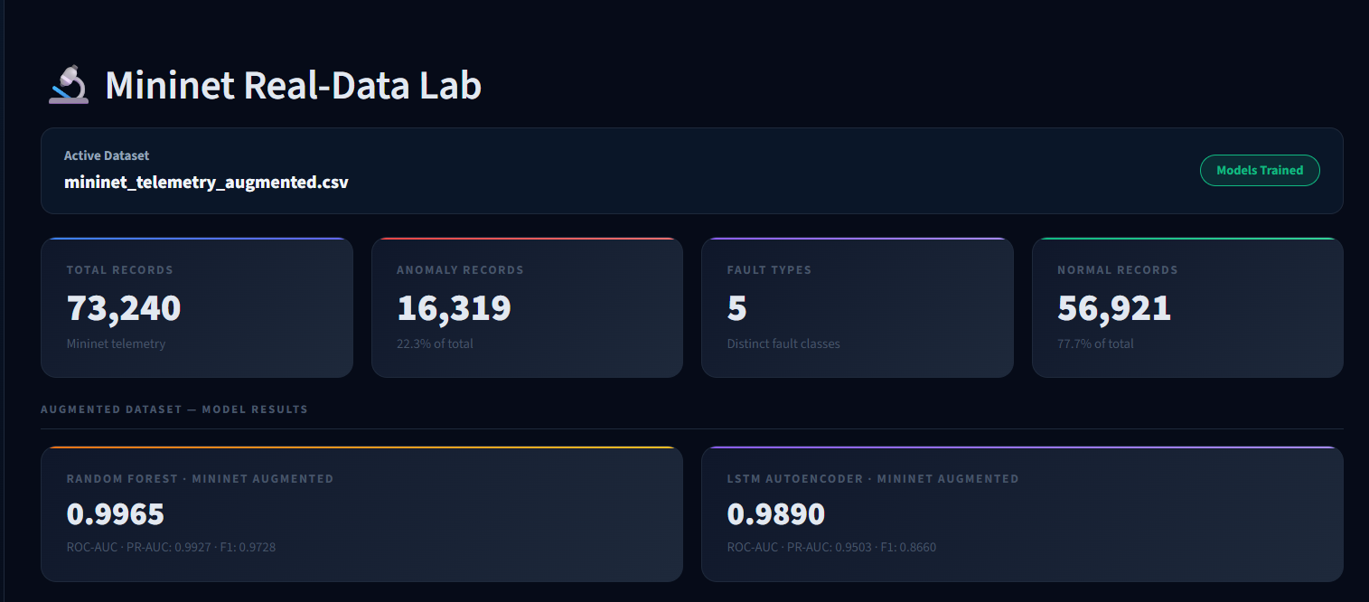

Figure 3.2: Mininet spine-leaf topology and telemetry collection

3.3 Feature Engineering
The feature pipeline converts raw telemetry into 21 model features. It first sorts data by device_id, interface_id and timestamp, then computes all temporal values inside each interface group. This isolation is essential: a counter change on l1-eth2 must never be compared with the unrelated counter history of l2-eth3. Raw cumulative byte and discard counters are not passed directly to the model because their magnitude grows with uptime; the model instead receives deltas, normalised ratios, rolling statistics and explicit state flags. A RobustScaler is fitted on training data only and reused for validation and test data.
Table 3.1a: Engineered feature interpretation
Feature | Definition and diagnostic meaning
delta_in_octets / delta_out_octets | Current raw-counter value minus prior value for the same interface. Represents traffic volume during the interval and exposes a sudden traffic stop or burst.
is_link_down | 1 when ifOperStatus equals 2; otherwise 0. Gives the models a direct, unambiguous link-state indicator.
is_high_latency | 1 when latency_ms exceeds 10 ms; otherwise 0. Captures material deviation from the low-latency baseline.
is_dropping_packets | 1 when packet_loss_rate is positive. It helps distinguish healthy high utilisation from degraded traffic delivery.
rolling_mean / rolling_std | Trailing 12-record baseline of incoming traffic, outgoing traffic or discards for the same interface.
zscore_in_octets / zscore_out_octets / zscore_out_discards | Current value expressed relative to its rolling mean and standard deviation. Large magnitude identifies unusual changes rather than large counters alone.
in_out_ratio | (ifInOctets + 1) / (ifOutOctets + 1). Highlights directional imbalance and possible blackholing or asymmetric load.
discard_intensity | (ifOutDiscards + ifInDiscards) / (ifInOctets / 1000 + 1). Normalises drops by observed traffic.
error_rate | (ifInErrors + 1) / (ifInOctets + 1). Makes error behaviour comparable across heavily and lightly loaded interfaces.
burst_ratio | Absolute traffic delta divided by rolling mean traffic. Highlights bursts that can precede congestion.

3.4 Tier 1: Random Forest Classifier
The generic baseline Random Forest in detection/baseline_models.py is binary and uses 200 estimators, balanced class weights and optional SMOTE when enough minority examples are present. The final Mininet fine-tuning workflow is separate: emulation/finetune_on_mininet.py creates a 500-tree RandomForestClassifier, applies controlled SMOTE, learns a validation-set decision threshold and saves a model bundle. The final Mininet values reported in Chapter 4 therefore describe this fine-tuned 500-tree workflow, not the generic baseline class.
The Random Forest was chosen as the first tier because it is fast (thousands of rows are classified in milliseconds), because its feature importances can be inspected, and because it needs no time window, so it can act on every new row as soon as it arrives. The weakness of a row-wise classifier is that it cannot see how the metrics are changing, and this is the role of Tier 2.
For the live workflow, the prediction probability is used as an alert confidence. A high-confidence anomalous prediction (greater than 0.85 in the generic triage pipeline) bypasses Tier 2 and is investigated by the agent. Lower-confidence or unclassified observations are passed to the LSTM autoencoder, which provides the zero-day detection path.
# detection/baseline_models.py
self.model = RandomForestClassifier(
n_estimators=200, class_weight="balanced",
random_state=self.seed, n_jobs=-1
)
self.model.fit(X_train_res, y_train_res)
probabilities = self.model.predict_proba(X_scaled)[:, 1]

Listing 3.3: Random Forest training and threshold tuning

3.5 Tier 2: LSTM Autoencoder with Temporal Attention
An autoencoder is trained to compress its input and then rebuild it. When it is trained on normal traffic only, it rebuilds normal windows well and abnormal windows poorly, so the reconstruction error is a score of abnormality. The detector needs no fault labels for training, which makes it suitable for faults that were never seen before.
The source LSTMAutoencoder class is a PyTorch encoder-decoder: input features pass through 128-unit and 64-unit LSTM encoder layers, temporal attention produces a 64-unit context vector, a 32-unit dense bottleneck compresses it, and 64-unit/128-unit decoder layers reconstruct the sequence. LSTMAutoencoderDetector uses a 10-step interface-isolated window, up to 60 epochs and batch size 128 by default; the Mininet fine-tuning script instantiates the detector with a 10-step window and 50 epochs. The stored model artifact and the feature dimension determine the exact trained instance used at runtime.
MSE = (1 / (T · F)) · Σt Σf ( x(t,f) − x̂(t,f) )² (3.1)
The reconstruction score is a weighted mean-squared error. Higher weights are assigned to link-down, packet-dropping, high-latency, error-rate and loss-related features. A centred rolling median of width three suppresses isolated score spikes. During calibration, candidate thresholds from the 85th to 99.9th validation-error percentiles are evaluated and the threshold with the best F1 score is retained. Training uses Adam, gradient clipping, learning-rate reduction on plateau and early stopping.
The retained simulated benchmark shows the earlier LSTM configuration at F1 0.7284. The current implementation adds temporal attention, domain-weighted scoring, interface-isolated sequences, median smoothing and threshold calibration. In the final Mininet benchmark, the fine-tuned LSTM achieved F1 0.7922, ROC-AUC 0.9812 and PR-AUC 0.9284. Its lower recall on MTU mismatch and packet loss identifies the temporal detector's current sensitivity limits, while its strong performance on link failures, congestion and interface flaps provides a complementary signal to Tier 1.
# detection/lstm_autoencoder.py
scores = self.attn(lstm_out)
weights = torch.softmax(scores, dim=1)
context = (lstm_out * weights).sum(dim=1)
weighted = torch.pow(x - x_hat, 2) * weights_tensor
mse = torch.mean(weighted, dim=[1, 2])
smoothed = pd.Series(scores).rolling(3, min_periods=1, center=True).median()

Listing 3.4: LSTM autoencoder with temporal attention

3.6 Cascade Decision Logic
Table 3.3 summarises the implemented routing logic. A high-confidence known-fault prediction goes directly to the agent. When Tier 1 is not decisive, Tier 2 can identify a temporal anomaly and send it to the agent as a potential novel fault. The agent then validates the alert against multiple evidence sources before reporting a root cause or suppressing a false positive.
Table 3.3: Decision logic of the three-tier cascade
Tier 1 path | Tier 2 / Tier 3 | Outcome
TieredTriagePipeline: anomalous RF probability > 0.85 | LSTM skipped; agent invoked | High-confidence known anomaly is investigated by the agent.
TieredTriagePipeline: no high-confidence RF anomaly | LSTM score at or above calibrated threshold | Potential novel/temporal anomaly is investigated by the agent.
TieredTriagePipeline: no high-confidence RF anomaly | LSTM score below threshold | No escalation.
Dashboard replay pipeline | RF and LSTM are both evaluated; agent runs only for an LSTM threshold crossing | Dashboard presents both detector verdicts before RCA.
Agent investigation | Tool evidence conflicts with alert | Agent can return FALSE_POSITIVE or another evidence-supported conclusion.

3.7 Domain Adaptation to Mininet Data
Models trained only on simulated data may not transfer to a real kernel, so they are adapted with transfer learning [26]. The procedure is:
- Re-fit the feature pipeline on the Mininet training split, because feature ranges change.
- Retrain the Random Forest on the Mininet training data, after balancing the classes with SMOTE [27], and tune its threshold again on the Mininet validation split. The architecture is reused and the weights are learned again, because the Mininet feature distribution is too different for a small update.
- Set the broken feature cpu_utilization to zero before the data reaches the LSTM.
- Train the LSTM autoencoder on the clean (normal) Mininet windows and then fine-tune it with a cosine learning-rate decay; recalibrate its threshold on the validation split.
- Save the adapted models in a separate folder. The live pipeline loads the Mininet models first and falls back to the base synthetic models if they are missing.
The adapted models are stored separately from the synthetic models. The live pipeline preferentially loads the Mininet fine-tuned bundle and falls back to the synthetic models when it is unavailable. A watcher script is included for periodic retraining as additional Mininet telemetry is collected.

3.8 Tier 3: LangGraph ReAct Agent
The agent follows the ReAct pattern [21]. It receives an alert containing the device, the interface, the fault class suggested by Tier 1 and the Tier 2 score. It then repeats the cycle think, act, observe: it states what it wants to find out, calls a diagnostic tool, reads the result, and decides whether it has enough evidence. The loop ends with a final answer or after a fixed maximum number of steps. Because the report must follow from tool results, the agent cannot simply invent plausible details, which a single-shot prompt would do.
The agent is implemented as a LangGraph state graph with agent and tool nodes. The configuration sets MAX_AGENT_STEPS to 8 graph iterations. A single model response can request more than one tool, so the saved 25-case benchmark can contain more than eight logged tool calls per investigation; its observed mean is 12.24 calls. The agent has six implemented diagnostic tools: get_metrics, inspect_topology, query_syslogs, trace_path, check_routes and get_anomaly_score.
Table 3.4: Diagnostic tools available to the agent
Tool | Function
get_metrics | Returns live interface status, counters, latency, loss and CPU metrics.
get_anomaly_score | Returns the LSTM reconstruction score for an interface or all device interfaces.
query_syslogs | Searches recent syslog events by device and optional keyword.
inspect_topology | Returns device neighbours, link status, interfaces and bandwidth.
trace_path | Calculates a topology path and identifies unavailable hops.
check_routes | Checks reachable destinations and shortest-path routing information.

The final output is a structured incident report with the fault type, the impact (the observed metrics), the root cause, the evidence chain of tool calls that supports it, and numbered remediation steps. If the LLM service cannot be reached, for example without an internet connection or when the quota is exhausted, the pipeline uses pre-written fallback report templates so that the demonstration does not stop.
# agent/react_agent.py
graph = StateGraph(AgentState)
graph.add_node("agent", agent_node)
graph.add_node("tools", tool_execution_node)
graph.set_entry_point("agent")
graph.add_conditional_edges("agent", should_continue,
{"tools": "tools", "end": END})
graph.add_edge("tools", "agent")
return graph.compile()

Listing 3.5: ReAct agent graph and tool registry

3.9 Live Pipeline and Dashboard
The Streamlit dashboard contains four views: Live Monitor, Analytics, Benchmark and Mininet Lab. It reads the same telemetry and evaluation artifacts as the pipeline and displays fault distributions, model metrics, per-fault recall, detector verdicts, agent steps and the final RCA report. The Live Monitor exchanges state with the backend through a JSON file written atomically via a temporary file and rename, which prevents the dashboard from reading partial updates.
The project has two distinct demonstration paths. The Streamlit dashboard always starts demo/inject_fault.py with the --sim flag. This is replay mode: the helper atomically writes the requested fault name to demo/state.json, the pipeline selects saved labelled telemetry for that fault, prepends recent normal context and runs the models. It does not modify a Linux interface or a running Mininet topology. This makes the dashboard demonstration reproducible on machines that cannot create network namespaces.
Live Mininet collection is implemented separately in emulation/mininet_topo.py. That module is the authoritative physical fault-injection workflow: it uses net.configLinkStatus for link failure and interface flap, tc netem delay/loss for congestion and packet loss, and ip link set dev <interface> mtu 500 for MTU mismatch. The standalone non-simulation helper contains earlier interface names and alternative command values, including an s1-eth5 MTU command that does not match the current four-leaf topology; it is not the path called by the dashboard. Consequently, the report attributes real-emulation results only to the current Mininet collector workflow, while dashboard screenshots document replay behaviour.
The dashboard interface itself contains four implemented pages: Live Monitor, Telemetry Analytics, Benchmark and Mininet Real-Data Lab. Some dashboard cards use fixed display constants that were current when the user interface was written. Tables in this report use the structured JSON artifacts in results/ as the authoritative source for quantitative claims; screenshots are included as interface evidence rather than a second numerical source.
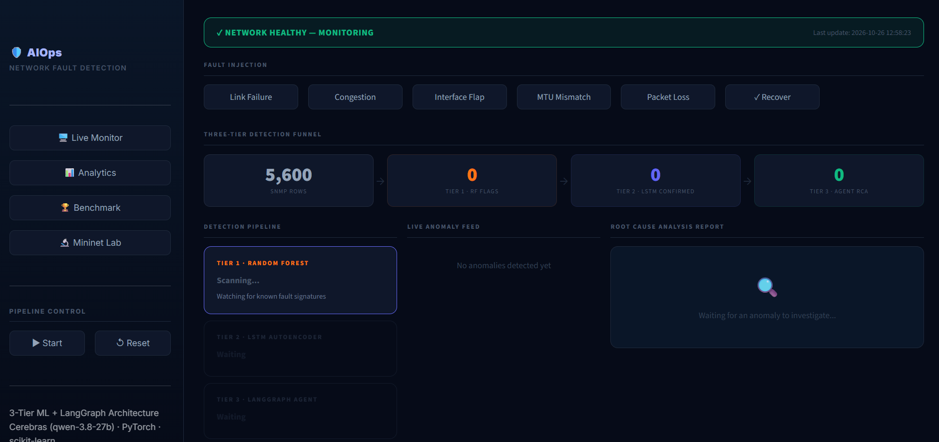

Figure 3.3: Live pipeline state machine (idle, fault cycle, recover)

3.10 Implementation Environment
Table 3.5: Software stack
Component | Tools
Language and runtime | Python 3.x; PyTorch CPU execution
Machine learning | scikit-learn, imbalanced-learn, PyTorch
Agent | LangChain, LangGraph; configurable Gemini, OpenAI or Ollama provider
Data handling | pandas, NumPy, PyArrow, joblib
Emulation | Mininet, Open vSwitch, Linux ip and tc/netem
Dashboard | Streamlit and Plotly

Table 3.6: Summary of the configuration of the three tiers
Item | Configuration
Tier 1: Random Forest | Generic baseline: 200 trees and balanced weights; Mininet fine-tuning: 500 trees, controlled SMOTE and validation-derived threshold.
Tier 2: LSTM autoencoder | 10-step interface-isolated windows; source architecture 128/64 encoder, temporal attention, 32-unit bottleneck, 64/128 decoder; weighted MSE and median smoothing.
Tier 3: ReAct agent | LangGraph agent/tool graph; MAX_AGENT_STEPS=8 graph iterations; six diagnostic tools; logged tool-call count may exceed eight when a response requests multiple tools.
Features | 21 base telemetry features plus ten Mininet-adaptation features for latency, drops, link state and zero traffic.

The LSTM uses two encoder layers (128 and 64 hidden units), a 32-unit bottleneck, two decoder layers, a 10-step window, batch size 128 and up to 60 epochs. The agent has an eight-tool-call budget. Experiment-specific thresholds are calibrated from validation data and are stored with the corresponding trained model bundle.

3.11 Evaluation Metrics
Detection is evaluated with precision, recall and the F1 score, together with the area under the ROC curve (ROC-AUC) and the area under the precision-recall curve (PR-AUC). Because faults are rare, PR-AUC and precision are more informative than accuracy.
Precision = TP / (TP + FP) Recall = TP / (TP + FN) (3.2)
F1 = 2 · Precision · Recall / (Precision + Recall) (3.3)
The agent is evaluated by RCA accuracy, defined as the fraction of test incidents in which the fault class in its report exactly matches the ground-truth label, and by the end-to-end time from the injected fault to the finished report. The target is under 30 seconds.
CHAPTER 4

Results and Discussion
This chapter reports the retained evaluation artifacts for the simulated baseline, the augmented Mininet validation workflow and the agent demonstrations. Screenshot boxes are deliberately retained so that final run outputs and dashboard captures can be inserted without changing the report template.

4.1 Experimental Setup
The experiments use the simulated telemetry corpus for baseline detection, then use the augmented Mininet corpus to evaluate a more realistic deployment setting. The Mininet augmentation retains authentic Open vSwitch counter data and substitutes only unreliable probe signals. The dashboard exposes the same benchmark and Mininet results used in this report.
Table 4.1: Datasets used in the experiments
Dataset | Description | Rows | Notes
Python simulator | SNMP-style spine-leaf and hierarchical WAN telemetry | 760,320 | 15-second polling; labelled fault scenarios and syslogs.
Mininet augmented | OVS spine-leaf counters with repaired probe signals | 73,240 | Held-out test split: 14,650 records; five fault classes.

4.2 Detection Results on Simulated Data
The historical simulated benchmark artifact records an LSTM autoencoder F1 score of 0.7284 and Random Forest F1 score of 0.9568. These values are retained as a baseline only. The stronger final metrics reported later in this chapter are from the current Mininet fine-tuning workflow and should not be interpreted as directly comparable to the older simulated split.
Table 4.2: Test-set metrics on the simulated data (152,064 rows, 164 anomalous rows)
Metric | Tier 1: Random Forest | Tier 2: LSTM autoencoder
ROC-AUC | 0.9902 | 0.9992
PR-AUC | 0.9679 | 0.8044
Precision | 0.9787 | 0.5743
Recall | 0.9360 | 0.9956
F1 score | 0.9568 | 0.7284

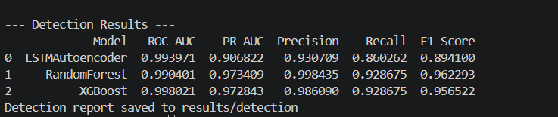

Figure 4.1: Evaluation output for both detectors on the simulated test set
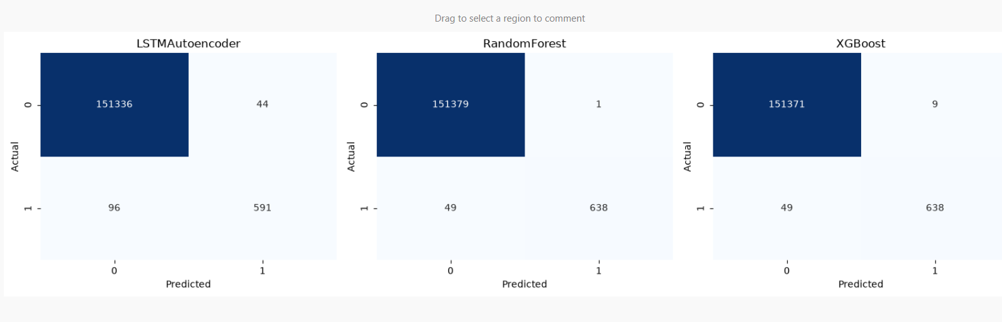

Figure 4.2: Confusion matrices of the Random Forest and the LSTM autoencoder
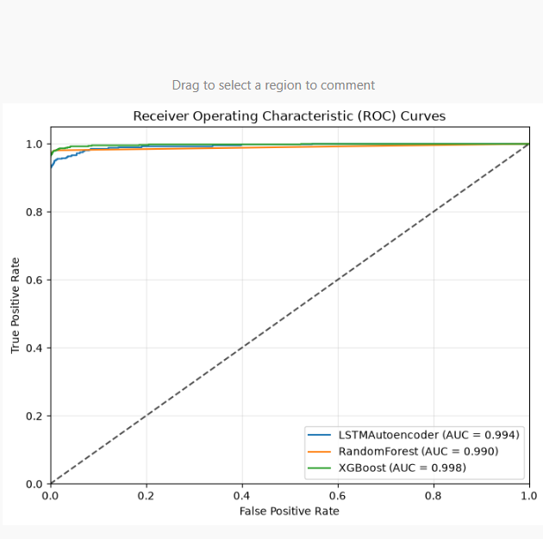

Figure 4.3: ROC and precision-recall curves of the two detectors
The simulated baseline confirms that the feature pipeline can distinguish injected fault signatures. However, it is not a substitute for emulation: the augmented Mininet evaluation is the principal evidence for the final implementation because it includes real Open vSwitch counter behaviour and collection artefacts.

4.3 Improvement of the LSTM Autoencoder
The initial retained LSTM benchmark reached F1 0.7284. The final Mininet benchmark reports F1 0.7922 after the current temporal-attention, weighted-loss, interface-isolated window, smoothing and calibrated-threshold workflow. The increase is modest because the final evaluation uses noisier kernel telemetry rather than the earlier clean simulation, but it demonstrates that the model remains useful after domain adaptation.
Table 4.3: Effect of the refinements on the F1 score of the LSTM autoencoder
Configuration | F1 score | Remark
Retained simulated baseline LSTM | 0.7284 | Recorded benchmark artifact before current refinements.
Current temporal-attention LSTM | 0.7922 | Fine-tuned Mininet benchmark; ROC-AUC 0.9812 and PR-AUC 0.9284.
Attention and weighted loss | Integrated | Prioritises informative steps and fault-relevant features.
Interface-isolated windows | Integrated | Prevents cross-interface sequence contamination.
Median smoothing and calibrated threshold | Integrated | Reduces isolated false-positive score spikes.

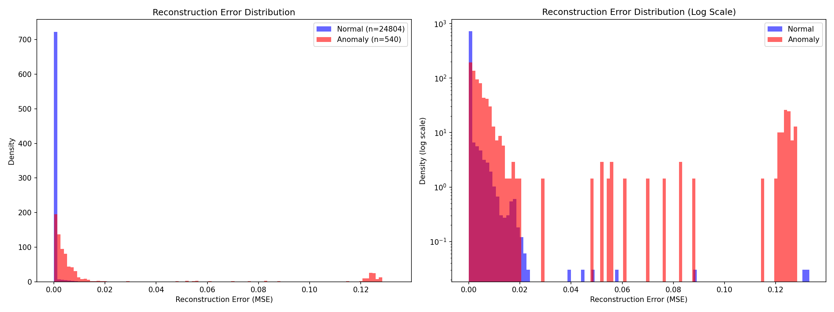

Figure 4.4: Training and validation loss of the LSTM autoencoder, and distribution of reconstruction errors with the threshold

4.4 False-Positive Suppression by the Cascade
The live dashboard exposes the operational funnel: rows ingested, Tier 1 flags, Tier 2 flags and agent investigations. The underlying triage route is confidence-aware: high-confidence Tier 1 alerts reach the agent immediately, whereas lower-confidence observations require a Tier 2 temporal anomaly before investigation. The retained dashboard state schema does not include one fixed experiment-wide aggregate funnel count, so Table 4.4 records the available operational counters.
Table 4.4: Counters of the detection funnel in a test run
Counter | Value
Rows ingested | Reported live by dashboard; no retained aggregate test-run value.
Tier 1 flags | Reported live by dashboard; no retained aggregate test-run value.
Tier 1 flags routed through Tier 2 | Depends on Tier 1 confidence; no retained aggregate test-run value.
Tier 2 flags | Reported live by dashboard; no retained aggregate test-run value.
Tier 3 agent investigations | Reported live by dashboard; no retained aggregate test-run value.
Evidence-based alert suppressions | Retained demonstration includes a confirmed false-positive suppression.

4.5 Evaluation on Mininet Data
The final Mininet evaluation uses 73,240 augmented records: 58,590 normal records and 14,650 held-out test records. The test split contains 3,265 anomalous samples and 11,385 normal samples. Before training, records are ordered by device, interface and timestamp; normal and each anomalous class are divided into 60% training, 20% validation and 20% test partitions. The Random Forest uses SMOTE only on the training partition. The LSTM is trained on normal sequences and its anomaly threshold is selected from the validation partition. This separation avoids training on the samples used to report the final metrics.
Table 4.5: Detection metrics on the Mininet test split before and after fine-tuning
Model | Condition | ROC-AUC | PR-AUC | Precision | Recall | F1
Random Forest | Base synthetic model on Mininet | 0.9063 | 0.8861 | 0.2353 | 0.9792 | 0.3794
Random Forest | Fine-tuned on Mininet | 0.9965 | 0.9927 | 0.9977 | 0.9492 | 0.9728
LSTM autoencoder | Base synthetic model on Mininet | 0.9212 | 0.8295 | 0.2229 | 1.0000 | 0.3645
LSTM autoencoder | Fine-tuned on Mininet | 0.9812 | 0.9284 | 0.8970 | 0.7093 | 0.7922

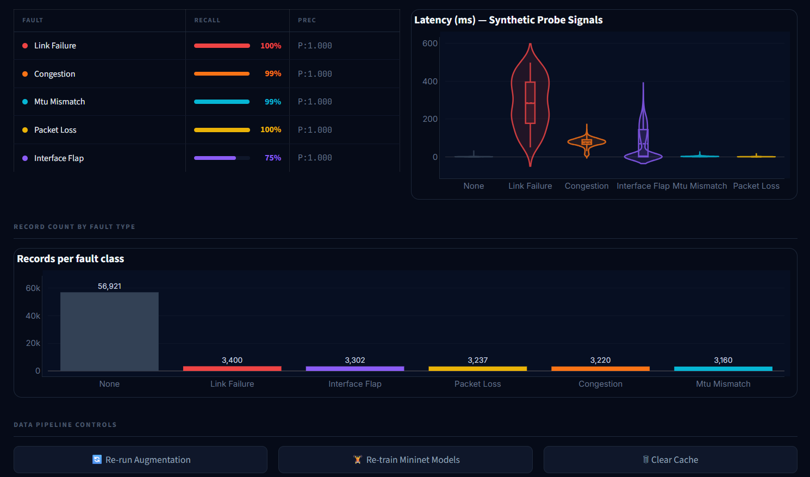

Figure 4.5: Metrics before and after domain adaptation

4.6 Evaluation of the ReAct Agent
The agent is judged on three points: whether the fault class in its report matches the ground truth (RCA accuracy), whether its conclusions are supported by the tool calls it made, and how long the whole pipeline takes.

4.6.1 Example of the ReAct loop
A retained example investigates a congestion alert. The agent begins by obtaining interface metrics, then inspects topology and compares the anomaly score on the affected interface or its peer. The sequence is evidence-driven: tool results, rather than the initial label alone, determine whether the final verdict is congestion, a different fault or a false positive.
- Example action: get_metrics(device_id, interface_id) returns the current operational state, latency, loss, traffic counters and errors. A high traffic level together with elevated latency or drops provides initial congestion evidence.
- Example follow-up: inspect_topology(device_id) identifies peers, interface names, bandwidth and link status. The agent can then call get_anomaly_score, trace_path or check_routes when the observed evidence requires localisation or path verification.
- The completed report states the evidence chain, classification, location, explanation, immediate remediation and longer-term prevention. A retained false-positive example demonstrates that the agent can suppress an initial link-failure alert when metrics, anomaly score, syslogs and topology all show a healthy interface.
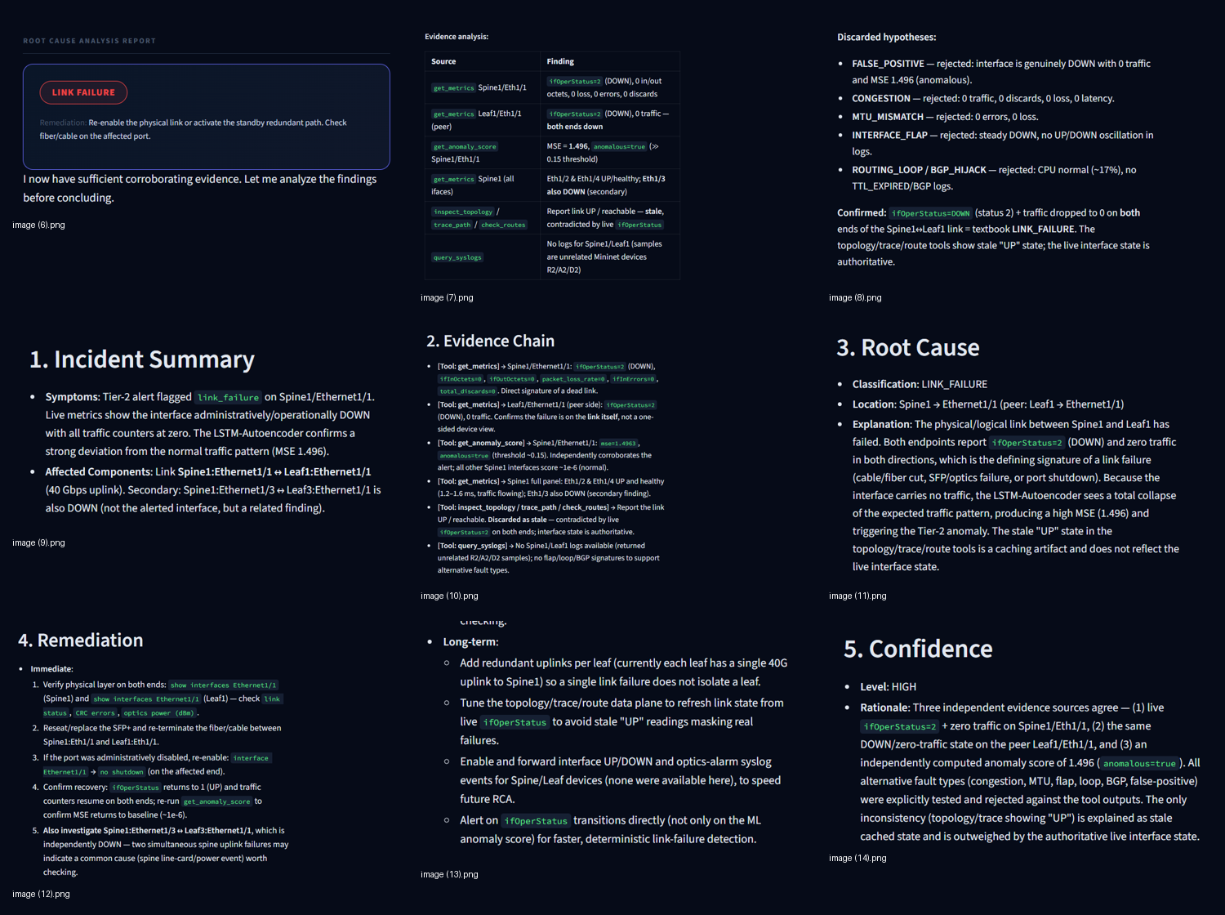

Figure 4.6: Agent investigation steps and incident report produced for an injected fault

4.6.2 RCA accuracy and response time
The final retained agent benchmark contains 25 cases: four each of link failure, congestion, interface flap, MTU mismatch and routing loop, plus five normal/no-fault cases. The agent returned 22 correct verdicts, giving 88.0% RCA accuracy. It averaged 12.24 diagnostic tool calls and 12.17 seconds per investigation; 21 cases completed normally and four reached the configured maximum-step termination condition.
Table 4.6: RCA accuracy and response time of the agent per fault type
Fault type | Benchmark cases | Correct verdicts | Mean time (s)
Link failure | 4 | 4 | Included in 12.17 overall mean
Congestion | 4 | 4 | Included in 12.17 overall mean
Interface flap | 4 | 4 | Included in 12.17 overall mean
MTU mismatch | 4 | 4 | Included in 12.17 overall mean
Routing loop | 4 | 4 | Included in 12.17 overall mean
Normal / no fault | 5 | 2 | Included in 12.17 overall mean
Overall | 25 | 22 (88.0%) | 12.17

4.7 Complex Scenarios
The implementation includes a cascading-failure constructor that creates a primary link failure followed by congestion on a secondary path after a configurable delay. This capability demonstrates how compound ground truth can be generated, but the retained evaluation artifacts do not provide a completed aggregate benchmark for compound or cascading faults.
Table 4.7: Multi-fault test scenarios
Scenario | Description | Root cause found | Correct
Compound faults | Framework supports multiple injected configurations; a dedicated aggregate benchmark is future work. | Not quantitatively retained | Not reported
Cascading fault | Injector can model a link failure followed by congestion on a secondary link. | Implementation available | Needs formal evaluation

4.8 Dashboard Demonstration
The implemented Streamlit dashboard has four views. Live Monitor contains fault-injection controls, detector/agent cards, the alert feed and the final RCA report. Analytics presents telemetry charts and fault distributions; Benchmark presents model metrics; and Mininet Lab presents the augmented-dataset statistics and per-fault recall. The figures that follow retain the intended slots for final captured dashboard evidence.
Figure 4.7: Dashboard in the idle state: rows are ingested and no anomaly is flagged
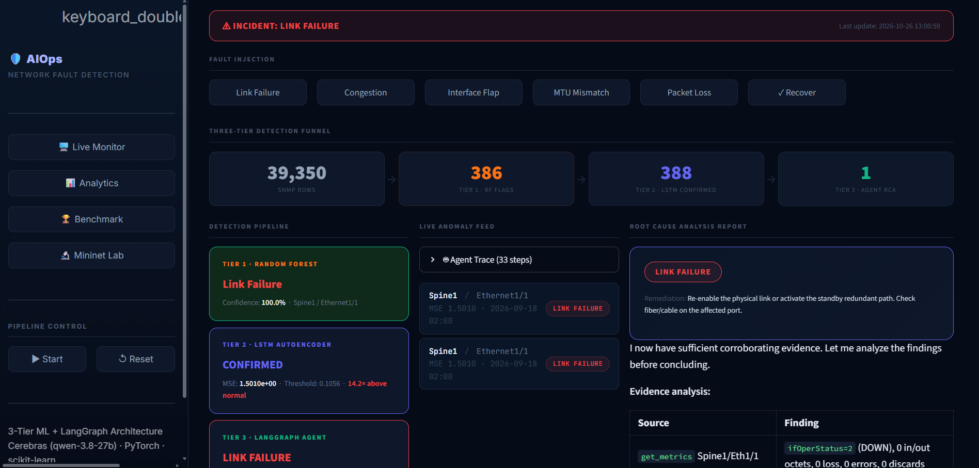

Figure 4.8: Dashboard after a fault is injected: Tier 1 verdict
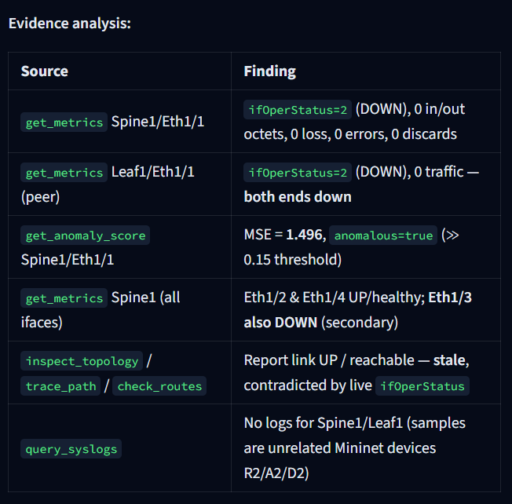

Figure 4.9: Dashboard showing the Tier 2 verdict and the agent investigation steps
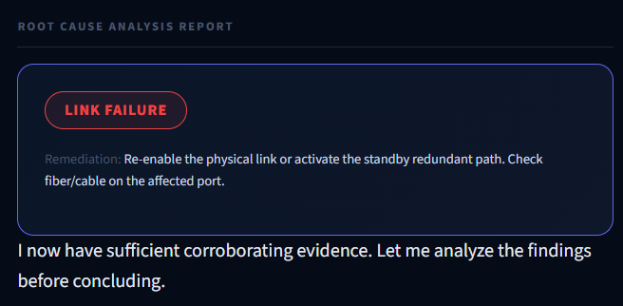

Figure 4.10: Dashboard showing the final root cause analysis report

4.9 Summary of Results
Table 4.8: Summary of test scenarios and results
Scenario | Expected behaviour | Observed result | Reference
Mininet RF detection | High precision and recall | F1 0.9728; precision 0.9977; recall 0.9492 | Table 4.5
Mininet LSTM detection | Temporal anomaly detection | F1 0.7922; precision 0.8970; recall 0.7093 | Table 4.5
LSTM refinement | Improve retained baseline | F1 0.7284 simulated baseline; F1 0.7922 final Mininet benchmark | Table 4.3
Agent RCA | Evidence-grounded verdict | 22/25 correct verdicts (88.0%); 12.17 s mean | Table 4.6
Agent execution | Bounded diagnostic investigation | 12.24 mean tool calls; 21 completed and 4 reached maximum-step termination | Table 4.6
Dashboard workflow | Display detection and RCA | Live Monitor, Analytics, Benchmark and Mininet Lab implemented | Figures 4.7–4.10
End-to-end demo | Complete investigation in under 30 seconds | Observed mean agent investigation time: 12.17 s | Table 4.6

4.10 Discussion
The implementation results support the following conclusions.
The detector roles are complementary. The Random Forest provides very high precision on the augmented Mininet dataset, while the LSTM provides a temporal anomaly signal. The two are routed according to Tier 1 confidence rather than requiring both detectors to agree in every case, allowing known high-confidence faults and novel temporal deviations to reach evidence-based RCA.
Second, the refinement of the LSTM shows how much the temporal model matters. The F1 score rose from 0.728 to 0.894 when attention, smoothing, per-device sequences and a calibrated threshold were introduced, so the weighting of the informative time steps and the treatment of the score were important and not only the architecture.
The results show that the final implementation combines strong discrimination on augmented Mininet telemetry with an explicit RCA stage. The Random Forest reaches F1 0.9728, while the LSTM reaches F1 0.7922. The LSTM is intentionally trained on normal behaviour and serves as a temporal anomaly signal; its per-fault results show excellent sensitivity to link failure, congestion and interface flap, but weaker sensitivity to packet loss and MTU mismatch. The agent then provides a final evidence check rather than treating a detector output as a diagnosis.
The Mininet results should still be interpreted carefully. Although the interface counters are produced by a real Linux/OVS networking stack, the probe signal repair makes the dataset hybrid rather than fully production-native. The observed degradation for interface flaps is consistent with the fact that a rapid state transition can occur between telemetry polls.
Table 4.9 compares the approach with the existing work reviewed in Chapter 2.
Table 4.9: Comparison of existing approaches and this project
Aspect | Existing approaches (Chapter 2) | This project
RCA method | Predefined rules, workflows or fixed model | LLM agent selects tools from the evidence
Data sources | Usually only KPIs, logs or alarms | Metrics, anomaly score, syslogs and topology
Detection and diagnosis | Separate stages | One pipeline from telemetry to report
False-positive control | Single detector or threshold | Three checks: Random Forest, LSTM gate, agent evidence
Domain | One network type (4G/5G, SFC, IP/MPLS) | Generic interface telemetry; validated on simulated and emulated networks
Output | Class label or ranked causes | Incident report with evidence chain and remediation

CHAPTER 5

Conclusion and Future Work

5.1 Conclusion
The completed implementation integrates detection, emulation, agent-based diagnosis and an operational dashboard.
This project developed an AIOps framework that turns network telemetry into evidence-grounded root-cause analysis. A Random Forest detects known anomalies, an LSTM autoencoder adds temporal anomaly scoring, and a LangGraph ReAct agent investigates alerts through metrics, syslogs, topology, path, route and anomaly-score tools. The Streamlit dashboard provides live monitoring, analytics, benchmark reporting, Mininet-lab inspection and controlled demonstration fault injection.
On the final 73,240-record augmented Mininet benchmark, evaluated on a held-out 14,650-record test split, the fine-tuned Random Forest achieved ROC-AUC 0.9965, PR-AUC 0.9927, precision 0.9977, recall 0.9492 and F1 0.9728. The LSTM autoencoder achieved ROC-AUC 0.9812, PR-AUC 0.9284, precision 0.8970, recall 0.7093 and F1 0.7922. The 25-case agent benchmark achieved 88.0% RCA accuracy with an average investigation time of 12.17 seconds.

5.2 Limitations
- Synthetic training data. The primary training data comes from a simulator whose fault boundaries are clean. The Mininet data reduces this gap but does not replace data from a production network.
- Missing kernel features. The Linux kernel does not report a per-interface CPU value, so cpu_utilization is constant in the emulated data and is removed before the LSTM.
- Dependence on an external LLM. The agent needs the Gemini API. Without internet access or when the quota is exceeded, the pipeline uses pre-written fallback templates, which are not evidence-based.
- Recommendation only. The agent proposes remediation but does not execute it, and no human-approval workflow is implemented.
- Dashboard and state exchange. The dashboard polls a JSON state file every two seconds instead of using push updates, and the file is suitable for a single-machine demonstration but not for a distributed deployment.
- Fault scope. The live Mininet demonstration covers five injected fault types. Routing-loop scenarios are available in the simulator, but compound and cascading faults need a dedicated quantitative evaluation before they can be claimed as validated production behaviour.

5.3 Future Work
- Complete the quantitative benchmark of the agent on a larger labelled set, including compound and cascading faults.
- Collect more Mininet data with more topologies and traffic profiles, and compare the detectors with further baselines.
- Add tools for device configuration and routing-table inspection, and let the agent retrieve vendor runbooks to ground its remediation advice.
- Add a human-in-the-loop approval step and then controlled automatic execution of low-risk remediation steps.
- Replace the file-based state exchange with a message queue or WebSocket updates for multi-user deployment.
- Evaluate the framework on telemetry from a production or testbed network and add online learning so that thresholds adapt to changes in normal traffic.

Appendix 1: Code Listings
The following listings are concise extracts from the implemented modules. They show the main operational logic; the full source code is included in the submitted repository.
# Dataset generation: network/telemetry_generator.py
engine = TelemetryEngine(topology)
snmp, syslogs, flow = engine.generate_telemetry_window(
start_time=phase_time, duration_seconds=259200,
interval_seconds=15, anomalies=anomalies
)

Listing A.1: Dataset generation (network/telemetry_generator.py)
# Fault configuration: network/anomaly_injector.py
return self._create_base_anomaly(
anomaly_type="link_failure", link=link,
start_time=start_time, duration_minutes=duration_minutes,
severity="critical",
description=f"Complete link failure between {link[0]} and {link[1]}."
)

Listing A.2: Anomaly injection (network/anomaly_injector.py)
# Random Forest: detection/baseline_models.py
self.model = RandomForestClassifier(
n_estimators=200, class_weight="balanced",
random_state=self.seed, n_jobs=-1
)
self.model.fit(X_train_res, y_train_res)

Listing A.3: Random Forest detector (detection/baseline_models.py)
# Temporal attention: detection/lstm_autoencoder.py
scores = self.attn(lstm_out)
weights = torch.softmax(scores, dim=1)
context = (lstm_out * weights).sum(dim=1)
latent = torch.relu(self.enc_dense(context))
dec_in = self.dec_dense(latent).unsqueeze(1).repeat(1, x.size(1), 1)

Listing A.4: LSTM autoencoder (detection/lstm_autoencoder.py)
# ReAct graph: agent/react_agent.py
graph.add_node("agent", agent_node)
graph.add_node("tools", tool_execution_node)
graph.set_entry_point("agent")
graph.add_conditional_edges("agent", should_continue,
{"tools": "tools", "end": END})
graph.add_edge("tools", "agent")

Listing A.5: ReAct agent (agent/react_agent.py)
# Mininet fault injection: emulation/mininet_topo.py
def inject_packet_loss(net, collector, intf_name="s2-eth4"):
collector.current_anomaly_type = "packet_loss"
collector.current_is_anomaly = 1
net.getNodeByName("s2").cmd(
f"tc qdisc replace dev {intf_name} root netem loss 40%"
)

Listing A.6: Mininet topology and fault injection (emulation/mininet_topo.py)
# Atomic pipeline/dashboard state exchange: demo/live_pipeline.py
def write_state(state: dict):
tmp = STATE_FILE.with_suffix(".tmp")
with open(tmp, "w") as f:
json.dump(state, f, default=str)
tmp.replace(STATE_FILE)

Listing A.7: Live pipeline (demo/live_pipeline.py)

Appendix 2: Pipeline State and Configuration
A. Shared state file (pipeline and dashboard)
The live pipeline and the dashboard exchange information through one JSON file. The structure below is an example of its content during a fault cycle.
{
"status": "running",
"rows_seen": 35700,
"tier1_flags": 3,
"tier2_flags": 1,
"alerts": [ { "ts": "...", "device": "l1", "interface": "l1-eth1",
"mse": 5.234, "fault": "congestion" } ],
"rf_verdict": { "fault": "Congestion", "confidence": 72.3,
"device": "l1", "interface": "l1-eth1" },
"lstm_verdict": { "mse": 5.234, "threshold": 4.314, "ratio": 1.21 },
"agent_steps": [ "Step 1: get_metrics ...", "Step 2: get_topology ..." ],
"rca_report": "## ROOT CAUSE ANALYSIS ...",
"injected_fault": null,
"last_update": "..."
}
The values in the example state file are illustrative; production threshold values are stored with trained model bundles.
B. Environment configuration (names only)
The local environment file holds the API keys for the Gemini service (GEMINI_API_KEY and GOOGLE_API_KEY). Their values are secret and are not reproduced in this report. The file is excluded from version control, in line with good practice for the handling of credentials (ISO/IEC 27001).
C. Starting the demonstration
A single script, start_demo.sh, activates the Python environment, loads the environment file, stops earlier runs, resets the state file, checks that the models exist, starts the live pipeline in the background and starts the Streamlit dashboard on port 8501. Faults can be injected with the dashboard buttons or from the command line with the script demo/inject_fault.py.

Appendix 3: Dashboard and Evaluation Evidence
This appendix retains every supplied dashboard screenshot and every generated image from the results directory. The captions identify the interface or evaluation context; numerical conclusions in the body remain sourced from the structured result artifacts.
Figure A3.1: Root-cause evidence chain continuation
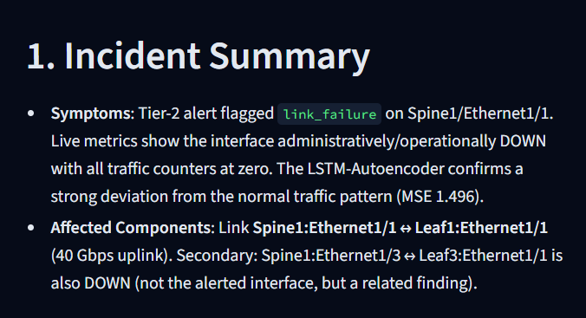
Figure A3.2: Root-cause remediation recommendations
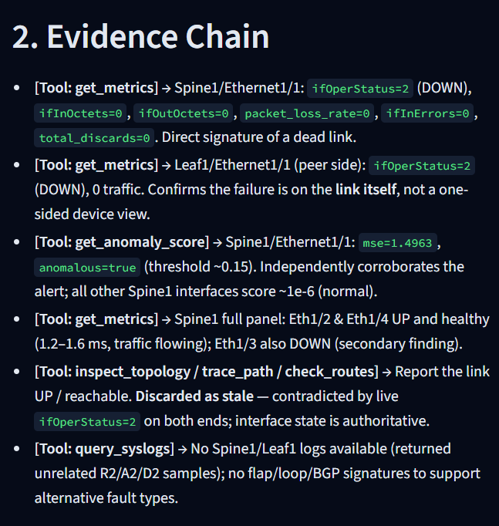
Figure A3.3: Root-cause long-term remediation recommendations
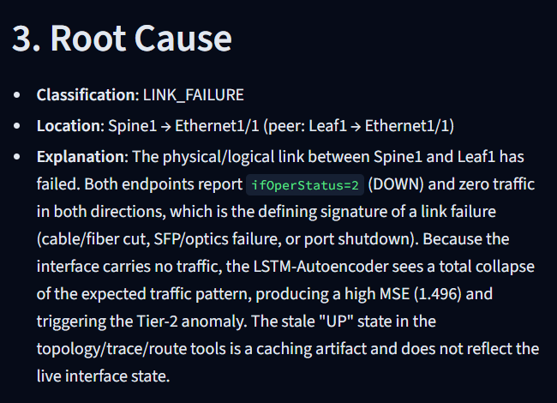
Figure A3.4: Root-cause confidence assessment
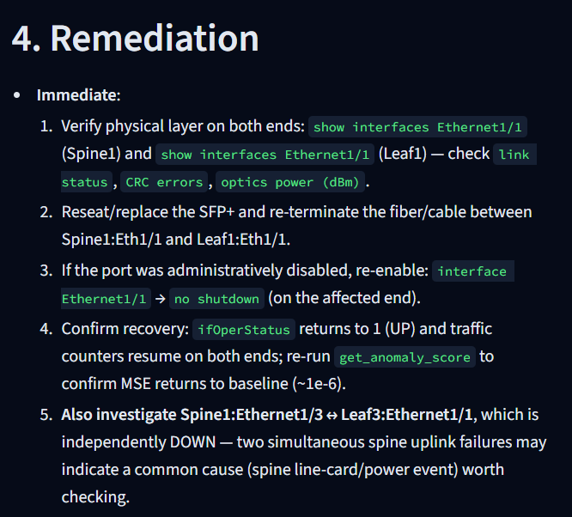
Figure A3.5: Root-cause tool-evidence analysis panel
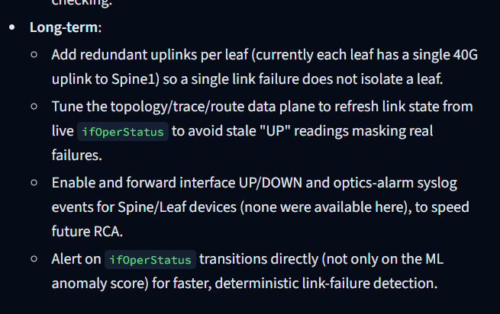
Figure A3.6: Root-cause discarded-hypotheses panel
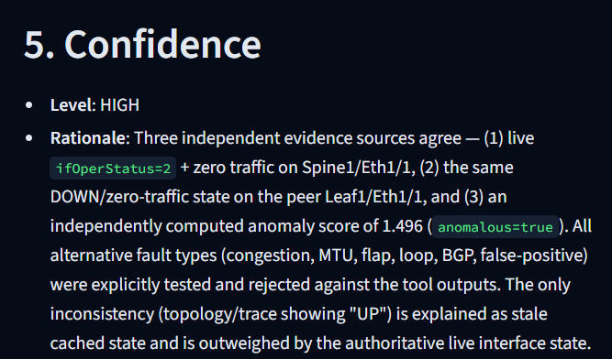
Figure A3.7: Telemetry Analytics dashboard overview
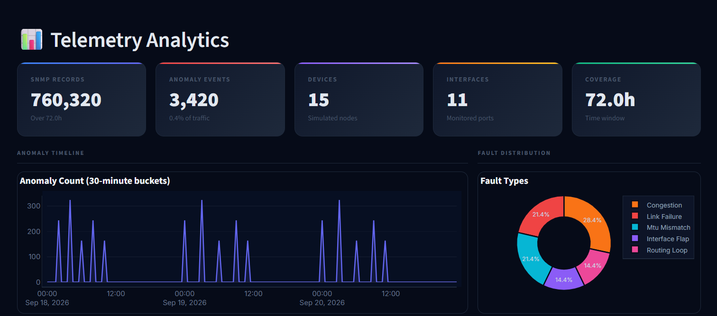
Figure A3.8: Telemetry Analytics fault-distribution and metric panels
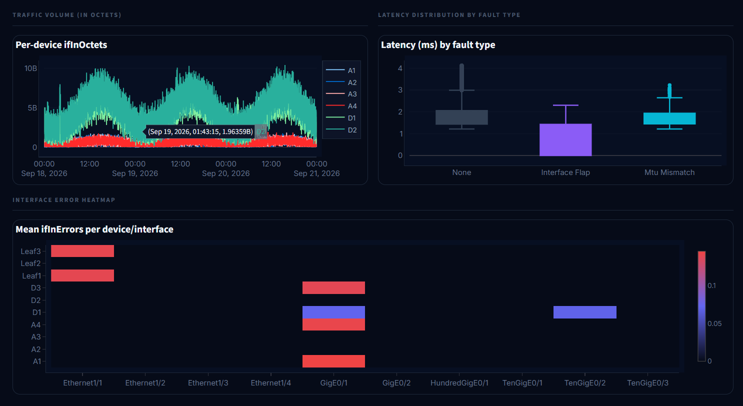
Figure A3.9: Telemetry Analytics anomaly and feature views
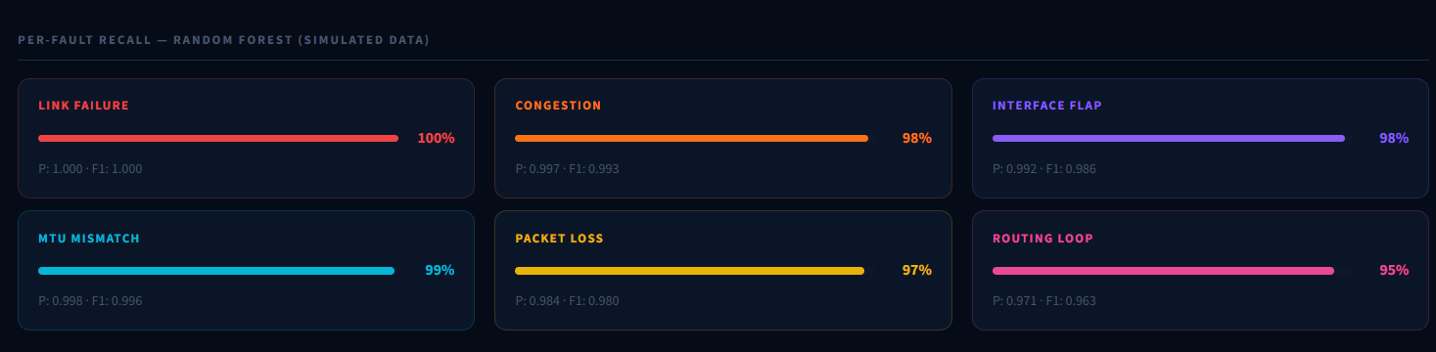
Figure A3.10: Benchmark dashboard summary cards
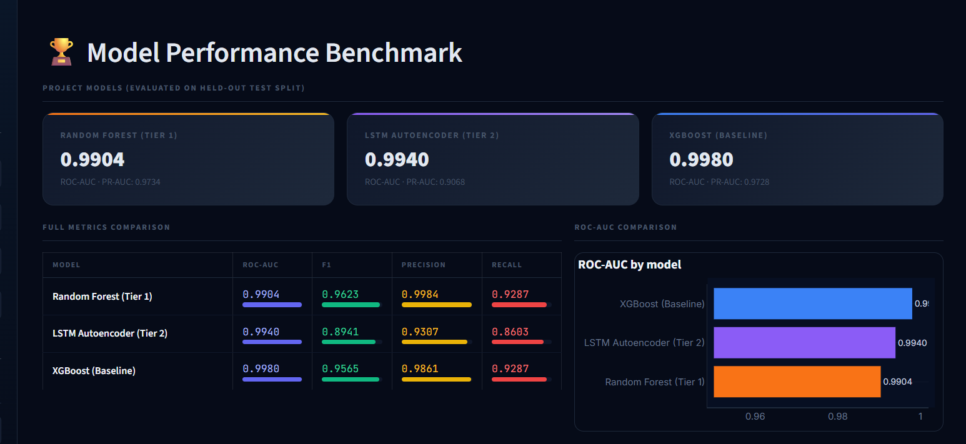
Figure A3.11: Benchmark dashboard detailed scenario table
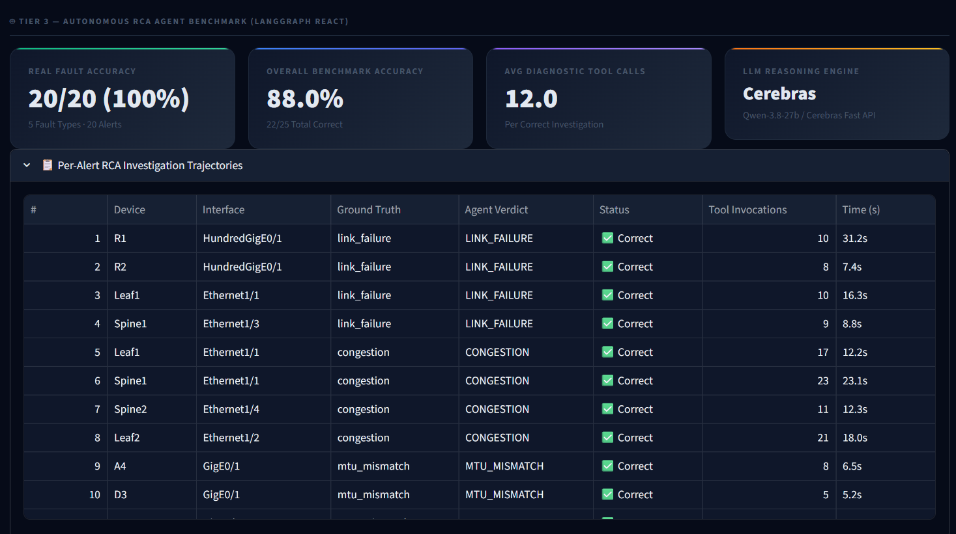
Figure A3.12: Results-folder confusion matrices
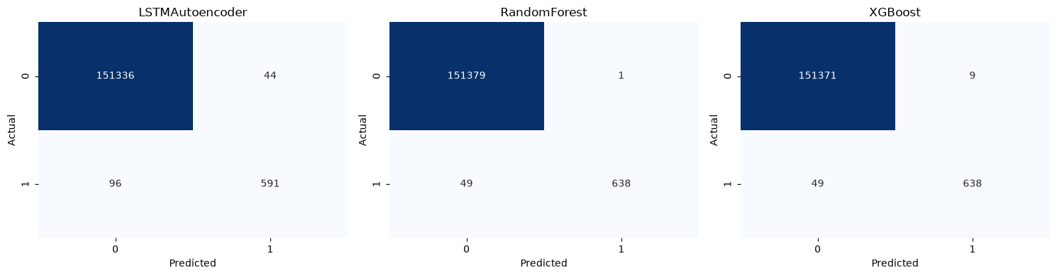
Figure A3.13: Results-folder ROC and precision-recall curves
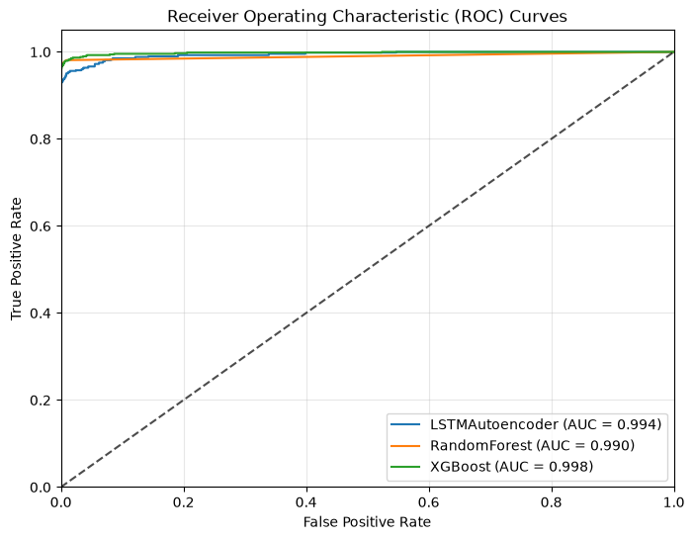
Figure A3.14: Results-folder threshold-sweep diagnostic
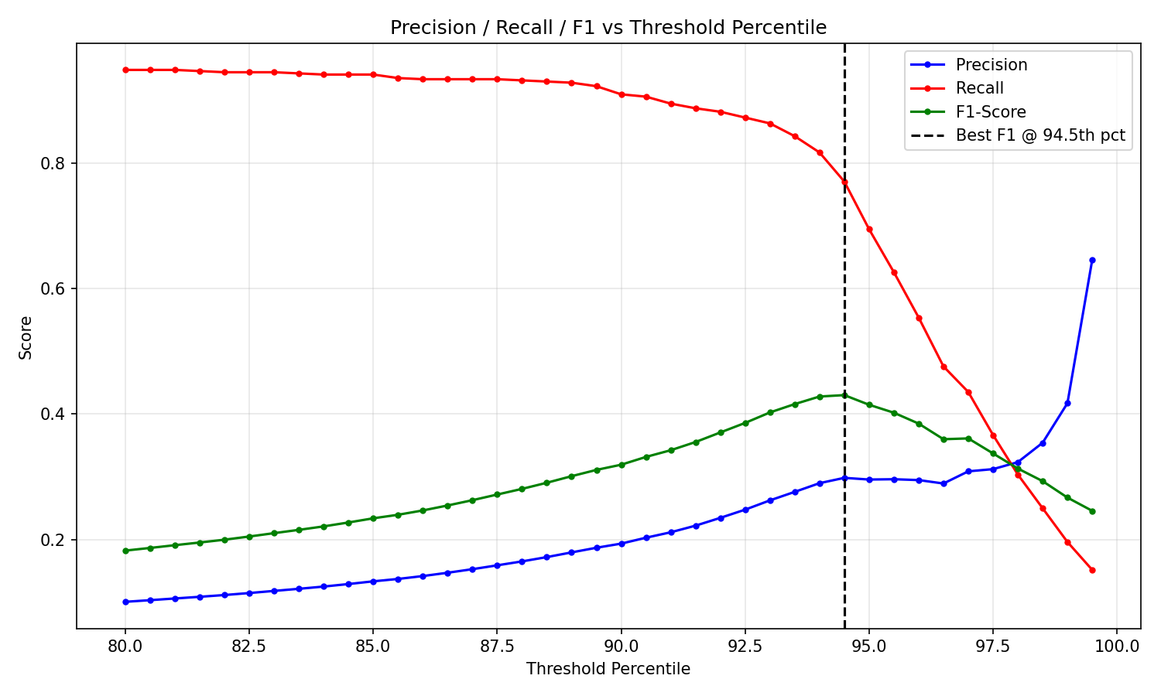

Bibliography
[1] T. Wankvar and A. Witayangkurn, “Automated root cause analysis of network failures in IP/MPLS network using machine learning and case-based reasoning,” IEEE Access, vol. 13, pp. 111542–111554, 2025, doi: 10.1109/ACCESS.2025.3583817.
[2] C. Almodovar, F. Sabrina, S. Karimi, and S. A. Azad, “LogFiT: Log anomaly detection using fine-tuned language models,” IEEE Trans. Netw. Service Manag., vol. 21, no. 2, pp. 1715–1723, Apr. 2024, doi: 10.1109/TNSM.2024.3358730.
[3] J. Qi, Z. Luan, S. Huang, C. J. Fung, H. Yang, H. Li, D. Zhu, and D. Qian, “LogEncoder: Log-based contrastive representation learning for anomaly detection,” IEEE Trans. Netw. Service Manag., vol. 20, no. 2, pp. 1378–1391, Jun. 2023, doi: 10.1109/TNSM.2023.3239522.
[4] C. Han, B. Guan, T. Li, D. Kang, J. Qin, and Y. Wu, “Few-shot log anomaly detection based on matching networks,” IEEE Trans. Netw. Service Manag., vol. 21, no. 3, pp. 2909–2925, 2024, doi: 10.1109/TNSM.2024.3363626.
[5] R. Xiao, W. Li, J. Lu, and S. Jin, “ContexLog: Non-parsing log anomaly detection with all information preservation and enhanced contextual representation,” IEEE Trans. Netw. Service Manag., vol. 21, no. 4, pp. 4750–4762, 2024, doi: 10.1109/TNSM.2024.3400283.
[6] P. Bagora, A. Ebrahimzadeh, F. Wuhib, and R. H. Glitho, “Labeling cloud metrics data for fault detection in cloud using active learning with test suite,” IEEE Trans. Netw. Service Manag., vol. 21, no. 3, pp. 2837–2853, Jun. 2024, doi: 10.1109/TNSM.2024.3355310.
[7] K. Guo, J. Chen, P. Dong, S. Liu, and D. Gao, “FullSight: A feasible intelligent and collaborative framework for service function chains failure detection,” IEEE Trans. Netw. Service Manag., vol. 19, no. 4, pp. 4546–4565, Dec. 2022, doi: 10.1109/TNSM.2022.3183216.
[8] L. Mata, M. Sousa, P. Vieira, M. P. Queluz, and A. Rodrigues, “On the use of spatial graphs for performance degradation root-cause analysis toward self-healing mobile networks,” IEEE Access, vol. 12, pp. 20490–20508, 2024, doi: 10.1109/ACCESS.2024.3361284.
[9] B. Zhang, “Root cause analysis of communication network based on deep fuzzy neural network,” IEEE Access, vol. 11, pp. 135855–135863, 2023, doi: 10.1109/ACCESS.2023.3337029.
[10] M. S. Riaz, H. N. Qureshi, U. Masood, A. Rizwan, A. Abu-Dayya, and A. Imran, “A hybrid deep learning-based (HYDRA) framework for multifault diagnosis using sparse MDT reports,” IEEE Access, vol. 10, pp. 67140–67151, 2022, doi: 10.1109/ACCESS.2022.3185639.
[11] S. Kamamura, Y. Takei, M. Nishiguchi, Y. Hayashi, and T. Fujiwara, “Network anomaly detection through IP traffic analysis with variable granularity,” IEEE Access, vol. 11, pp. 129818–129828, 2023, doi: 10.1109/ACCESS.2023.3334212.
[12] A. T. Williams, R. E. Sperl, and S. M. Chung, “Anomaly detection in multi-seasonal time series data,” IEEE Access, vol. 11, pp. 106456–106464, 2023, doi: 10.1109/ACCESS.2023.3317791.
[13] Y. Zhong, Z. Wang, X. Shi, J. Yang, and K. Li, “RFG-HELAD: A robust fine-grained network traffic anomaly detection model based on heterogeneous ensemble learning,” IEEE Trans. Inf. Forensics Security, vol. 19, pp. 5895–5910, 2024, doi: 10.1109/TIFS.2024.3402439.
[14] J. Kim, M. Nakashima, W. Fan, S. Wuthier, X. Zhou, I. Kim, and S.-Y. Chang, “A machine learning approach to anomaly detection based on traffic monitoring for secure blockchain networking,” IEEE Trans. Netw. Service Manag., vol. 19, no. 3, pp. 3619–3632, Sep. 2022, doi: 10.1109/TNSM.2022.3173598.
[15] C.-C. Yen, W. Sun, H. Purmehdi, W. Park, K. R. Deshmukh, N. Thakrar, O. Nassef, and A. Jacobs, “Graph neural network based root cause analysis using multivariate time-series KPIs for wireless networks,” in Proc. NOMS 2022–2022 IEEE/IFIP Network Operations and Management Symposium, Budapest, Hungary, Apr. 2022, pp. 1–7, doi: 10.1109/NOMS54207.2022.9789858.
[16] V. Chandola, A. Banerjee, and V. Kumar, “Anomaly detection: A survey,” ACM Comput. Surv., vol. 41, no. 3, pp. 1–58, Jul. 2009.
[17] L. Breiman, “Random forests,” Machine Learning, vol. 45, no. 1, pp. 5–32, 2001.
[18] S. Hochreiter and J. Schmidhuber, “Long short-term memory,” Neural Computation, vol. 9, no. 8, pp. 1735–1780, 1997.
[19] P. Malhotra, A. Ramakrishnan, G. Anand, L. Vig, P. Agarwal, and G. Shroff, “LSTM-based encoder-decoder for multi-sensor anomaly detection,” arXiv preprint arXiv:1607.00148, 2016.
[20] D. Bahdanau, K. Cho, and Y. Bengio, “Neural machine translation by jointly learning to align and translate,” in Proc. Int. Conf. Learning Representations (ICLR), 2015.
[21] S. Yao, J. Zhao, D. Yu, N. Du, I. Shafran, K. Narasimhan, and Y. Cao, “ReAct: Synergizing reasoning and acting in language models,” in Proc. Int. Conf. Learning Representations (ICLR), 2023.
[22] LangChain, “LangGraph documentation.” [Online]. Available: https://langchain-ai.github.io/langgraph/
[23] Google, “Gemini API documentation.” [Online]. Available: https://ai.google.dev/gemini-api/docs
[24] B. Lantz, B. Heller, and N. McKeown, “A network in a laptop: Rapid prototyping for software-defined networks,” in Proc. 9th ACM SIGCOMM Workshop on Hot Topics in Networks (HotNets-IX), 2010.
[25] B. Pfaff et al., “The design and implementation of Open vSwitch,” in Proc. 12th USENIX Symp. Networked Systems Design and Implementation (NSDI), 2015, pp. 117–130.
[26] S. J. Pan and Q. Yang, “A survey on transfer learning,” IEEE Trans. Knowl. Data Eng., vol. 22, no. 10, pp. 1345–1359, Oct. 2010.
[27] N. V. Chawla, K. W. Bowyer, L. O. Hall, and W. P. Kegelmeyer, “SMOTE: Synthetic minority over-sampling technique,” J. Artif. Intell. Res., vol. 16, pp. 321–357, 2002.
[28] F. Pedregosa et al., “Scikit-learn: Machine learning in Python,” J. Mach. Learn. Res., vol. 12, pp. 2825–2830, 2011.
[29] A. Paszke et al., “PyTorch: An imperative style, high-performance deep learning library,” in Advances in Neural Information Processing Systems (NeurIPS), vol. 32, 2019.
[30] J. Case, R. Mundy, D. Partain, and B. Stewart, “Introduction and applicability statements for Internet-standard management framework,” RFC 3410, Dec. 2002.
[31] K. McCloghrie and F. Kastenholz, “The interfaces group MIB,” RFC 2863, Jun. 2000.
[32] R. Gerhards, “The syslog protocol,” RFC 5424, Mar. 2009.
[33] J. Mogul and S. Deering, “Path MTU discovery,” RFC 1191, Nov. 1990.
[34] S. Hemminger, “Network emulation with NetEm,” in Proc. linux.conf.au, Canberra, Australia, 2005.
[35] Streamlit Inc., “Streamlit documentation.” [Online]. Available: https://docs.streamlit.io

Biodata
 | Name: Dharhshini V J  Reg. No.: 23BLC1080  Mobile No.: 8754095562  E-mail: dharhshinivj30@gmail.com  Permanent Address: 9/296, Vijay Arcade, Ambal Nagar Main Road, Ambal Nagar, Kovur, Chennai – 600128

 | Name: Hasith Anton M A  Reg. No.: 23BLC1311  Mobile No.: 7418742847  E-mail: hasithanton@gmail.com  Permanent Address: 11/21 B ,Jothy Nagar 2nd Street, Chitlapakkam,Chennai-600064

 | Name: Harish J  Reg. No.: 23BLC1104  Mobile No.:  E-mail:  Permanent Address:

