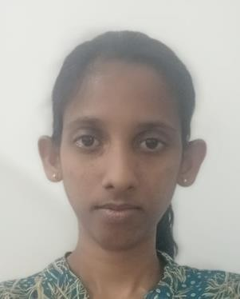

**NON**-**RELATED REFREES.**

* Mrs. Rasika Abeywardhana Chief technologist,

Head of Department, Product Development, SLITA

0718290312

* Mr. W.B.M.J Prasanna WijesundaraManager Printing Development Technical TRISCHEL FABRIC PVT LTD

0772310041

U.S VIPUNI CHATHUNIKA

**DATE OF BIRTH: 1996. 11.26**

EMAIL:[vipunichathunika96@gmail.com](mailto:vipunichathunika96@gmail.com) TELEPHONE :0702188977/0912228564

ADDRESS: WELANGATHUDUWAWATHTHA, AMBALANWATHTHA GALLE.

# CAREER OBJECTIVE

Pursuing a career opportunity in fashion designing field where I can utilize my fashion designing knowledge and experience while contributing to achieve the ultimate organizational goals as well as personal career growth.

# PROFESSIONAL QUALIFICATIONS

* Diploma in Information Technology conducted by Epic campus.
* English course conducted by non-formal education branch of the Ministry of Education.
* Spoken English course conducted by national programme of Vocational and Language skill development.
* Higher Education in Advanced Diploma in Fashion Designing and Product Development (which include Design Development, Textile Technology, Pattern Making,HR,Marketing-Management)

Sri Lanka Institute of Textile and Apparel (2022-2023)

* School Education at Rippon girls’ college, Galle.
* G.C.E (A/L)-Art Stream 1B 1C and 1S.
* G.C.E (O/L)-2Bs 3Cs and 4S.

# EXTRA CURRICULAR ACTIVITIES

* A junior prefect in Rippon Girls college.
* A member of the School Media unit.