**Smart Mobility: Voice-Activated Wheelchair for Enhanced Accessibility**

**Ms. Aruna Dore1, T Nagarjuna2, Adarsh B3, Bhuvanesh G4, Anumula Sai Ganesh5, Hasmita M A6, Rakshitha N K7**

1Assistant Professor, Electronics and Communication Engineering, Presidency University

2Student, Electronics and Communication Engineering, Presidency University

3Student, Electronics and Communication Engineering, Presidency University

4Student, Electronics and Communication Engineering, Presidency University

5Student, Electronics and Communication Engineering, Presidency University

6Student, Electronics and Communication Engineering, Presidency University

---------------------------------------------------------------------***---------------------------------------------------------------------

**Abstract -** This project presents the development of a voice-activated wheelchair designed to enhance accessibility for individuals with limited mobility. Addressing the challenges posed by traditional manual and joystick-controlled wheelchairs, this innovative solution employs readily available and cost-effective components. The system utilizes an Arduino Uno microcontroller as the central processing unit, an L298N motor driver for controlling DC gear motors, and an HC-05 Bluetooth module for wireless communication. A custom-designed interface within a Bluetooth-enabled smartphone application facilitates voice command input, enabling hands-free navigation. This approach offers increased independence and ease of use for individuals who struggle with conventional control mechanisms. The project details the hardware and software implementation, including circuit design, Arduino coding, and app development. Performance testing evaluates the system's voice recognition accuracy, response time, and maneuverability. The results demonstrate the potential of this voice-controlled wheelchair to significantly improve mobility and quality of life for users with disabilities, offering a more intuitive and accessible means of independent movement. This project highlights the effectiveness of integrating voice control technology with assistive devices to create practical and affordable solutions.

***Key Words*:** Voice-activated wheelchair, Assistive device, Independent movement, Cost-effective, Accessibility, Hands-free navigation

**1.INTRODUCTION**

**1.1 Background**

Mobility is a fundamental aspect of human independence and quality of life. For individuals with mobility impairments, performing everyday tasks and navigating their environment can present significant challenges. These impairments can arise from various conditions, including spinal cord injuries, cerebral palsy, muscular dystrophy, stroke, and age-related decline. The impact of limited mobility extends beyond physical limitations, often affecting social participation, employment opportunities, and overall well-being. Individuals may face difficulties accessing public spaces, transportation, and even their own homes, leading to social isolation and reduced independence.

Assistive technologies play a vital role in enhancing the quality of life for individuals with disabilities. By providing tools and solutions that address specific limitations, these technologies enable greater independence, participation, and access to opportunities. The field of smart mobility has emerged as a promising area, leveraging advancements in technology to create intelligent and adaptive mobility solutions. Smart mobility encompasses a range of technologies, including autonomous vehicles, intelligent transportation systems, and advanced assistive devices like smart wheelchairs. These technologies have the potential to revolutionize transportation and accessibility for everyone, especially for individuals with disabilities. Voice-activated wheelchairs represent a significant advancement in smart mobility for individuals with mobility impairments.

## 2. PROPOSED METHODOLOGY

**2.1 System Architecture**

The voice-controlled wheelchair system has four primary modules:

**(i). Voice Input Module:** It consists of a smartphone and an application, dedicated to the Android platform, with which the user gives voice commands through an interface.

**(ii). Bluetooth Communication Module:** This module employs the HC-05 Bluetooth module for wireless communication between the smartphone and the Arduino microcontroller.

**(iii). Control Module:** The Arduino Uno microcontroller serves as the central processing unit. It receives commands from the Bluetooth module and controls the motor driver.

**(iv). Motor Control Module:** The L298N motor driver controls the DC gear motors that power the wheelchair's wheels.

The system architecture of the whole system follows a sequential flow: The user provides a voice command to the smartphone application. The application processes the voice command and sends the corresponding control signal via Bluetooth to the Arduino. The Arduino receives the signal, interprets it, and sends the appropriate signals to the L298N motor driver. The motor driver then powers the DC motors, which make the wheelchair move according to the voice command.

**2.2 Component Working Principle**

* **Arduino Uno:** The Arduino Uno is a microcontroller board based on the ATmega328P microcontroller. It processes commands received from the Bluetooth module and generates control signals for the motor driver.
* **L298N Motor Driver:** L298N is a dual H-bridge motor driver, capable of controlling two DC motors at the same time. It supplies the current and voltage to drive the motors and can control the direction and speed of rotation.
* **HC-05 Bluetooth Module:** HC-05 is a Bluetooth serial port protocol module, which will establish wireless communication between the smartphone and Arduino. The module receives control signals from the smartphone application and transmits these to the Arduino board.
* **DC Gear Motors:** The DC gear motors are used to drive the wheels of the wheelchair. The gears reduce the speed of the motor while increasing its torque, which is the power needed to move the wheelchair.

**2.3 Voice Recognition and Bluetooth Communication**

Voice recognition is handled by the smartphone application. The user speaks a command, for example, “forward”, “backward”, “left”, “right”. The application uses the built-in speech recognition engine (such as Google Speech-to-Text API) of the smartphone to convert the spoken words into text. This text is then translated into a predefined command code. The application sends this command code wirelessly to the HC-05 Bluetooth module connected to Arduino. The HC-05 receives the data and sends it to the Arduino through serial communication.

**2.4 Control Algorithm**

The Arduino code contains a simple control algorithm. The Arduino will perform the action according to the command code received from the Bluetooth module.

* If the command code is “F” (forward), the Arduino sends signals to the L298N to drive both motors forward.
* If the command code is “B” (backward), the Arduino sends signals to the L298N to drive both motors backward.
* If the command code is “L” (representing "left"), the Arduino drives the right motor forward and the left motor backward, making the wheelchair turn left.
* If the command code is “R” (representing "right"), the Arduino drives the left motor forward and the right motor backward, making the wheelchair turn right.
* If the command code is “S” (representing “stop”), the Arduino sends the signal to the L298N motor driver to stop the motors.

**2.5 Power Supply and Safety Considerations**

The system should be powered by a suitable DC power supply, such as a rechargeable battery pack, to provide the necessary voltage and current for Arduino, motor driver, and motors. An important consideration in this project is safety. The following safety measures are adopted in this project:

* Software Limits: The software, when provided with limits (through the Arduino, for example) will ensure that no motors will exceed a safe speed or go outside of parameters.
* Stable Mounting: All components are mounted on the wheelchair frame in a way that prevents them from coming loose during operation

**3. SYSTEM DESIGN AND IMPLEMENTATION**

**3.1 Schematic** (in Proteus 8 Professional Tool)

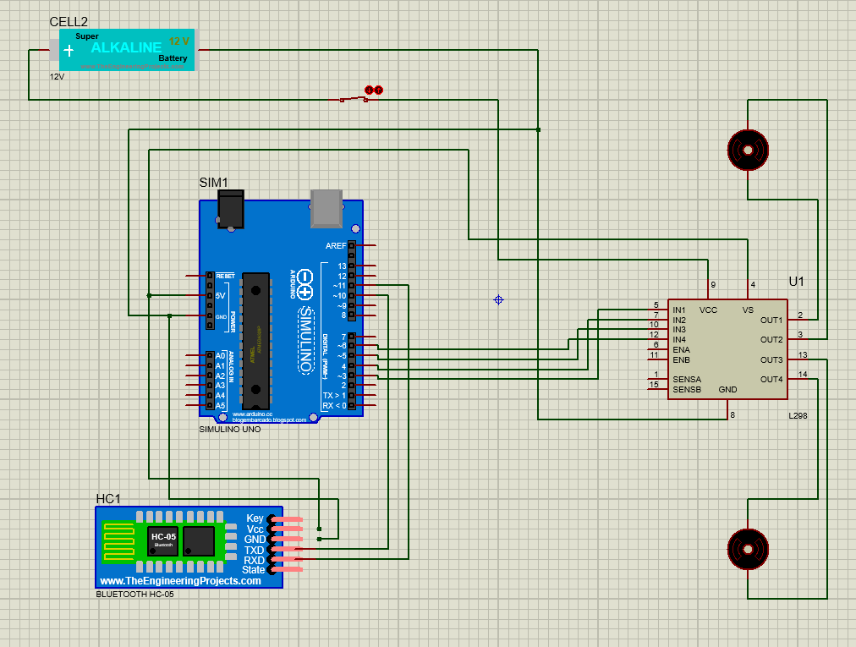

**Circuit Functionality:**

* **Power supply distribution:**

The motor driver, L298 is directly connected to the 12V battery, while the Arduino and all other components are supplied through a regulated 5V produced by the onboard voltage regulator of the Arduino.

* **Bluetooth Communication:**

The HC-05 module receives commands wirelessly, perhaps something like "forward" or "left".

All of these commands are sent to Arduino for processing.

* **Motor Control:**

Arduino processes commands through the Bluetooth module and sends the signals to L298.

L298 follows the level of IN1-IN4 input logic signals and follows different rotation directions for the motor, it will reverse, move backward, turn left, or move right.

* Control Flow:

The user gives commands in a specific voice.

The signal to that command is produced by HC-05 module.

The Arduino will understand what the signal means and control the motors connected to the L298 driver module.

**4.HARDWARE AND SOFTWARE INTEGRATION**

**(1).** Hardware components are connected according to the circuit diagram.

**(2).** The Arduino code is uploaded to the Arduino Uno with the help of the Arduino IDE.

**(3).** The smartphone application is designed and installed.

**(4).** The smartphone is paired with the HC-05 Bluetooth module.

**(5).** The system is tested by providing voice commands via the app, and the wheelchair's movement is observed.

**5. FLOW-CHART**

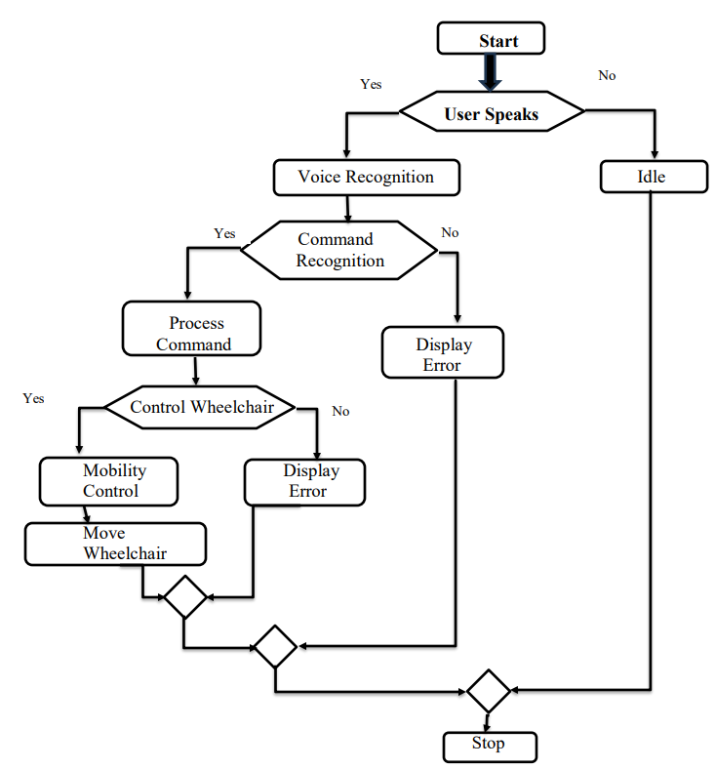

**6. RESULTS AND DISCUSSIONS**

The voice-activated wheelchair was tested through a series of tests to measure its performance. These tests include:

* Voice Recognition Accuracy Test: This measured the percentage of voice commands that were correctly recognized.
* Response Time Test: Test to measure time gap between issuing of a voice command to the wheelchair to respond.
* Maneuverability Test: This test evaluates the wheelchair's ability to execute different movements (forward, backward, left, right) accurately and smoothly.
* Range Test: Tested the effective communication range of the Bluetooth connection.

**6.1System Performance under various conditions**

* **Different Noise Levels:** In noisy environments, the voice recognition accuracy was adversely affected due to interference with the voice signal.
* **Different Surfaces:** the movement of a wheelchair was impacted due to incomplete surface, such as uneven, required more power and jerky movement.
* **Different Distances:** The Bluetooth connection became unstable beyond the effective range of 10 meters.

**7. GRAPHS AND TABLES**

**7.1 Voice Recognition vs. Noise Level**

|  |  |  |
| --- | --- | --- |
|  | **Noise Level** | **Voice Recognition** |
| **1** | Quiet (40 dB) | 95% |
| **2** | Moderate(60dB) | 85% |
| **3** | Loud (80 dB) | 75% |

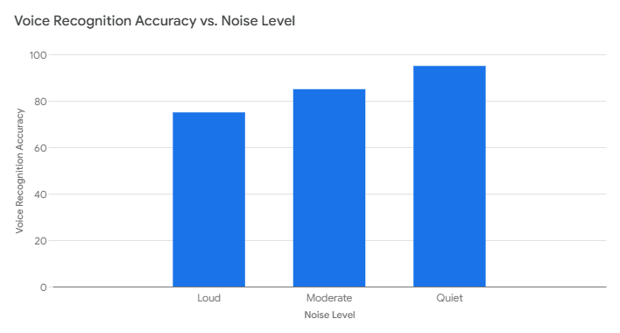

Fig-7.1 Voice Recognition vs. Noise Level

**7.2 Response Time vs. Command Type**

|  |  |  |
| --- | --- | --- |
|  | **Command Type** | **Response Time** |
| **1** | Forward | 0.45 |
| **2** | Backward | 0.55 |
| **3** | Left | 0.5 |
| **4** | Right | 0.6 |

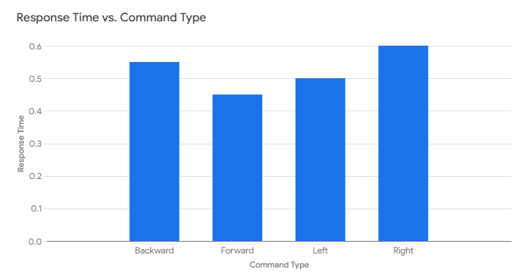

Fig-7.2 Response Time vs. Noise Level

**8. CONCLUSIONS**

This project, then, contributes to the field of assistive technology, proving, in this case, that voice control technology can be put into action to improve mobility for people with disabilities. Our work is a proof-of-concept for a control system that could have truly significant implications for people who are severely, naturally limited in their ability to move around freely. This research, therefore, addresses the problems of voice recognition accuracy and control system design, providing a foundation for future research and development in this area. It also shows the significance of user-centered design in the development of assistive technology, thus emphasizing the importance of adequate user testing and feedback to ensure that these technologies are effective for their intended users. We hope that it will inspire additional innovation and teamwork in the quest for assistive technologies that provide people with a disability the empowerment to live freer and more abundant lives.

**REFERENCES**

1. Prof. A.N. Mhetre, J.H. Garad, G.D. Damle, D.P. Kendre, K.S. Tamnar (2024), ‘Practical Implementation and Performance Evaluation Of A Voice-Controlled Wheelchair System’, DOI: <https://www.doi.org/10.56726/IRJMETS50130>.
2. K. Sangeetha, K. Arun, K.K. Goutham, J. Karthick (2020), ‘Voice Controlled Wheelchair for Physically Disabled People’, International Journal of Science and Healthcare Research Vol.5; Issue: 2; April-June 2020.
3. Prof. Manoj V. Bramhe, Navya Vijay, K. Bhagyashree Rao, Payal Bisen, Riddhi Navsalkar, Tanushri Bajganiya (2017), ‘Voice Controlled Wheelchair for Physically Disabled Person’, International Journal of Advanced Research in Electrical, Electronics and Instrumentation Engineering (IJAREEIE).
4. M. S. Arsha1, A. Remya Raj, S. R. Pooja, Rugma Manoj, S. A. Sabitha, Shimi Mohan (2020), ‘Voice Controlled Wheelchair’, International Journal of Research in Engineering, Science and Management Volume-3, Issue-9, September-2020.
5. Prarthana Metri, Priyanka Patil, Rajeshwari Karerudrannavar, Shruti Shivpuji, Prof. Sanmati Bedakihale (2023), ‘Voice Controlled Wheelchair’, International Journal of Research Publication and Reviews (IJRPR).
6. Samiksha Dagade, ShriyaAkole, Akshay Sonar, D.A.Itole (2023), ‘Voice Controlled Wheelchair For Physically Disabled’, International Journal of Creative Research Thoughts (IJCRT).
7. Prof. Varsha S Jadhav, Laxmi Gudaganavar, Suraksha Kavali, Ashwini Kale, Mohammed Saif (2024), ‘VOICE CONTROLLED WHEELCHAIR - An Assistive Technology for Improved Mobility’, International Research Journal of Engineering and Technology (IRJET) e-ISSN: 2395- 0056 Volume: 11 Issue: 04-Apr 2024
8. Fehr, L., Langbein, T., & Skaarup, S. (2000). Robotic assistive technology at the dawn of the new millennium. IEEE Transactions on Rehabilitation Engineering, 8(1), 1-13.
9. Ahmed I. Iskanderani, Foyzur Razzaque Tamim, Md. Masud Rana, Wasif Ahmed (2021), ‘Voice Controlled Artificial Intelligent Smart Wheelchair’, IEEE, DOI: 10.1109/ICIAS49414.2021.9642607.
10. Sumet Umchid, Pitchaya Limhaprasert, Sitthichai Chumsoongnern, Tanun Petthong (2019), ‘Voice Controlled Automatic Wheelchair’, IEEE, DOI: 10.1109/BMEiCON.2018.8609955.