**Department of Computer Science, IIT Bombay**

**AUTUMN SEMESTER JUL-NOV 2024**

**Soil Moisture Detection**

**Academic Programme :**

Foundations of Machine Learning (CS-725)

**Team Details :**

1. Hasmita Kurre : 23D0385

2. Chaitanya Shinge : 23M2116

3. Chanakya Vihar Challa : 24M2028

4. Rohit Kumar : 24M2029

**Team Contribution :**

* **Hasmita Kurre**Dataset Preparation and CNN implementation on the dataset.
* **Rohit Kumar**AlexNet implementation on the dataset.
* **Chaitanya Shinge**ResNet50 implementation on the dataset.
* **Chanakya Vihar Challa**MobileNetV2 implementation on the dataset.

**Submission**

* **GitHub Code:** <https://github.com/HasmitaKurre/CS725_FML/tree/main/FML_Project>
* **Soil Moisture Dataset:** <https://www.kaggle.com/datasets/hasmitakurre/nasa-soil-moisture-india-dataset>
* **Files to run:**
  + Launch jupyter notebook and in Code folder run below notebooks –
    - Run " 1_Get_NASA_Raw_Data_FML.ipynb" jupyter notebook.
    - Run " 2_Visualize_NASA_Raw_Data_FML.ipynb" jupyter notebook.
    - Run " 3_Visualize_Images_NASA_Image_Data_FML.ipynb" jupyter notebook.
    - Run " 4_Visualize_Images_NASA_Patch_Data_FML.ipynb" jupyter notebook.
    - Run " 5_Sampling_Classes.ipynb" jupyter notebook.
    - Run " 6_Preprocesing_Classes.ipynb" jupyter notebook.
    - Run " 7_CNN.ipynb" jupyter notebook.
    - Run " 8_Alexnet.ipynb" jupyter notebook.
    - Run " 9_MonbileNet.ipynb" jupyter notebook.
    - Run " 10_ResNet50.ipynb" jupyter notebook.
  + In Results folder find the results of Confusion matrix, Accuracy vs loss plot, Actual vs Prediction plot, ROC-AUC curve.

**Introduction :**

* This project aims to develop a system for soil moisture detection to accurately predict soil moisture levels.
* We had used **NASA-USDA**, SMAP soil moisture profile satellite data from 2015 to 2020 and processed india region.
* We performed data preprocessing and sampling techniques to fine tune the data.
* For this project we had explored ML algorithms for Image Classification like CNN, ResNet, AlexNet and MobileNet to detect the moisture and compared these algorithms by calculating their accuracy and f1-score.

**Dataset :**

* NASA-USDA SMAP soil moisture profile satellite data from 2015 - 2020
* Patch Dimensions: 396 x 396
* Training split: 70%
* Validation split: 20%

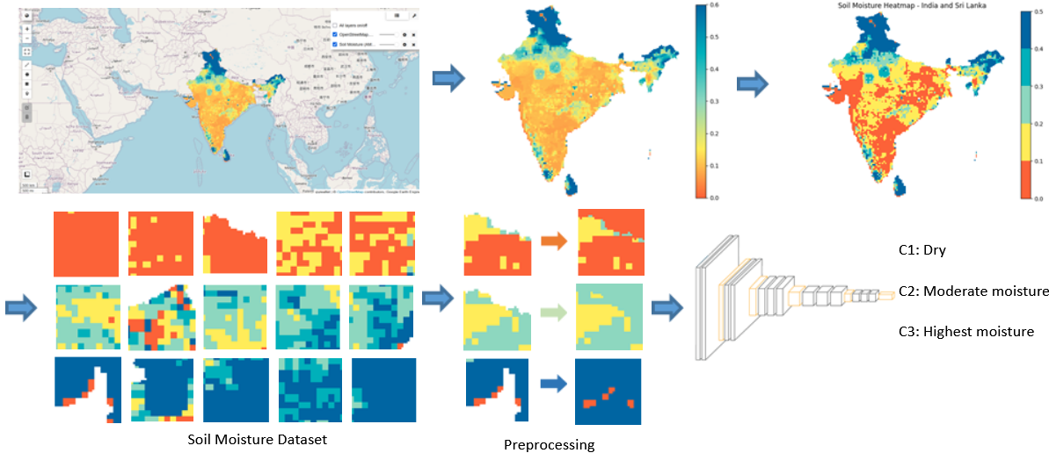

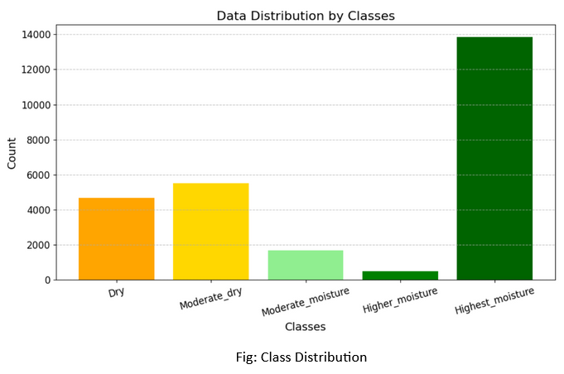

|  |  |
| --- | --- |
| **Moisture Class** | **#Patches** |
| Dry | 5001 |
| Moderate_Moisture | 5001 |
| Highest_Moisture | 5000 |

**Techniques Used:**

* Keras implementations of
  + Layers like 2D Convolution, 2D Max Pooling, Dense
  + Models like CNN, AlexNet, MobileNetV2, ResNet50
  + Optimizers like Adam, SGD
  + Loss functions like Sparse Categorical Cross Entropy
* Common Hyperparameters across Models
  + Loss functions Image Size: 96 x 96 x 3
  + Epochs: 200 (but also using Early Stopping)
  + Training Batch Size: 32
* Calculated Accuracy, F1-score, Recall and Precision using scikit-learn

**Results :**

* Observation :
  + All classes are classified perfectly.
  + Performance is consistent across each class.

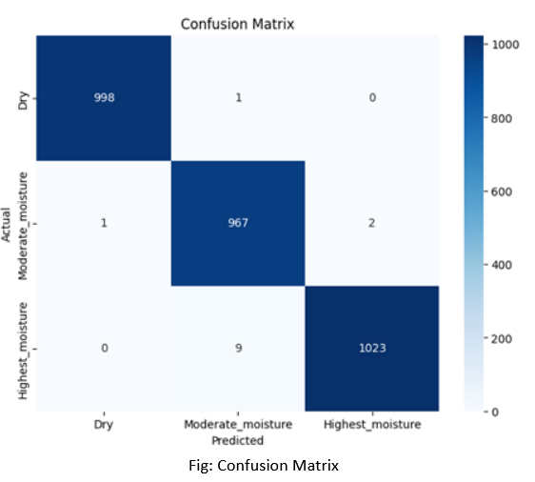

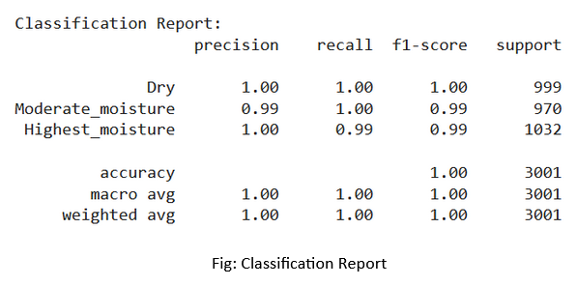

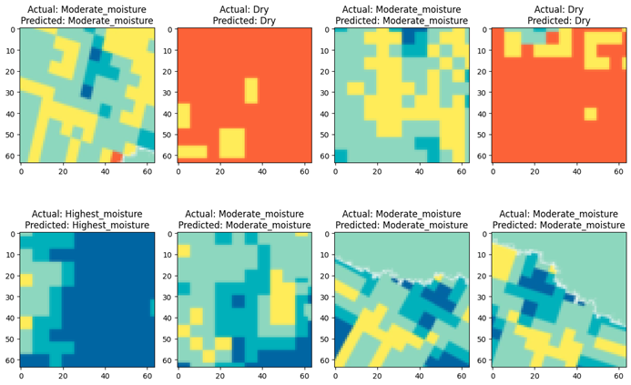

* **Observation :**
  + Model performs very well in classifying images without notable errors.
  + Minimal misclassifications and good predictions.

**Conclusion:**

* Our main aim is soil moisture detection to accurately predict soil moisture levels using various machine learning algorithms and compare their accuracy to find the best algorithm for the soil moisture detection.

|  |  |
| --- | --- |
| **Models** | **Test Accuracy** |
| CNN | 99.57% |
| ResNet50 | 99.66% |
| MobileNetV2 | 98.71% |
| AlexNet | 97.42% |