SIMATS ENGINEERING
ASSESSMENT TOOL 1: ANALYTICAL PROBLEM SOLVING
COURSE NAME | Cloud Computing and Big Data Analytics | COURSE CODE: CSA15
COURSE OUTCOME COVERED
CO2: Analyze virtualization architectures to identify performance and security issues in cloud computing environments. (BL3)
Bloom's Taxonomy: Manipulation (Level 2) | Question Count: 5 Total Marks: 50
Code of Conduct
I HASMITHA SRI S(192371001) (Name / Reg No) certify that this submission is my original work and that I have adhered to the guidelines specified for this assessment.
I understand that any violation of academic integrity rules will result in disciplinary action.
Signature of the student: HASMITHA SRI S

Question 1: Type-1 vs Type-2 Hypervisors for Mission-Critical Applications
Scenario: Compare Type-1 and Type-2 hypervisors for a cloud datacenter hosting mission-critical applications. Analyze performance, security, and manageability, then justify the better choice.
[Marks: 10]
Comparative Analysis
Aspect | Type-1 (Bare-Metal) | Type-2 (Hosted)
Performance | Runs directly on hardware with minimal overhead; near-native CPU/memory/I-O performance suited to heavy production workloads. | Runs on top of a host OS, so every I/O and CPU cycle is mediated an extra layer, adding overhead and reducing throughput.
Security | Smaller, dedicated attack surface (no general-purpose host OS to compromise); stronger isolation between VMs. | Inherits every vulnerability of the underlying host OS, giving attackers a larger attack surface and an extra layer to breach.
Manageability | Centralized enterprise management suites (e.g., vCenter) support large-scale automation, monitoring, and clustering. | Typically managed per-machine through a desktop console; not designed for large-scale datacenter orchestration.
Resource Efficiency | Can consolidate many production VMs per host with predictable performance (better for capacity planning). | Host OS itself consumes CPU/RAM/storage, reducing the resources actually available to guest VMs.
Justification of the Better Choice
- For a datacenter hosting mission-critical applications, a Type-1 (bare-metal) hypervisor is the clearly better choice: it eliminates the host-OS layer that both adds performance overhead and enlarges the security attack surface.
- Its enterprise-grade management tooling supports the high availability, live migration, and centralized monitoring that mission-critical workloads require at scale.
- Type-2 hypervisors remain useful for development/testing on individual machines, but are not appropriate for production datacenter hosting where uptime, security, and performance are non-negotiable.
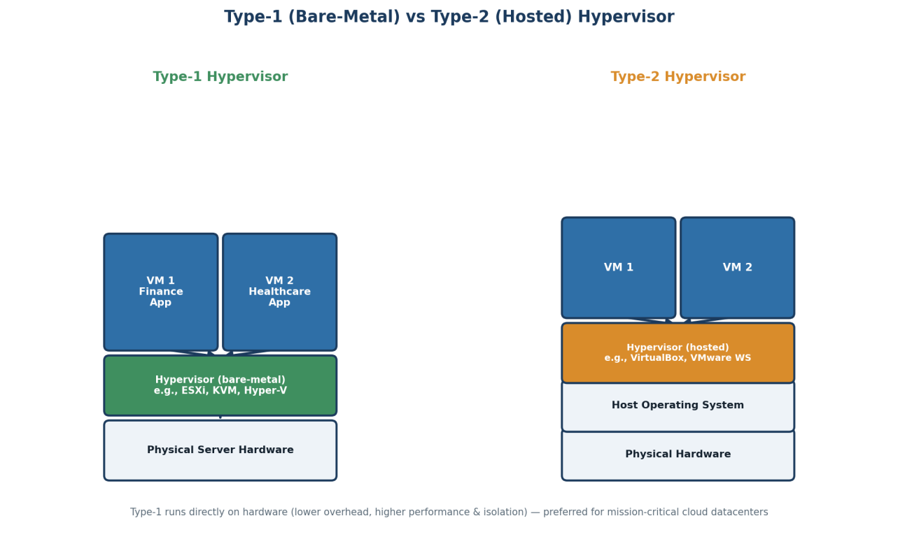

Question 2: Isolating Finance, Healthcare, and Student Portal Workloads
Scenario: A cloud provider must isolate workloads belonging to finance, healthcare, and student portals on the same hardware. Analyze how virtualization architecture supports isolation and identify two major attack surfaces.
[Marks: 10]
How Virtualization Architecture Supports Isolation
- The hypervisor creates strictly separated virtual machines for each tenant (finance, healthcare, student portal), each with its own virtual CPU, memory space, and virtual disk, so one tenant's VM cannot directly read or write another's memory or storage.
- Virtual networking (VLANs/virtual switches/software-defined networking) segments tenant traffic so packets from the healthcare tenant are never visible to the finance or student-portal tenant, even though they share the same physical NIC/switch.
- Resource governance (CPU/memory reservations and limits) prevents one noisy tenant from starving the others of physical resources, preserving performance isolation alongside data isolation.
- Hardware-assisted virtualization features (e.g., Intel VT-x/AMD-V, IOMMU) enforce isolation at the CPU and memory-controller level, making it far harder for a guest VM to break out of its boundary.
Two Major Attack Surfaces
- Hypervisor / VM-escape vulnerabilities: a flaw in the hypervisor itself could let a malicious or compromised VM (say, in the student-portal tenant) break out of its sandbox and access the memory or resources of the finance or healthcare VM running on the same host.
- Shared infrastructure side-channels: because tenants share the same physical CPU cache, memory bus, and network hardware, side-channel attacks (e.g., cache-timing attacks) or misconfigured shared virtual networks/storage can leak sensitive data across tenant boundaries even without a direct hypervisor exploit.
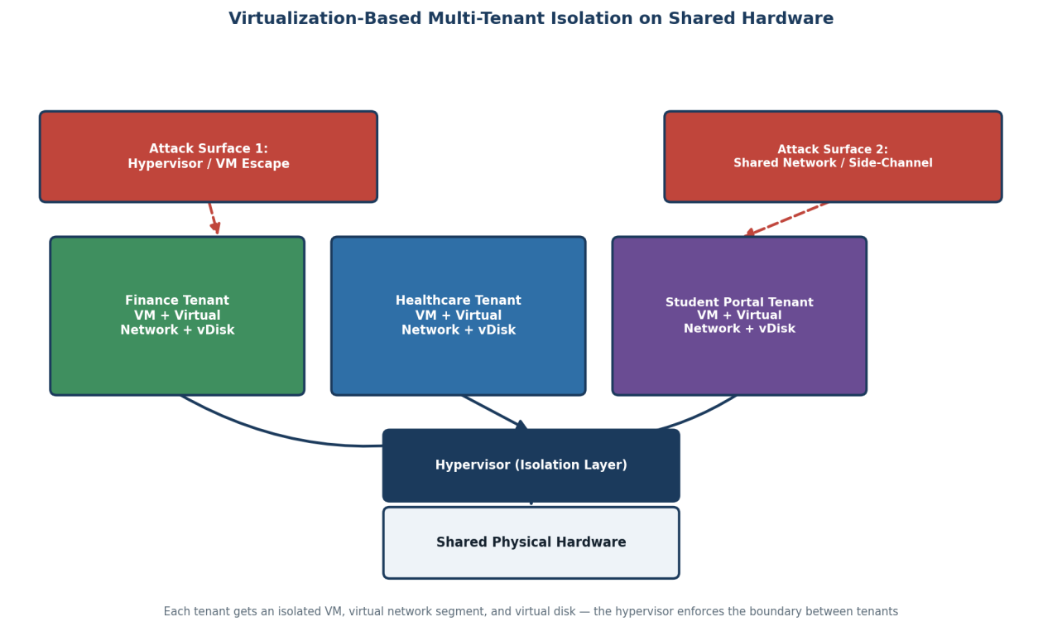

Question 3: Diagnosing a VM Host Utilization Snapshot
Scenario: CPU 92%, memory 88%, storage I/O latency 35 ms, average VM boot time 170 s. Recommend corrective actions and explain the likely bottlenecks.
[Marks: 10]
Reading the Snapshot
- CPU at 92% is above the generally accepted healthy operating threshold (~80%), indicating the host is close to CPU saturation and VMs are likely experiencing scheduling delays (CPU ready time).
- Memory at 88% is also above the safe threshold, suggesting the hypervisor may be resorting to memory ballooning, compression, or swapping to disk to satisfy VM memory demands — all of which degrade performance.
- Storage I/O latency of 35 ms is well above the normal range for enterprise storage (typically under 10-20 ms), pointing to a storage subsystem that cannot keep up with the I/O requests being issued.
- A 170-second average VM boot time is unusually slow (healthy boot times are typically well under a minute), which is consistent with a host that is simultaneously CPU-, memory-, and I/O-constrained during boot.
Likely Bottlenecks
- CPU over-commitment: too many vCPUs allocated relative to physical cores are competing for scheduling time, directly explaining the high CPU usage and slow boot times.
- Memory over-commitment: total VM memory demand exceeds physical RAM, forcing the hypervisor into costly swapping/ballooning, which compounds the slow boot and general sluggishness.
- Storage subsystem saturation: the high I/O latency suggests either too many VMs sharing the same datastore/disks, insufficient IOPS capacity, or a misconfigured storage tier, all of which slow every disk-dependent operation including VM boot.
Recommended Corrective Actions
- Right-size VM CPU/memory allocations and use resource pools/reservations to prevent over-commitment beyond what physical hardware can support.
- Migrate some VMs to other hosts (using live migration/VMware vMotion or equivalent) or add hosts to the cluster to redistribute load and reduce contention.
- Upgrade or reconfigure storage — move to faster storage tiers (SSD/NVMe), spread VM disks across more datastores, or increase provisioned IOPS to bring latency back under acceptable limits.
- Enable and monitor performance-based alerting (CPU ready time, memory swap rate, disk latency) so early warning is available before thresholds are breached again.
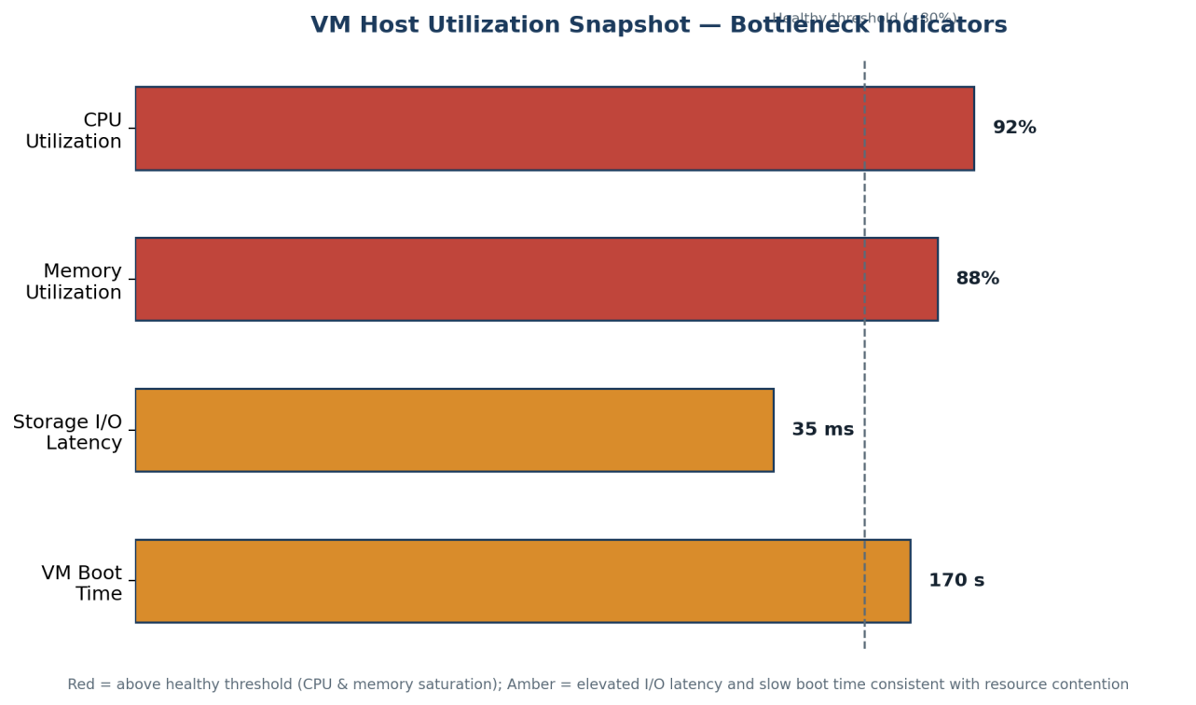

Question 4: Software-Defined Datacenter (SDDC) Agility vs Traditional Datacenter
Scenario: Analyze how Software Defined Datacenter architecture improves agility compared with a traditional datacenter. Support your answer with compute, storage, and network virtualization considerations.
[Marks: 10]
Compute Virtualization
- Traditional datacenters dedicate physical servers to specific applications, so provisioning new capacity means procuring, racking, and configuring new hardware — a process that takes days to weeks.
- An SDDC pools compute capacity across many physical hosts through hypervisors, so new virtual machines or containers can be provisioned from that pool via an API call in minutes, with no physical procurement delay.
Storage Virtualization
- Traditional storage is tied to fixed SAN/NAS arrays that must be manually configured (LUNs, zoning) for each application, making storage changes slow and error-prone.
- Software-Defined Storage (SDS) in an SDDC abstracts physical disks into a flexible, policy-driven storage pool; capacity, performance tier, and replication can be assigned to a workload programmatically and adjusted on demand.
Network Virtualization
- Traditional networking relies on manually configured physical switches/routers/firewalls, so creating a new network segment or security policy requires manual, error-prone changes to physical devices.
- Software-Defined Networking (SDN) in an SDDC lets administrators define virtual networks, load balancers, and firewall rules entirely in software, decoupled from physical topology, and apply them instantly across the datacenter.
Overall Agility Gained
- Because compute, storage, and networking are all abstracted into software-controlled pools, an SDDC can be managed and automated through a single unified policy layer and APIs, enabling self-service provisioning, faster scaling, and consistent policy enforcement — agility that a traditional, hardware-bound datacenter simply cannot match.
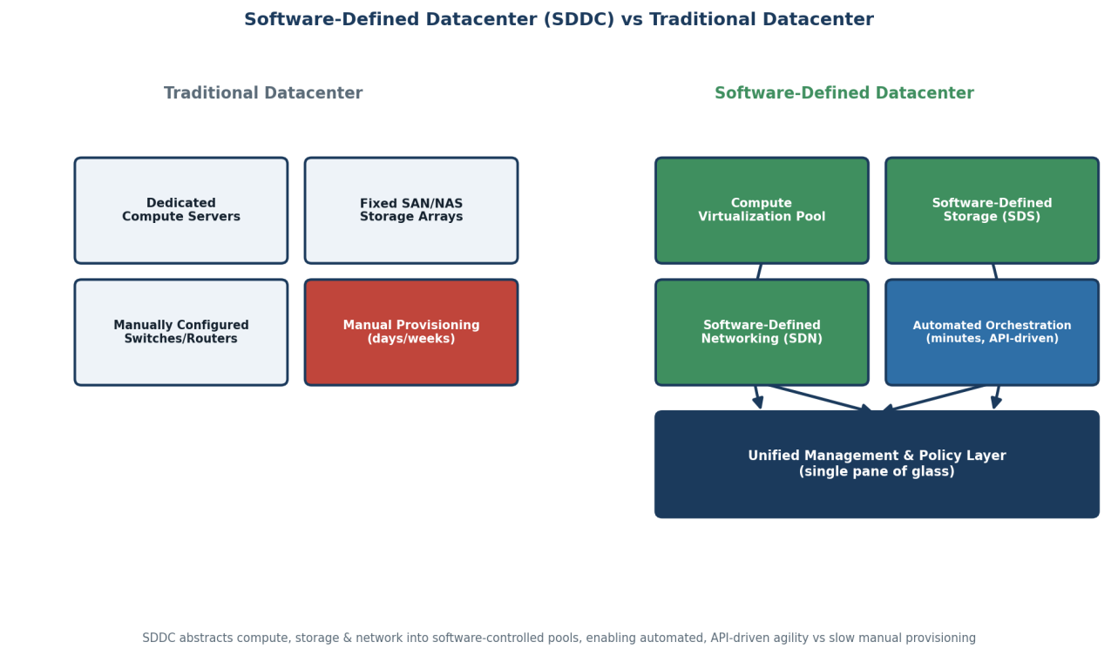

Question 5: Fixing Identity Mismatches in a Multi-Cloud Federation
Scenario: A multi-cloud federation project fails due to identity mismatches between providers. Analyze the issue and propose a secure identity and privacy design using federation concepts.

Analysis of the Root Issue
- Identity mismatches typically occur because each cloud provider maintains its own separate identity store with different user attributes, naming conventions, and authentication protocols, so a user's identity on Provider A is not automatically recognized or trusted by Provider B or C.
- Without a common trust framework, each provider ends up requiring separate credentials, leading to duplicated, inconsistent accounts, broken single sign-on, and gaps where access is either wrongly granted or wrongly denied across clouds.
- This also creates a privacy and audit problem: without a single source of truth for identity, it becomes difficult to track who accessed what across the federation, which undermines both security and compliance.
Proposed Secure Identity and Privacy Design
- Establish one central, authoritative Identity Provider (IdP) for the organization, using open federation standards such as SAML 2.0 or OpenID Connect/OAuth 2.0, so identity is defined and managed in exactly one place.
- Set up a federation trust relationship between the central IdP and each cloud provider, so every provider trusts and validates the same signed identity assertions/tokens rather than maintaining its own separate user database.
- Issue short-lived, signed tokens (SAML assertions or JWTs) containing only the minimum necessary attributes (principle of least privilege / data minimisation) to protect user privacy as identity claims cross cloud boundaries.
- Layer attribute-based access control (ABAC) and multi-factor authentication (MFA) on top of the federated identity, so access decisions in each cloud are made consistently based on verified user attributes and roles, not on separately managed local accounts.
- Maintain centralized logging of authentication and federation events across all providers, giving the organization one unified audit trail for security monitoring and regulatory compliance.
