SIMATS ENGINEERING
ASSESSMENT TOOL 2 : SCENARIO-BASED
COURSE NAME | Cloud Computing and Big Data Analytics | COURSE CODE: CSA1516
COURSE OUTCOME COVERED
CO2: Analyze virtualization architectures to identify performance and security issues in cloud computing environments. (BL3)
Bloom's Taxonomy: Manipulation (Level 2) | Question Count: 5 Total Marks: 25
Code of Conduct
I HASMITHA SRI S(192371001) (Name / Reg No) certify that this submission is my original work and that I have adhered to the guidelines specified for this assessment.
I understand that any violation of academic integrity rules will result in disciplinary action.
Signature of the student: HASMITHA SRI S

Question 1: Cloud Architecture for a Video Streaming Platform
Scenario: A media company wants to migrate its video streaming platform to the cloud. The system must handle millions of concurrent users with minimal buffering.
(a) Cloud Architecture Using Scalability and Caching Techniques
- Global DNS / GeoDNS routes each user to the nearest healthy region, minimising latency at the very first hop.
- A Content Delivery Network (CDN) with edge Points of Presence (PoPs) caches popular video segments (using adaptive bitrate formats such as HLS/DASH) close to the viewer, so repeat requests never touch the origin.
- Video is pre-transcoded into multiple bitrate/resolution renditions and stored in object storage (e.g., Amazon S3), acting as the durable origin for the CDN.
- An in-memory cache (e.g., Redis/Memcached) stores frequently accessed metadata such as titles, thumbnails, and recommendations, cutting database load.
- Microservices (catalog, playback authorization, recommendation, billing) are containerised and independently scalable, avoiding a single monolithic bottleneck.
(b) Role of Load Balancing and Auto-Scaling in Smooth Streaming
- A Layer-7 load balancer distributes incoming playback/API requests evenly across a fleet of streaming servers, preventing any single node from being overwhelmed during peak hours (e.g., a new episode release).
- Health checks performed by the load balancer automatically remove unhealthy instances from rotation, so users are never routed to a failed server.
- Auto-scaling groups monitor real-time metrics (CPU, network throughput, active connections) and add new streaming/transcoding instances within minutes when a viewership spike is detected, then scale back down afterward.
- Combined with CDN caching, load balancing ensures that only a small fraction of requests reach origin servers, so buffering stays minimal even under millions of concurrent sessions.
(c) Cost Optimization Strategies for High-Demand Workloads
- Use Reserved/Committed-use instances for predictable baseline traffic and Spot/low-priority instances for elastic transcoding workloads, since transcoding jobs can tolerate interruption.
- Apply storage tiering: keep newly released, high-demand content on standard storage and move older, rarely watched content to cold/infrequent-access tiers.
- Cache aggressively at the CDN edge to reduce expensive data-egress and origin compute charges.
- Use auto-scaling with scheduled scale-down during predictable low-traffic hours, and set budgets/alerts to catch cost anomalies early.
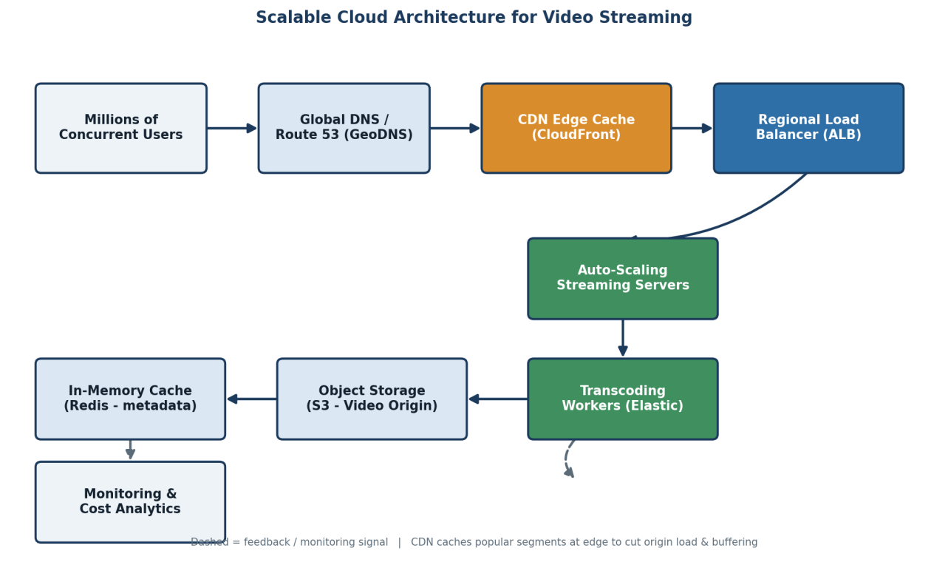

Question 2: Multi-Cloud Container Orchestration for a Fintech Startup
Scenario: A fintech startup is deploying applications using containers across multiple cloud providers and faces challenges in maintaining consistency and managing deployments.
(a) Container Orchestration and Multi-Cloud Strategy
- Package every service as a Docker container and store versioned images in a central container registry, ensuring the exact same artifact is deployed everywhere.
- Use Kubernetes as the common orchestration layer on each provider (Amazon EKS, Azure AKS, Google GKE), so deployment manifests (YAML) remain identical across clouds.
- Adopt Infrastructure-as-Code (Terraform) and GitOps (e.g., ArgoCD/Flux) so cluster configuration and application state are version-controlled and applied consistently to all clouds.
- A CI/CD pipeline builds, tests, and pushes images once, then triggers synchronized rollouts to every cloud cluster, removing manual, provider-specific deployment steps.
(b) Handling Service Discovery and Scaling
- A service mesh (e.g., Istio/Linkerd) spanning clusters provides consistent service discovery, mutual TLS, and traffic routing regardless of which cloud a service instance runs on.
- Kubernetes' internal DNS resolves service names to pod IPs within a cluster; a global/multi-cluster service registry extends this resolution across cloud boundaries.
- Horizontal Pod Autoscalers (HPA) scale pods per cluster based on CPU/memory/custom metrics (e.g., transaction rate), while the mesh's global load balancer shifts traffic toward the least-loaded or nearest cloud region.
(c) Benefits and Risks of Multi-Cloud Deployment
- Benefits: avoids vendor lock-in, improves resilience (one provider's outage does not take the platform down), and enables choosing the most cost-effective or compliant provider per workload — important for regulated fintech data.
- Risks: increased operational complexity, inconsistent native services between providers, higher networking/data-transfer cost, and a larger security surface that requires unified identity and monitoring across all clouds.
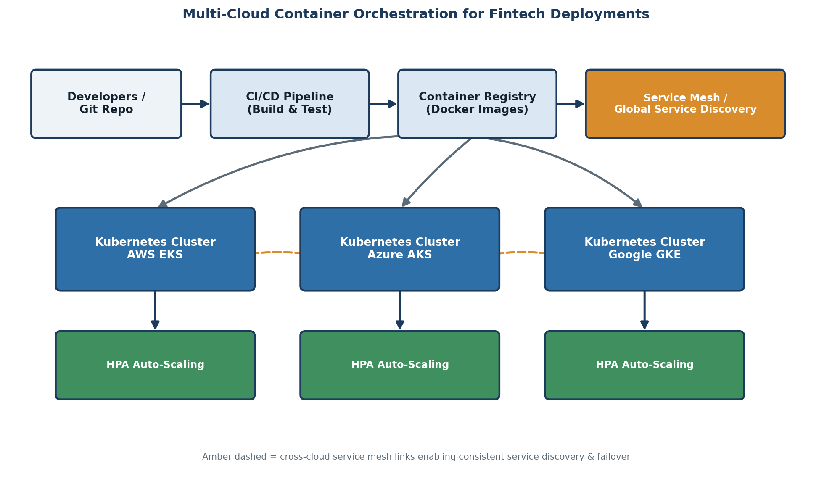

Question 3: Backup and Disaster Recovery for an E-Learning Platform
Scenario: An e-learning platform experiences data loss due to accidental deletion in the cloud and needs a robust backup and disaster recovery strategy.
(a) Backup, Replication, and Versioning Design
- Enable object versioning on cloud storage so every overwrite or delete creates a recoverable prior version instead of destroying data permanently.
- Schedule automated, incremental snapshots of databases (hourly) and full backups (daily), stored separately from production to protect against accidental or malicious deletion.
- Configure cross-region replication so a live copy of course content, videos, and student records exists in a geographically distant secondary region.
- Store long-term backups in a write-once-read-many (WORM) or immutable backup vault so even an administrator cannot delete backups before their retention period expires.
(b) Achieving Recovery Time Objective (RTO) and Recovery Point Objective (RPO)
- RPO (maximum tolerable data loss) is achieved by tuning replication/snapshot frequency — e.g., near-continuous replication yields an RPO of seconds to minutes, while daily backups yield an RPO of up to 24 hours.
- RTO (maximum tolerable downtime) is achieved through automated recovery runbooks/scripts that spin up a standby environment or restore from the replica automatically, rather than relying on manual intervention.
- Regular disaster-recovery drills validate that the actual restore time and data currency meet the promised RTO/RPO targets.
(c) Steps to Ensure Business Continuity During Failures
  - 1. Detect the incident via monitoring/alerting (e.g., unexpected deletion event or region outage).
  - 2. Isolate the affected resource to prevent the failure from propagating further.
  - 3. Trigger the automated recovery runbook to restore from the latest valid snapshot/replica.
  - 4. Redirect user traffic (DNS/load balancer) to the recovered or standby environment.
  - 5. Verify data integrity and conduct a post-incident review to refine backup policies.
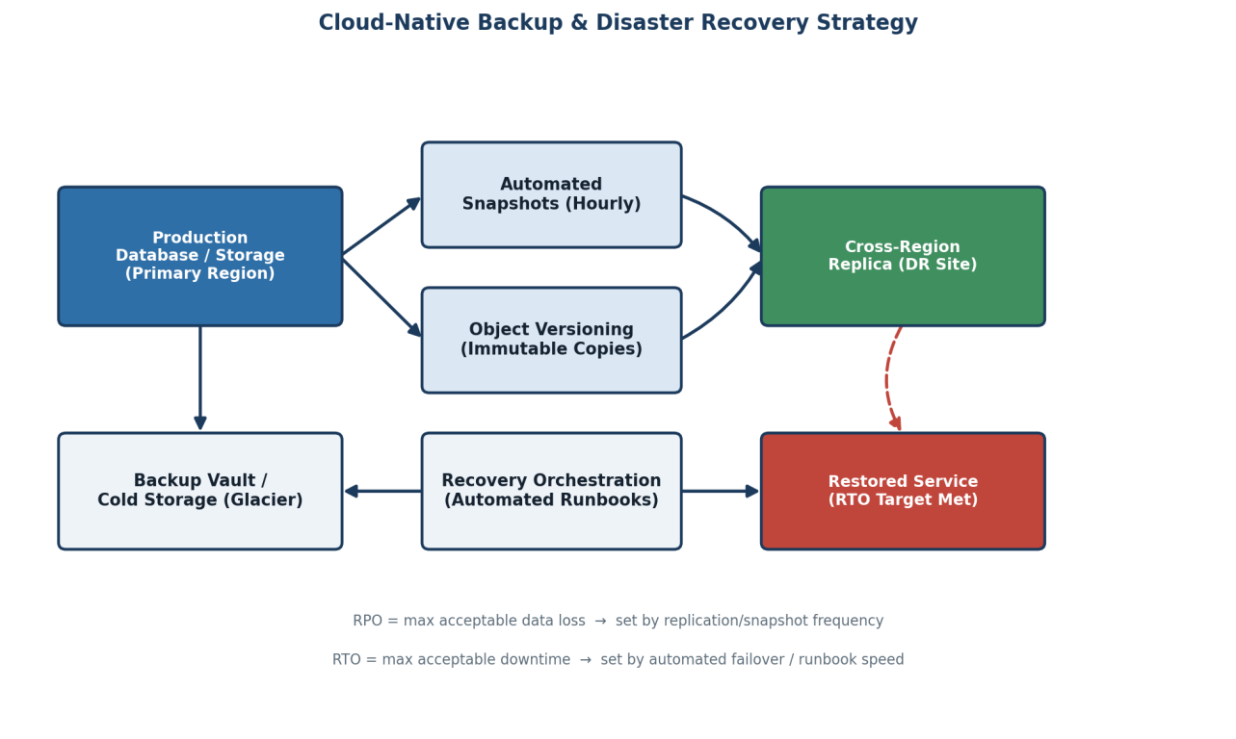

Question 4: Hybrid Cloud Model for a Government Agency
Scenario: A government agency is adopting a hybrid cloud model for sensitive and non-sensitive data, with some applications required to remain on-premises due to compliance.
(a) Hybrid Architecture for Secure Communication
- Keep compliance-bound applications and sensitive citizen data on-premises, inside the agency's own data centre, satisfying data-residency and regulatory requirements.
- Deploy non-sensitive, publicly facing, or highly scalable workloads (citizen portals, information services) in the public cloud, where elasticity is more cost-effective.
- Connect the two environments through a dedicated, encrypted link — a site-to-site VPN or a private connection such as AWS Direct Connect/Azure ExpressRoute — instead of routing traffic over the public internet.
- Segment networks with firewalls and private subnets on both sides so only explicitly permitted traffic can cross between on-premises and cloud.
(b) Identity Management and Encryption
- Use a federated identity model: the on-premises Identity Provider (e.g., Active Directory) is linked to the cloud's IAM/SSO via SAML or OAuth/OpenID Connect, giving one unified identity across both environments.
- Apply role-based access control (RBAC) and the principle of least privilege so cloud services can only access the specific on-premises resources they need, and vice versa.
- Encrypt data in transit (TLS/IPSec over the VPN tunnel) and at rest (cloud KMS-managed keys, on-prem disk/database encryption), with keys rotated and access-logged for audit.
- Enable multi-factor authentication (MFA) for all administrative access, especially to systems handling sensitive citizen data.
(c) Challenges in Managing Hybrid Cloud Environments
- Maintaining consistent security policy and monitoring across two fundamentally different environments (on-prem tools vs. cloud-native tools).
- Network latency and bandwidth costs on the interconnect link, especially for data-heavy workloads.
- Ensuring identity, access, and audit logs stay synchronized so a single unified view of 'who accessed what' is available for compliance reporting.
- Skill gaps — teams need expertise in both traditional on-prem infrastructure and modern cloud platforms.
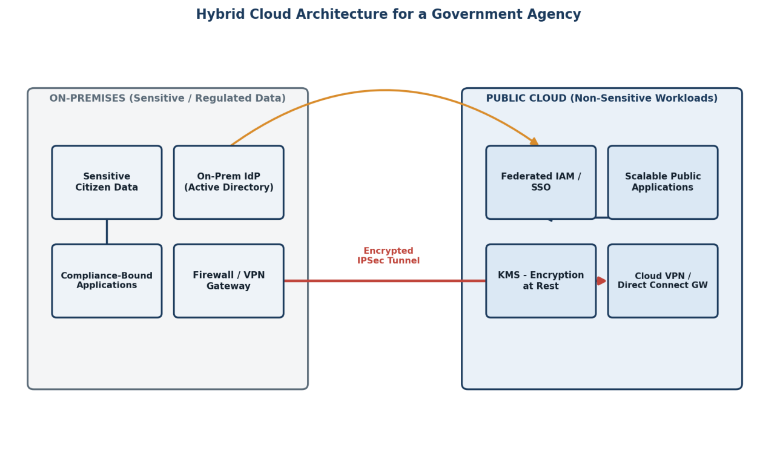

Question 5: High Availability and Fault Tolerance for a SaaS Application
Scenario: A SaaS provider needs high availability and fault tolerance so the application keeps operating even if one region goes down.
(a) Multi-Region Deployment Strategy
- Deploy the application stack (app servers, databases, caches) identically in at least two geographically separate cloud regions — an active region serving live traffic and a second active or standby region ready to take over.
- Use an active-active model where both regions serve traffic simultaneously (best resource utilisation, near-zero failover time) or active-passive where the second region stays warm/idle until needed (simpler consistency model).
- Front the regions with a global traffic manager/DNS that performs continuous health checks and routes users based on latency and region health.
(b) Data Replication and Failover Configuration
- Configure synchronous replication within a region (for strong consistency on critical data) and asynchronous cross-region replication (to keep the secondary region's data near-current without adding latency to every write).
- An automated failover controller continuously evaluates region health; on detecting a regional outage it promotes the replica database to primary and updates the global traffic manager to redirect all users to the healthy region.
- Design applications to be stateless where possible (session state in a distributed cache, not local memory) so any region can serve any user's request after failover.
(c) Monitoring and Alerting for Proactive Issue Detection
- Continuous synthetic health checks and real-user monitoring (RUM) track latency, error rates, and availability per region.
- Centralized logging and metrics dashboards (e.g., Prometheus/Grafana or cloud-native monitoring) aggregate signals from all regions into one pane of glass.
- Threshold- and anomaly-based alerts notify on-call engineers before users are significantly impacted, and automated runbooks can trigger failover without waiting for manual action.
- Regular chaos-engineering drills (deliberately failing a region) validate that failover and alerting actually work as designed.
