SIMATS ENGINEERING
ASSESSMENT TOOL 3: APPLICATION BASED QUESTIONS
COURSE NAME | Cloud Computing and Big Data Analytics | COURSE CODE: CSA1516
COURSE OUTCOME COVERED
CO2: Analyze virtualization architectures to identify performance and security issues in cloud computing environments. (BL3)
Bloom's Taxonomy: Manipulation (Level 2) | Question Count: 5 Total Marks: 25
Code of Conduct
I HASMITHA SRI S(192371001) (Name / Reg No) certify that this submission is my original work and that I have adhered to the guidelines specified for this assessment.
I understand that any violation of academic integrity rules will result in disciplinary action.
Signature of the student: HASMITHA SRI S

Question 1: Auto-Scaling and Load Balancing for Seasonal Traffic Spikes
Scenario: A company experiences unpredictable traffic spikes during seasonal sales.
How Auto-Scaling and Load Balancing Handle the Demand
- A load balancer sits in front of the web/application tier and distributes every incoming request across all currently running server instances, so no single server is overloaded when traffic surges.
- An auto-scaling group continuously watches metrics such as CPU utilisation, request queue length, and response latency, and automatically launches new instances the moment demand crosses a defined threshold — well before the sale traffic peaks.
- As the sale winds down, auto-scaling removes the extra instances, so the company only pays for capacity while it's actually needed (elastic, pay-as-you-go scaling).
- Database read replicas and a distributed cache layer are added alongside the web tier so the backend does not become the new bottleneck once the front end scales.
How This Reduces Downtime and Improves User Experience
- Because capacity grows automatically with demand, the site avoids the classic 'crash during flash sale' failure mode where fixed infrastructure runs out of headroom.
- Health checks let the load balancer instantly stop sending traffic to any instance that becomes unresponsive, so a single server failure never becomes a visible outage.
- Consistent response times keep checkout flows fast, directly protecting conversion rates and customer trust during the highest-revenue period of the year.
Role of Monitoring Tools
- Monitoring dashboards (e.g., CloudWatch, Azure Monitor, Grafana) give real-time visibility into traffic, error rates, and instance health, which is exactly the signal auto-scaling policies act on.
- Alerting notifies the operations team of anomalies (e.g., a sudden error-rate spike) that automated scaling alone might not fix, allowing quick manual intervention.
- Post-event analytics from monitoring data help the company right-size its scaling policies and reserved capacity ahead of the next sale.
Real-World E-Commerce Example
Large e-commerce platforms such as Amazon and Flipkart rely heavily on auto-scaling during events like the Big Billion Days or Prime Day sales — capacity is scaled up by orders of magnitude for a few days and scaled back down immediately after, so the platform stays responsive under record traffic while avoiding the cost of running that peak capacity year-round.
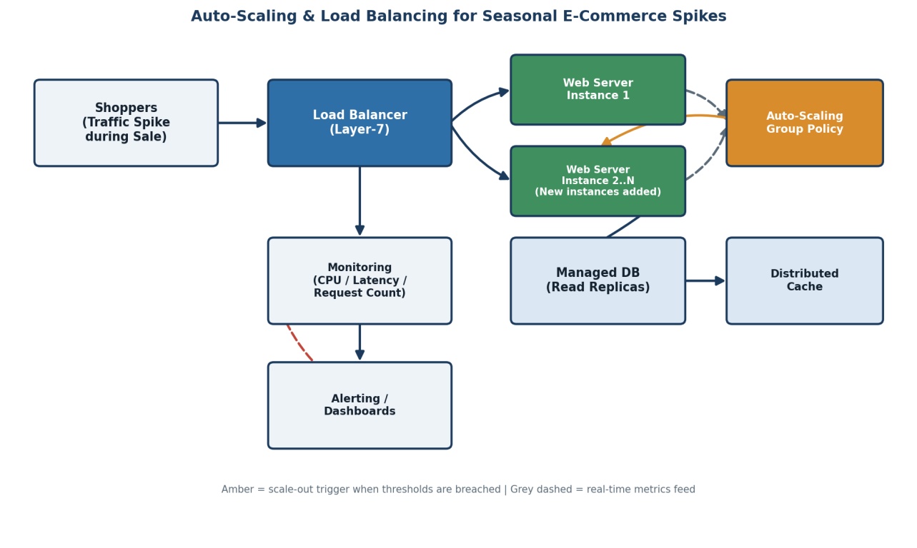

Question 2: Secure Cloud Storage for Backup Data
Scenario: An organization wants to store large volumes of backup data securely in the cloud.
Durability and Data Redundancy
- Cloud storage services automatically replicate every object across multiple physical devices and multiple Availability Zones within a region, so the loss of a single disk or data-centre does not lose data.
- Many providers advertise eleven-nines (99.999999999%) annual durability by design, achieved through erasure coding and continuous integrity checks that repair any detected corruption automatically.
- Cross-region replication adds a further copy in a geographically distant location, protecting against a full regional disaster.
Encryption and Access Control for Sensitive Backup Data
- Data is encrypted in transit (TLS) while being uploaded/downloaded, and encrypted at rest using provider-managed or customer-managed keys (KMS), so stolen disks or intercepted traffic reveal nothing readable.
- Fine-grained IAM policies and bucket/object-level access control ensure only specific authorized roles (e.g., the backup service account) can read, write, or delete backup data.
- Versioning and object-lock/WORM settings prevent accidental or malicious deletion — even an administrator cannot bypass the retention window.
Cost Advantages Compared to Traditional Storage
- No upfront capital expenditure on physical tape libraries, disk arrays, or an off-site facility — the organization pays only for the storage actually consumed.
- Storage tiering (hot, cool, cold/archive) automatically moves infrequently accessed backups to far cheaper storage classes without any manual data migration.
- Elimination of maintenance, power, cooling, and hardware refresh costs that traditional on-premises backup infrastructure requires every few years.
Disaster Recovery Use Case
If a ransomware attack encrypts the organization's production servers, the immutable, versioned backups stored in a separate cloud account/region cannot be touched by the attacker. The IT team restores clean data from the most recent uninfected snapshot into a freshly provisioned environment, meeting the agreed RTO/RPO and resuming operations without paying any ransom.
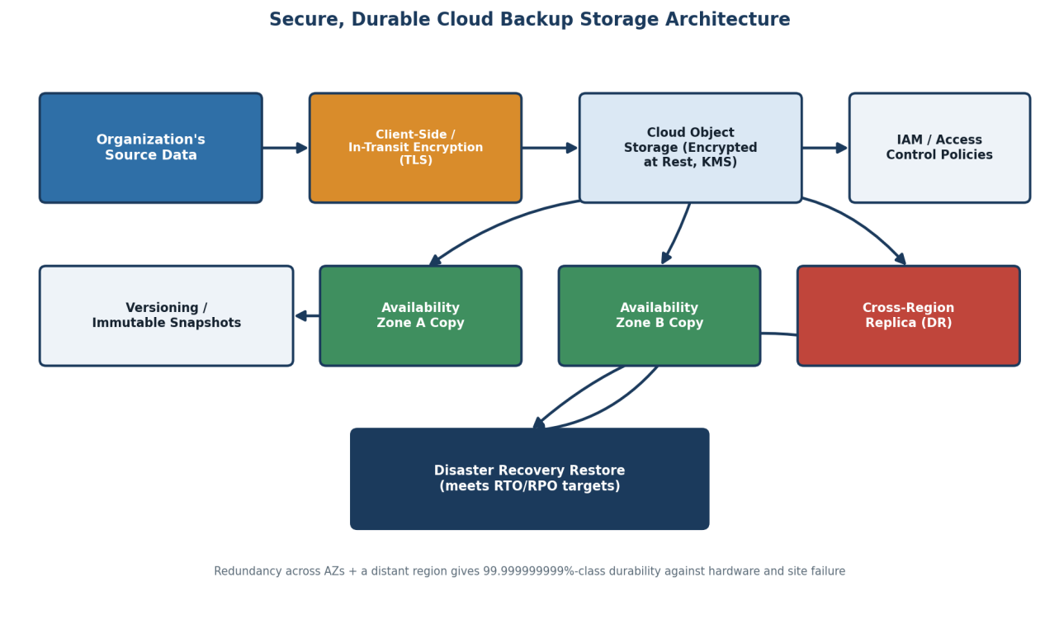

Question 3: CDNs and Edge Servers for Global Mobile App Deployment
Scenario: A mobile app company plans to deploy its application globally.
How CDNs Improve Performance and Reduce Latency
- A Content Delivery Network caches static and semi-static content (images, videos, API responses, app assets) on servers distributed across many geographic locations, instead of serving every user from one central origin.
- When a user requests content, it is served from the nearest cache location rather than travelling across the globe to the origin server, cutting round-trip time dramatically.
- Because most requests are answered directly from the edge, load on the origin server drops sharply, which also improves origin performance for the requests that do need it.
How Edge Servers Enhance User Experience Across Regions
- Edge servers placed in each major region (North America, Europe, Asia-Pacific, etc.) mean a user in Mumbai and a user in São Paulo both get near-local response times instead of one of them suffering long-distance latency.
- Some edge locations also run lightweight compute (edge computing/functions) to personalise content or perform authentication checks close to the user, further reducing perceived latency.
- Consistent low latency across regions is critical for mobile users on variable-quality networks, where every extra round trip is felt more acutely than on fixed broadband.
How Cloud Providers Support Global Availability
- Major providers operate CDN and edge networks with hundreds of points of presence worldwide (e.g., Amazon CloudFront, Azure CDN, Google Cloud CDN, Cloudflare), which the app can plug into without building its own global network.
- Multi-region deployment of backend services, combined with global DNS/traffic management, ensures the app's API layer itself is also close to users, not just its static assets.
Real-Time Streaming / Gaming Example
A live-streaming or multiplayer gaming platform depends on the same CDN/edge principles: video segments or game-state updates are pushed through edge PoPs so viewers/players in different countries experience minimal buffering or input lag, which is essential for a real-time, interactive experience to feel responsive worldwide.
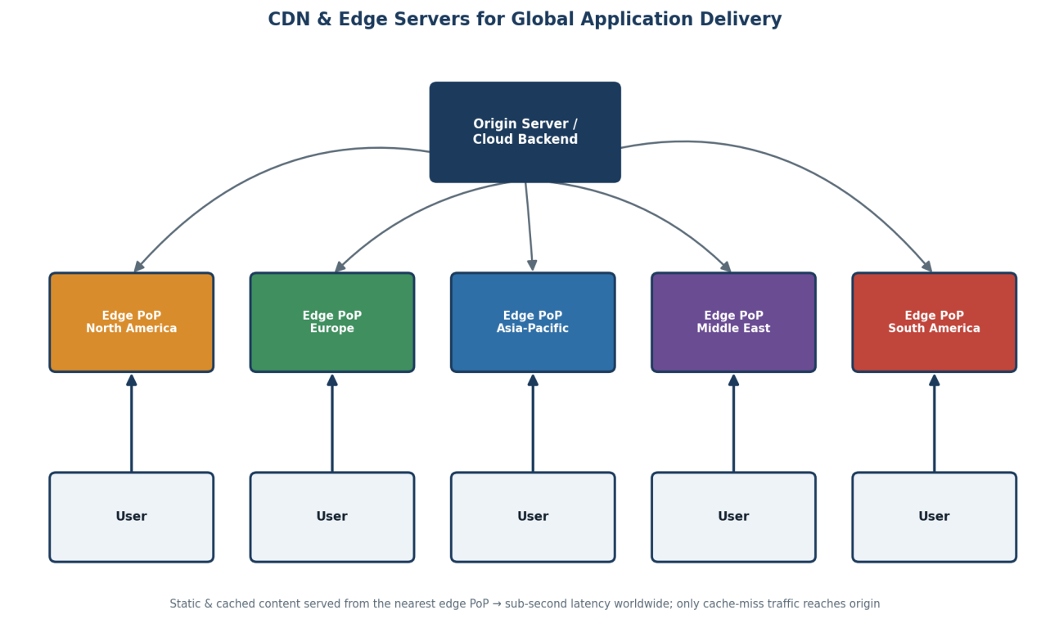

Question 4: Compliance and Data Security for a Financial Institution
Scenario: A financial institution requires strict compliance and data security in cloud usage.

How Cloud Providers Support Regulatory Compliance and Auditing
- Major cloud providers maintain certifications against standards relevant to finance (PCI-DSS, ISO 27001, SOC 2, and local regulations such as RBI guidelines or GDPR), and publish compliance reports the institution can rely on for its own audits.
- Built-in compliance/audit services (e.g., AWS Config, Azure Policy) continuously check that deployed resources follow required configurations and flag any drift.
- Shared-responsibility model: the provider secures the underlying infrastructure, while the institution is responsible for correctly configuring identity, data classification, and application-level controls — clear audit trails on both sides support regulator reviews.
Role of Logging, Monitoring, and Encryption in Security
- Immutable, centralized audit logs (e.g., every login, configuration change, and transaction access) create a tamper-evident trail that regulators and internal auditors can review.
- Continuous monitoring/SIEM tools correlate events in real time to detect suspicious activity such as unusual access patterns or potential fraud, enabling rapid response.
- Encryption in transit and at rest, combined with strict key management (KMS/HSM), ensures that even if data is intercepted or storage is compromised, sensitive financial data remains unreadable.
Ensuring Data Sovereignty Requirements Are Met
- The institution selects cloud regions located within the required country/jurisdiction and configures storage and processing policies to pin data to those regions only.
- Data residency controls and contractual guarantees from the provider ensure backups, replicas, and even support access do not leave the approved jurisdiction.
- Regular compliance audits verify that no service inadvertently replicates or processes data outside the permitted geography.
Example Involving Sensitive Financial Transactions
When a customer makes an online funds transfer, the request passes through MFA-protected authentication, is encrypted end-to-end, is processed only within the bank's approved region, and every step — from login to transaction approval — is logged immutably so that if the transaction is later disputed or investigated, a complete, tamper-proof audit trail is available to regulators.
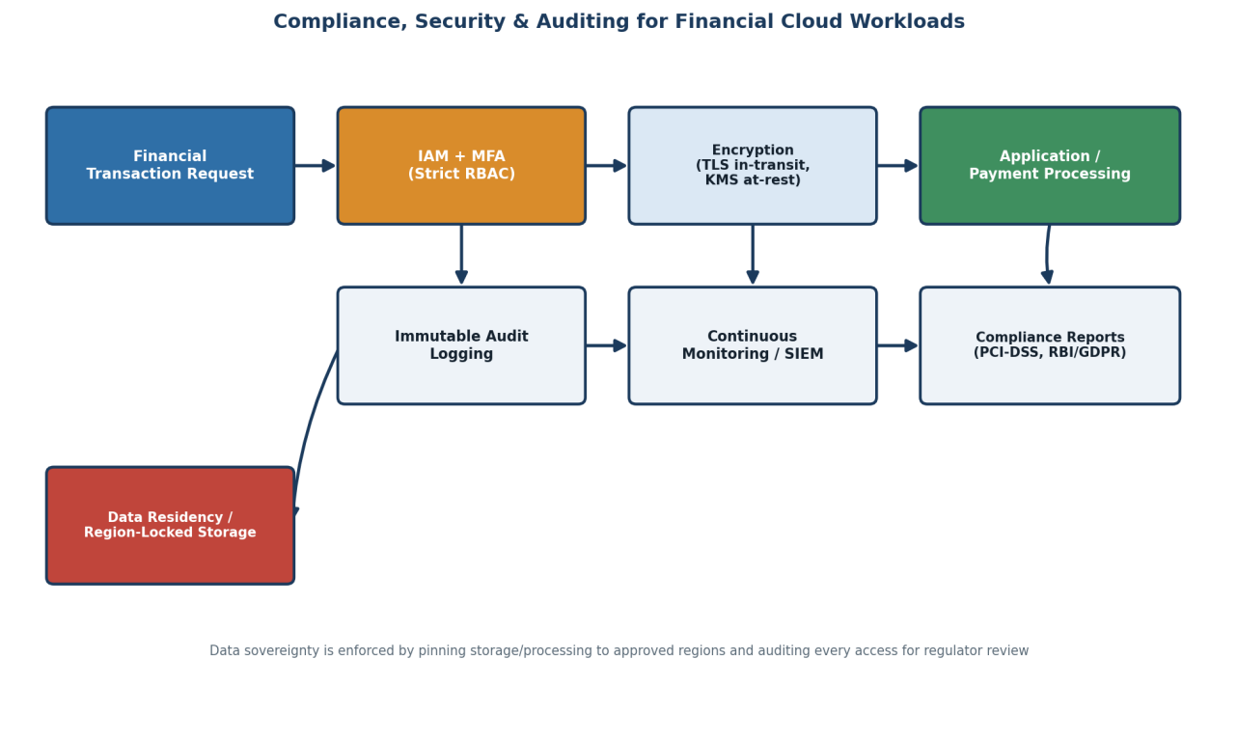

Question 5: Containerization and Orchestration for Application Deployment
Scenario: A development team wants to adopt containerization for application deployment.
Containers vs Virtual Machines: Performance and Resource Usage
- A virtual machine includes a full guest operating system on top of a hypervisor, so each VM carries significant CPU, memory, and storage overhead and typically takes minutes to boot.
- A container shares the host machine's OS kernel and only packages the application plus its dependencies, making containers far lighter — they start in seconds and many more containers can run on the same hardware compared to VMs.
- This lighter footprint means containers are better suited to fast, frequent deployments and efficient use of cloud compute, while VMs still offer stronger isolation for workloads that need a completely separate OS or kernel.
How Orchestration (Kubernetes) Simplifies Deployment and Scaling
- Kubernetes automates scheduling containers onto available nodes, so developers describe the desired state (how many replicas, what resources) instead of manually placing containers on servers.
- It performs self-healing — automatically restarting or rescheduling containers that crash or fail health checks — and horizontal scaling by adding or removing pod replicas based on load, similar in spirit to auto-scaling groups.
- Rolling updates and rollbacks let teams deploy new application versions with zero downtime, and roll back instantly if a problem is detected.
Portability Benefits Across Cloud Environments
- Because a container packages the application with all its dependencies, the same image runs identically on a developer's laptop, an on-premises server, or any major cloud provider's Kubernetes service (EKS, AKS, GKE).
- This portability avoids vendor lock-in and allows teams to adopt a multi-cloud or hybrid-cloud strategy, moving workloads between providers with minimal rework.
Microservices-Based Application Example
An online food-delivery platform can be built as independent microservices — order management, payments, restaurant catalog, delivery tracking, and notifications — each packaged as its own container and deployed on Kubernetes. Each service can be scaled, updated, and deployed independently (e.g., scaling the order service alone during a lunch-hour rush), which would be far harder to achieve with one large monolithic application.
