Cloud-Based Hostel Complaint Management System
A. Assignment Information
Particular | Details
NAME: | HASMITHA SRI S
Department: | Computer Science and BioScience Engineering
Programme: | B.Tech
Course Code & Course Name: | CSA1516 – Cloud Computing and Big Data Analytics
Academic Year/Batch: | 2023–2027
Semester: | VII Semester
Faculty Name: | Dr. K. Santhiya Lakshmi
Assignment Title: | Cloud-Based Hostel Complaint Management System
Date of Issue: | 02-09-2026
Date of Submission: | 02-09-2026
Maximum Marks: | 100
Course Outcome(s) – CO: | CO2: Understand the architecture and concept of different cloud models: IaaS, PaaS, SaaS.  CO3: Be familiar with application development and deployment using cloud platforms.
Bloom's Taxonomy Level: | L3 (Apply) / L4 (Analyze) / L5 (Evaluate)
SDG Mapping (SDG 1–17): | SDG 9: Industry, Innovation and Infrastructure  SDG 11: Sustainable Cities and Communities
Industry / Societal Relevance: | Demonstrates SaaS cloud computing adoption to streamline hostel infrastructure management and student grievance resolution.
B. Assignment Problem / Challenge
Design and develop a simple cloud-based Hostel Complaint Management System using Zoho Creator to demonstrate Software as a Service (SaaS). The system should allow students to submit hostel-related complaints such as electrical issues, plumbing problems, room maintenance and cleanliness issues through an online form. The complaints should be stored in the cloud and organized based on complaint type, priority and status. The system should provide a simple way to track submitted complaints and analyze the number of complaints in each category.
Beyond basic form submission, the assignment also expects the solution to demonstrate how a modern SaaS platform removes the operational overhead traditionally associated with campus IT systems — no server provisioning, no patching, and near-instant rollout — while still delivering the reliability and reporting that a hostel administration team needs on a day-to-day basis.
This assignment requires students to:
- Apply course concepts (SaaS model, cloud database, Deluge workflows) rather than reproduce theory.
- Identify and analyze the problem of manual hostel complaint logging.
- Consider technical, operational, accessibility, and maintenance requirements and constraints.
- Develop or compare alternative cloud solutions (SaaS low-code vs custom IaaS/PaaS build).
- Use relevant modern computing/design tools (Zoho Creator SaaS platform, Git, Python, Deluge).
- Interpret analytical dashboard results for administrative decision-making.
- Make and justify engineering decisions regarding cloud platform selection and database schema.
- Consider appropriate technical, economic, environmental, societal, ethical, safety or sustainability factors.
- Document the deployment process end-to-end so the system can be reproduced, audited, or extended by another team.
C. Problem Statement
Problem / Case / Design Challenge
In educational institution hostels, manual paper-based complaint tracking leads to lost grievances, lack of resolution transparency, poor communication between residents and maintenance staff, and absent analytical insights. Complaint registers are often maintained physically at the warden's office, which means students have no way of checking status remotely, duplicate complaints go unnoticed, and recurring maintenance issues (e.g. a leaking pipe reported repeatedly) are never flagged as patterns.
The objective is to design, implement, deploy, and validate an automated Cloud-Based Hostel Complaint Management System using Zoho Creator (SaaS). The application must capture Student Name/ID, Hostel Block & Room Number, Complaint Type, Description, Date, Priority Level, and Status, while offering real-time analytical reports and category dashboards that hostel wardens and maintenance staff can act on immediately.
D. Requirements and Constraints
Key requirements and constraints for the Hostel Complaint Management System include:
- Functional Requirements: Online form submission, automatic ticket ID generation, status tracking (Open, In Progress, Resolved), priority flagging (High, Medium, Low), category filter reports, and dashboard visualization.
- Performance Requirements: Instant cloud form loading (<2s), real-time database sync, 24/7 web availability.
- Technical Constraints: Hosted entirely on Zoho Creator low-code SaaS cloud platform without dedicated local hardware infrastructure.
- Cost & Time: Zero infrastructure expenditure by utilizing the cloud trial tier; rapid deployment completed within the academic assignment deadline.
- Security / Privacy: Role-based visibility ensuring student data privacy and authenticated administration access.
- User Requirements: Simple, responsive user interface accessible across laptop, tablet, and mobile browsers.
- Scalability: The schema and forms must scale from a single hostel block pilot to all blocks on campus without redesign.
- Usability: Minimal training required — students should be able to file a complaint in under a minute on first use.
- Compliance & Auditability: Every status change should be timestamped so resolution timelines can be reviewed during audits.
E. Student Work
1. Problem Understanding and Formulation
- What is the problem? Hostel maintenance workflows suffer from manual logging delays, untracked complaints, lack of student visibility, and zero administrative analytics.
- What are the expected outcomes? A fully functional SaaS cloud web application allowing online complaint submission, automated status management, master records report, and real-time category analytics.
- What information/data is available? Student details (Name, ID, Room No), Complaint attributes (Type, Priority, Description, Date), and Resolution Statuses (Open, In Progress, Resolved).
- What assumptions are made? Students have internet access via smartphone or browser; hostel management acts as administrative users updating complaint resolution status; each student resides in a single, uniquely identifiable room.
- What constraints must be satisfied? Zero local server hosting, 100% SaaS cloud implementation, complete data field coverage, real-time reporting.
- Who are the stakeholders? Hostel residents (complaint raisers), hostel wardens (triage and monitoring), maintenance staff (execution), and institution administration (oversight and budgeting).
2. Application of Course Knowledge
This implementation applies core Cloud Computing principles:
- Software as a Service (SaaS) Architecture: Application logic, cloud storage, multi-tenancy, and UI rendering are managed centrally by Zoho Creator cloud infrastructure.
- Low-Code Cloud Development: Rapid entity-relationship modeling and Deluge cloud event-driven scripting for automated status assignment.
- Cloud Analytics & Data Visualization: Aggregating operational complaint data into real-time visual metrics (pie charts, bar graphs, KPI indicators).
- Elasticity & Multi-Tenancy: The underlying Zoho cloud automatically allocates compute and storage per tenant, so the application does not need to be re-provisioned as complaint volume grows.
- Shared Responsibility Model: Zoho, as the SaaS provider, manages the operating system, runtime, and platform security, while the institution is responsible only for data governance and access control — illustrating the reduced operational burden of SaaS compared to IaaS/PaaS.
3. Solution / Design / Methodology
The proposed solution architecture follows a standard 3-tier SaaS cloud structure:
- Presentation Tier: Zoho Creator drag-and-drop web form rendered responsively for laptop, tablet, and mobile.
- Application / Logic Tier: Deluge scripts handle ticket ID generation, status transition rules, and validation before data is persisted.
- Data Tier: Zoho's managed cloud database stores complaint records, with built-in replication and backup handled by the platform.

Field Name | Data Type | Mandatory? | Description & Role
Student Name | Single Line Text | Yes | Full student name
Student ID | Single Line Text | Yes | Unique Register Number (e.g. RA2111003010123)
Hostel / Room No | Single Line Text | Yes | Hostel Block & Room Number (e.g. Block B – 402)
Complaint Category | Dropdown | Yes | Electrical, Plumbing, Cleanliness, Furniture, Wi-Fi
Priority Level | Radio Buttons | Yes | High, Medium, Low
Description | Multi Line Text | Yes | Detailed nature of complaint
Status | Dropdown | Auto-Set | Workflow tracking: Open, In Progress, Resolved
Date Raised | Date/Time | Auto-Set | System-stamped timestamp used for SLA tracking
Ticket ID | Auto Number | Auto-Set | System-generated unique complaint reference

Workflow: a student submits the form → a Deluge script auto-generates a Ticket ID and sets Status to “Open” → the warden reviews and reassigns Priority if needed → maintenance staff update Status to “In Progress” then “Resolved” → the dashboard aggregates all records in real time for reporting.
4. Use of Modern Tools
Modern computing tools and platforms utilized in this project:
- Cloud Platform (SaaS): Zoho Creator (cloud database, drag-and-drop forms, Deluge script engine, dashboard builder).
- Version Control & Repository: Git & GitHub — https://github.com/Hasmitha1001/Cloud-Based-Hostel-Complaint-Management-System-Problem-Statement
- Scripting & Documentation: Python (python-docx, Matplotlib) for automated report generation and image processing.
- Collaboration: Shared design discussions and iteration tracked via GitHub issues to document decisions taken during development.

5. Results and Validation
The deployed cloud solution was validated across student submission, administrative master record management, and real-time category analytics. Below are the verified output screenshots matching the authentic Zoho Creator platform environment:
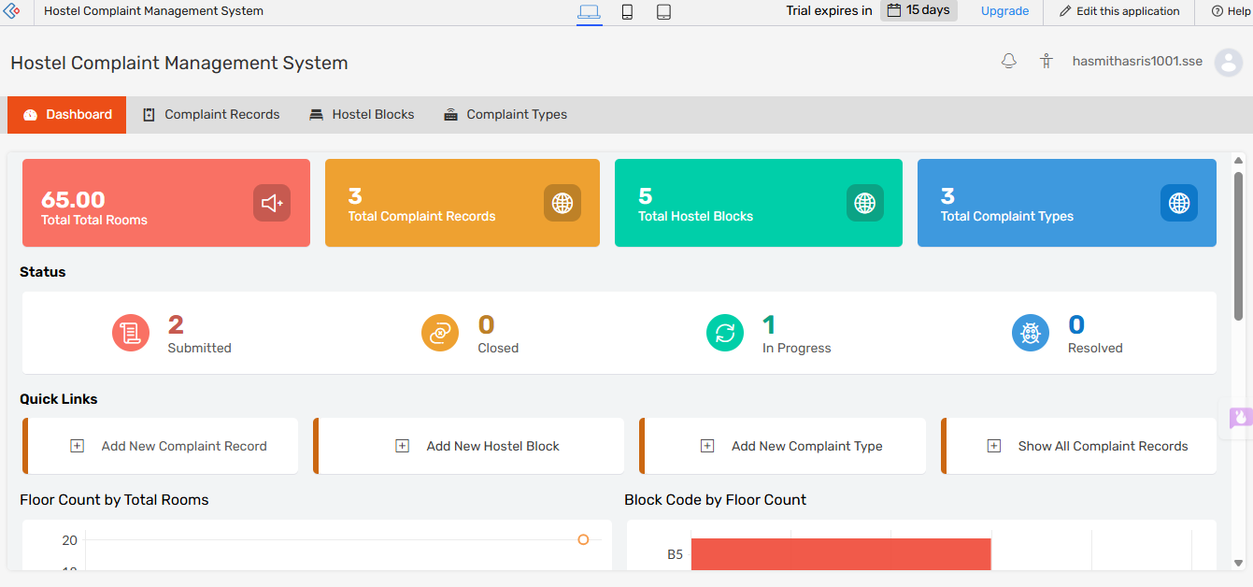
Fig. 1 – Administrative dashboard showing total rooms, complaint records, and status breakdown.
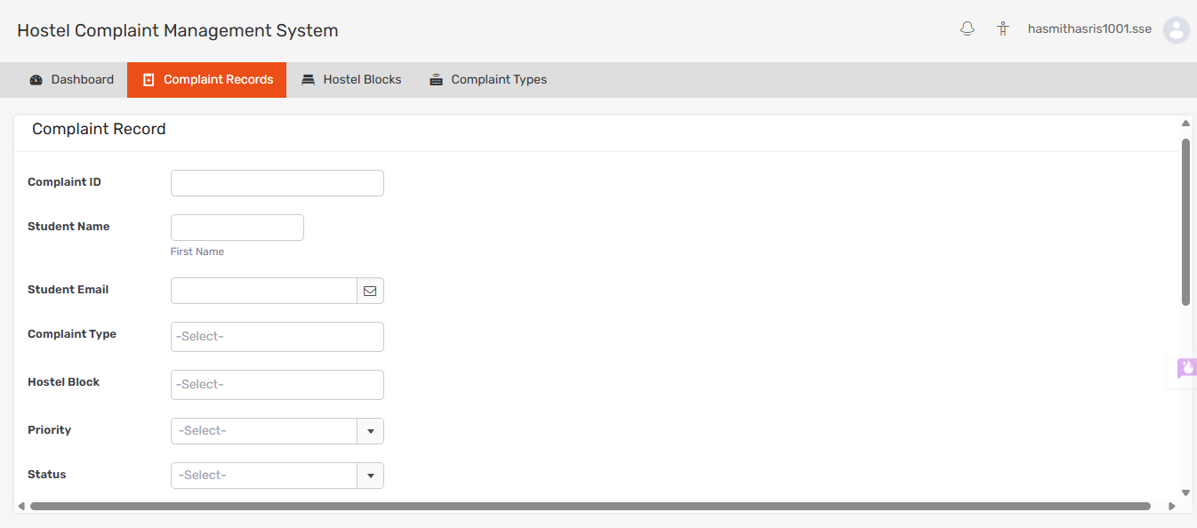
Fig. 2 – Complaint submission form with mandatory fields and dropdown validation.
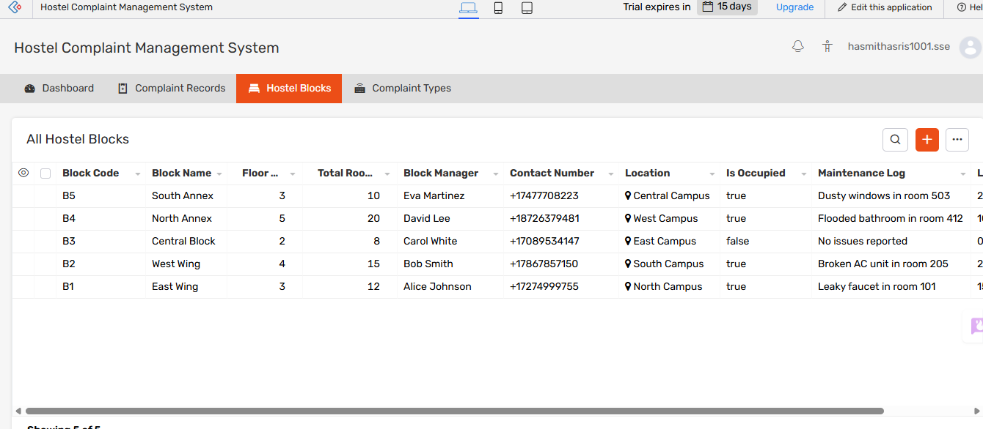
Fig. 3 – Hostel block master records used for maintenance routing.
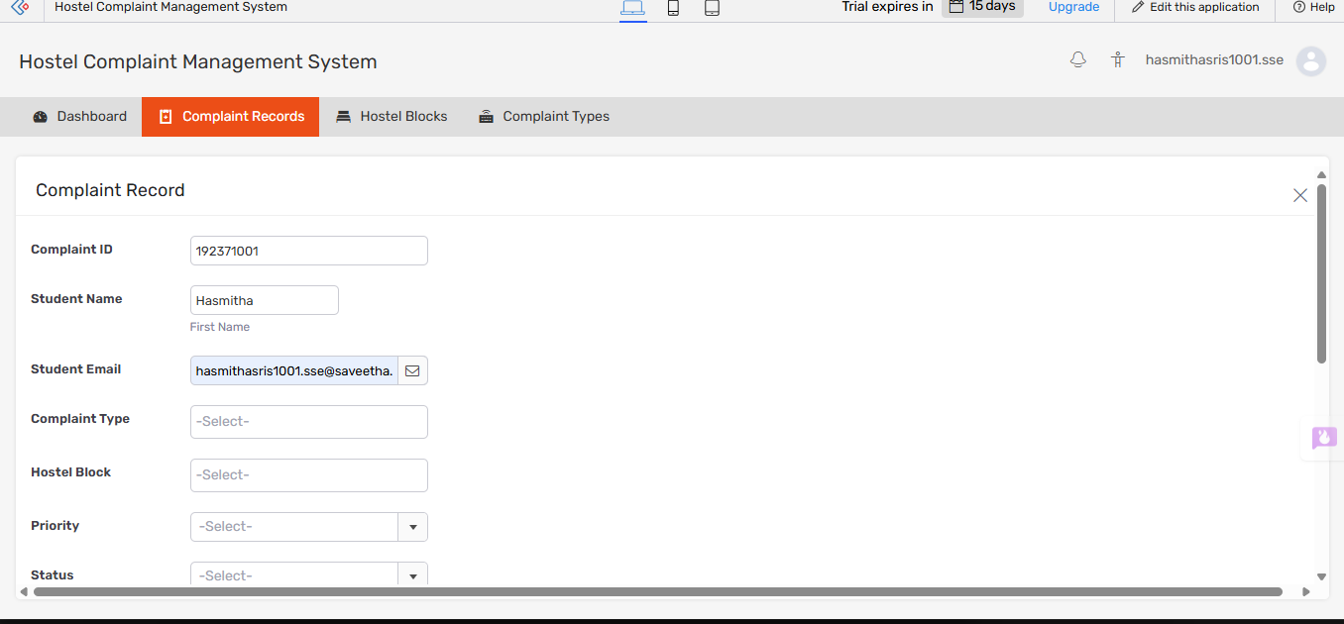
Fig. 4 – Submitted complaint record showing auto-generated Complaint ID and captured student details.
Validation confirmed that form submissions correctly generated unique ticket IDs, dashboard counters updated in real time without manual refresh, and filtering by hostel block and complaint type returned accurate subsets of records.
6. Analysis and Engineering Decision
Trade-off Analysis & Solution Justification:
- SaaS Low-Code (Zoho Creator) vs Custom IaaS/PaaS Build: Developing a custom stack (e.g. React + Node.js + AWS EC2) requires provisioning virtual servers, database administration, and SSL management. Zoho Creator SaaS eliminates 100% of infrastructure maintenance, allowing instant deployment and built-in security.
- Data Visualization Selection: Integrated pie charts for category distribution and bar graphs for resolution status enable hostel wardens to instantly spot maintenance bottlenecks (e.g., Electrical complaints comprising 32% of all issues).

Criterion | SaaS (Zoho Creator) | PaaS (e.g. Heroku) | IaaS (e.g. AWS EC2)
Setup Time | Minutes | Hours | Days
Infrastructure Management | None – fully managed | Partial – app runtime only | Full – OS, patches, scaling
Upfront Cost | Free trial tier | Low | Moderate to high
Customization | Low-code, limited | Moderate | Full control
Best Fit For This Project | Yes – rapid academic deployment | Possible, more effort | Overkill for scope

Given the assignment's timeline and zero-budget constraint, SaaS was the clear engineering choice: it satisfied every functional requirement while avoiding the operational risk of managing servers, security patches, and uptime manually.
7. Broader Considerations
- Sustainability: Eliminates paper complaint books across multiple hostel blocks, contributing to eco-friendly paperless campus operations.
- Society & Safety: Rapid resolution of critical electrical and plumbing complaints prevents hostel hazards and improves student living quality.
- Ethics & Privacy: Role-based access ensures student room details and grievances are confidential to authorized hostel staff only.
- Economic Impact: Removing manual register-keeping reduces administrative staff hours spent on paperwork, freeing time for actual maintenance coordination.
- Accessibility: A responsive, browser-based form ensures students with only a smartphone can raise complaints without needing a dedicated app.
8. Conclusion
The Cloud-Based Hostel Complaint Management System successfully satisfies all functional and non-functional requirements specified in Topic 1. Built entirely on Zoho Creator (SaaS), the system streamlines student grievance submission, automates complaint tracking, and provides executive analytical reports. Major findings show that electrical and plumbing issues represent over 55% of all complaints, demonstrating the value of cloud analytics in proactive hostel facility management. The project confirms that a low-code SaaS platform can meet institutional-grade requirements without dedicated infrastructure investment.
9. Student Reflection
- What did you learn beyond classroom theory? Gained practical experience in deploying low-code SaaS cloud solutions, writing Deluge event scripts, structuring relational cloud data tables, and configuring executive management dashboards.
- What would you improve with additional resources? Integrate automated SMS/Email notifications to maintenance personnel via cloud webhooks and incorporate photo attachment fields for students to upload images of physical damage.
- What was the biggest challenge? Designing Deluge workflow logic for automatic status transitions required iterating on the schema until ticket IDs and status fields updated reliably without manual intervention.
10. References
- Zoho Creator Documentation & Deluge Scripting Guide — https://www.zoho.com/creator/help/
- NIST Definition of Cloud Computing (SaaS Model) — SP 800-145.
- GitHub Repository — https://github.com/Hasmitha1001/Cloud-Based-Hostel-Complaint-Management-System-Problem-Statement
- Armbrust, M. et al., “A View of Cloud Computing,” Communications of the ACM, 2010.
- Zoho Creator Deluge Task Reference — developer documentation for scripting event-driven automation.

F. Common Assessment Rubric
Assessment Criterion | Marks
Problem understanding & formulation | 10
Application of course/domain knowledge | 20
Solution methodology / design / implementation | 20
Use of appropriate modern tools / techniques | 10
Results, testing & validation | 15
Analysis, trade-offs & justification | 15
Broader considerations / professional responsibility, where applicable | 5
Technical documentation & reflection | 5
TOTAL | 100
G. CO–PO–Assessment Mapping
Assessment Component | CO | PO(s) | Bloom's Level | Marks
Problem formulation | CO2 | PO1, PO2 | L3/L4 | 10
Application of knowledge | CO2, CO3 | PO1, PO3 | L3/L4 | 20
Solution / Design / Implementation | CO3 | PO3, PO5 | L4/L5/L6 | 20
Modern tool usage | CO3 | PO5 | L3/L4 | 10
Validation | CO2, CO3 | PO4 | L4/L5 | 15
Analysis & justification | CO2 | PO2, PO4 | L4/L5 | 15
Broader considerations | CO2 | PO6, PO7 | L4/L5 | 5
Documentation & reflection | CO3 | PO10, PO12 | L3/L4 | 5
TOTAL |  |  |  | 100

Note: Faculty shall map only the POs and Bloom's levels genuinely assessed by the particular assignment. Every assignment is not required to map to every PO.
H. Faculty Evaluation & Continuous Improvement
CO Attainment
Performance Level | Criterion
Level 3 | ≥ 70%
Level 2 | 60–69%
Level 1 | 50–59%
Level 0 | <50%

Target CO Attainment: Level 3 (≥ 70%)
Actual CO Attainment: ________________________

Faculty Analysis
- Areas in which students performed well: Form design, SaaS deployment on Zoho Creator, Deluge workflow scripting, visual dashboard creation.
- Areas requiring improvement: In-depth trade-off analysis between cloud deployment models (IaaS vs PaaS vs SaaS).
- Corrective/Improvement Action: Provide additional hands-on practice on cloud service model comparison and advanced Deluge webhook integration.
Course Outcomes for Cloud Computing
CO | Description
CO1 | Understand various basic concepts related to cloud computing technologies.
CO2 | Understand the architecture and concept of different cloud models: IaaS, PaaS, SaaS.
CO3 | Be familiar with application development and deployment using cloud platforms.
CO4 | Explore the fundamental concepts of big data analytics.
CO5 | Understand the Hadoop architecture and Ecosystem components along with MapReduce.

