Architecture Diagram

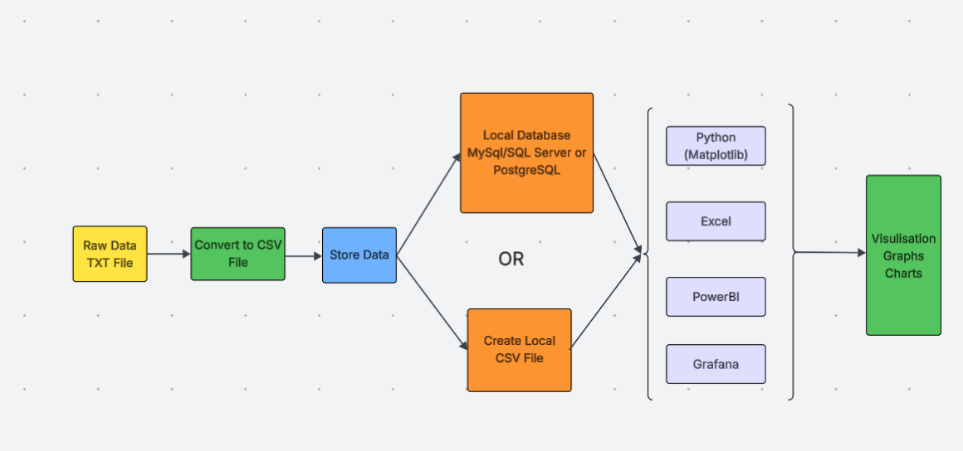

Requirement

You have been approached by a local Café chain to help them visualise their cafes performance in terms of sales and profit by store.

They also wish to include customer buying habits, in terms of what was purchased and how often, they would also like to know how the products were paid for.

All data must be anonymised so the clients name and card details must be removed at the earliest point of the data ingestion process.

They are unsure which type of visualization is best, so would like your advice on this.
They are also open to your suggestions on the best visualisation tool to use.

They have asked that you use Microsoft Windows or MAC infrastructure and produce a local pilot system, for them to review.

The RAW Data will be provided to you as a text file, which is just a subset of the data they would like to process.

If the pilot is successful they wish to expand it to cater for more branches, so any solution must be scalable and easily migrated to the cloud or local server.
They would like you to explore at least one of the data storage options initially:

- Using a Local Database
- Using locally stored CSV files

Approach

You have a choice on how you approach building a solution for the client.

Choice 1:

Build a simple data pipeline made up of ‘Extract’, ‘Transform’ and ‘Load’ functions that will extract information from a data source, clean the data of any incorrect or badly formed records and remove any PII (Card Number, Name etc..) then upload it to a Local MySQL database for storage.

Use Python, Docker, MySQL or other database systems, to build a solution, (docker is also optional) or if you wish you can choose other software development tools to use.

You then need to import this data into a visualisation tool to display the data in a user friendly and easily understandable format.

Choice 2:

Import the raw data , clean and format it and produce the visualizations directly from the visualisation tool you have chosen to display the data in a user friendly and easily understandable format.

User Interface

In terms of User Interface they have left the choice up to you as this is only a pilot and it is dependent on time constraints.

1. You can just run an application from a command prompt or by clicking on an Icon and give them some instructions on how to do this

2. You can choose to build a CLI, GUI

3. You can customize an existing visualization tools user interface

Data Source and Structure

The record structure and data types you need to consider, should be based on the following record structure.

Products - Customer Name, Drink, Price, Branch, Payment Type, Card Number, Date/Time
Dave “Latte 2 £3.50” Epsom Card 0123456 12/08/2024

Delivery Deadline - Approx 4 Weeks from Project Initiation

Final Deliverables to the Client –

- Deliver a Product demo of the applications functions (5 Mins)

- Create and Deliver a Client Facing Presentation on the benefits to the client of your application, explaining about the types of visualizations you used and why you chose them, also ones you rejected. (5 Mins)

- Create and Deliver a White board session with the Client, explaining how the Application Works and your design decisions around data storage and visualisation tools, listing alternative approaches with alternatives.(5 mins)

You should document your development process and write an explanation of the tools and components used in your solution.

Source Control - You must use GIT and GIThub for source control if you are working on the coding version of the project, there is no requirement to use branches unless you want to.

If you are not coding, there is no need to use GIT or GIT Hub or the tools below, but if you wish to for documentation,please do.

Tools you will need for the coding task
GIT/GIT Hub – For version control and documentation
VScode – IDE for developing Software
Python - To run the code

Phase 1 - Set up Development Infrastructure
1. Install Python
2. Install VS Code
3. Setup your project directory structure
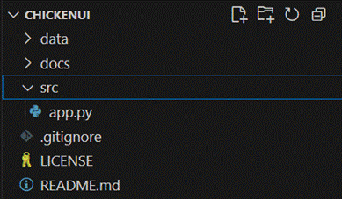
4. Setup a Local GIT Repository and connection to your personal GIT hub repository (Make sure it is Private)
Phase 2 – Build and Test the Product
1. Create a simple ETL and Data Viz Program (app.py)
Phase 3 – Final Deliverables to the Client

Useful Links

Data and Visualisation

CSV to Grafana - https://grafana.com/blog/2025/02/05/how-to-visualize-csv-data-with-grafana/
TXT to CSV to Excel - https://www.exceldemy.com/convert-text-file-to-excel-automatically/
Python CSV and TXT files - Transforming TXT to CSV: A Guide to Python Conversion - SoftHandTech
Matplotlib - Matplotlib Cheatsheet
Matplotlib - Matplotlib Tutorial
Power BI - Get data from comma separated value (CSV) files - Power BI | Microsoft Learn
Power BI - Power Query Text/CSV connector - Power Query | Microsoft Learn

Development Environment

Python https://www.python.org/downloads/
- tick box add Python.exe to path
VS Code - https://code.visualstudio.com/download
GIT Bash - https://gitforwindows.org/
GIT Hub Signup - https://github.com
Microsoft Python Tutorials - https://www.youtube.com/watch?v=jFCNu1-Xdsw&t=1s
VS Code Tutorial - https://www.youtube.com/watch?v=jFCNu1-Xdsw&t=1s

