Meeting Room Booking App

# 1. Overview

The Meeting Room Booking App allows users to mark a room as 'Busy' when a meeting starts   
and 'Available' when a meeting ends. This provides real-time visibility into room availability and avoids scheduling conflicts.

# 2. Key Features

- Meeting Start: Marks the room as 'Busy'.  
- Meeting End: Marks the room as 'Available'.  
- Real-time Room Status: Displays current availability status.  
- Simple UI: Provides clear buttons to toggle between states.

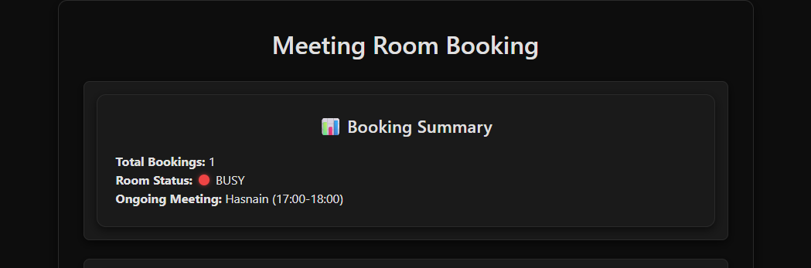

# 3. User Flow

1. User enters the meeting room.  
2. User presses 'Start Meeting' → System updates room status to 'Busy'.  
3. While the meeting is ongoing, others see the room status as 'Busy'.  
4. At the end of the meeting, user presses 'End Meeting' → System updates room status to 'Available'.  
5. Status is reflected immediately for everyone.

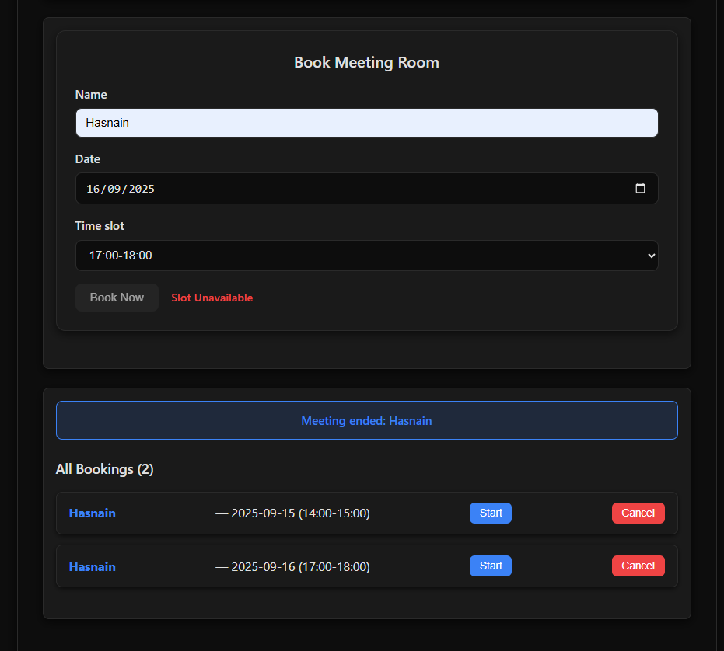

# 4. Technical Requirements

- Frontend: Simple web  
- Backend: Server to manage room states and push updates in real-time.

# 5. Example UI

