Mid Exam I.T.C Lab
In question 1 we were asked to create a simple web page with 2 tables. First table with heading student info which contained personal info like reg.id , Name , section , email , program etc. The second table with heading Favorite contained 2 favorite colors. Fist color was used as the background for both tables and second color was used as hyperlink color. Lastly we ended the task with a footer with text we were given. We had to use external css for styling the whole web page. Firstly I made the whole webpage in simple html them I proceeded with applying css on each section one by one header->table->link->footer etc.
Git Commands used.
Git remote add origin | Git commit | Git clone
To connect our repository link with gitbash so we can upload our files there. | A comment to specify what we did. | Used to clone github repository

Git bash commands.
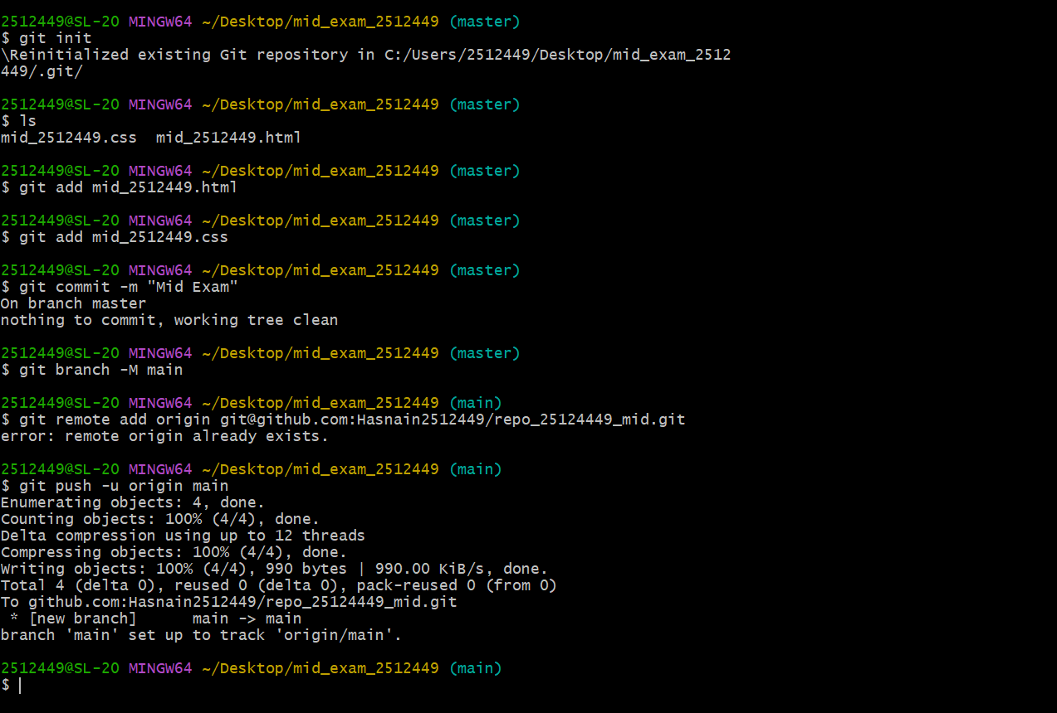
Html code .
<!DOCTYPE html>
<html lang="en">
<head>
<meta charset="UTF-8">
<meta name="viewport" content="width=device-width, initial-scale=1.0">
<title>Mid 2512449</title>
<link rel="stylesheet" href="mid_2512449.css">
</head>
<body>
<header>
<h1>Name = Muhammad Hasnain Ali</h1>
<h1>Reg.ID = 2512449</h1>
</header>
<h2>Student Info</h2>
<table>
<theader>
<tr>
<th>Reg id</th>
<th>Name</th>
<th>E.mail</th>
<th>Program</th>
<th>Section</th>
<th>Github</th>
</tr>
</theader>
<tr>
<td>2512449</td>
<td>M.Hasnain Ali</td>
<td>bscs2512449@szabist.pk</td>
<td>BSCS</td>
<td>1H</td>
<td><a href="https://github.com/Hasnain2512449">Hasnain 2512449</a></td>
</tr>
</table>
<h2>Favourite</h2>
<table>
<tr>
<td>Favourite color 1 </td>
<td>Favourite color 2 </td>
</tr>
<tr>
<td style="background-color: aquamarine;">blue</td>
<td style="background-color: aquamarine;color: red;">red </td>
</tr>
</table>
</body>
<footer>
<p>2025 2512449 – SZABIST</p>
</footer>
</html>

Css code
header{
background-color: blue;
}
table{
margin: 5%;
font-family: 'Courier New', Courier, monospace;
background-color: aqua;
border: 2px solid black;
padding: 10px;
text-align: center;
}
tr{
border: 2px solid black;
}
th,td{
border: 2px solid black;
}
a{
color: red;
}
p{
font-family: Impact, Haettenschweiler, 'Arial Narrow Bold', sans-serif;
color: grey;
background-color: antiquewhite;
text-align: center;
}

Github repository public link ( https://github.com/Hasnain2512449/repo_25124449_mid )

