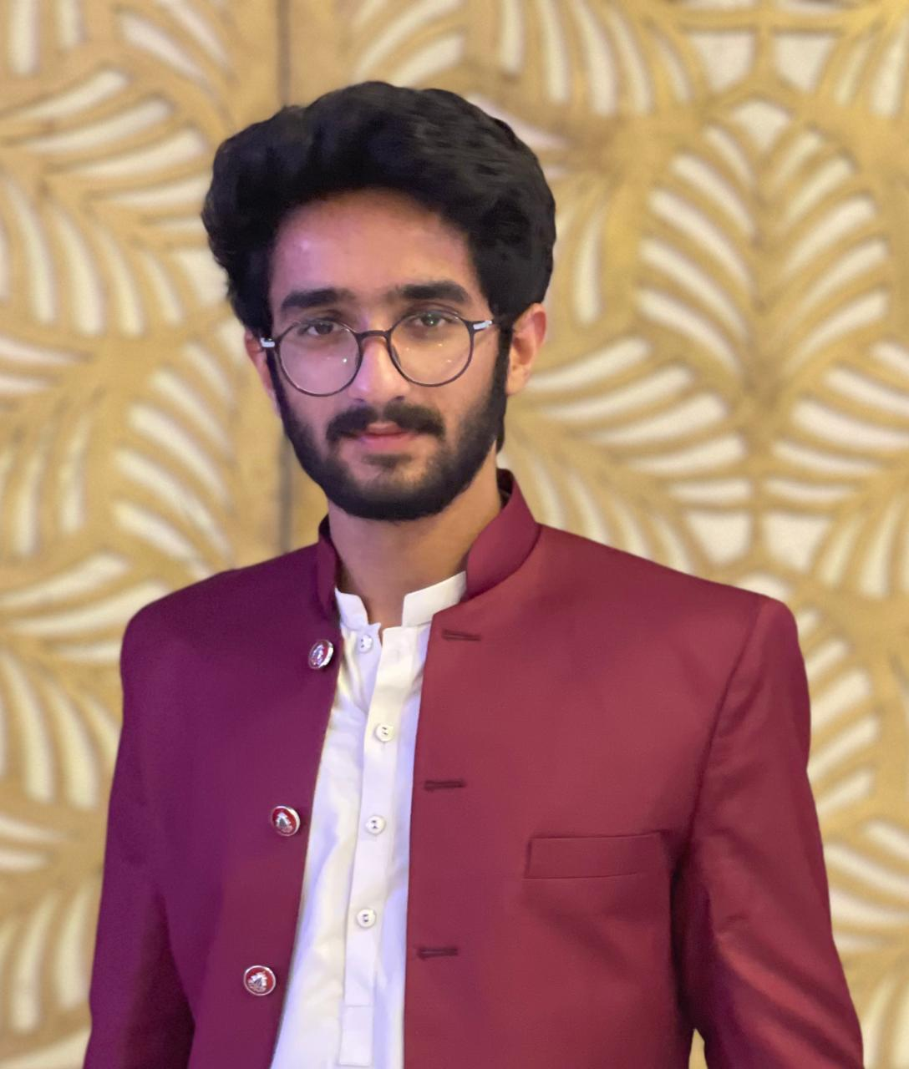
ABDUL HAYEE

Street # 35 Naseeb Manzil Tibba Azeem Shah Ghorey Shah Road LHR.
Mob # 0331-4192624
CAREER OBJECTIVE:

Outgoing with strong and effective organizational and communication skills, able to work on own initiative and as part of a team. Dedicated to maintaining high quality standards. Versatile and learns new tasks/skills quickly.

QUALIFICATION:
DEGREE | SUBJECTS | YEAR | COLLEGE/SCHOOL
BSCS | Computer Science | 2020-24 | Superior University LHR
HSSC | Pre-Engineering | 2019 | Superior College LHR
SSC | Science | 2017 | BISE Lahore

SKILLS

LANGUAGE SKILLS:
 | English Language Courses from a Private Institute.
  English
  Urdu
  Reading | Writing | Listening | Speaking
  Good | Good | Good | Good
  Good | Good | Good | Good

- Professional Photo & Videographer
- Professional Graphic Designer
- HTML beginner

PERSONAL INTEREST:
- Website Development
- Photography and Videography

PERSONAL INFORMATION:
DOB: 13-02-2001
NATIONALITY: Pakistani
HOMETOWN: Lahore

REFERENCE:
Reference will be furnished on demand.

