**Web Development**

**Task 3**

Attach is the PHP Script which have 2 function below is the name of functions:

1. **getFactorial** ()
2. **createChessBoard** ()

**getFactorial()** Completethis function such that it takes a parameter in integer and returns its factorial. The Parameter must be passed as Integer, if any other data type is passed, function should return error “ Please provide correct data type”

Output:  
The factorial of 3 is 6

**createChessBoard()** Create a Chess Board using HTML Table and Loops in PHP  
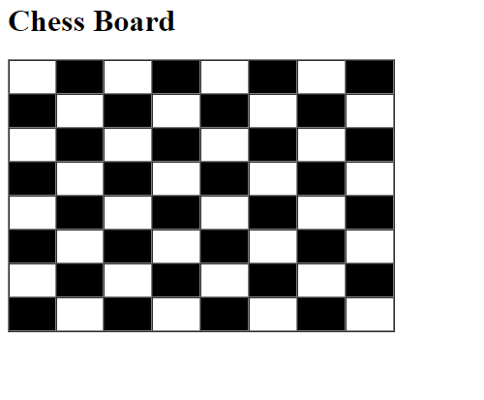

**Best of Luck**