

INFORMATION SECURITY
Assignment 01

Module 1: Cybersecurity Threats, Vulnerabilities, and Attacks

Name: Hasnain Ali
Class: BESE-13 (A)
CMS ID: 408546

Instructor : Hirra Anwar

Screenshots:

Completion and Results:

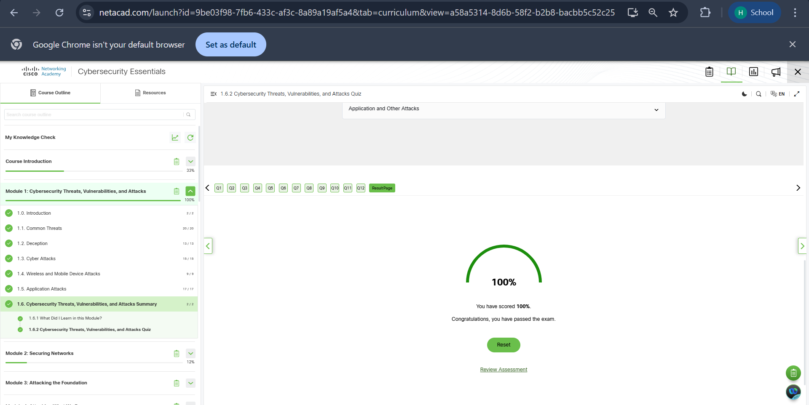

Within Module Completion (Screenshots of Mcqs and Fill in the blanks):

1.1 Module :

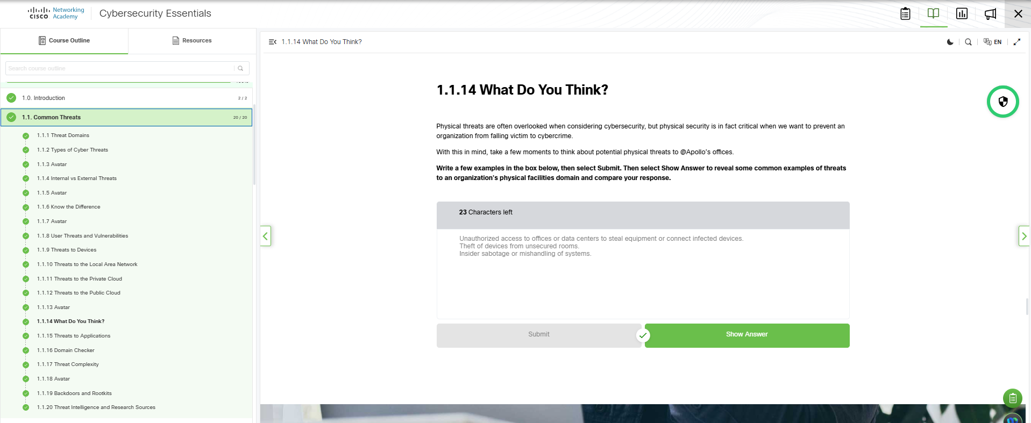
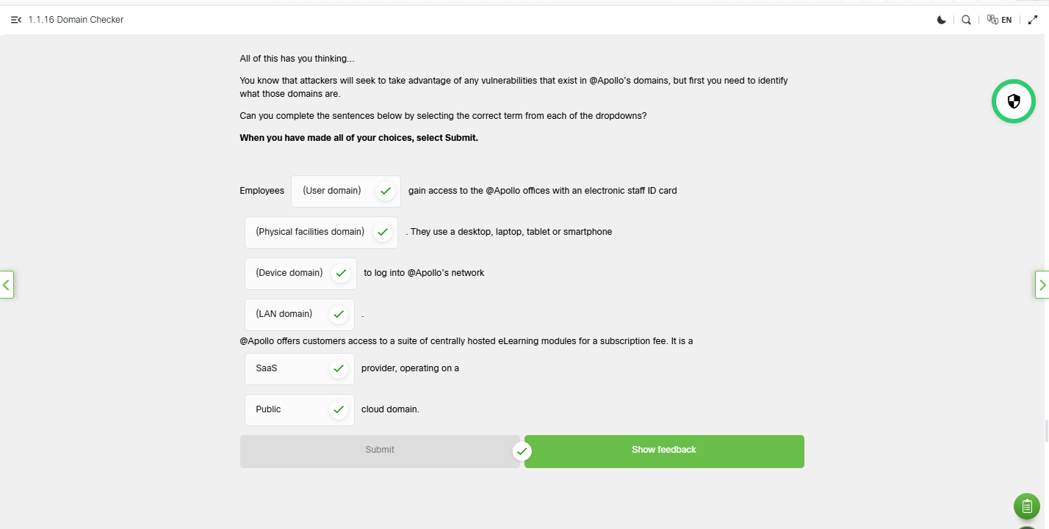

1.2 Module :
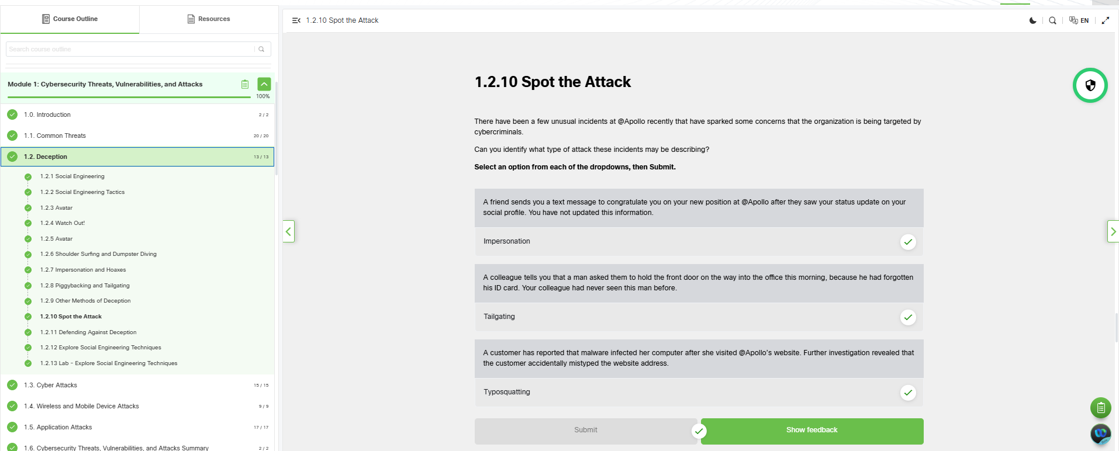

1.3 Module :

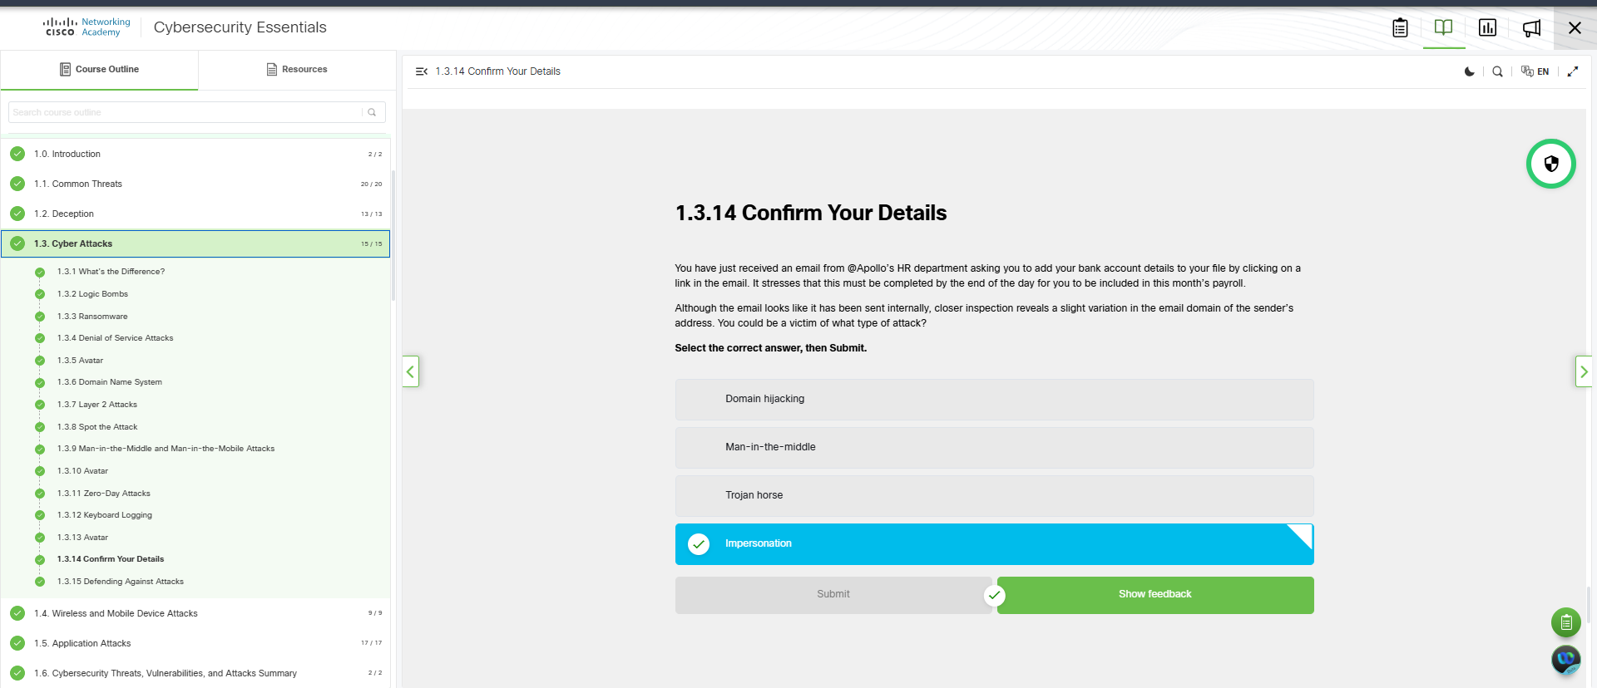

1.4 Module :

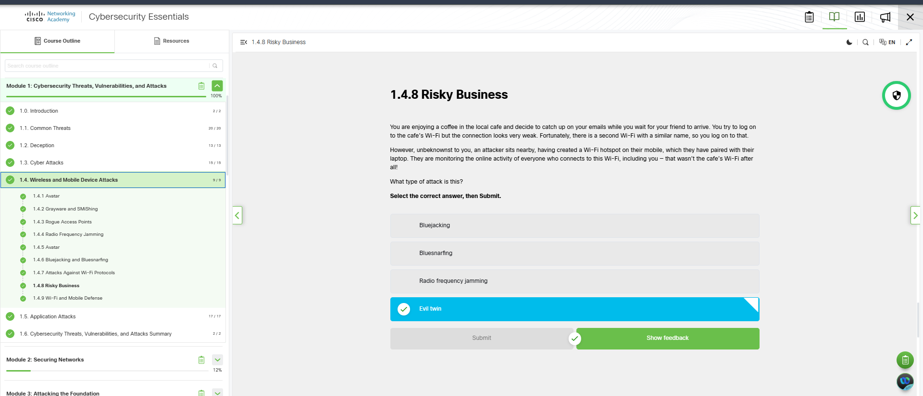

1.5 Module :

