Akbar Sabri, Anaba Shafiq ,Hasnain Asim

  L1F17BSCS0589,L1F17BSCS0212,L1F17BSCS0273

OOAD FINAL PROJECT

# System Requirement

A vending machine is an automated machine that provides items such as snacks, beverages,and lottery tickets to consumers after money, a credit card, or a specially designed card is inserted into the machine. It is an efficient way to get products or items. The user will  have an efficient and modern way. Products may include candy, cookies, chips, fresh fruit, milk, cold food, coffee and other hot drinks, bottles, cans of soda, and even frozen products like ice cream. These products can be sold from machines that include snacks or beverages,

The purpose of this vending machine is to dispense daily commodities without the need of a cashier. Vending machine could be of any daily used or important item. This is more like a self-service .

It solves the problem of queues as user doesn't have to stand in long queues.

This is an snack Vending machine. A local snacks business intends to install a new snack vending machine(SVM).It is machine  to allow the user to buy basic snacks vending SVM machine will consist of a screen, keypad, cash deposit slot ,cash dispenser, and a snack dispenser. The user simple comes to the machine.

There is a keypad on the machine with the instructions on the screen .That guides the user about how to use the snack vending machine. The user has to use the keypad and follow the instruction to select the desired product. On successful selection of the product the vending machine will take payment for the item is any snack in this case.

If the payment amount is less than the billed amount the product will not disperse, if the amount is greater than the billed amount  the balanced amount is returned. If the Payment is also successful the item is dispersed which in this case can either be a snack or beverage.

**The user interface of the snack vending machine contains the following hardware components:**

·        A screen to display messages to the user

·        A keypad to receive input from the user

·        A cash deposit slot to receive payment

·        A cash dispenser to return the balance (if any)

·        A snack dispenser for user  to take snacks

# Requirements

**Upon first approaching the SVM, the user should experience the following sequence of events:**

1. The screen displays a welcome message

⇒Welcome To Snack Vending System!

1. The screen  prompts the user to press the start button to begin the process.
2. The choices for snacks are displayed on screen

⇒A choice is given between juices and snacks

1. A message is prompted on screen to asking user to enter a choice.

                      ⇒What Do You Want To Buy?

0.) Snack.

1.) Juice.

1. The user enters a choice , using the keypad.
2. All the snacks or drinks are displayed on the screen with the code for selection
3. The user is asked to enter the snack or drink choice

(This is basically the number of item with its name .)

8. If the user enters a valid choice for a snack, the screen displays the price. If the user enters an invalid choice , the screen displays an invalid choice message, then the SVM returns to Step 1 to restart the vending process

9. If the choice is appropriate, a message will prompt on screen asking the user  for payment.

10.   A choice of cancellation will always be there.

11. If the user presses cancel the process will go back to step 1 and the currently made choices will be reversed.

12. If the payment is received and the amount is valid, a thank you message will appear and ask the user  to take his snack from the snack dispenser.

13. If the payment received is less than the amount billed then a message will prompt on screen asking for the remaining amount

14. If the payment received is greater than the amount billed then a problem arises that is the user had entered an amount that is greater than the amount the user was required to insert. To overcome this issue the machine will return the amount back to the user by calculating the balance amount. The amount returned will be in the currency notes of 500,100,50,20,10,5. Due to lack of physical output devices the screen will print the amount with the number of notes on screen.

14. A  message will prompt on screen asking the user to take the balance amount.

15. If the process is completed once a receipt will be printed on screen, the receipt will display the day and time of the purchase and name of the product.

16. After the user picks his or her item  the screen will again to step one with updating of the item taken that is the welcome message.

17. The new user may come and use it.

**The snack vending machine works with the following ooad topics that are :**

* Association
* Composition
* Inheritance
* Singleton design pattern concept used
* There is no memory leakage

# Nouns Identified

Vending machine

Machine

Snack

Beverages

Juices

Keypad

Screen

Cash Depositor

Cash

Cash Dispenser

Snack Dispenser

Time

Date

Amount

Payment

Product

User

# Nouns Chosen

VendingMachine

SnackDatabase

Time

Date

Keypad

Screen

Cash Depositor

Cash Dispenser

Snack Dispenser

# Verbs Identified

# Verbs Chosen

# Actors

🡺Customer

# Use Case Diagram

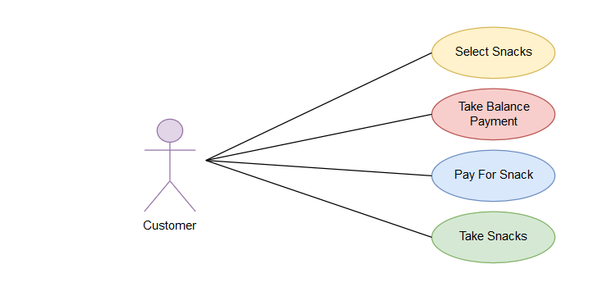

# Activity Diagram

## Dispense Snack:

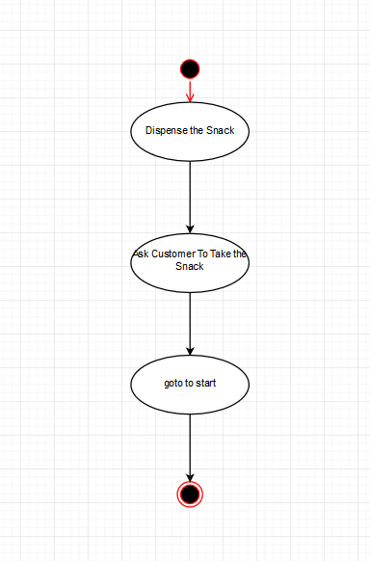

## Dispense Balance:

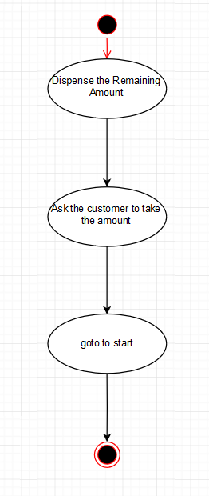

## Receive Payment

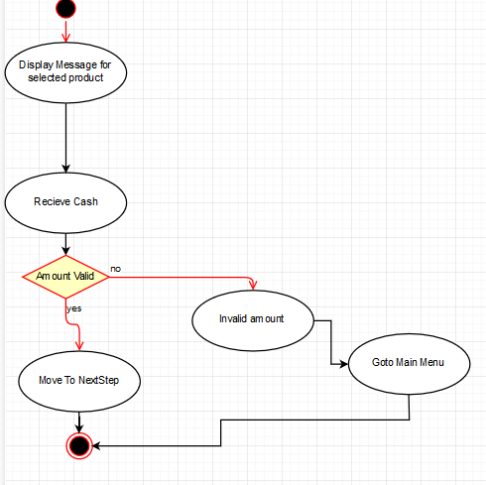

## Select Product

# Class Diagram

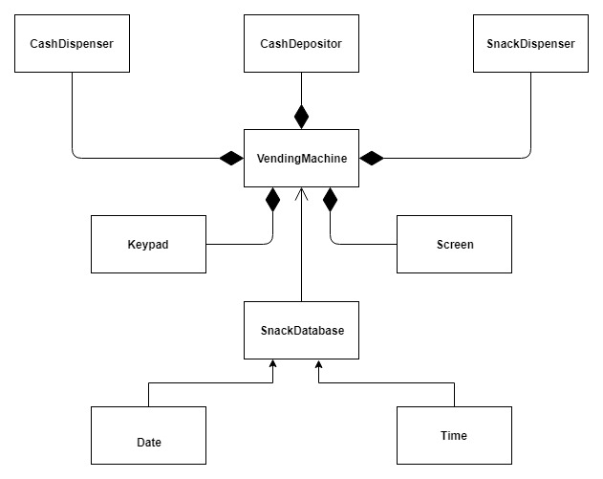

# UML DIAGRAM

