**Final Project**

Programming Fundamental

**Teacher: Sir Muhammad Abbas**

ATM Machine Project using C Language

**This program simulates a real ATM Machine, allowing users to deposit, withdraw and check their balance**

1 .Area This C program simulates an ATM machine.

2. It allows users to deposit, withdraw, and check their balance

3 .The program uses a do-while loop to repeatedly display a menu of options for the user to choose from (deposit, withdraw, check balance, or exit) until the user chooses to exit.

4 .The program uses a switch statement to determine which action to take based on the user's choice.

5. The program also includes basic error handling, such as checking for insufficient balance when withdrawing.

Source code of project

/* ATM Machine project using C program

This program simulates a real ATM Machine,

Allowing users to deposit, withdraw and check

Their balance. */

#include<stdio.h>

int main()

{

int option;

float balance = 0.0, deposit, withdraw;

printf("\nWelcome to ATM Machine\n");

printf("\n1. Deposit");

printf("\n2. Withdraw");

printf("\n3. Check Balance");

printf("\n4. Exit");

do

{

printf("\nEnter your option: ");

scanf("%d", &option);

switch (option)

{

case 1:

printf("\nEnter amount to deposit: ");

scanf("%f", &deposit);

balance = balance + deposit;

printf("\nYour current balance is %.2f", balance);

break;

case 2:

printf("\nEnter amount to withdraw: ");

scanf("%f", &withdraw);

if(balance >= withdraw)

{

balance = balance - withdraw;

printf("\nYour current balance is %.2f", balance);

}

else

printf("\nInsufficient balance");

break;

case 3:

printf("\nYour current balance is %.2f", balance);

break;

case 4:

printf("\nThank you for using our services!");

break;

default:

printf("\nInvalid option!");

}

} while (option != 4);

return 0;

}

**The output of this program is as follows:**

The output of this program would simulate the actions of an ATM Machine. When the program is run, it would display the welcome message and the main menu options: deposit, withdraw, check balance, and exit.

When the user selects option” 1”, the program would prompt the user to enter an amount to deposit, read the input, add the deposit to the current balance, and display the updated balance. When the user selects option “2”, the program would prompt the user to enter an amount to withdraw, read the input, check if the balance is sufficient, and if the balance is sufficient, subtract the withdrawal amount from the current balance and display the updated balance. If the balance is not sufficient, it would display an "Insufficient balance" message .When the user selects option “3”, the program would display the current balance .When the user selects option “4’’, the program would display a message thanking the user for using the ATM Machine and exit the program .If the user enters an invalid option, the program would display an "Invalid option!" message. The program would continue to prompt the user to enter an option and display the corresponding message or updated balance until the user selects option 4 to exit.

# OUTPUT

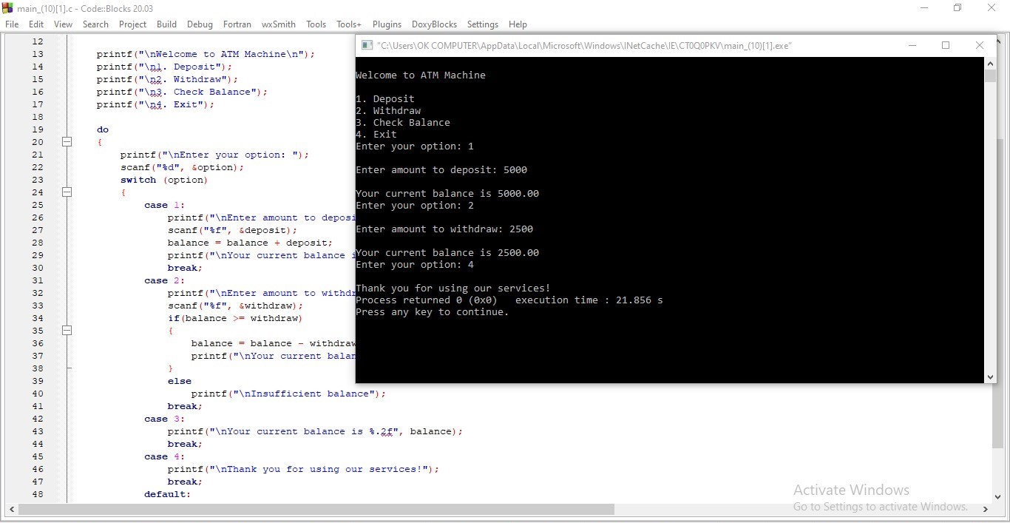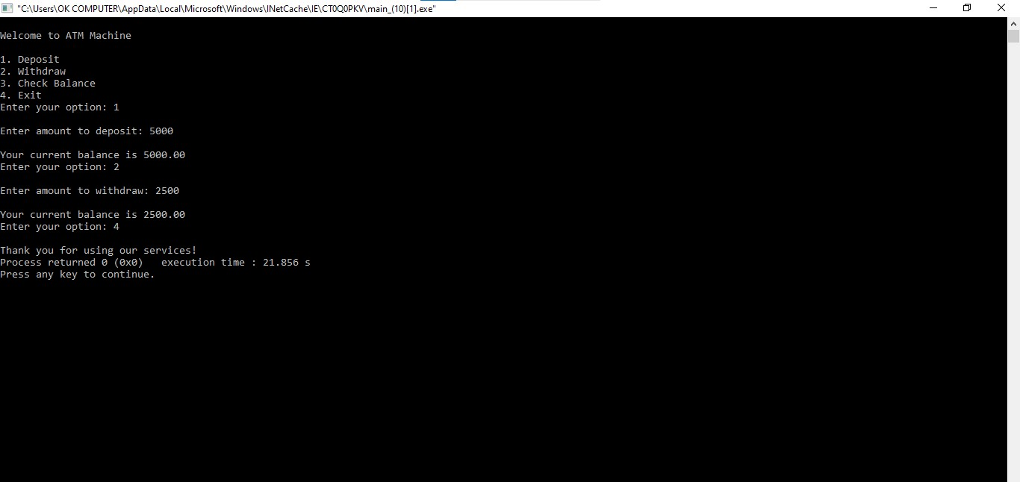

**As for flowchart**

The program starts by displaying the ATM Machine welcome message and the main menu options: deposit, withdraw, check balance, and exit.

The program enters a do-while loop, where it prompts the user to enter an option and reads the input using the scanf function.

The program then uses a switch statement to check the user's selected option and perform the corresponding action.

If the user selects option 1, the program prompts the user to enter an amount to deposit, reads the input using the scanf function, and adds the deposit to the current balance.

If the user selects option 2, the program prompts the user to enter an amount to withdraw, reads the input using the scanf function, and checks if the balance is sufficient to perform the withdrawal. If the balance is sufficient, the program subtracts the withdrawal amount from the current balance, otherwise, it displays an "Insufficient balance" message.

If the user selects option 3, the program displays the current balance.

If the user selects option 4, the program displays a message thanking the user for using the ATM Machine and exits the loop and the program.

If the user enters an invalid option, the program displays an "Invalid option!" message .The program continues to loop until the user selects option 4 to exit. The program ends by returning 0

**Proven and function of project**

**Proven of the project**

The provided code is an example of a ATM Machine written in C programming language. However, it is not a proven and functional system as it is a simple . To make it a functional program, it would require further development and testing. It's a good practice to always test the code and check for bugs before using it in a production environment, and always make sure to follow the best practices of programming and security.

**Function of the project**

* The main() function: This is the starting point of the program, where the execution begins.
* The program enters a do-while loop, where it prompts the user to enter an option and reads the input using the scanf function.
* The program then uses a switch statement to check the user's selected option and perform the corresponding action

These functions work together to create a basic ATM Machine that allows the user to add deposit balance, withdraw or check balance .