**CD4017**

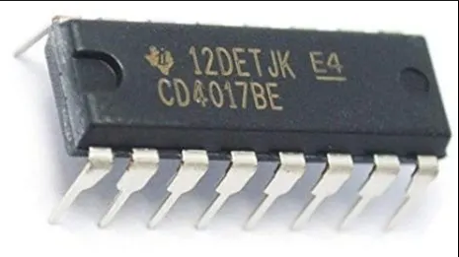

**INTRODUCTION:**

**CD4017** is a 16 pin CMOS decade counter/ Divider.  It takes clock signal from the clock input and turns on the 10 output in sequence, each time when it receives clock input pulses.

**PINS DIAGRAM AND WORKING:**

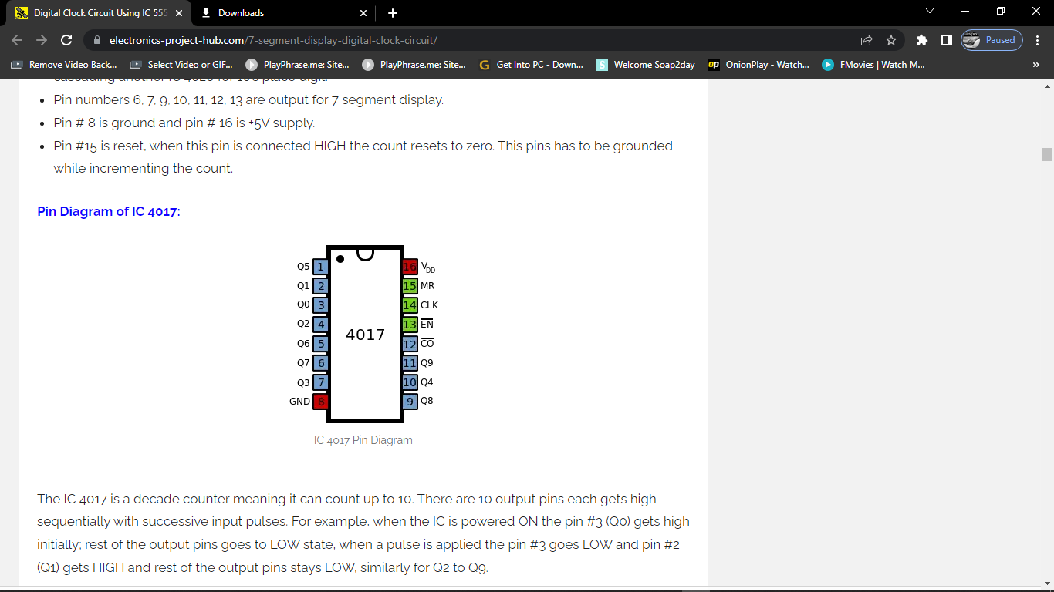

There are 10 output pins each gets high sequentially with successive input pulses. For example, when the IC is powered ON the pin #3 (Q0) gets high initially; rest of the output pins goes to LOW state, when a pulse is applied the pin #3 goes LOW and pin #2 (Q1) gets HIGH and rest of the output pins stays LOW, similarly for Q2 to Q9.

* Pin numbers 1, 2, 3, 4, 5, 6, 7, 9, 10, 11 are output pins.
* Pin #8 is GND and pin #16 is Vcc.
* Pin #15 is reset, when this pin connects to HIGH signal the count reset to zero. It has to be grounded during normal operations.
* Pin #14 is clock input.
* Pin# 13 is clock enable; when this pin is connect to Vcc the pulse will be ignored, during normal operation this pin has to be grounded.
* Pin #12 is for carry out function.

**APPLICATIONS:**

* + LED chaser circuit
  + Simple counter