

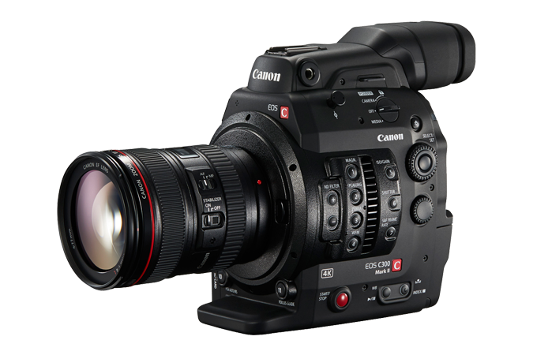

Brand Name:

Canon

Product Name:

DSLR Camera

Specifications:

|  |  |  |
| --- | --- | --- |
| Megapixels | 20.2 |  |
| Total Pixels | 20.6 |  |
| Sensor Size | 35.8 x 23.9mm |  |
| Pixel Dimensions | 5472 x 3648 |  |
| Pixel Size | 6.54µm |  |
| Diffraction-Limited Aperture | f/10.5 |  |
| Aspect Ratio | 3:2 |  |
| Sensor Cleaning | EOS Integrated Cleaning System with fluorine coated Low-Pass Filter |  |
| Lens Mount | EF (excludes EF-S lenses), TS-E, MP-E |  |
| FOVCF | 1.0x |  |
| Image Processor | DIGIC 5+ |  |