

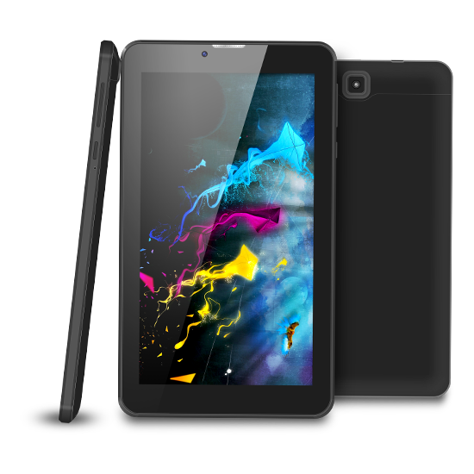

Brand Name:

Dany

Product Name:

T-470

Body:

Metalic

Specifications:

• Storage: 16GB

• CPU: 1.2 GHz

• RAM: 1 GB

• Camera: 5 MP

• Screen Size: 7 inch inch