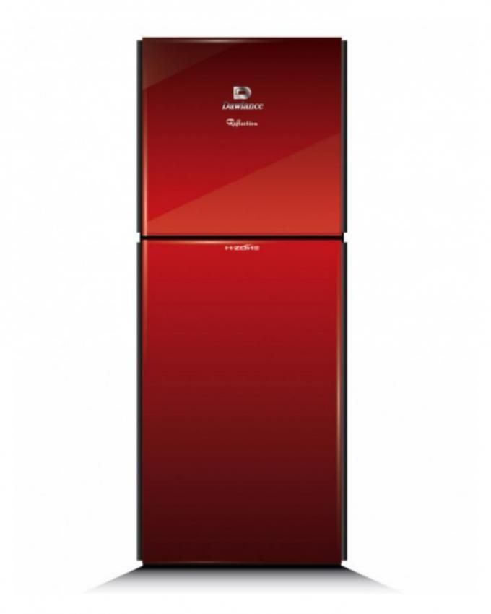

Brand Name:

Dawlance

Product Name:

Fridges

Superior Cooling

Experience winters in the scorching heat of summer! Yes, your unthinkable dream has been successfully translated into concrete reality, as Haier get this high quality Air Conditioner at your very disposal, to accomplish the job in its true spirit. This AC is certainly the right choice is a reliable choice and the right pick for anyone who wants the best for their household.

Efficient Power Compressor

Dawanlance have the best capability to cool the entire room in a minute. He highly efficient power compressor of Split Air Conditioner 1.5 Ton - HSU-18LK  gives the best cooling even on the hottest of days even if it is 52 degrees outside, you will remain cool.

Easy To Maintain

Dawlance always strives to bring you the most convenient solutions. This Haier Air Conditioner has an easy to wash panel and the airflow vents can be easily and conveniently cleaned without any special tools for quick cleaning of the inside of the air conditioner. The dust can be easily removed and this Haier AC results to be more durable as it is easy to maintain too.

Specifications:

* Capacity: 1.5 Ton
* Design: Wall Mount
* Functionality: Cooling Only
* 20% power saving with high energy
* work upto 52 ℃(T3 condition)
* auto restart
* Concealed LED display