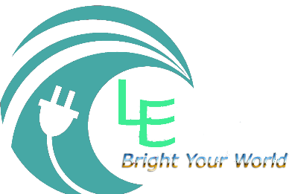

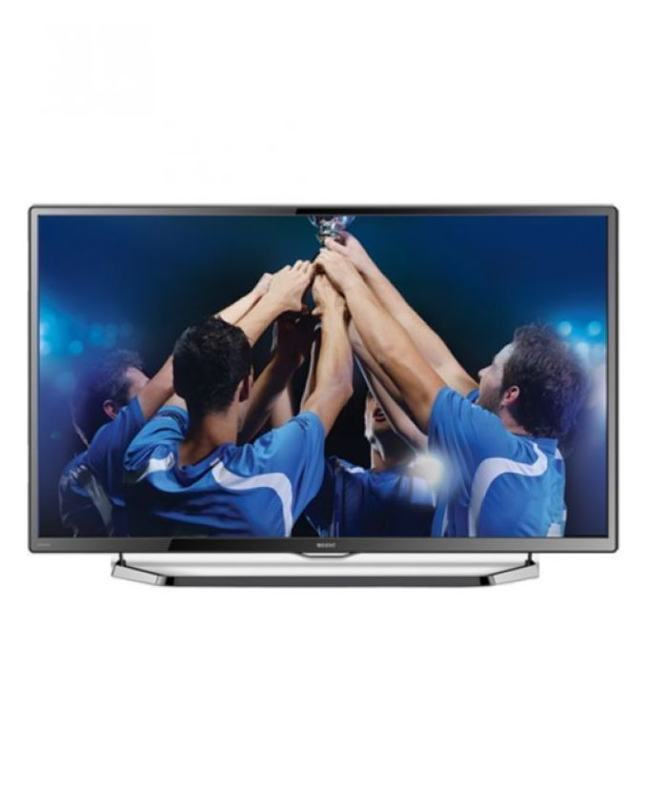

Brand Name:

Orient

Product Name:

LED

Maintainance:

* Keep clean and display very good. Multi Languages + External Hard disk (Upto 1 Tb) + Google Play Store

Specifications:

* Full HD
* 1080p
* HDMI (2) + USB (1)
* Dolby Sound
* Multi Languages + Full Color Optimizer