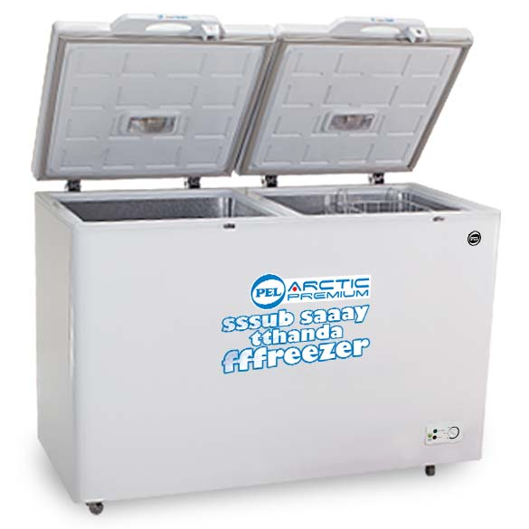

Brand Name:

Pel

Product Name:

Deep Freezer

Best Cooling

Experience winters in the scorching heat of summer! Yes, your unthinkable dream has been successfully translated into concrete reality, as Haier get this high quality Air Conditioner at your very disposal, to accomplish the job in its true spirit. This AC is certainly the right choice is a reliable choice and the right pick for anyone who wants the best for their household.

Easy To Maintain

Pel special tools for quick cleaning of the inside of the air conditioner. The dust can be easily removed and this Haier AC results to be more durable as it is easy to maintain too.

Specifications:

* Capacity: 2.5
* Cooling : Best
* 30% power saving with high energy
* work upto 55 ℃( condition)
* auto restart