**NAME:** Hasnat bin sayed

**ID:** 18-37619-1

**SECTION:** A

**Abstract:**

The Convolutional Neural Network gained popularity through its use with image data, and is currently the state of the art for detecting what an image is, or what is contained in the image. The primary purpose for a convolutional layer is to detect features such as edges, lines, blobs of color, and other visual elements. The filters can detect these features. The more filters that we give to a convolutional layer, the more features it can detect properly. In this report, I have written details about the implementation of CNN architecture to classify the MNIST hand written dataset which has been uploaded before. To classify the MNIST dataset, I used 3 types of optimizer ADAM, SGD, RMSProp to check different accuracy level.

**Introduction:**

The Convolutional Neural Network (CNN) is a type of artificial neural network which is used in image processing and recognition. In CNN optimizers are the algorithms or methods used to change the attributes of your neural network such as weights and learning rate in order to reduce the losses. In the mid project I had used three types of optimizers. They are

Adam,SGD,RMSprop.Their details are given below

Adam is an optimization algorithm that can be used instead of the classical stochastic gradient descent procedure to update network weights iterative based in training data. Adam is a popular algorithm in the field of deep learning because it achieves good results fast

SGD is an iterative method for optimizing an objective function with suitable smoothness properties. But ADAM is much faster than SGD.

RMSprop is a gradient-based optimization technique used in training neural networks. This normalization balances the step size (momentum), decreasing the step for large gradients to avoid exploding and increasing the step for small gradients to avoid vanishing

**Result:**

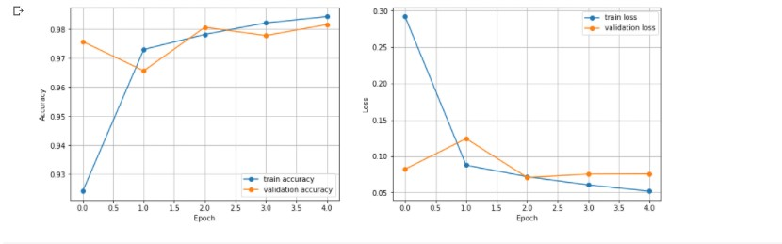

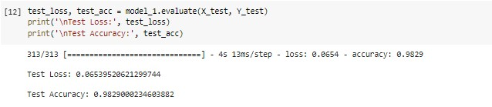

At first, I had used Adam optimizer and got 98.25% accuracy and 7.18% loss.

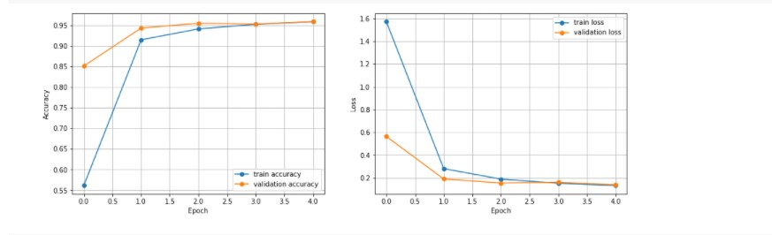

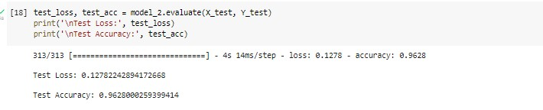

Secondly, I had used SGD optimizer and got 95.37% accuracy and 15.89% loss.

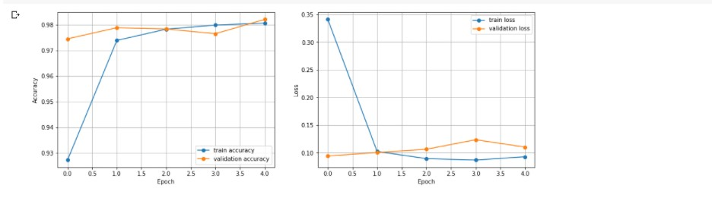

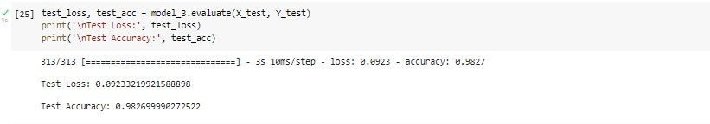

Lastly, I had used RMSProp optimizer and got 97.06% accuracy and 22.73% loss.

**Discussion:**

In this mid project report I had used 3 types of optimizers which are ADAM, SGD and RMSProp.I found some difference between their accuracy. ADAM is much faster and effective than SGD and RMSProp. Adam optimizer gives much higher performance than the previously used optimizer. My ADAM optimizer accuracy is 98.25%. Then the second better optimizer is RMSProp which is also good and its accuracy is 97.06%. Last one is SGD and the accuracy of SGD is 95.37% which is a little bit less than the accuracy of ADAM and RMSProp. So, we can say that ADAM optimizer is the fastest and highly accurate optimizer in my case.

**Reference:**

1. <https://machinelearningmastery.com/adam-optimization->algorithm-for-deep-learning/
2. <https://ruder.io/optimizing-gradient-descent/>
3. <https://medium.com/analytics-vidhya/a-complete-guide-to-adam->and-rmsprop-optimizer-75f4502d83be