DevOps Mid Lab Task

- GitHub Repo Link: Hasnatrasool163/HabitHubDevOps
- Docker Hub Image Link: https://hub.docker.com/r/hasnat163/habithub
- Azure Kubernetes Url: http://68.210.104.119:3000/

Screenshots:
Docker Build:
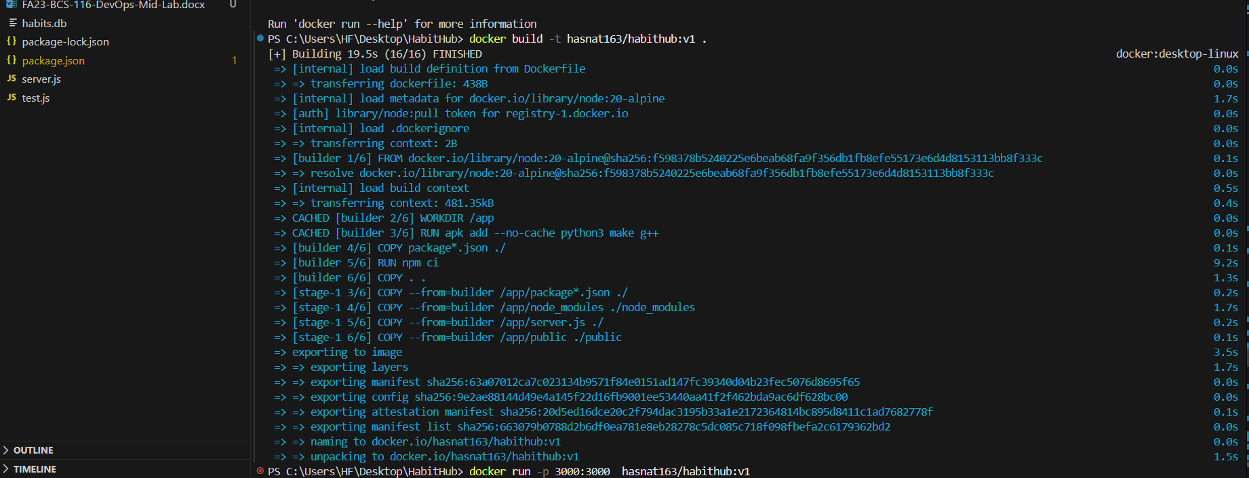
Docker Desktop:
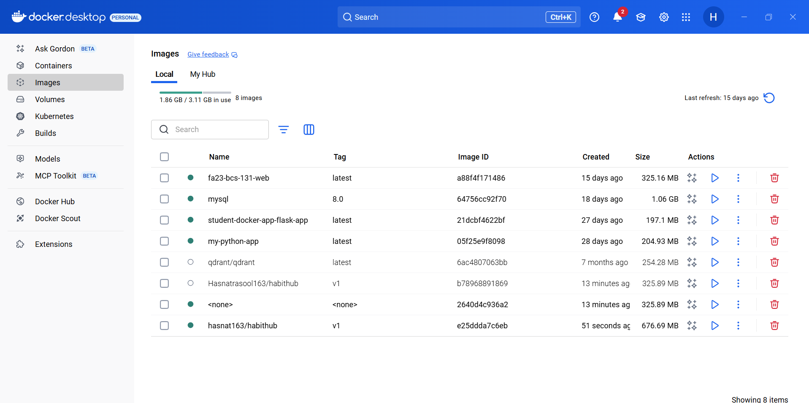
Docker Run:
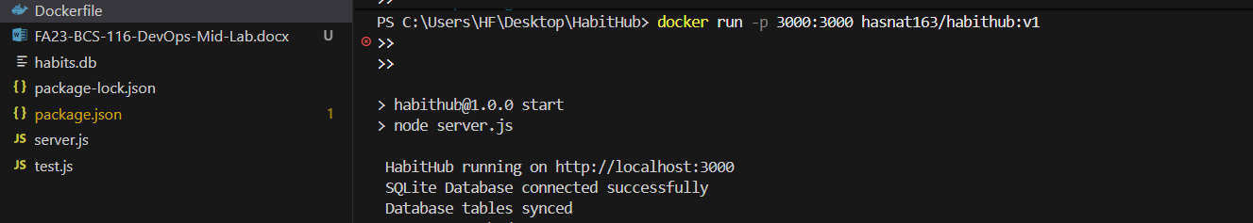
Docker Push:
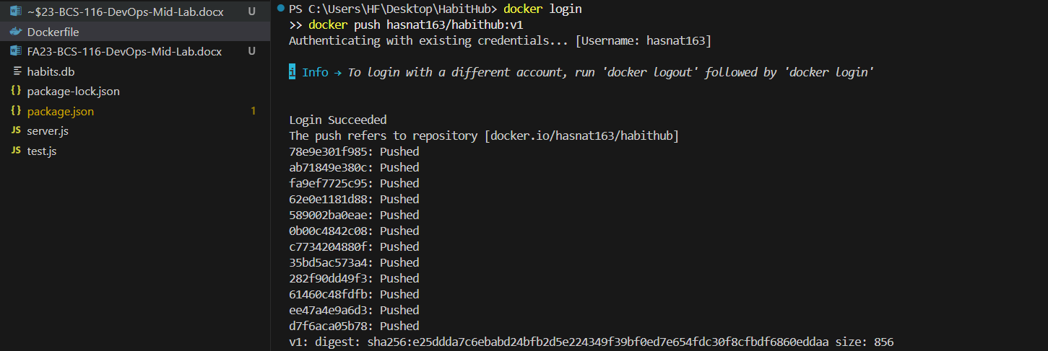
GitRepoSetup:
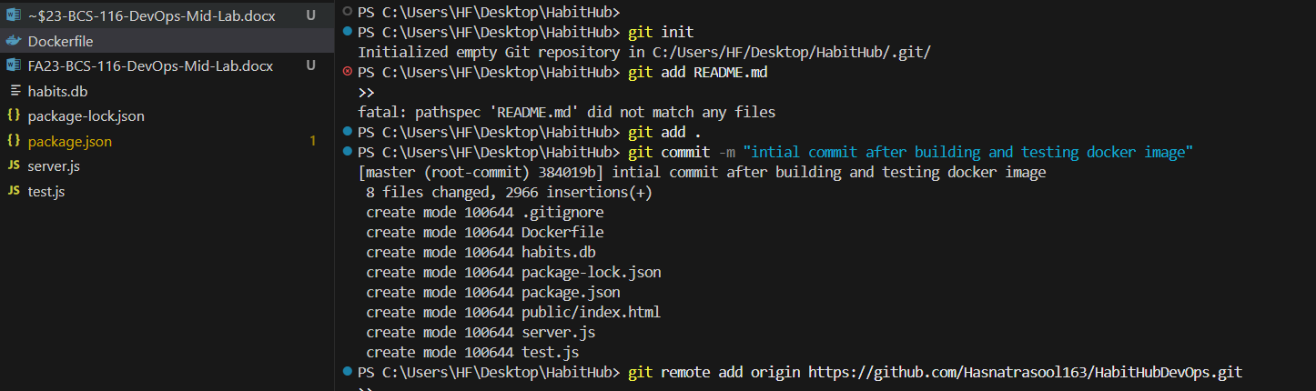
Git Push Code:
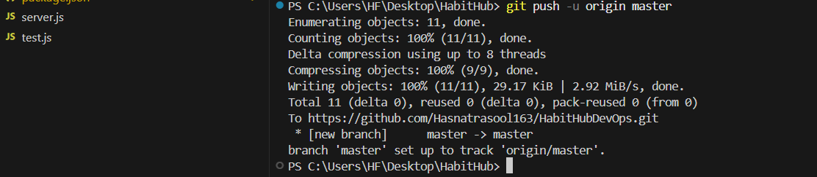
GitHub Online:
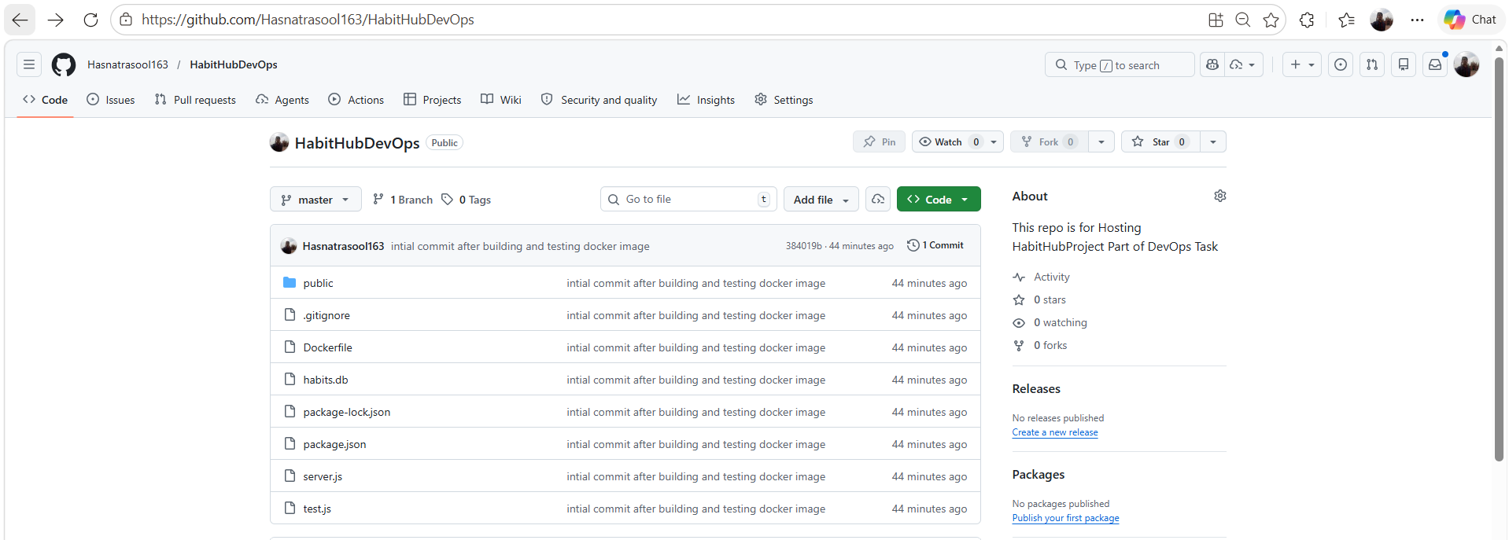
K8S cluster:
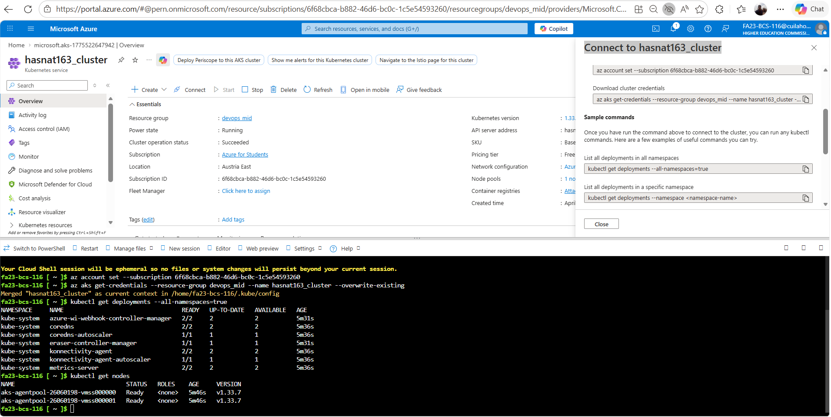
Live Check Cluster Ip:
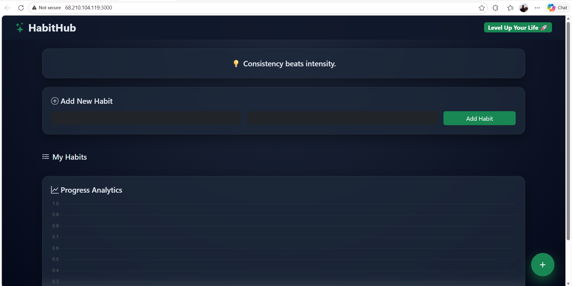
Deployment Logs:
