Assignment-1
Eclipse code
package first.java;
public class first {
public static void main(String[] args)
{// TODO Auto-generated method stub
System.out.println("Hello world!!");
}
}
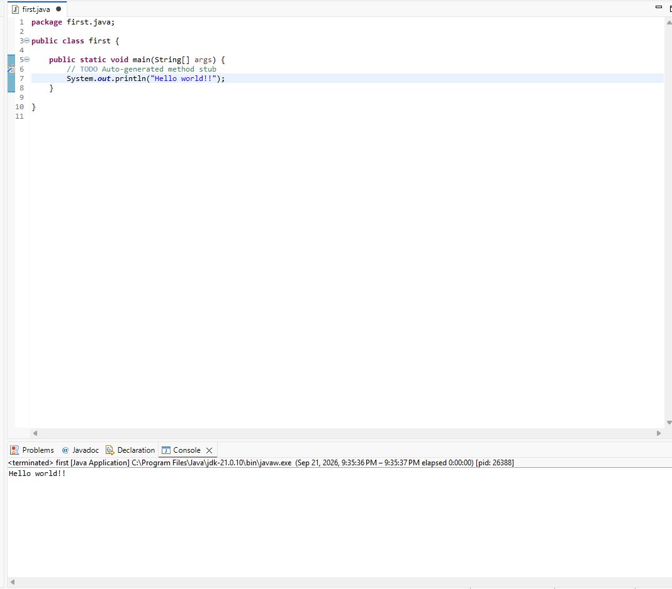
Notepad code
class first{
void display()
{
for(int i=1;i<=10;i++)
{
System.out.print(2*i+" "); }
}
public static void main(String [] args){
System.out.println("Hello World!!!");
//first obj=new first();
display(); } }



