Assignment_Day_2
Submitted by: Mohd. Hasnen Mirza (260840120109)
Ankit Singh Thakur (260840120026)

Que 1: Create a menu driven program for calculator to add , subtract, multiply and divide two integers, two floats, two doubles.
The application will continuously display the menu till the exit choice is not selected.
File:- calculator.java
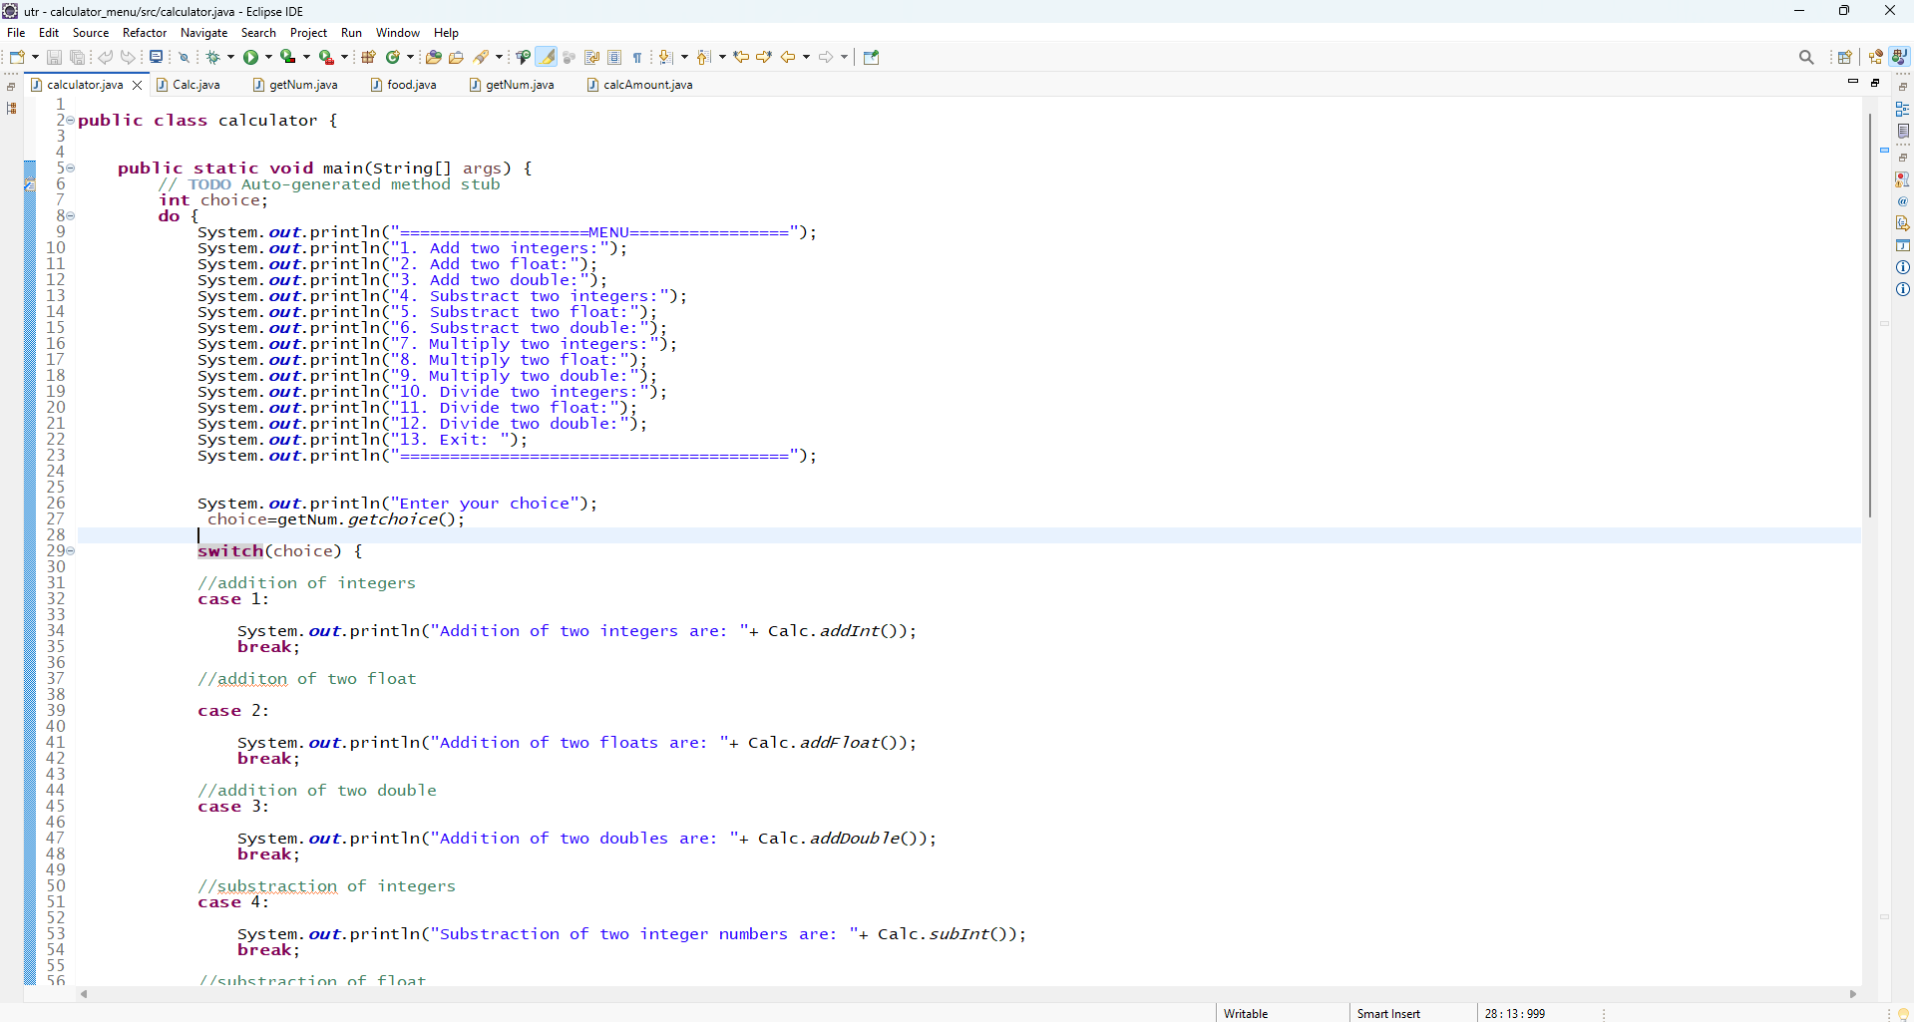
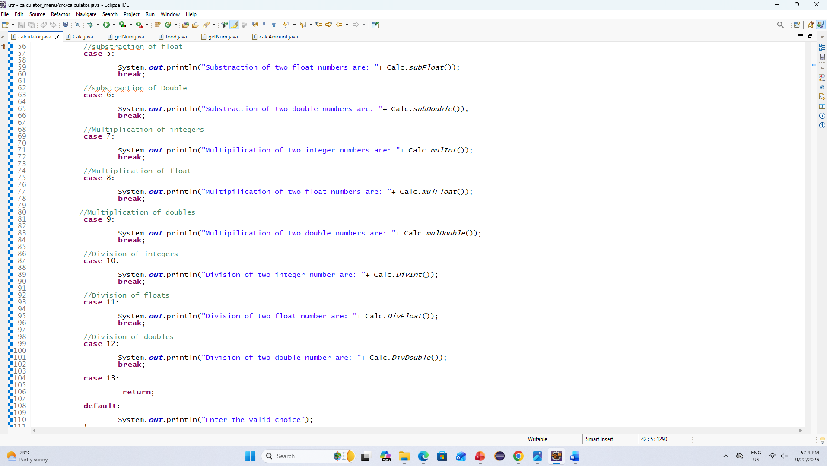

File:- Calc.java
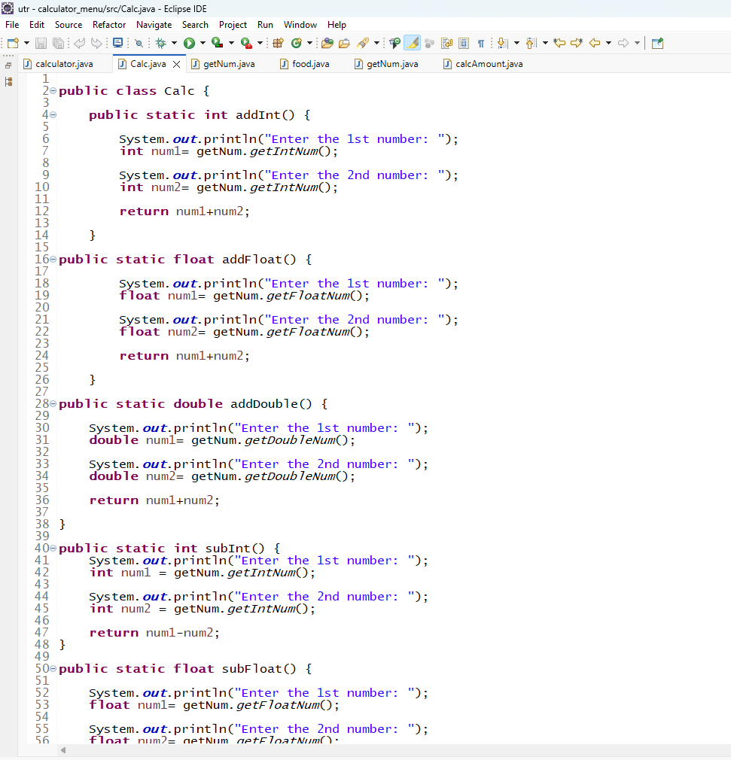

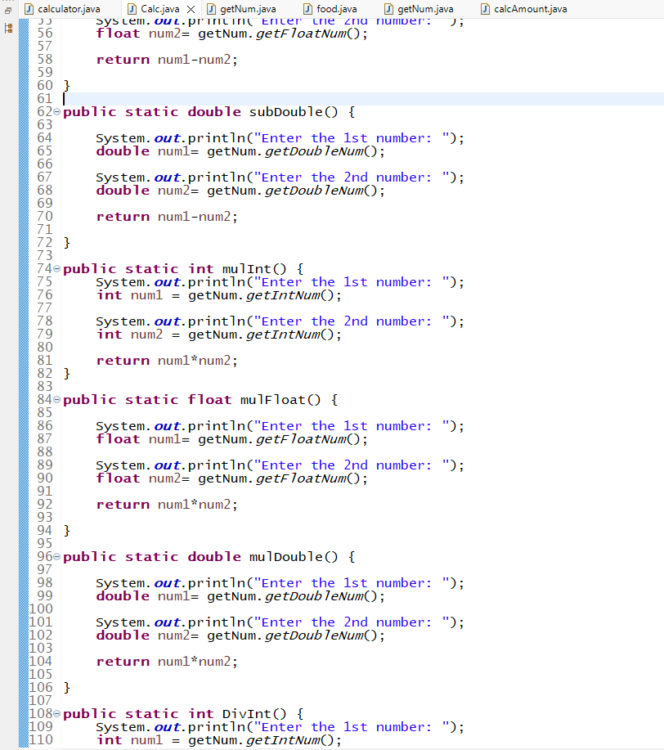

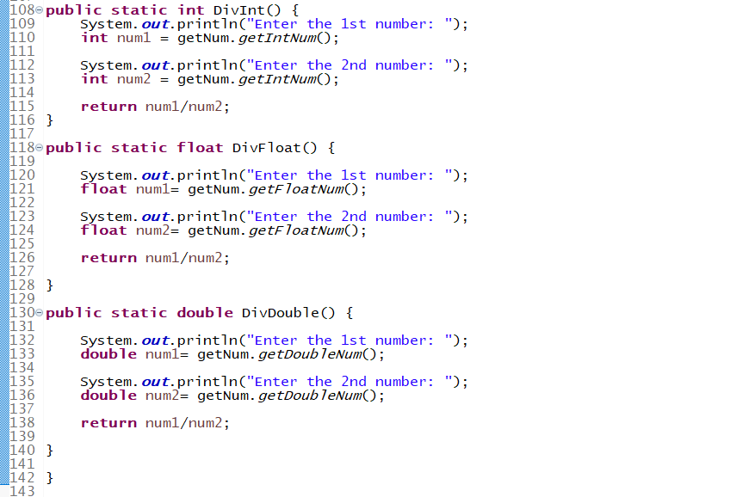

File:- getNum.java

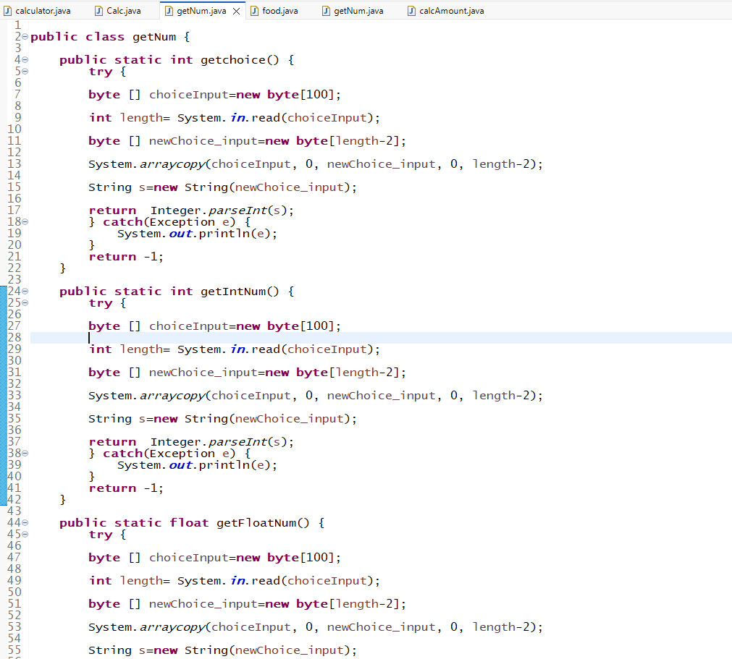

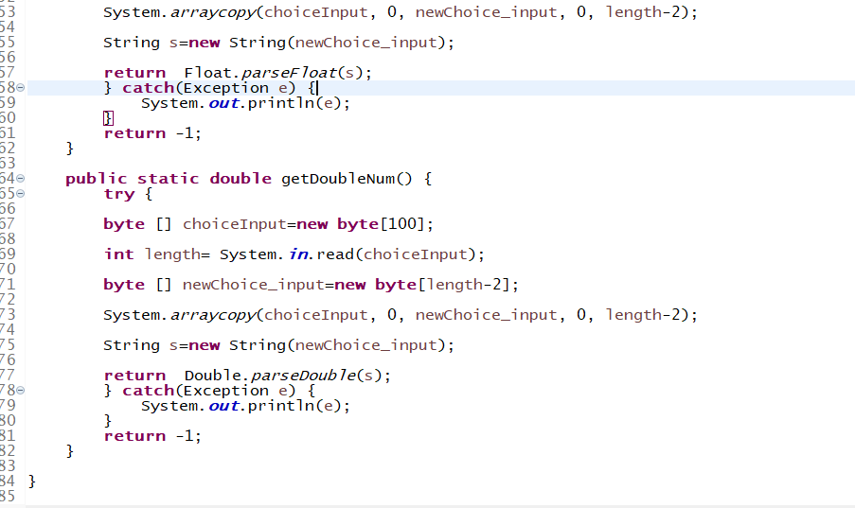

Que2:-
Display food menu to user. User will select items from menu along with the quantity. (eg 1. Dosa 2. Samosa 3. Idli ... 10 . Generate Bill ) Assign fixed prices to food items(hard code the prices)
When user enters 'Generate Bill' option(10) , display total bill & exit.

File:- food.java

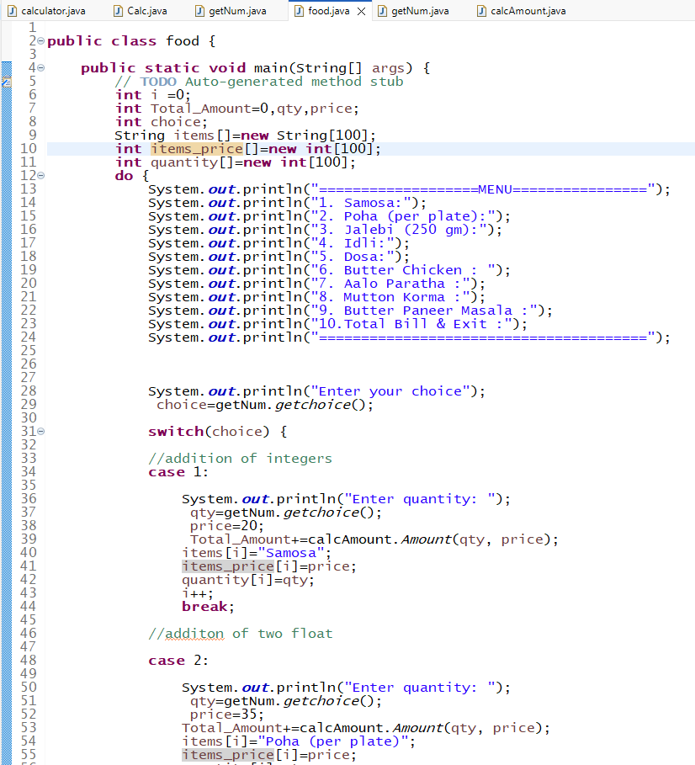

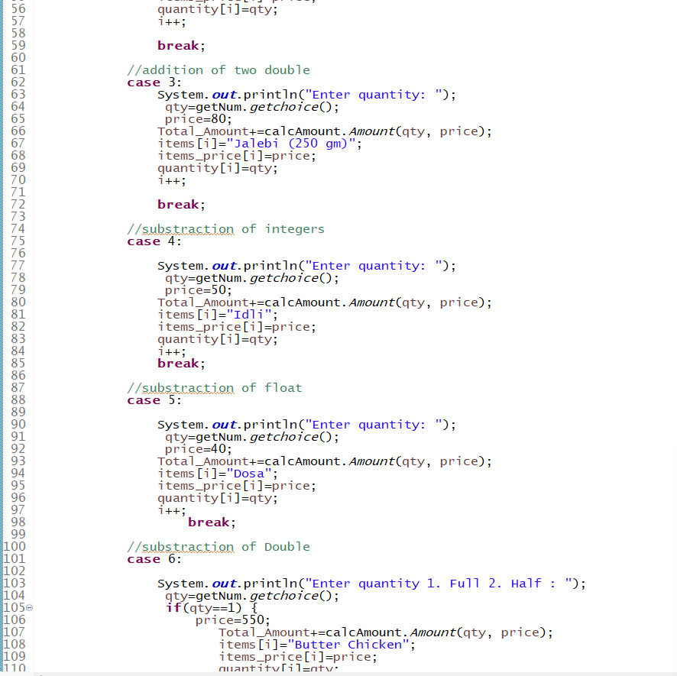

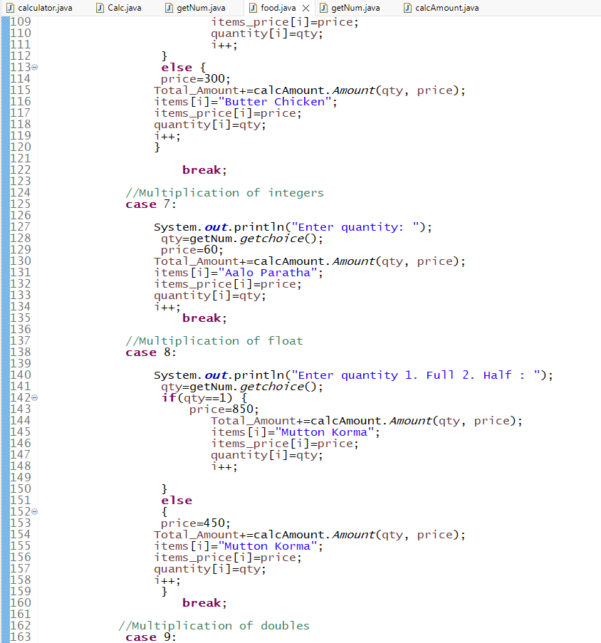

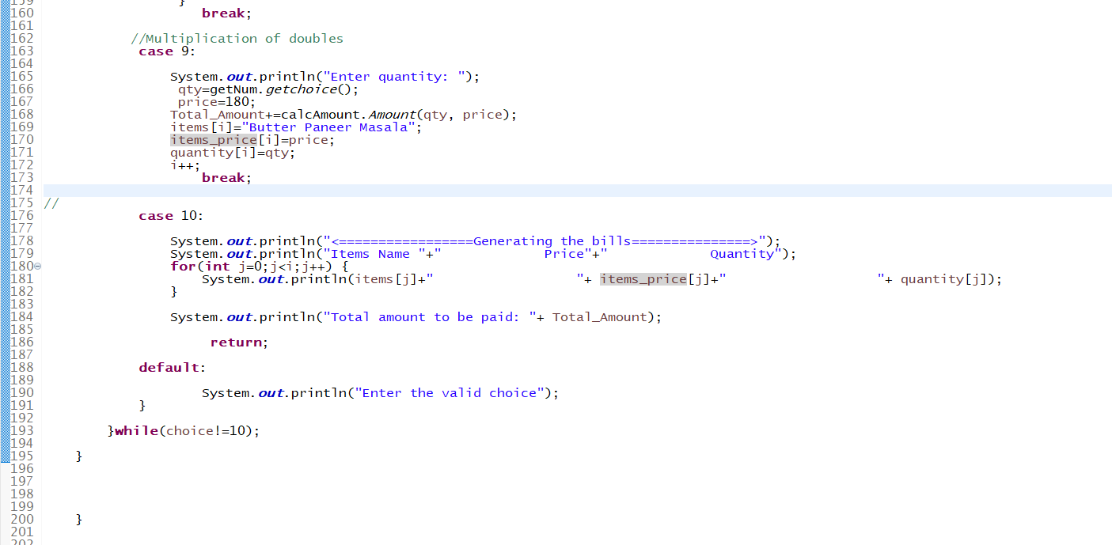

File:- calcAmount.java
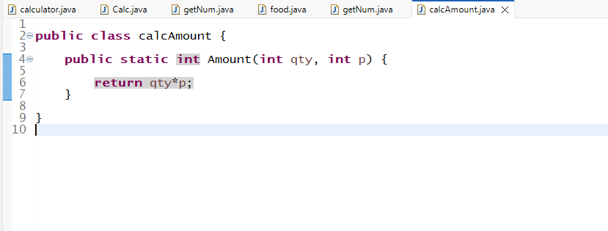

File:-getNum.java

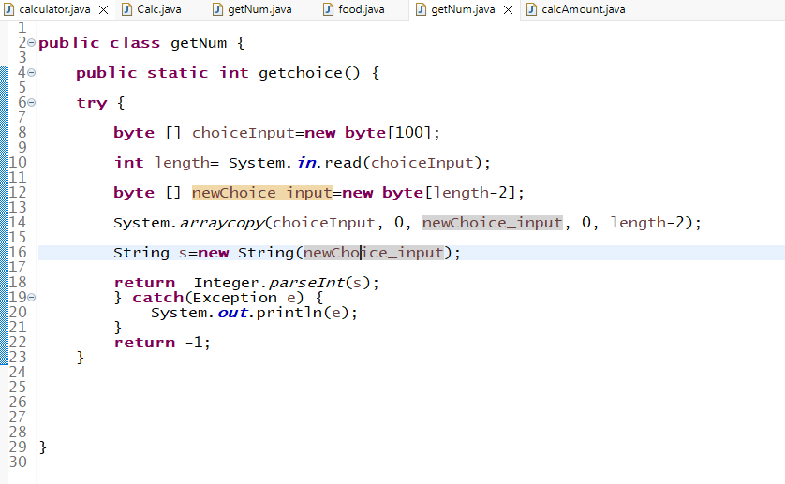

Que3=
****
***
**
*
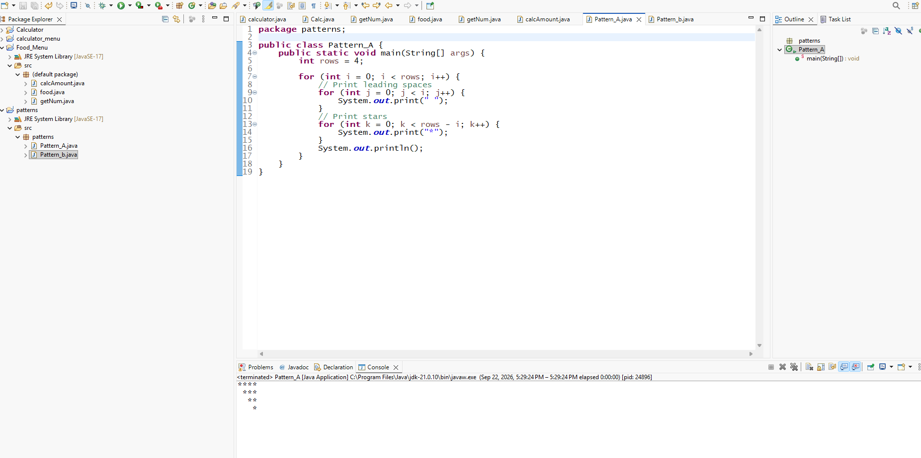
b.
******
** **
* *
** **
******



