The project I have decided to create is a Meta-Assembler written in C++. This takes a program written in assembly language from an external “.txt” file and converts the program to a “.cdm” file, formatted correctly. The text file should be structured with each instruction on a newline. Each line should contain an opcode and operand (if applicable), separated by a comma, with no spaces.

An example is:

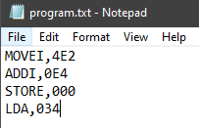

The program will then read these line by line, and check whether the opcode exists in a predefined table of structs. The structs contain two variables, the opcode is stored in the first and the respective operand prefix is stored in the second. The instructions are written in accordance to the lab work I had completed previously and therefor use different operand prefixes to the pre-set sheets, and the table of instructions I have used can be found attached.

The program then adds the operand prefix to the start of the given operand, and outputs the result in a cdm file format.

An example result is:

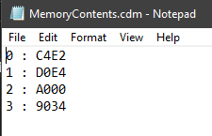

The files can be found in: “Tech Project\Meta Assembler\Meta Assembler\Files”