

_____________________________________________________________________________________

**Wide Chandelier With Shades**

Brand: Kichler

**$ 864**

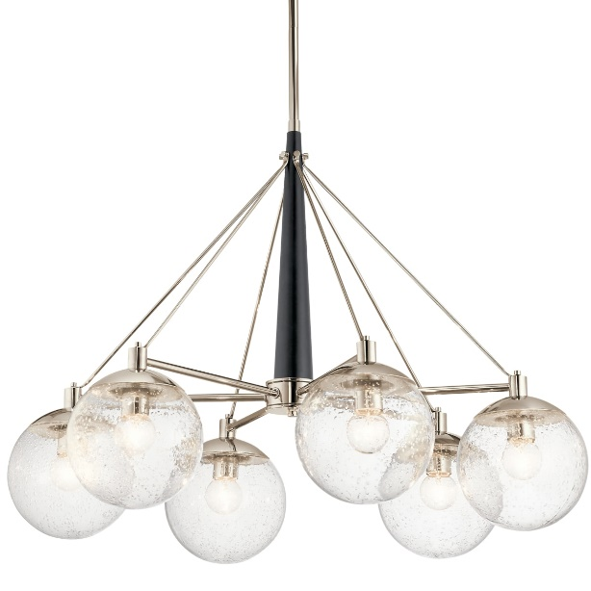

Lorem ipsum dolor sit amet consectetur adipisicing elit. Incidunt tempora nulla dolor reiciendis ut dicta maiores quam, nemo amet commodi ipsam illo suscipit ratione. Quos perspiciatis nisi harum qui eos!