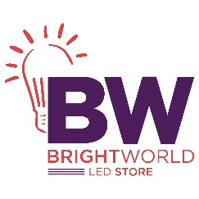

_____________________________________________________________________________________

**1 Light LED Track Spot**

Brand: Minka Lavery

**$ 60**

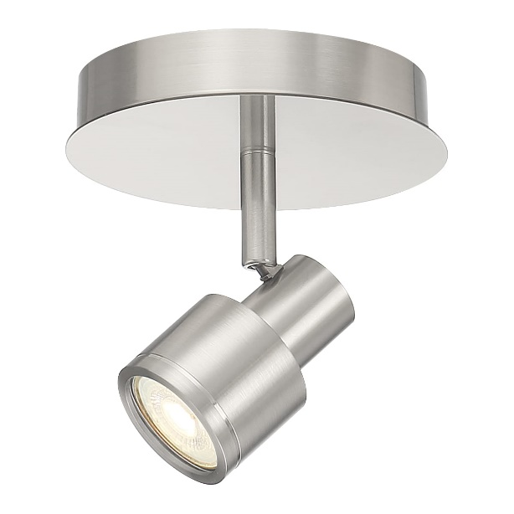

Lorem ipsum dolor sit amet consectetur adipisicing elit. Incidunt tempora nulla dolor reiciendis ut dicta maiores quam, nemo amet commodi ipsam illo suscipit ratione. Quos perspiciatis nisi harum qui eos!