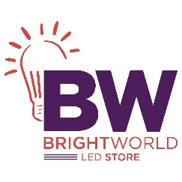

_____________________________________________________________________________________

**4 Light Wide LED Light**

Brand: Progress Lighting

**$ 118**

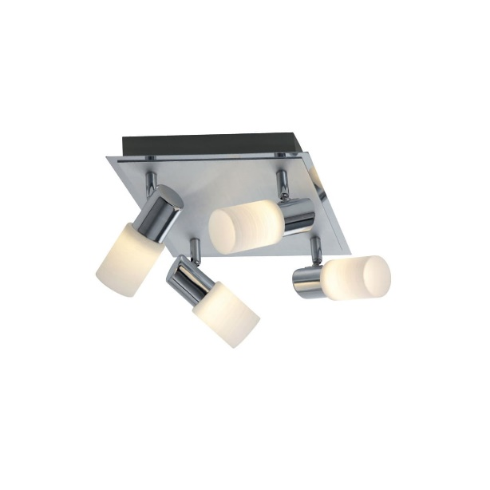

Lorem ipsum dolor sit amet consectetur adipisicing elit. Incidunt tempora nulla dolor reiciendis ut dicta maiores quam, nemo amet commodi ipsam illo suscipit ratione. Quos perspiciatis nisi harum qui eos!