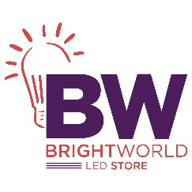

_____________________________________________________________________________________

**LED Street Light 120W**

Brand: Minka Lavery

**$ 238**

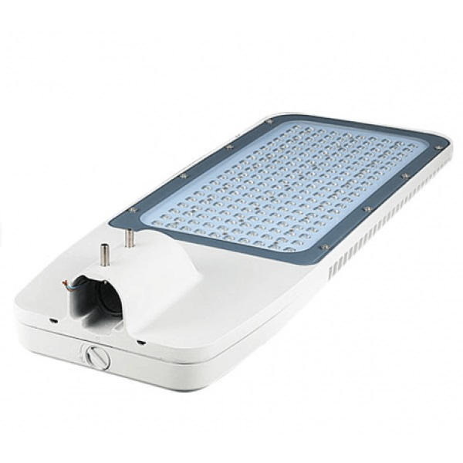

Lorem ipsum dolor sit amet consectetur adipisicing elit. Incidunt tempora nulla dolor reiciendis ut dicta maiores quam, nemo amet commodi ipsam illo suscipit ratione. Quos perspiciatis nisi harum qui eos!