

_____________________________________________________________________________________

**Light Works With Alexa**

Brand: Maxim

**$ 43**

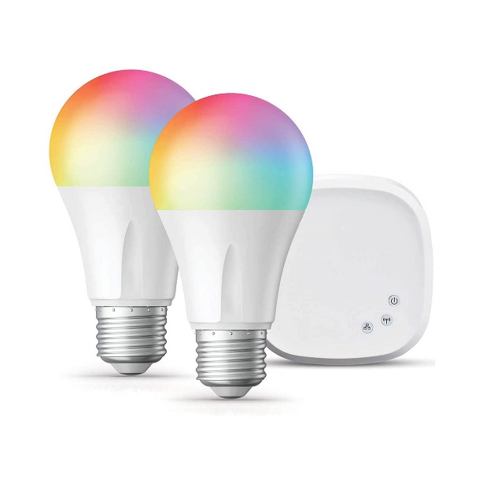

Lorem ipsum dolor sit amet consectetur adipisicing elit. Incidunt tempora nulla dolor reiciendis ut dicta maiores quam, nemo amet commodi ipsam illo suscipit ratione. Quos perspiciatis nisi harum qui eos!