3/30/2023

BSE203193 - MUHAMMAD HASSAAN

[company name]

Section:2

SCD_ASSIGNMENT

**Basic info to run the functions**

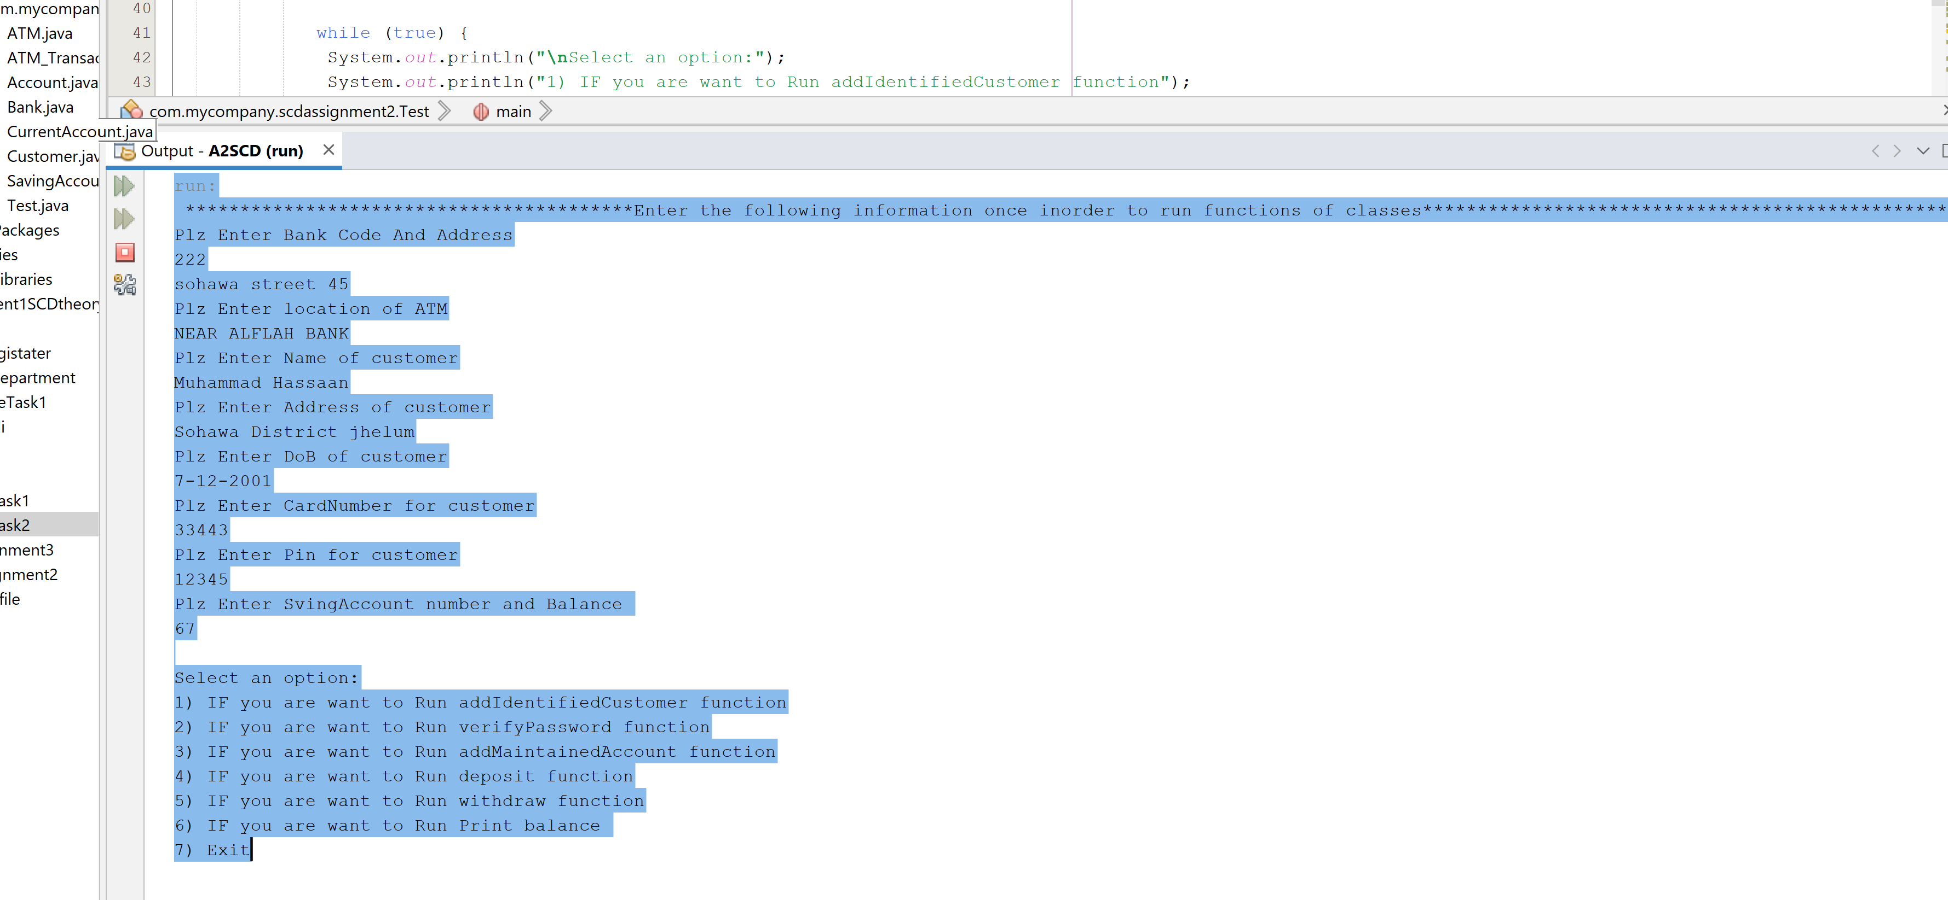

**Option1(customer added successfully no exception)**

**Option2 (as pin mached so run successfully)**

**Option3(Account is Added to maintain Accounts so run successfully)**

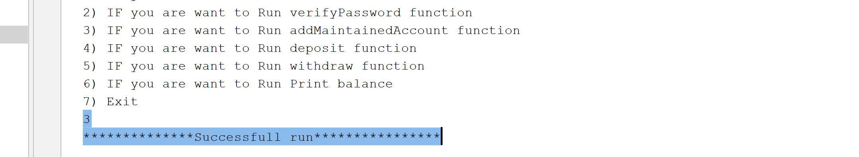

**Option4(Amount is deposited so run successfully)**

**Option5(Amount is withdrawal so run successfully)**

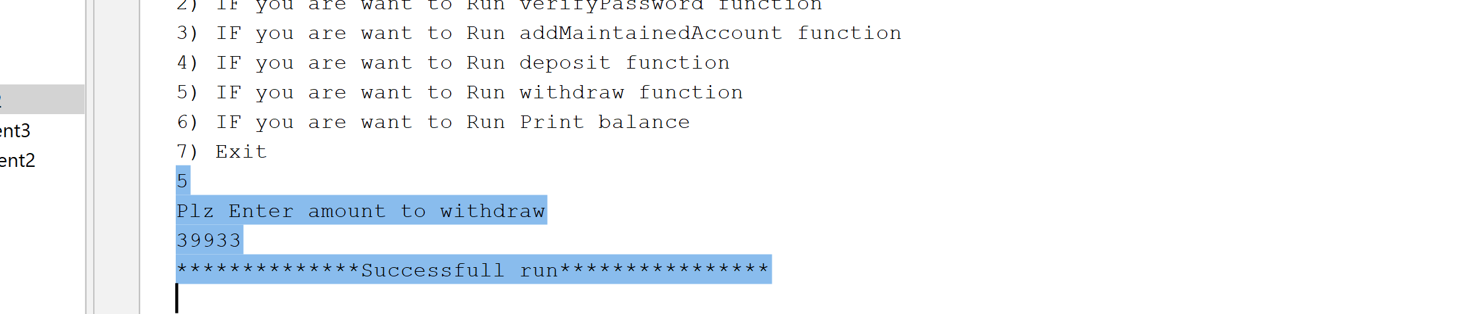

**Option6(no exception so run successfully)**

