Task 1:

.model small

.stack 100h

.data

.code

mov ax,@data

mov ds,ax

mov ah,01

int 21h

.if(al>'8')

mov dl, 'A'

mov ah, 02

int 21h

.elseif(al>'7')

mov dl, 'B'

mov ah, 02

int 21h

.elseif(al>'6')

mov dl, 'C'

mov ah, 02

int 21h

.elseif(al>'5')

mov dl, 'D'

mov ah, 02

int 21h

.else

mov dl, 'F'

mov ah, 02

int 21h

.endif

exit:

mov ah,4ch

int 21h

end

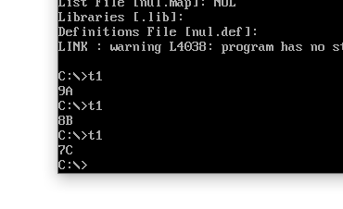

Task 2:

.model small

.stack 100h

.data

string1 db 'My world is beautiful','$'

str1 db ' Character found','$'

str2 db ' Character not found','$'

.code

mov ax,@data

mov ds,ax

mov ah,01

int 21h

mov si,offset string1

mov cx, lengthof string1

L1:

mov dl,[si]

cmp al,dl

je found

inc si

loop L1

nfound:

lea dx,str2

mov ah, 09h

int 21h

jmp exit

found:

lea dx,str1

mov ah, 09h

int 21h

exit:

mov ah,4ch

int 21h

end

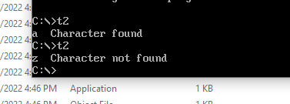

TASK 3:

.model small

.stack 100h

.data

.code

mov dl,48

mov cx,10

mov bl, 51

mov ax,0

L1:

mov al,dl

div bl

cmp ah, 0

je print

inc dl

jmp L2

print:

mov ah,02

int 21h

inc dl

L2:

LOOP L1

exit:

mov ah,4ch

int 21h

end

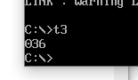

Task 4:

.data

str1 db 'Good morning', '$'

str2 db 'Good day', '$'

str3 db 'Good evening', '$'

time db ?

.code

mov ax,@data

mov ds,ax

mov ah,01

int 21h

mov time,al

.if(time <= '5')

lea dx, str1

mov ah, 09h

int 21h

.elseif(time <= '9')

lea dx, str2

mov ah, 09h

int 21h

.else

lea DX, str3

mov ah, 09h

int 21h

.endif

exit:

mov ah,4ch

int 21h

end

