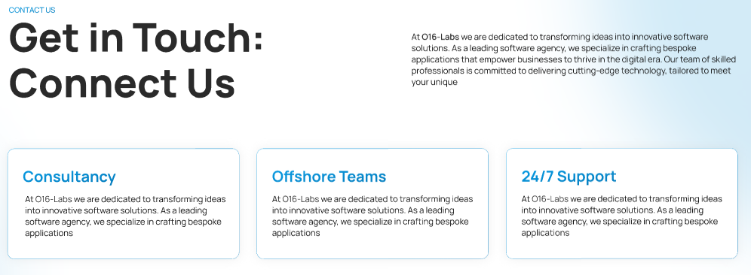

### It’s Always Nice to Talk!

Have a new project idea? Or you simply need to buff an existing digital product as per the latest trends? Get in touch today and we’ll hook you with our business development team. Here are all the ways you can contact us! Also, schedule a visit to our office by clicking on the link here

| **Fill Out the Form** Take time to fill out the form for us and we’ll get back to you. | **Write an Email**  Comfortable writing an email? Share your thoughts with us on our official ID | **Call Conversation**  Schedule a 15/30-minute free call with our project consultants. |
| --- | --- | --- |

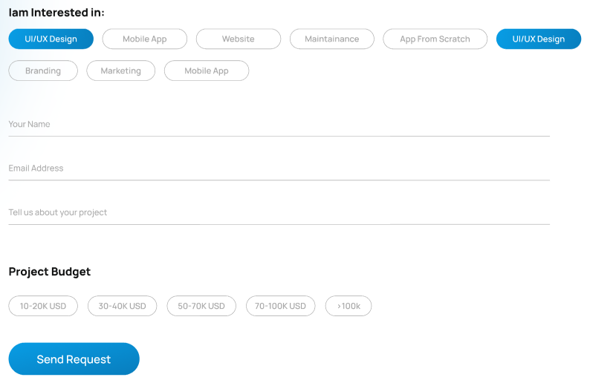

#### Don’t Have Time? Let’s Be Fast!

—----------------------------Add Options Here—-------------------------

#### Tell Us Your Budget

—-----------------Add Pricing Options Here—----------------------