O16 - About Us Page

**1.**

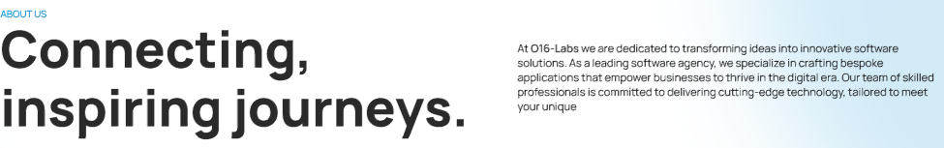

## Building Apps, For Generations!

We are in the mobile app development industry for long enough to see trends, breakthroughs come and go. Our approach is different, as we don’t just make another MOBILE APP, but create meaningful digital experiences and fill that void in the tech world that would benefit generations to come.

**2.**

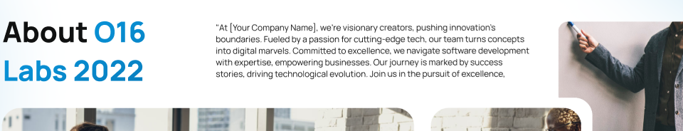

## You’ll Love To Know Us Up-Close!

Like others, we will never say that we are the top, #1, best app development company. But, we leave that to your experience with us, as well as our portfolio that’s 100% genuine. As for being a mobile app development company, we started more than a decade ago so, there’s more to us than meets the eye!

**3.**

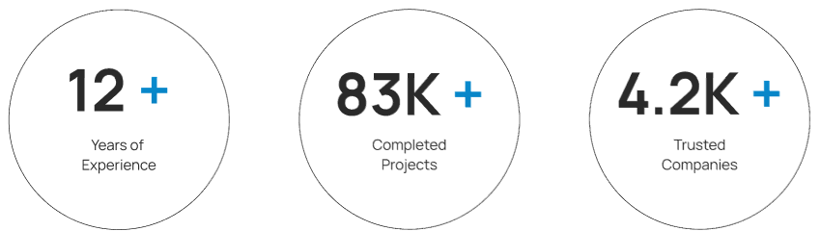

1. **Android** - Extremely user-friendly & feature-rich
2. **iOS -** Advanced, engaging, best performing
3. **React Native** - iOS and Android programming, with precision
4. **Flutter** - Cross-platform apps, flawless delivery, seamless experience

**OR**

1000+ Projects Delivered

1000+ Tech experts On-board

$$$ Investment Raised for Startups

**4.**

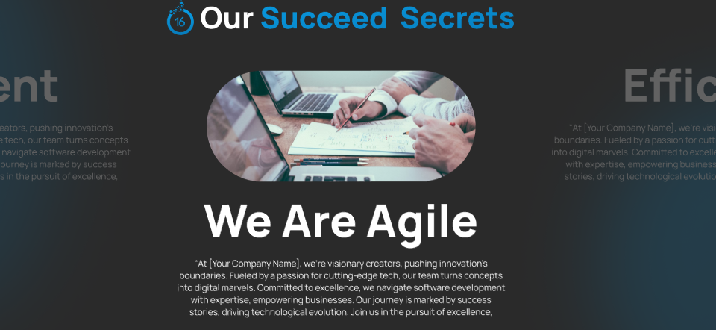

## Success That Matters/Shows/Speaks

### Build With Innovation

We can build custom mobile apps that are tailored exactly as per your business services and resonates to your brand ethos, ready to market faster.

### Accelerate and Grow

We work side-by-side with tech giants and thought leaders to set product dynamics, help you expand with flexibility and agility.

### Launch High & Proud

Ready for the big day? We help launch your app with full-throttle and support for relevant app stores, with post-launch support too.

**5.**

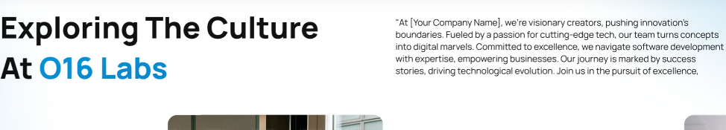

#### The Life & Times That Makes & Shapes Us!

We are a pack of tech geeks, nerds and all creative souls that would never stop exploring and experiencing. A home-like environment, with a friendly, supportive culture where you are welcome to win, fail, stay neutral but never stop trying! We mentor, coach and lead with a vision that creates future leaders, not just managers and bosses.

**6.**

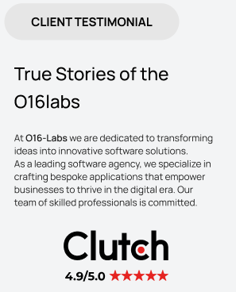

#### Hear From Our Clients!

##### Real People, Real Comments! Not AI-generated, Nor stolen from Google

O16 Labs is proud to have worked with some of the industry’s most reputable brands and Fortune 500 companies. And they’re equally happy with almost all, turning into our long-term partners and growth supporters. Here’s what they have to say!

**7.**

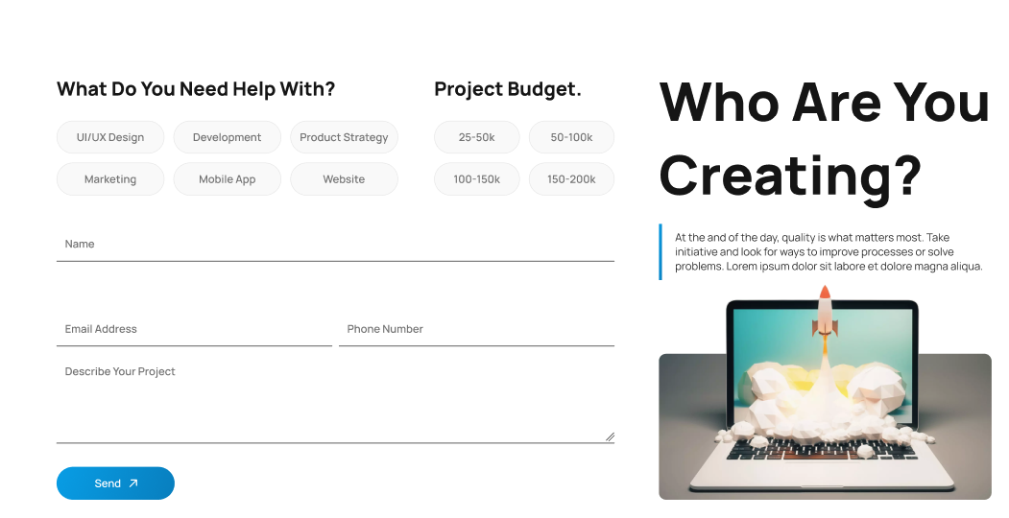

### Hey There! We’re Here to Make You Awesome With Tell Us Your Budget

### What is Your Target Industry?

Your development project and industry are aligned with each other.

Share the details to come clean and allow us to work our magic in making

you shine with the best product or digital solution.

**8.**

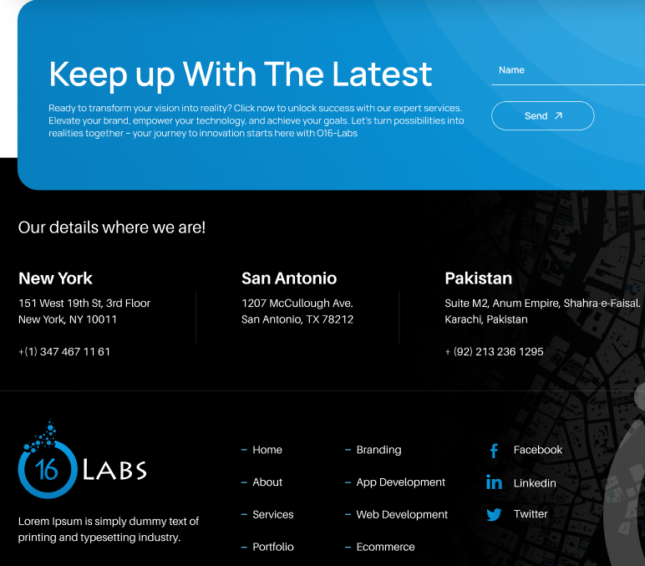

#### Your Journey to Digital Transformation Starts Here

Perfect solutions take time to brew and come forth. Book a 10-minute call with our consultant to discuss what you seek and we’ll love sharing all the secrets. Hop on to the digital change bandwagon and ride your way to awesomeness.

##### We Are Located Here