TASK03
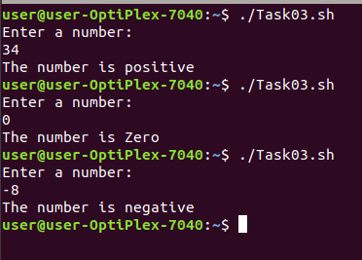
#!/bin/bash

echo "Enter a number:"
read num

if(($num>0))
then
echo "The number is positive"

elif(($num<0))
then
echo "The number is negative"

else
echo "The number is Zero"

fi

Task02
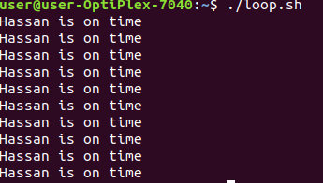
#!/bin/bash

#for loop
for i in {1..10}
do
echo "Hassan is on time"
done

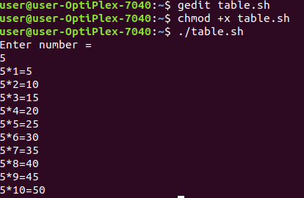

Task 04 Table of number
#!/bin/bash

echo "Enter number = $num"
read num

for i in {1..10}
do
echo "$num*$i="$(expr $num \* $i)
done
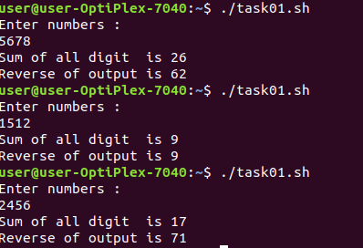
Task01

#!/bin/bash

echo "Enter numbers : "
read n
single=0
sum=0
for ((i=1 ; $n>0 ; i++))
do

single=$(( $n % 10 ))
n=$(($n / 10))
sum=$(( $sum + $single ))

done
echo "Sum of all digit is $sum"

s=0
r=0

for ((i=1 ; $sum>0 ; i--))
do
s=$(( $sum % 10 ))
r=$(( $r * 10 + $s ))
sum=$(( $sum / 10 ))
done

echo "Reverse of output is $r"

