Zombie
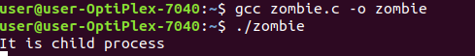
#include <stdio.h>
#include <stdlib.h>
#include <sys/types.h>
#include <unistd.h>

int main()
{

int pid = fork();

if (pid > 0)
sleep(20);

else if (pid ==0)
{ printf("It is child process\n");
}
else if (pid<0)
{ printf("Fork Failed to create child process\n");
}

else
{
exit(0);
}

return 0;

}

Orphan
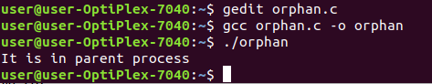
#include<stdio.h>
#include <sys/types.h>
#include <unistd.h>

int main()
{

int pid = fork();

if (pid > 0)
printf("It is in parent process\n");

else if (pid == 0)
{
sleep(30);
printf("It is in child process\n");
}

return 0;
}

