**OOAD**

**Classes**

**Inheritance Classes:**

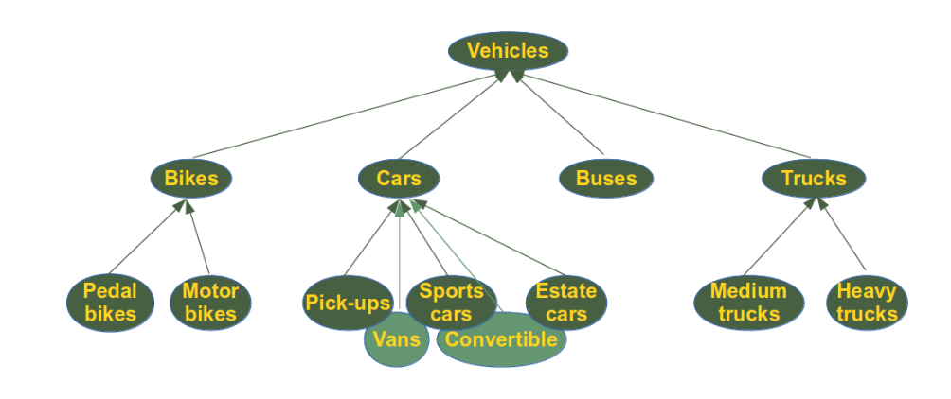

class Person(object):

    def __init__(self, name):

        self.name = name

    def getName(self):

        return self.name

    def isEmployee(self):

        return False

class Employee(Person):

    def isEmployee(self):

        return True

emp = Person("Hassam")

print(emp.getName(), emp.isEmployee())

emp = Employee("kazmi")

print(emp.getName(), emp.isEmployee())

**Abstract Classes:**

from abc import ABC, abstractmethod

class Polygon(ABC):

    # abstract method

    def noofsides(self):

        pass

class Triangle(Polygon):

    # overriding abstract method

    def noofsides(self):

        print("I have 3 sides")

class Pentagon(Polygon):

    def noofsides(self):

        print("I have 5 sides")

class Hexagon(Polygon):

    # overriding abstract method

    def noofsides(self):

        print("I have 6 sides")

class Quadrilateral(Polygon):

    # overriding abstract method

    def noofsides(self):

        print("I have 4 sides")

# Driver code

R = Triangle()

R.noofsides()

K = Quadrilateral()

K.noofsides()

R = Pentagon()

R.noofsides()

K = Hexagon()

K.noofsides()