Name: Muhammad Hassan

Roll No: 233516

Subject: Visual Programming_lab

Submitted to: Mam Atka

Submission Date: 24/09/2024

**Task_1**

**Make A Directory:**

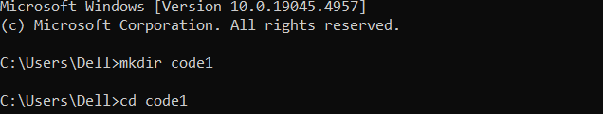

**DOT.NET New Console:**

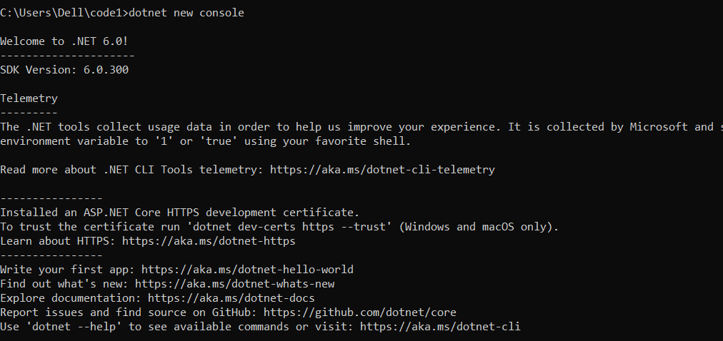

**DOT.NET Restore:**

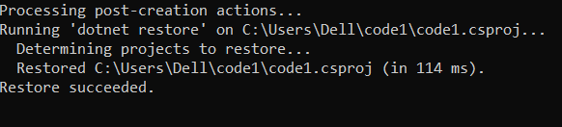

**DOT.NET Run:**

