EduTrack: Educational Management Platform
Mobile App Development Project Report

1. Project Title
App Name: EduTrack - Educational Management Platform
Team Members:
- Oneeb Tariq - 251694198
- Ghulam Hassan - 261925576
Course: Mobile App Development
Instructor: Umber Nisar
Date: November 30, 2025

2. Overview
Objective: Build a comprehensive educational management platform that streamlines course management, attendance tracking, task organization, and real-time communication between instructors and students. The app provides separate interfaces for students and instructors with role-based features including quiz creation, popup questions, Q&A walls, journal entries, and smart notifications.
Platform: Cross-platform (Android & iOS) using Flutter/Dart
Tools: Android Studio, VS Code, Firebase Console, Git

3. Features
Feature | Description | Status
User Authentication | Firebase Authentication with separate student/instructor roles, profile management | Completed
Course Management | Create, edit, archive courses; enrollment requests; student management | Completed
Attendance System | OTP-based attendance with photo verification, camera integration, location tracking | Completed
Real-time Notifications | Firebase Cloud Messaging for quizzes, questions, enrollments, task reminders | Completed
Quiz System | Schedule quizzes, multiple choice questions, real-time results tracking | Completed
Popup Questions | Live questions during class with instant answer submission and analytics | Completed
Q&A Wall | Course-specific discussion boards with threaded replies and notifications | Completed
Task Management | To-do lists with due dates, priorities, completion tracking, calendar sync | Completed
Calendar Integration | Device calendar sync, event reminders, deadline visualization | Completed
Notes & Journal | Rich text editing with formatting (bold, italic, underline), bullet points | Completed
Profile System | User profiles with avatar, major, age, editable information | Completed
Settings & Preferences | Notification toggles, reminder intervals, dark/light theme | Completed
Firestore Integration | Real-time database for courses, attendance, questions, notifications | Completed
Role-based Access | Different features and permissions for students vs instructors | Completed
Activity Monitoring | Real-time listeners for course activities with smart notifications | Completed

4. Screenshots & UI Design
The EduTrack application features a modern, intuitive user interface with the following design choices:
Clean Material Design: Follows Flutter Material Design guidelines with consistent spacing, elevation, and visual hierarchy

Gradient Accents: Course cards and action buttons use subtle gradients for visual appeal and depth
Google Fonts Integration: Inter font family for professional, readable typography across all screens
Color-coded Categories: Courses use distinct color schemes for easy visual identification
Responsive Layouts: Adaptive UI that works seamlessly on different screen sizes
Dark/Light Theme: Theme provider implementation with system-responsive color schemes
Bottom Navigation: Intuitive navigation bar for quick access to main features
Card-based Layout: Information organized in cards with shadows for clear separation
Icon-driven Actions: Recognizable Material Icons for common actions throughout the app
Real-time Indicators: Live status badges and activity indicators for courses and notifications

5. Technology Stack
Frontend Framework: Flutter 3.9.2 / Dart SDK
Backend & Services:
- Firebase Core 2.24.0 - App initialization
- Firebase Authentication 4.17.0 - User management
- Cloud Firestore 4.14.0 - NoSQL database
- Firebase Storage 11.6.0 - File storage
- Firebase Messaging 14.7.10 - Push notifications
Key Dependencies:
- Provider 6.1.5 - State management
- Google Fonts 6.1.0 - Typography
- Table Calendar 3.0.9 - Calendar UI
- Camera 0.10.5 - Photo capture
- Mobile Scanner 7.1.3 - QR code scanning
- Geolocator 11.0.1 - Location services
- Permission Handler 11.0.1 - Runtime permissions
- Shared Preferences 2.2.2 - Local storage
- Sensors Plus 7.0.0 - Device sensors
- Intl 0.19.0 - Internationalization

6. Challenges & Solutions
1. Permission Errors in Firestore
Issue: Initial Firestore rules caused PERMISSION_DENIED errors for notifications and Q&A replies.
Solution: Implemented comprehensive security rules with collection group support, proper instructor validation, and list permissions for real-time listeners.
2. Text Formatting Implementation
Issue: Initial approach using dynamic TextField styles affected all text instead of just newly typed content.
Solution: Switched to marker-based formatting (**bold**, *italic*, __underline__) with a custom FormattedTextWidget parser for display.
3. Real-time Notification Delivery
Issue: Push notifications weren't triggering for all event types consistently.
Solution: Created ActivityMonitorService with Firestore .snapshots() listeners for real-time monitoring of questions, quizzes, and enrollments.
4. Role-based Navigation
Issue: Students and instructors needed different menu options and permissions.
Solution: Implemented RouteManager utility with dynamic route resolution based on user type, plus RoleGuard widgets for screen protection.
5. Attendance Photo Verification
Issue: Needed reliable camera integration with photo upload and verification.
Solution: Integrated camera plugin with Firebase Storage, implemented OTP system with geolocation verification for enhanced security.
6. Calendar Synchronization
Issue: Task deadlines needed to sync with device calendar.
Solution: Implemented device_calendar plugin integration with permission handling and bi-directional event synchronization.

7. Learning Outcomes
Throughout the development of EduTrack, the team gained comprehensive experience in:
- Flutter state management using Provider pattern for reactive UI updates
- Firebase integration including Authentication, Firestore, Storage, and Cloud Messaging
- Implementing complex security rules in Firestore with role-based access control
- Real-time data synchronization using Firestore streams and listeners
- Push notification architecture with background and foreground handlers
- Camera integration, image capture, and cloud storage operations
- Permission handling for location, camera, storage, and calendar access
- Building responsive UIs with Material Design principles
- Theme management with dark/light mode support
- Git version control and collaborative development workflows
- Debugging techniques for mobile app issues using logs and error tracking
- Rich text editing implementation with custom parsing logic

8. Future Work
- Add group study rooms with video conferencing integration
- Implement assignment submission and grading system
- Create analytics dashboard for student performance tracking
- Add offline mode with local caching and sync when online
- Integrate external learning resources (e.g., YouTube, Khan Academy)
- Implement peer-to-peer study matching system
- Add support for file attachments in Q&A wall and notes
- Create mobile-responsive web version using Flutter Web
- Add functionality for a Teacher’s Assistant to manage things in Courses along with Instructors

9. Links
GitHub Repository: https://github.com/Hassan-6/EduTrack

10. Conclusion
Summary: EduTrack is a comprehensive educational management platform that successfully bridges the gap between students and instructors through real-time communication, automated attendance tracking, and intelligent task management. The application has been thoroughly tested on Android devices running Android 11+ and demonstrates robust performance with Firebase backend integration.

Team Contributions:
Oneeb Tariq (251694198): UI/UX Design, Core Logic Implementation, Quiz & Question Features, Notification System, Activity Monitoring Service, Theme Management
Ghulam Hassan (261925576): CRUD Operations, Attendance System, Camera Integration, Firebase Integration (Auth, Firestore, Storage), Firestore Security Rules

11. Declaration
We confirm that this project represents our original work. All external resources, libraries, and tools used have been properly documented and attributed.

Signatures:
_______________________ _______________________
Oneeb Tariq Ghulam Hassan

Date: November 30, 2025

Attachments

A. Code Snippets

1. Firebase Authentication Integration
// lib/services/auth_provider.dart
class AuthProvider with ChangeNotifier {
final FirebaseAuth _auth = FirebaseAuth.instance;
User? _user;
String? _userType;
Future<void> signIn(String email, String password) async {
try {
UserCredential userCredential = await _auth.signInWithEmailAndPassword(
email: email,
password: password,
);
_user = userCredential.user;
// Fetch user type from Firestore
final doc = await FirebaseFirestore.instance
.collection('users')
.doc(_user!.uid)
.get();
_userType = doc.data()?['userType'] ?? 'student';
RouteManager.setUserType(_userType!);
notifyListeners();
} catch (e) {
throw Exception('Sign in failed: $e');
}
}
}

2. Real-time Activity Monitoring
// lib/services/activity_monitor_service.dart
class ActivityMonitorService {
static final ActivityMonitorService _instance =
ActivityMonitorService._internal();
factory ActivityMonitorService() => _instance;
void startStudentMonitoring(String userId) async {
final enrolledCourses = await FirebaseService
.getAllCoursesWhereStudentEnrolled(userId);
for (var courseId in enrolledCourses) {
// Monitor popup questions
FirebaseFirestore.instance
.collection('courses')
.doc(courseId)
.collection('popupQuestions')
.where('isActive', isEqualTo: true)
.snapshots()
.listen((snapshot) {
for (var change in snapshot.docChanges) {
if (change.type == DocumentChangeType.added) {
_showPopupQuestionNotification(
change.doc.data()!, courseId);
}
}
});
// Monitor quizzes
FirebaseFirestore.instance
.collection('courses')
.doc(courseId)
.collection('quizzes')
.where('isActive', isEqualTo: true)
.snapshots()
.listen((snapshot) {
for (var change in snapshot.docChanges) {
if (change.type == DocumentChangeType.added) {
_showQuizNotification(change.doc.data()!, courseId);
}
}
});
}
}
}

3. Text Formatting with Markers
// lib/utils/text_formatter.dart
class FormattedTextWidget extends StatelessWidget {
final String text;
List<TextSpan> _parseText(String text, TextStyle baseStyle) {
final List<TextSpan> spans = [];
int currentIndex = 0;
while (currentIndex < text.length) {
// Check for bold (**text**)
if (text.substring(currentIndex, currentIndex + 2) == '**') {
final endIndex = text.indexOf('**', currentIndex + 2);
if (endIndex != -1) {
final boldText = text.substring(currentIndex + 2, endIndex);
spans.add(TextSpan(
text: boldText,
style: baseStyle.copyWith(fontWeight: FontWeight.bold),
));
currentIndex = endIndex + 2;
continue;
}
}
// Check for italic (*text*)
if (text[currentIndex] == '*') {
final endIndex = text.indexOf('*', currentIndex + 1);
if (endIndex != -1) {
final italicText = text.substring(currentIndex + 1, endIndex);
spans.add(TextSpan(
text: italicText,
style: baseStyle.copyWith(fontStyle: FontStyle.italic),
));
currentIndex = endIndex + 1;
continue;
}
}
// Regular text
spans.add(TextSpan(text: text[currentIndex], style: baseStyle));
currentIndex++;
}
return spans;
}
}

B. Firestore Security Rules
rules_version = '2';
service cloud.firestore {
match /databases/{database}/documents {
function isInstructor() {
return request.auth != null &&
get(/databases/$(database)/documents/users/$(request.auth.uid))
.data.userType == 'instructor';
}
function isCourseInstructor(courseId) {
return request.auth != null &&
get(/databases/$(database)/documents/courses/$(courseId))
.data.instructorId == request.auth.uid;
}
match /courses/{courseId} {
allow read: if request.auth != null;
allow create: if isInstructor();
allow update, delete: if isCourseInstructor(courseId);
match /popupQuestions/{questionId} {
allow read: if request.auth != null;
allow create, delete: if isCourseInstructor(courseId);
allow update: if isCourseInstructor(courseId) ||
(request.auth != null &&
request.resource.data.diff(resource.data)
.affectedKeys().hasOnly(['responses']));
}
}
match /notifications/{notificationId} {
allow read, list: if request.auth != null &&
resource.data.userId == request.auth.uid;
allow create: if request.auth != null;
}
}
}

C. Test Cases
Test Case | Input | Expected Output | Status
User Login | Valid credentials | Navigate to main menu | Pass
User Login | Invalid credentials | Show error message | Pass
Course Creation | Complete course details | Course created successfully | Pass
Attendance OTP | Correct OTP + location | Attendance marked | Pass
Attendance OTP | Wrong OTP | Error: Invalid OTP | Pass
Popup Question | Submit answer | Answer recorded, notification sent | Pass
Quiz Submission | All answers selected | Score calculated, results shown | Pass
Task Creation | Title, date, priority | Task added to list | Pass
Task Completion | Mark task complete | Task moved to completed section | Pass
Q&A Post | Question text | Question posted to wall | Pass
Q&A Reply | Reply to question | Reply added, notification sent | Pass
Note Formatting | Apply bold to text | Text wrapped with ** markers | Pass
Notification Toggle | Disable notifications | No notifications received | Pass
Dark Mode Switch | Toggle theme | App switches to dark theme | Pass
Course Enrollment | Request enrollment | Request sent to instructor | Pass

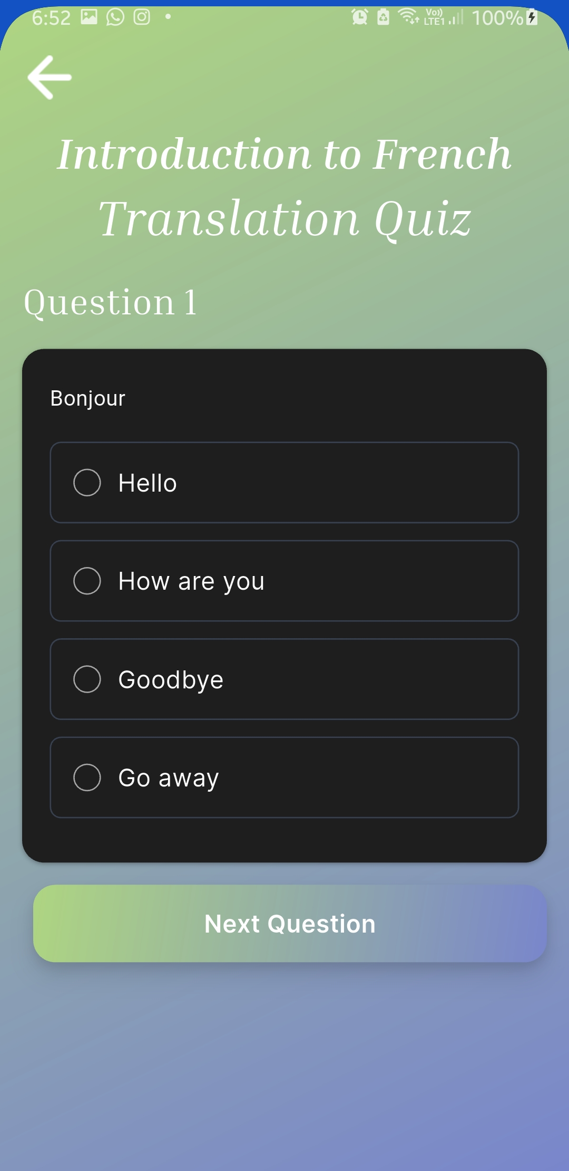
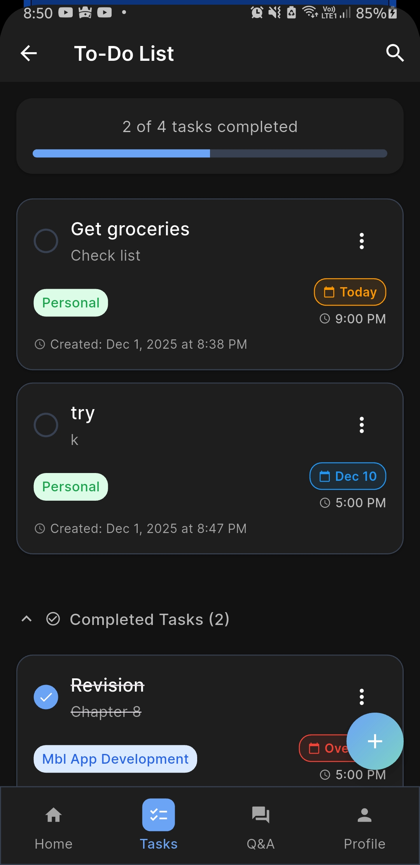
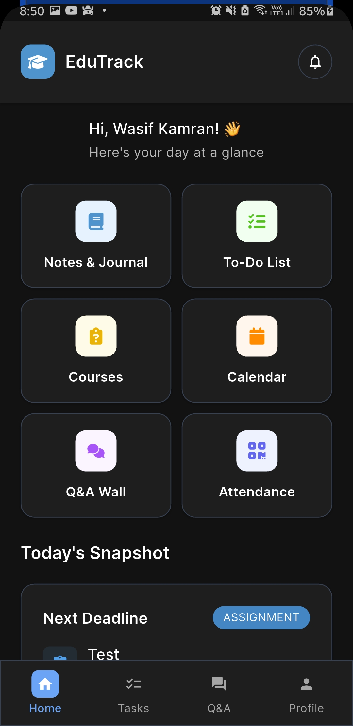
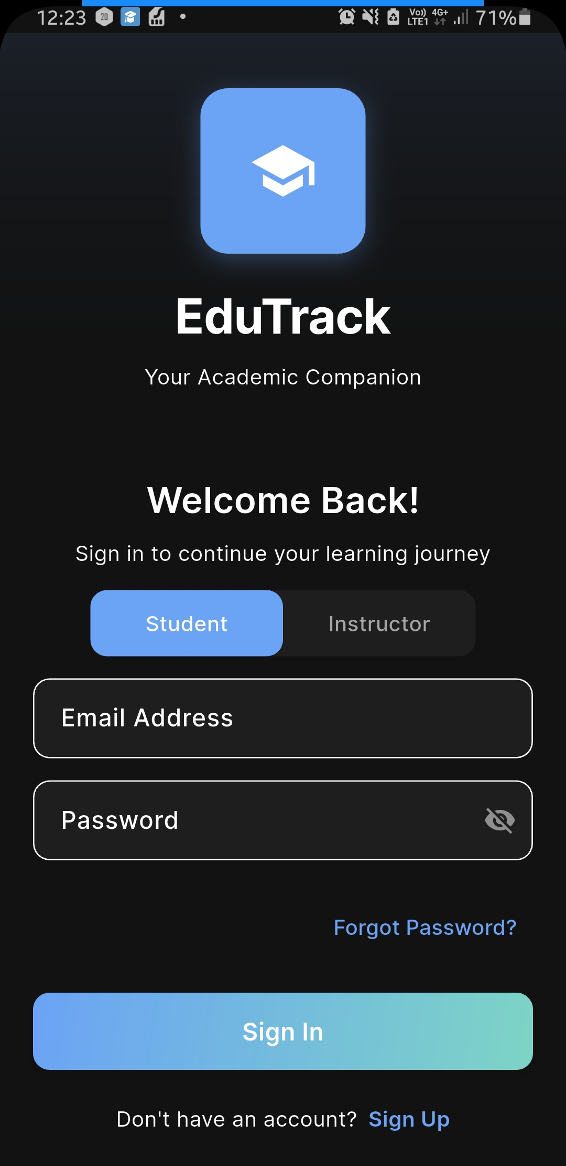
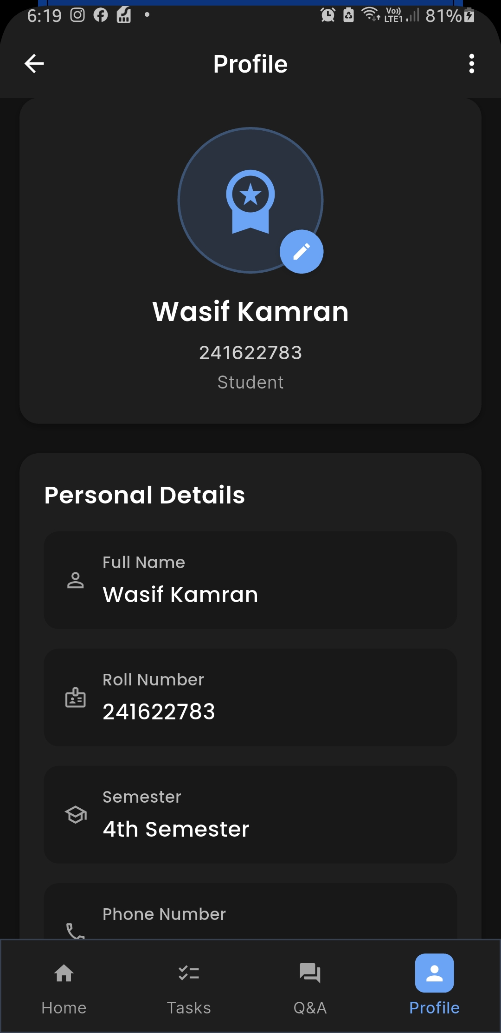
D. Screenshots
