- Create virtual environment (python –m venv env)
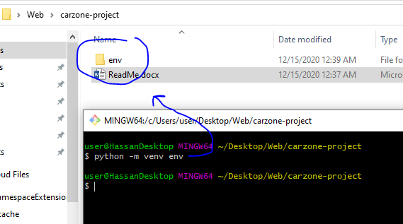
- Activate virtual environment (source env/Scripts/activate )
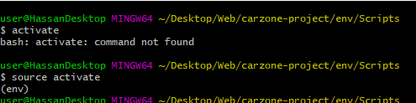
- Install Django version 3.0.7 (pip install Django==3.0.7)
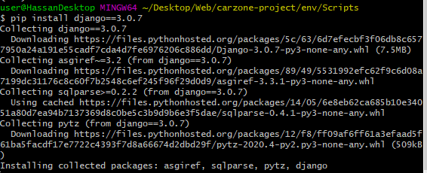
- Create the project called carzone (django-admin startproject carzone .)
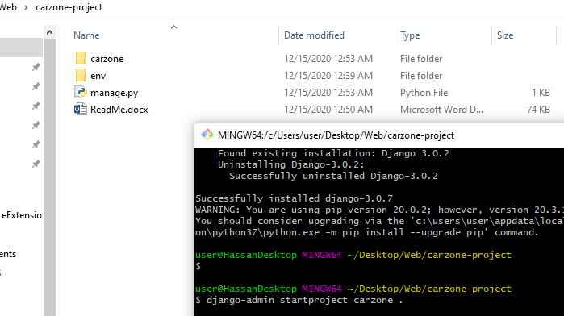
- Open file in VS and run server ( python manage.py runserver )
- python manage.py startapp pages

- add pages app to setting.py ('pages.apps.PagesConfig',)

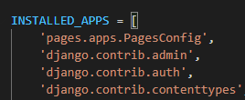

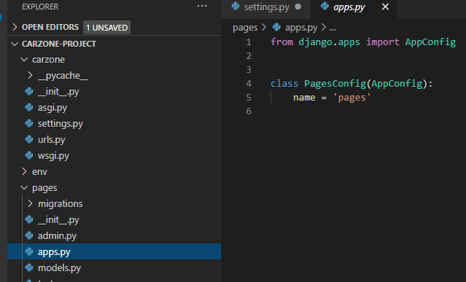
- create urls.py in pages app and go to admin urls.py to redirect the home page to pages.url and create template that has home.html in the top level folder.
Admin urls | Pages urls
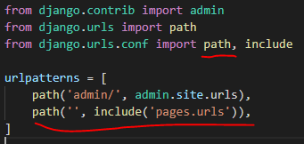 | 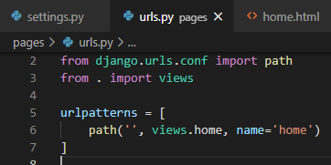

- Add the templates to setting.py
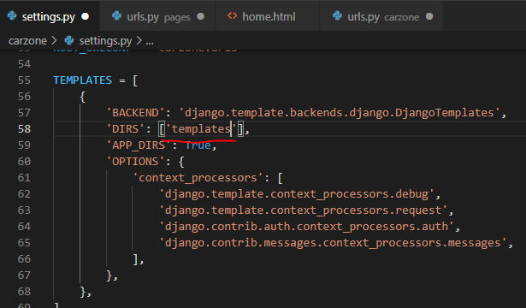
- Create the render to the page inside the app view.py

