**Database**

*2024 - second semester*

|  |  |  |  |  |
| --- | --- | --- | --- | --- |
| **Sign** | **Role Participated in** | **ID** | **Name** |  |
|  | **(Leader)** |  | **Hassan Mohammed Alzourei** | **1** |

**Project Milestone#2**

**Description**

-The restaurant is divided into two parts: one side is managed by the staff taking orders and the other is managed by the manager who manages the staff, the menu content, and can make salary reports.

-The cashier employee takes customer orders and information to complete the order through the system and registers customers who want to earn points to make discounts after a while of orders.

-The customer information will assist us in sending promos and points to them.

-The invoice will have information about the order like the date of order, how many items have been ordered, and information on the customer with points they earned, and so on

-The manager can access sales reports which can also know the most order items, the least order items, and the total orders. The manager can also modify the menu, and it is possible to add items and set a price for each item, or it is possible to delete items.

**System Constraints:**

- Each employee can have one account

- Only one Employee can be the manager

- Manager can print multiple Sales reports

- Employee can create Manipulate Invoices

- Customer phone number is a primary key

- Each menu item has a limit

**ER Diagram**

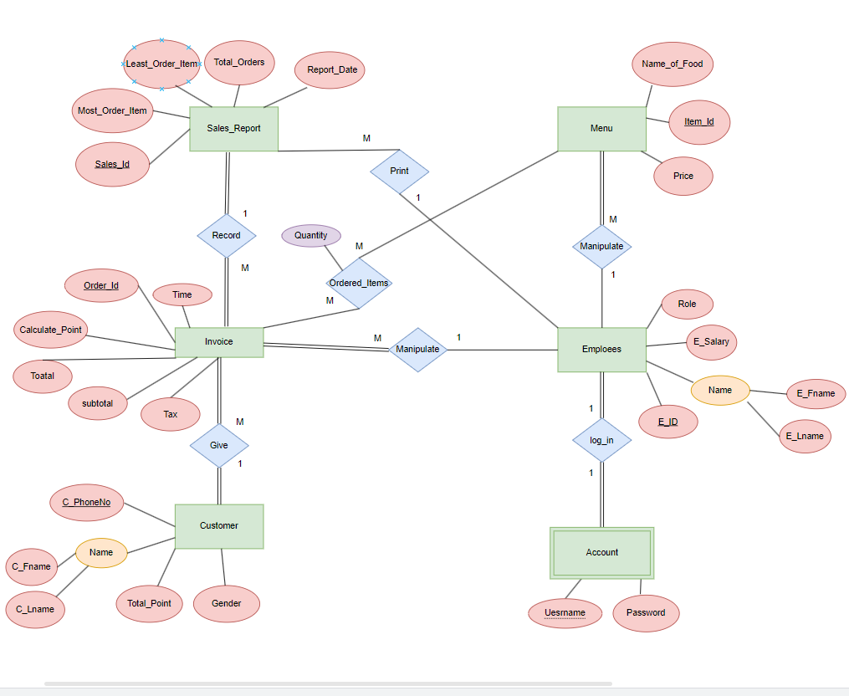

**Relation Schema**

**Relational Schema Mapping**

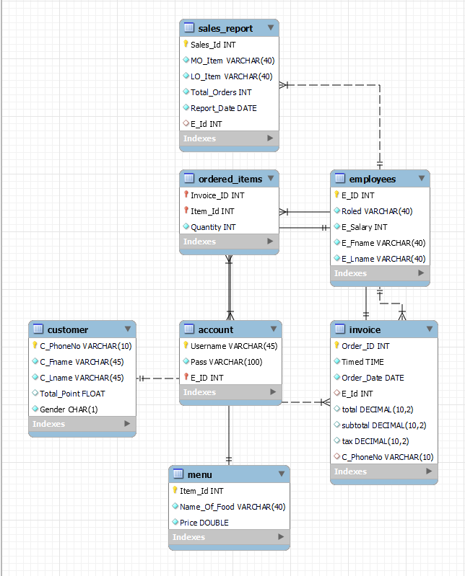

**Employee**

**Account**

**Customer**

**Invoice**

**Sales_Report**

**Menu**

**Ordered_items**

**SQL Query Statements**

SQL Query Statements (5 marks)

Write all SQL Queries required in your system to achieve all requirements (screenshot the result for each query)

**Insert**

**Delete**

**Update**

**Like and Not Like**

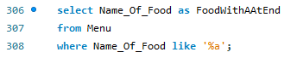

**Between**

**In**

**Order by**

**Is null**

**Intersect**

NOTE// MySQL does not support Intersect directly .

**Except**

NOTE// MySQL does not support Except directly .



**Union**

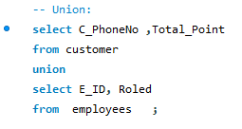

**Aggregate Functions**













**Aggregate Functions + Group By + Having**

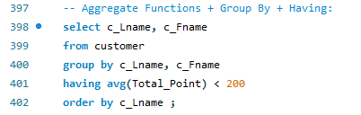

**NATURAL JOIN**

**Full OUTER JOIN**

NOTE// MySQL does not support Full OUTER JOINdirectly .

**Exist**

**Nested Query**

**Trigger**

**View**

**CREATE PROCEDURE**

**Function**





