


AI and social media usage in doing research and the affection on search engines like google

Made by students:
Hassan Ibrahim Sayed
Ahmed abo bakr
Khaled Hamdan
Presented to Dr. Sarah Osama

Table of content.
Name | page
introduction | 2
Research question | 3
Descriptive analysis on variables | 4
Tables | 7
Graphs | 14
inferential statistics | 24
Conclusion and research fingings | 26

- introduction:
In the modern digital era, the landscape of academic and general research has undergone a profound transformation. For decades, traditional search engines—most notably Google—served as the primary gateways to information, establishing a standard for speed and library access. However, the rapid emergence of Generative Artificial Intelligence (AI) platforms and the evolution of social media platforms into unconventional search engines have fundamentally altered how individuals discover, gather, and assess information. Today, researchers are no longer dependent on a single utility; instead, they navigate a complex ecosystem of competing tools, each offering distinct advantages in terms of presentation, speed, and information depth.
While traditional search engines index web pages based on indexing algorithms, AI tools synthesize immediate answers, and social media platforms offer highly visual, community-driven or peer-reviewed knowledge. This shifting dynamic raises significant questions regarding user satisfaction, perceived data security, trust in platform outputs, and the extent to which information verification habits vary across populations. Understanding these preferences is vital, as it sheds light on whether traditional search frameworks are being systematically outpaced or if they remain crucial backbones of information security and credibility.
Our main objectives:
• see how much people use AI tools and search engines in terms of daily search volumes and usage frequencies among student and gender demographics.
• Evaluate the underlying operational drivers—such as trust, speed, security, and information abundance—that dictate why users prioritize one research tool over another.
• Statistically test whether overall user satisfaction with these emerging platforms deviates significantly from established population baselines.
• Assess the structural differences in how users approach information verification and platform reliance across varying education levels and genders.

-research questions
1- How does the frequency of AI usage compare to search engines and social media when conducting research?
2- What are the primary factors (e.g., security, trust, abundance of information, speed) that drive user preference for specific research tools?
3- What are the overall satisfaction levels for AI, Search Engines, and Social Media, and how do they compare to baseline expectations?
4- Is the proportion of individuals who completely avoid using AI, Search Engines, or Social Media significantly different from an expected 20% baseline?
5- To what extent do users verify the information they gather during research, and what verification methods do they rely on?
6- When social media is utilized for research, which specific platforms (e.g., YouTube, TikTok, Facebook) are the most dominant?
Our questionnaire:
Link for the survey itself (https://hassanibrahimelsayaf.questionpro.com/t/AdE2PZ8vgT)
Link for the survey as a pdf (https://www.pdffiller.com/s/m9BtmrQKLJ)

Descriptive analysis:
first we are going to show all of our data variables which are 30 variables
we will describe all of our variables using statistics that can be used for each type we are explaining.
1-AI_usage (Mean: 0.736 / 73.6%): The vast majority of your sample (73.6%) uses Artificial Intelligence heavily ("a lot") for conducting research.
2-SocialMedia_usage (Mean: 0.754 / 75.4%): Even higher than AI which is weird, 75.4% of respondents heavily utilize social media platforms as a utility when searching for information.
3-SearchEngine_usage (Mean: 0.684 / 68.4%): Traditional search engines (like Google) have the lowest heavy-usage percentage among the three (68.4%), which directly highlights why your research question is so relevant.
These first three are showing the first 3 questions in the survey data
4-AI_General_Search_Ranking (Mean: 1.68, Mode: 1): Respondents ranked their choices from 1 (Most Used) to 3 (Least Used). With a median of 2.0 and a mode of 1, it confirms that a huge portion of users position AI/Search Engines at the top of their general daily routines.
5-Search engines e.g. google_General_Search_Ranking (Mean: 1.50, Mode: 1): When ranking search engines specifically, the mode of 1 shows they heavily dominate as a primary structural search foundation.
6-Social media_General_Search_Ranking (Mean: 2.17, Mode: 3): With a mode of 3 (Least Used) and a higher mean, social media is structurally ranked as a secondary or tertiary research tool compared to the other two options.
And we can comment on saying that people use social media in research but we guess that they really doesn’t prefer it.
Google_Searches_out_of_5 (Mean: 3.33, Median: 3.0): On average, out of 5 research tasks, users explicitly turn to Google about 3.3 times.
These variables uses the 4th and 6th questions from the questionnaire.
7-secure ai (Mean: 0.403 / 40.3%): Less than half of the respondents feel that AI platforms are truly secure or protective of their personal information.
8-secure search engines (Mean: 0.701 / 70.1%): Traditional search engines are heavily trusted, with 70.1% of the sample viewing them as safe and protective. This is a major finding for your paper.
9-secure social media (Mean: 0.087 / 8.7%): An incredibly small fraction of users feel safe typing or finding secure data on social media.
These variables uses the 7th question from the questionnaire.
10-Youtube (Mean: 0.596 / 59.6%): By far the most popular social media tool for research, used by nearly 60% of the sample.
11-Facebook (Mean: 0.421 / 42.1%): The second most used platform in your dataset.
12-Tiktok (Mean: 0.245 / 24.5%): Used by roughly a quarter of the sample.
13-SocialMedia_for_Research_instagram (Mean: 0.157 / 15.7%): Used by 15.7% of respondents.
14-Reddit (Mean: 0.140 / 14.0%): Used by 14.0% of respondents.
15-X (Twitter) (Mean: 0.070 / 7.0%): The least used social media search medium (7%)
16-No_SocialMedia_for_Research (Mean: 0.228 / 22.8%): Around 22.8% explicitly avoid using social media for finding serious data.
These variables uses the 9th question from the questionnaire.
17-Prefer_Reviews or ratings (Mean: 2.33, Mode: 3,which is both in the survey): This tracks user preference for ratings vs. written reviews. The mode of 3 shows a strong collective preference for a combination of both metrics.
18-RealPeople_Info_Acceptance (Mean: 1.03, Mode: 1, which is yes in the survey): A strong indication that interacting with or hearing from real human perspectives directly impacts whether information is accepted or validated.
19-SocialMedia_Research_speed (Mean: 0.491 / 49.1%): Almost half of your sample specifically values social media because of how fast they can acquire snackable content.
20-Preference_Security (Mean: 0.175 / 17.5%): Security is a minor priority driver when selecting general tools.
21-Preference_Info_Trust (Mean: 0.298 / 29.8%): Trust in the accuracy of data dictates choices for 29.8% of users.
22-Preference_Info_Quantity (Mean: 0.543 / 54.3%): An absolute volume/abundance of resources is the most dominant preference factor (54.3%).
23-Tiktok_Short_Info_Reviews (Mean: 0.105 / 10.5%): A minor 10.5% of users actively look for short-form review structures like TikTok video explanations.
24-No_SocialMedia_Usage (Mean: 0.192 / 19.2%): Roughly 19.2% do not use general social media tools natively during academic research.
These variables uses the 10th , 11th , and 12th questions from the questionnaire.
25-Verify_Info_General (Mean: 1.75, Mode: 1): Captures the habit of cross-checking facts. A mode of 1 indicates that users consistently verify the data they interact with across all channels.
26-Study_Level (Mean: 2.59, Median: 3.0): Shows the makeup of your survey sample. With a median of 3, your dataset leans more toward university students than high schoolers.
27-Gender (Mean: 0.421 / 42.1% Females): Since in our code it is mapped that 0 is Male and 1is Female , the mean reveals that your sample is 42.1% Female and 57.9% Male.
These variables uses the 13th , 16th , and 20th questions from the questionnaire.
28-SearchEngine_Satisfaction_Rating
Mean: 69.56 | Median: 76.0 | Mode: 70.0
Std Dev: 24.70 | Variance: 610.29
Skewness: -0.60
Kurtosis: -0.025
Interpretation: The negative skewness value of -0.60 reveals that user satisfaction curves are heavily shifted toward the high end of the rating spectrum (as confirmed by a median of 76.0). Interestingly, the kurtosis is remarkably close to zero (-0.025). This signals a Mesokurtic distribution, meaning that despite the high-satisfaction bias, the scores drop off and peak in a shape that cleanly mirrors a standard normal bell curve.
29-AI_Satisfaction_Rating
Mean: 64.17 | Median: 70.0 | Mode: 100.0
Std Dev: 26.25 | Variance: 689.14
Skewness: -0.79
Kurtosis: 0.027
Interpretation: Artificial Intelligence holds a strong negative skewness of -0.79, demonstrating an even more aggressive user concentration toward elevated scores (supported by a prominent mode of 100.0). Similar to search engines, its kurtosis is practically zero (0.027), affirming a stable Mesokurtic profile. This shows that the distribution of user sentiment for AI is regular, tightly shaped, and follows a clean bell-like curve centered around its high marks.
30-SocialMedia_Satisfaction_Rating
Mean: 42.40 | Median: 40.0 | Mode: 0.0
Std Dev: 9.23 | Variance: 85.20
Skewness: 0.44
Kurtosis: -0.727
Interpretation: Social media satisfaction tells a completely reversed statistical story. The positive skewness of 0.44 confirms that satisfaction scores are clustered toward the lower end of the rating matrix (evidenced by a mode of 0.0). More importantly, it features a strong negative kurtosis value of -0.727, defining a Platykurtic distribution. This mathematically proves that there is no uniform consensus on social media satisfaction; the curve is flat and highly spread out, reflecting highly fractured and widely variable user opinions across the entire population.
These variables uses the 5th questions from the questionnaire.

Tables:
In this section we will be showing some tables that are helpful for understanding the data because they like summarize the data and show it as a collection.
1-firs we have boolean tables

SocialMedia_usage_frequency | Count | Percentage
True | 43 | 75.4%
False | 14 | 24.6%
By looking at our first three tables we can see that they are exactly showing the same thing we understood from the first stats we did when we got the mean and the percentage for each of them
SearchEngine_usage_frequency | Count | Percentage
True | 39 | 68.4%
False | 18 | 31.6%
AI_usage_frequency | Count | Percentage
True | 42 | 73.7%
False | 15 | 26.3%
secure ai | Count | Percentage
False | 34 | 59.6%
True | 23 | 40.3%
secure search engines | Count | Percentage
True | 40 | 70.2%
False | 17 | 29.8%
secure social media | Count | Percentage
False | 52 | 91.2%
True | 5 | 8.8%

By looking at our second three tables we can see that most people said that search engines are secure although it is not like really a huge percentage.
SocialMedia_for_Research_instagram | Count | Percentage
False | 48 | 84.2%
True | 9 | 15.8%

Reddit | Count | Percentage
False | 49 | 85.9%
True | 8 | 14.%

X(twitter) | Count | Percentage
False | 53 | 92.9%
True | 4 | 7%
Tiktok | Count | Percentage
False | 43 | 75.4%
True | 14 | 24.6%
Analysis of Social Media Platform Distribution for Research
When evaluating the specific platforms utilized by individuals who use social media as an informational utility, the data reveals a distinct preference for visual and video-centric networks.
Out of the entire sample, YouTube emerges as the dominant platform, with 59.6% (34 participants) confirming its active use. This is followed by Facebook at 42.1% (24 participants) and TikTok at 24.6% (14 participants), showcasing the rising authority of video media formats in modern research workflows. Conversely, textual or thread-based networks represent a marginal footprint, with Instagram (15.8%), Reddit (14.0%), and X/Twitter (7.0%) serving as minor options.
Crucially, the No_SocialMedia_for_Research variable shows that only 22.8% (13 participants) completely abstain from using social networks during research tasks. This mathematically confirms that an overwhelming 77.2% of the population integrates social media into their personal information discovery loops, highlighting the ongoing disruption of traditional search engines.

Youtube | Count | Percentage
True | 34 | 59.6%
False | 23 | 40.3%

Facebook |  | Count
False | 33 | 57%
True | 24 | 42.1%
No_SocialMedia_for_Research | Count | Percentage
False | 44 | 77.2%
True | 13 | 22.8%

SocialMedia_Research_speed | Count | Percentage
False | 29 | 50.9%
True | 28 | 49.1%

Preference_Security | Count | Percentage
False | 47 | 82.4%
True | 10 | 17.5%

Preference_Info_Trust | Count | Percentage
False | 40 | 70.2%
True | 17 | 29.8%
Tiktok_Short_Info_Reviews | Count | Percentage
False | 51 | 89.5%
True | 6 | 10.52%
Preference_Info_Quantity | Count | Percentage
True | 31 | 54.4%
False | 26 | 45.6%
No_SocialMedia_Usage | Count | Percentage
False | 46 | 80.7%
True | 11 | 19.3%
To understand the operational characteristics that attract users to their preferred tools specifically on social media the study evaluated six distinct motivating factors.
The empirical results indicate that the single most dominant driver is the abundance and quantity of information sources, chosen by 54.4% (31 participants) of the sample population. Following closely behind is computational speed, which serves as a vital priority for 49.1% (28 participants). Combined, these two metrics show that modern researchers are primarily looking for rich repositories of data delivered immediately.
Conversely, qualitative or structural factors prove less critical in guiding initial user choice. Baseline trust in information accuracy motivates 29.8% (17 participants), platform data security guides only 17.5% (10 participants), and short-form video reviews represent a minor motivator at 10.5% (6 participants). Finally, 19.3% (11 participants) explicitly noted that they do not incorporate social media tools into their search preferences. These distributions indicate that platforms offering voluminous results at instant speeds.

Gender | Count | Percentage
males | 33 | 57.89%
females | 24 | 42.%

We can see from this table that most of our survey participants are males.
General_Search_Ranking_AI | Count | Percentage
skipped | 3 | 5.2%
1 | 23 | 40.3%
2 | 20 | 35.1%
3 | 11 | 19.3%
2- quantitative variables or variables that didn’t have only two values.
Analysis of Comparative Tool Priority Rankings
To evaluate the precise hierarchy of modern platform reliance, respondents ranked their usage of different research utilities on an ordinal scale from 1 (Most Used) to 3 (Least Used).
The empirical distributions show a compelling structural shift toward emerging technologies over conventional and social channels. When isolating the ranking of Artificial Intelligence platforms (General_Search_Ranking_AI), an outright majority of the cohort heavily prioritizes it, with 40.3% (23 participants) placing AI at Rank 1 and 35.1% (20 participants) placing it at Rank 2. Combined, a staggering 75.4% of respondents position AI as either their primary or secondary daily search vehicle.
This matches closely with traditional search engines (e.g., Google), which hold a similar primary footprint with 38.6% (22 participants) designating it at Rank 1. In stark contrast, social media is heavily relegated to a tertiary option, with a clear majority of 54.4% (31 participants) ranking it at level 3 (Least Used), while only a minor 12.3% isolate it as a primary tool.
Methodologically, these figures prove that Generative AI has successfully established parity with—and by a slight margin, outpaced—traditional indexing search engines as the top-tier priority utility for academic and general research workflows even if there skipped values are less than search engines, while social media is not mostly preferred.

Search engines e.g. google | Count | Percentage
skipped | 8 | 14.1%
1 | 22 | 38.6%
2 | 17 | 29.8%
3 | 10 | 17.5%

Social media | Count | Percentage
Skipped | 7 | 12.3%
1 | 7 | 12.3%
2 | 12 | 21.1%
3 | 31 | 54.4%
Also we wanted to say an important note over here about the skipped values we actually could remove them at least from the tables but we kept them to keep the comparison unbiased and to show that skipping might me some reason for difference.

Prefer_Reviews or ratings | Count | Percentage
ratings | 7 | 12.50%
reviews | 21 | 37.50%
both | 28 | 50%
Analysis of User Evaluation, Trust, and Information Verification Behaviors:
these tables here evaluated user assessment preferences, reliance metrics, and validation habits.
When inspecting platform feedback preferences (Prefer_Reviews or ratings), user behavior heavily favors contextual depth over simplistic metrics. An integrated combination of both written reviews and ratings is favored by 49.12% (28 participants), while standalone text reviews are preferred by 36.84% (21 participants). In contrast, plain numeric metrics (ratings only) satisfy a minor 12.28% of the cohort. This preference for comprehensive, humanized information aligns closely with the RealPeople_Info_Acceptance metric, where an overwhelming 71.93% (41 participants) confirm "yes"—knowing real individuals are behind the shared data directly helps them accept and believe it. Fact-checking remains highly prevalent within this sample ecosystem. The distribution for Verify_Info_General demonstrates that a strong majority of 57.89% (33 participants) actively answer "Do verify" regarding their research discoveries, with an additional 36.84% (21 participants) stating they "Sometimes verify." This mathematically confirms that 94.73% of the cohort routinely evaluates their findings for reliability, leaving a minimal 3.51% who do not verify data Finally when tracking how often participants turn to traditional search engines out of 5 consecutive research the responses peak at 3 tasks (31.58%), showing a balanced hybrid approach. However, the data highlights a clear polarization: a significant 21.05% (12 participants) remain absolute purists who utilize traditional search engines for all 5 tasks, while a small 3.51% (2 participants) select "0" tasks, indicating they have fully transitioned away from traditional search architectures in favor of alternative tools. These findings show that while new search mediums are widely embraced, users approach them with clear verification filters and deeply value the accountability of peer perspective structures.

RealPeople_Info_Acceptance | Count | Percentage
yes | 41 | 82.00%
no | 9 | 18.00%
Verify_Info_General | Count | Percentage
Do verify | 33 | 58.93%
Doesn’t verify | 2 | 3.57%
Sometimes verify | 21 | 37.50%
Google_Searches_out_of_5 | Count | Percentage
1 | 4 | 7.02%
2 | 12 | 21.05%
3 | 18 | 31.57%
4 | 9 | 15.78%
5 | 12 | 21.05%
0 | 2 | 3.51%

AI_Satisfaction_Rating | Count | Percentage
(-0.001, 20.0] | 3 | 5.26%
(20.0, 40.0] | 5 | 8.77%
(40.0, 60.0] | 18 | 31.57%
(60.0, 80.0] | 16 | 28.07%
(80.0, 100.0] | 15 | 26.31%
Our tables here shows continuous satisfaction ratings (0–100 scale)also we have a table that shows us our respondent student level consisting of 96.49% active students (66.67% University level; 29.82% High School) and 3.50% users that are not students Traditional search engines maintain strong elite loyalty, commanding the largest single user concentration with 40.35% assigning near-perfect scores between 80.0 and 100.0. Generative AI serves as a highly stable alternative, with 85.95% of the sample scoring it above a moderate baseline of 40.0. Conversely, social media platforms suffer a severe satisfaction deficit; an outright majority of 52.63% rated their satisfaction below 40.0, with 28.07% clustering in the lowest possible tier (0.0–20.0). These distributions mathematically reveal that while higher education demographics rapidly integrate interactive AI models into their workflows, traditional engines retain a distinct advantage in ultimate user satisfaction, whereas social networks fail to satisfy the objective criteria required for rigorous academic inquiry.

SocialMedia_Satisfaction_Rating | Count | Percentage
(-0.001, 20.0] | 16 | 28.07%
(20.0, 40.0] | 14 | 24.56%
(40.0, 60.0] | 13 | 22.80%
(60.0, 80.0] | 7 | 12.28%
(80.0, 100.0] | 7 | 12.28%
SearchEngine_Satisfaction_Rating | Count | Percentage
(-0.001, 20.0] | 3 | 5.26%
(20.0, 40.0] | 6 | 10.52%
(40.0, 60.0] | 11 | 19.30%
(60.0, 80.0] | 14 | 24.56%
(80.0, 100.0] | 23 | 40.35%
Study_Level | Count | Percentage
Not a student | 2 | 3.50%
High school | 17 | 29.82%
UNI | 38 | 66.67%

charts:
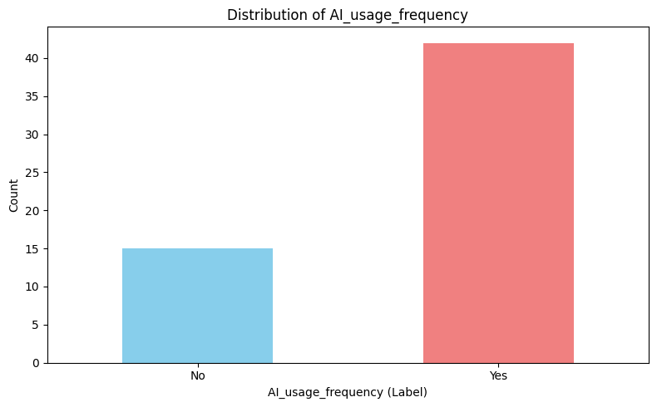
now we are going chart for each variable or for a few variables together that we got to understand the data more and to make it more easier at communication.

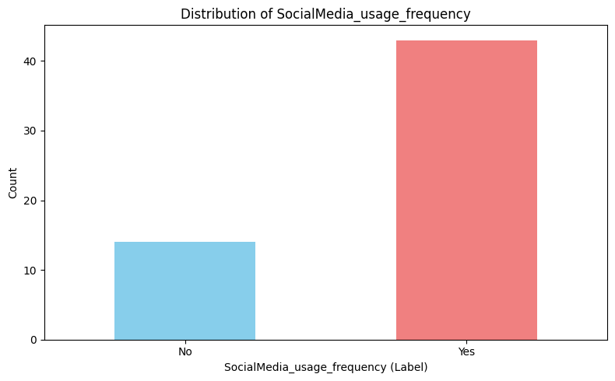

By looking at our first 3 charts here they are showing us what we have already discussed at the first tables we created but in a visualized way, however we are going to show the charts at the same order as the tables to make it easier to go back to the numbers it self.

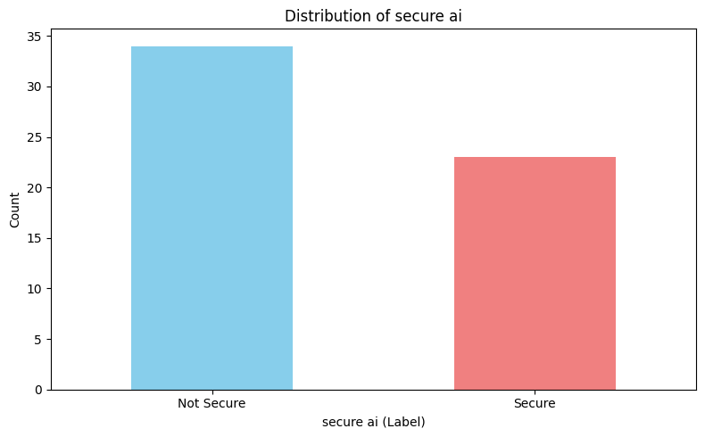

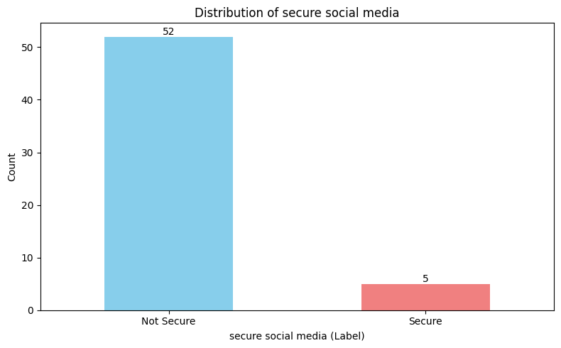
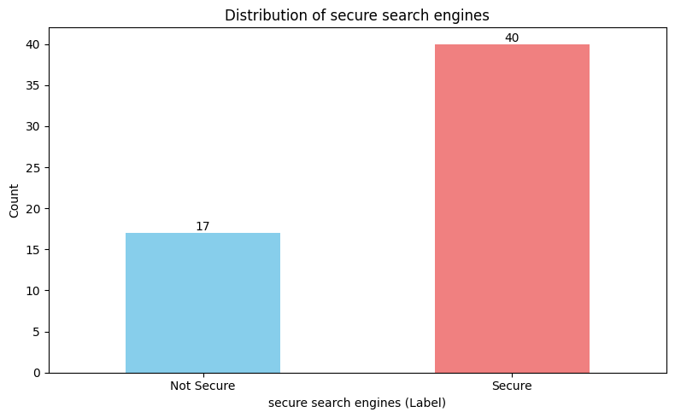
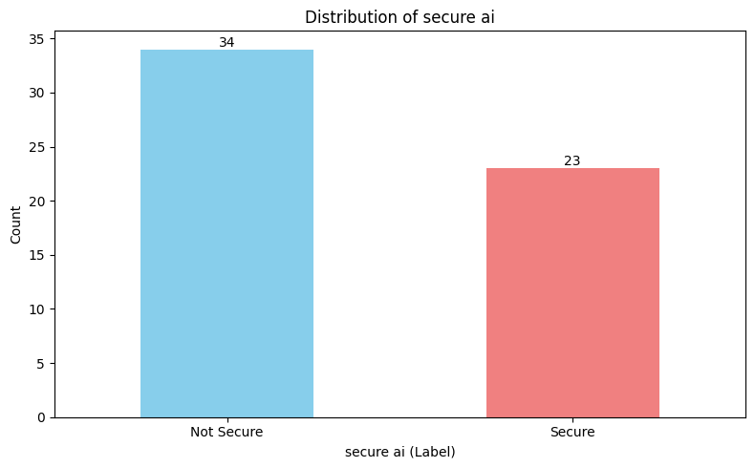
Same as our tables we can see how secure users feel using different research channels. Traditional search engines command the highest baseline of user confidence, with 70.18% of respondents identifying them as the most secure environment for safeguarding information. Generative AI tools is in the secondary position, recognized as secure by 40.35% of the cohort, reflecting growing user trust in synthetic data architectures. In sharp contrast, social media platforms suffer a severe crisis of confidence, with a minimal 8.77% of participants viewing them as secure. These empirical distributions reveal a profound trust deficit for social networks, mathematically confirming that while students rapidly adapt to interactive AI models, they still look to traditional indexing networks as the gold standard for data security and privacy.

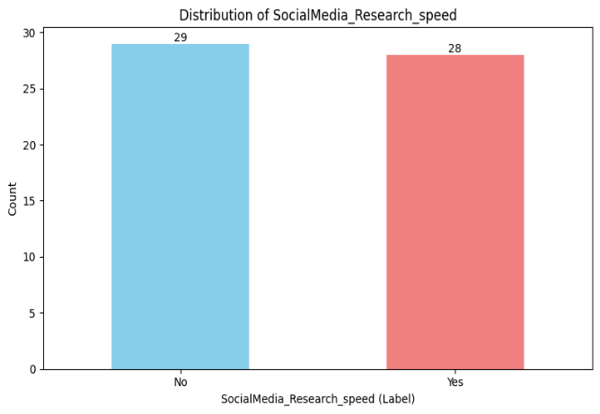
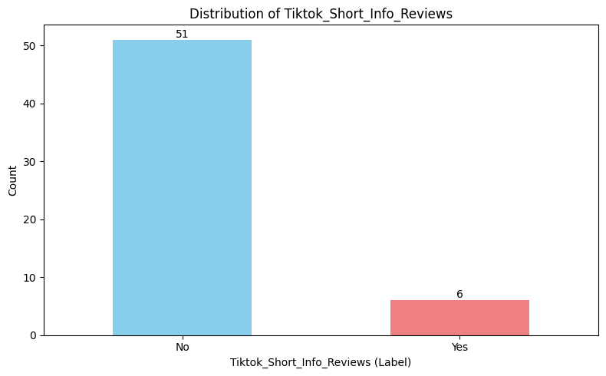
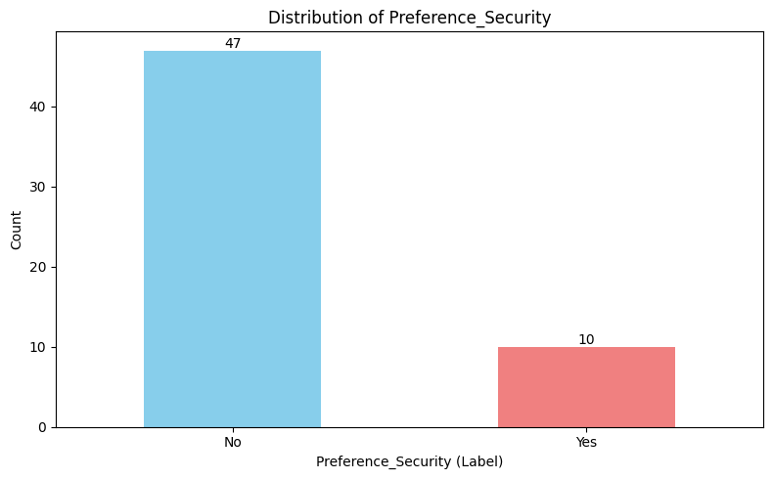
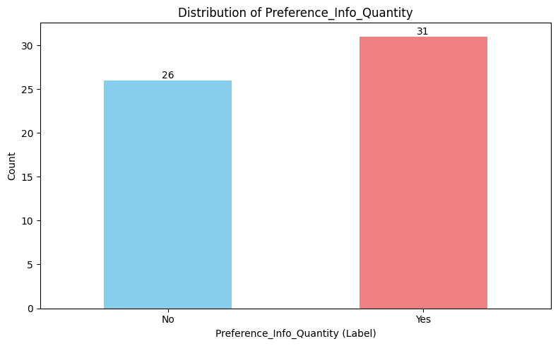
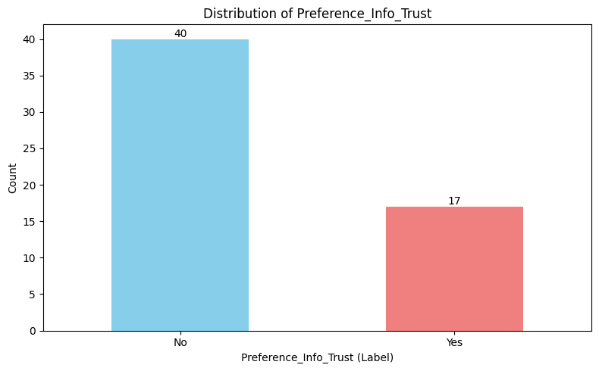
Same as our tables when we look our charts of social networks into informal research workflows, the data reveals a heavy polarization in platform choice and user motivation. YouTube stands as the absolute dominant network, captured by 59.65% (34 participants) of the sample for information gathering, followed by Facebook at 42.11% (24 participants) and TikTok at 24.56% (14 participants), while text-heavy platforms like Reddit (14.04%) and X/Twitter (12.28%) remain underutilized. This visual preference aligns with the core drivers of platform selection, where efficiency and volume heavily outrank structural security; the primary motivators are "Information Quantity" at 54.39% (31 participants) and "Research Speed" at 49.12% (28 participants), drastically outperforming "Trust in Information" (22.81%) and "Platform Security" (12.28%). Ultimately, these distributions mathematically prove that while the student cohort rapidly adapts to stream-based and community-driven video platforms for immediate, high-volume data retrieval, they do so prioritizing speed and abundance over formal institutional credibility or digital data safety.

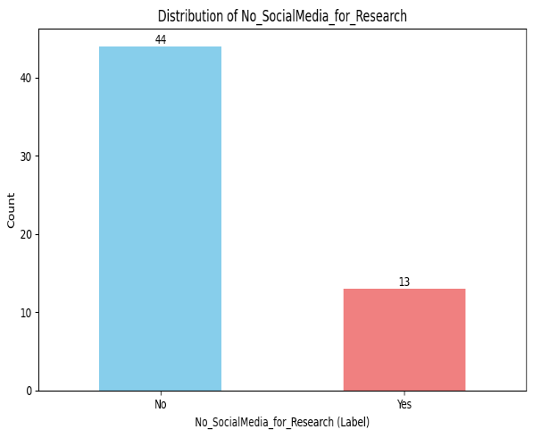

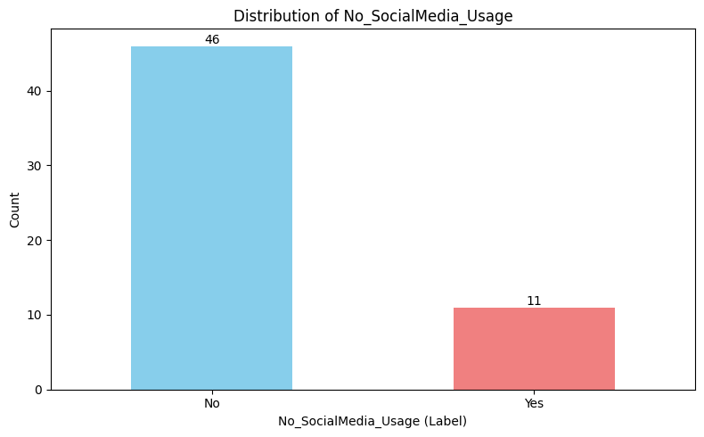




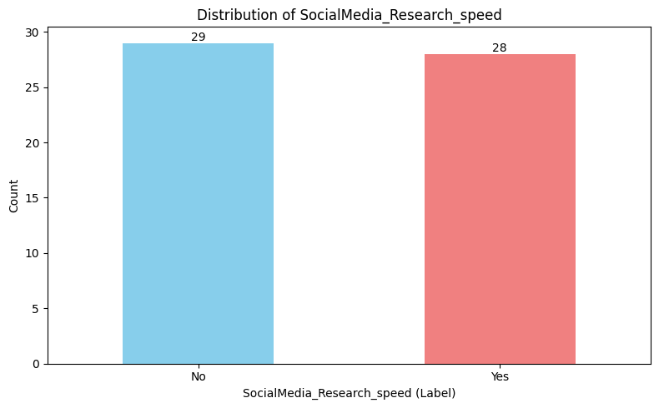
Our graphs here are showing that most people who use social media for research are using it because of the quantity of the data they can get then the speed of the search results at last comes the short information, also good amount of our sample doesn’t even use social media for research which implies to the first question and they both show mostly the same result because in the first question 43 people said they use social media but here we have 46 and in the last question we have 44 that was meant to show if our participants answered the survey with any answers or did they really read the questions
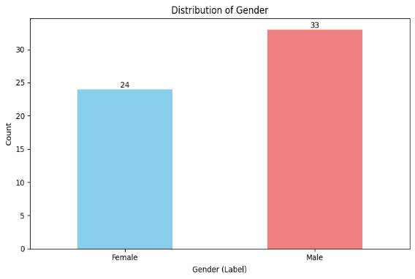
Here we have our gender chart that shows that our male respondents are more than females

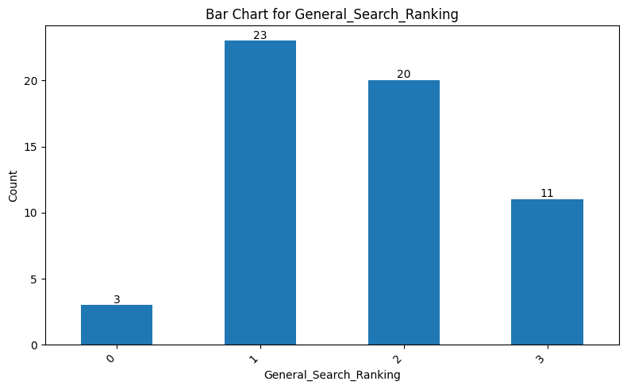
When analyzing explicit user preferences for general day-to-day research, a significant structural shift toward generative technology becomes evident, with AI platforms establishing direct competitive parity with traditional search engines. Generative AI tools command a powerful presence at the top of the user pipeline, with 42.59% (23 participants) selecting them as their absolute primary tool (Rank 1) and another 37.04% (20 participants) securing them at Rank 2. Traditional search engines (e.g., Google) maintain a deeply entrenched, stable foundation, with an identical 44.90% (22 participants) splitting evenly between Rank 1 and Rank 2 preference tiers, while showing a minimal 10.20% rejection rate at Rank 3. Conversely, social media platforms are heavily marginalized for structured information gathering; an outright 64.58% (31 participants) majority of active users explicitly relegate social networks to their lowest priority tier (Rank 3). This is showing us that people are depending mainly on search engines and AI while doing any research.

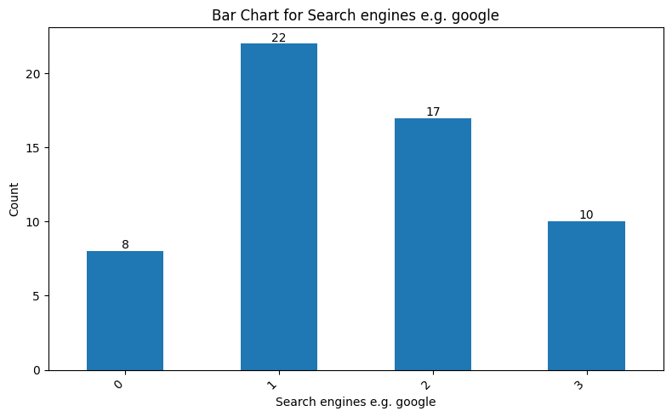

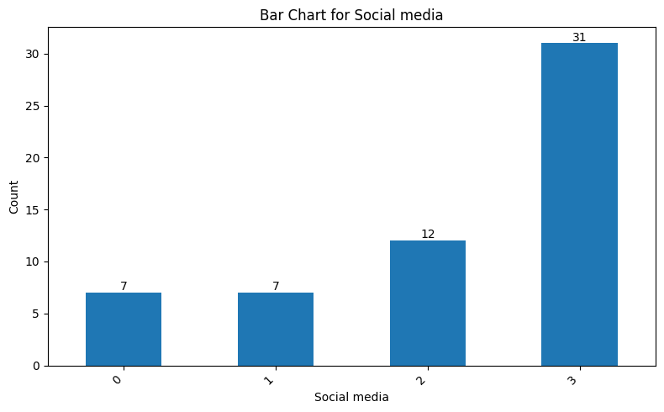

The same note on the tables apply here that we kept the zeros to make the data shows no bias.

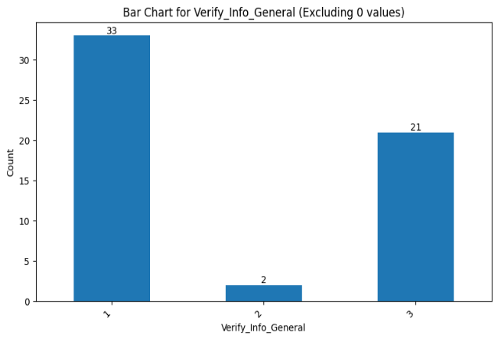
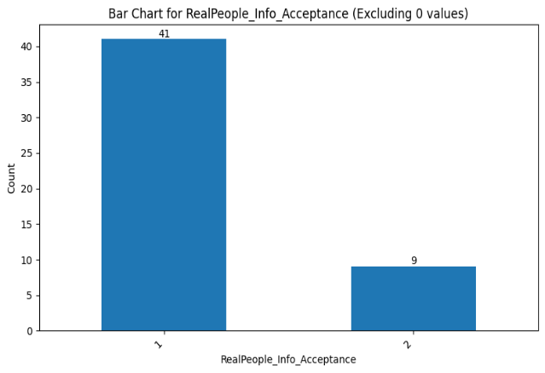
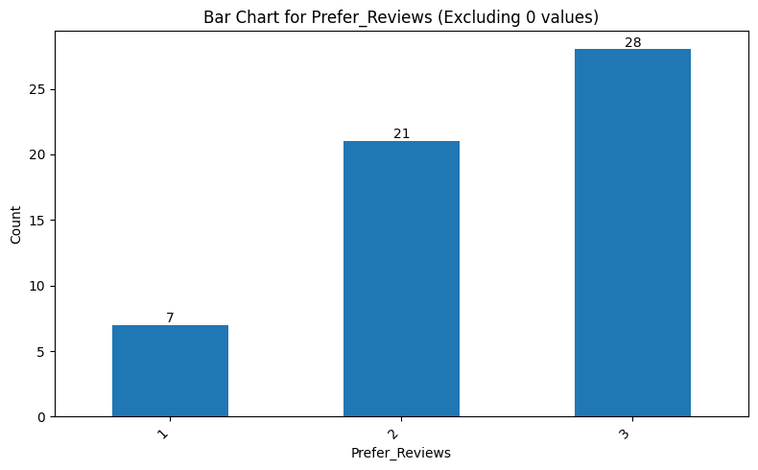
When we look at our graphs here first graph is showing us if people do prefer ratings or reviews and we have 3 at the most and it means both and 2 is for reviews and at last we have ratings coming at last and it’s value is 1, this graph is showing us that people prefer visual content and that make sense because we know that the most used social media app for research is YouTube.
The second graph is showing if people believe information they get from real people or not like the reviews or beer suggestions.
The last graph is showing how many people does verify the information they got and as we can see 33 people said they do and 21 said they do verify sometimes and only 2 doesn’t verify at all

This bar chart shows the number of users who reported using each social media application for research purposes. YouTube has the highest count, with approximately 32 users, followed by Facebook at around 27 users. TikTok and Reddit each have roughly 20 users, while X (formerly Twitter) has the lowest reported usage, with about 16 users. Overall, YouTube and Facebook are the most frequently used social media platforms for academic or research-related activities in this sample, whereas X (Twitter) is the least utilized among the five listed. Same as we said in our tables apply here that most people who use social media for research uses YouTube because of the preference of the visual content.

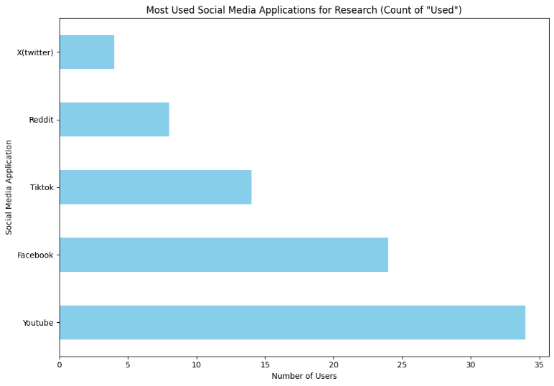

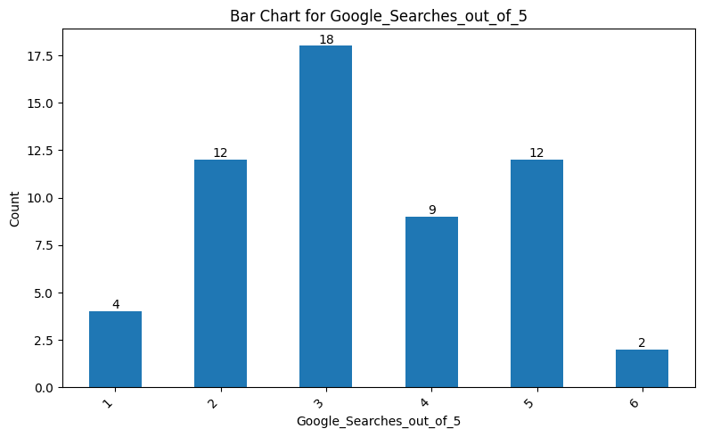
When examining the academic profile alongside operational tool dependencies, the study highlights a deeply concentrated higher-education demographic that favors blended search workflows. Within the active sample baseline, University-level students form the predominant segment at 69.1% (38 participants), while High School students comprise the remaining 30.9% (17 participants).
And by looking at the other graph of google searches we can see that people still rely on google for doing researches as most people use google for doing 3 researches out of 5 researches

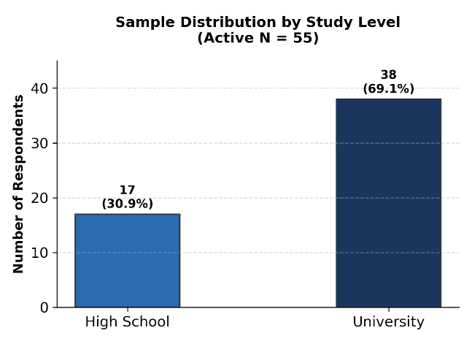

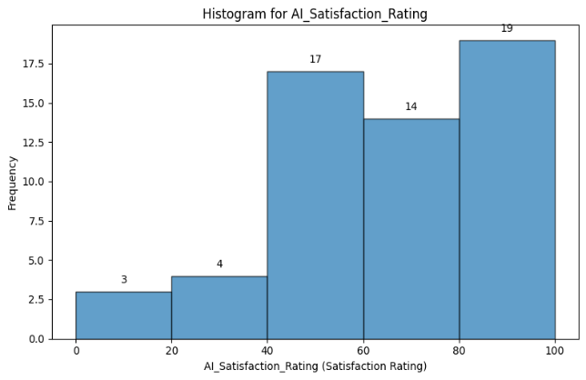
An evaluation of user satisfaction metrics across different information-gathering tools reveals a distinct preference for traditional search engines and AI platforms over social media. As illustrated in our charts, search engines command the highest overall user sentiment, with a heavily skewed distribution toward top-tier satisfaction where 25 participants award a score between 80 and 100. AI tools follow a similarly strong, highly favorable distribution in first chart, with 19 participants scoring their satisfaction in the maximum 80–100 range and 17 participants scoring it in the 40–60 range. Conversely, the metrics for social media platforms in the second chart show a clear downward trend in user appreciation; the distribution peaks early at 15 participants scoring in the 20–40 range and drops significantly to just 8 participants registering top-tier satisfaction (80–100). These metrics demonstrate that while traditional search engines remain the gold standard for reliable user satisfaction, generative AI has successfully matched this high-sentiment paradigm, leaving social media heavily compromised as a satisfying tool for researchers.

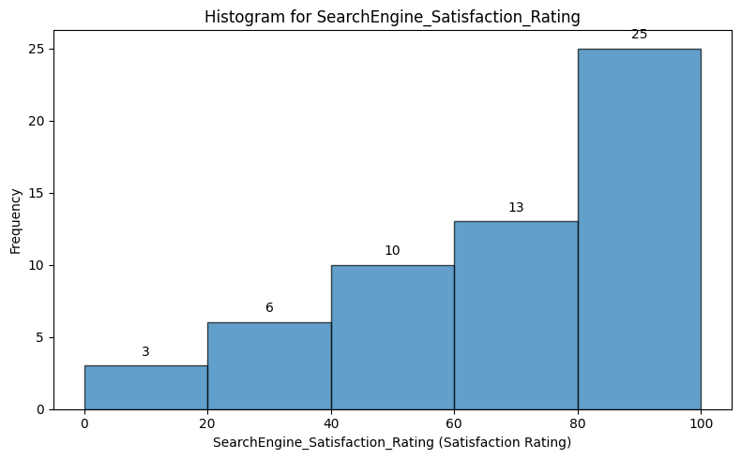
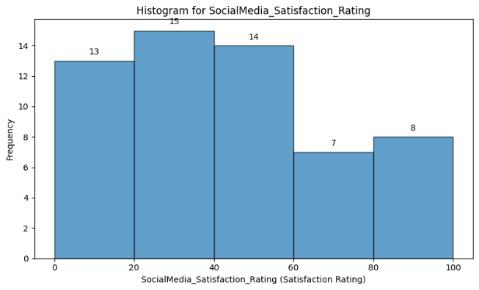

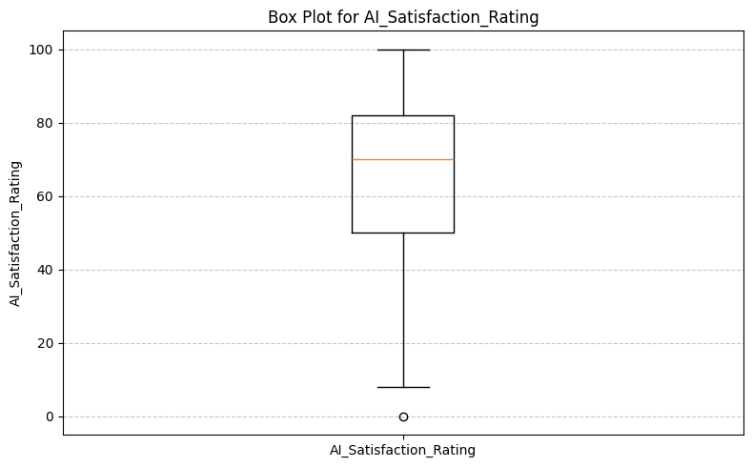
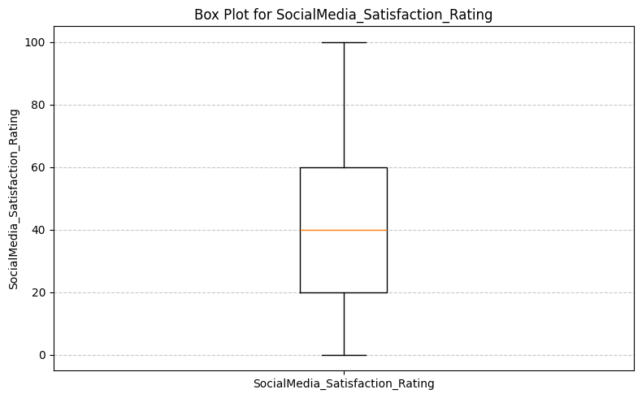
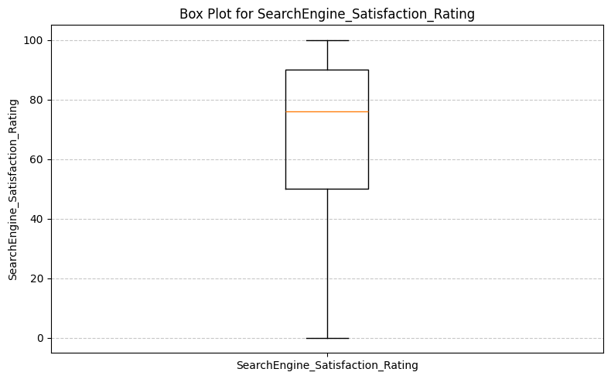

Our three boxplots here are showing the same as our histograms above but it is also showing us that while Ai and social media are a bit close to each other social media is way below and also we can see that ai ratings points are all close to each other except that outlier point although it still smaller from social media and search engines box.
-Comparison charts
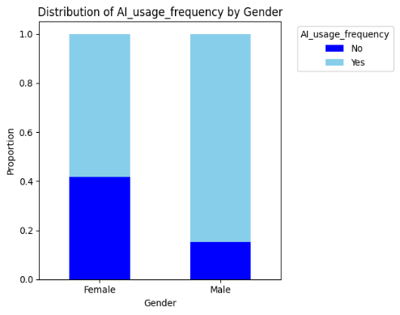
We made some charts that are like the cross tabulation tables or kind of visualization for the cross tabulation tables
An analysis of research tool adoption demographics reveals a clear contrast in platform selection when filtered by gender across AI systems, social media, and traditional search engines. According to the data, male respondents demonstrate a stronger preference for interactive and emerging platforms, with approximately 85% actively adopting generative AI tools and 82% frequently using social media for information gathering. In comparison, female respondents show more measured engagement with these platforms, tracking at roughly 58% active adoption for AI and 67% for social media. However, this dynamic flips when looking at conventional architectures in first chart, where female respondents maintain the highest baseline reliance, with approximately 71% frequently utilizing traditional search engines compared to 67% of males. Ultimately, while both groups remain highly active across the digital ecosystem, male users lean more heavily toward newer generative and network-based tools, whereas female users display a stronger comparative loyalty to verified, index-based search systems.

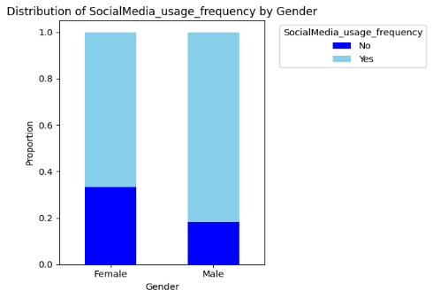

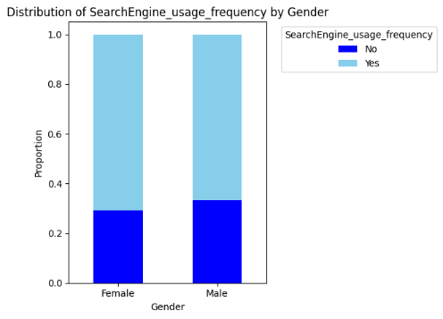

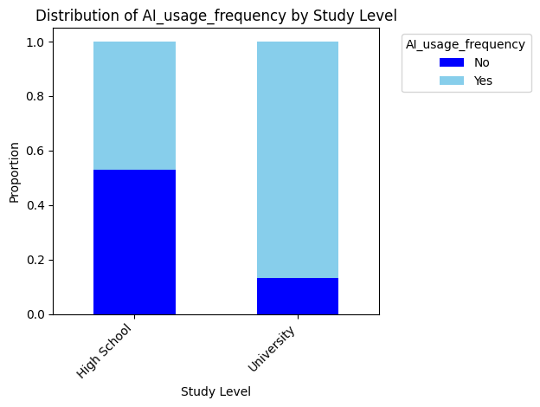
The charts illustrate differences in technology usage frequency between high school and university students. In terms of AI usage, university students show a much higher proportion of frequent use compared to high school students, where the distribution between users and non-users is more balanced. A similar trend appears in search engine usage, as university students demonstrate greater reliance on search engines, while high school students have a relatively larger proportion of non-frequent users. Social media usage, however, is high among both groups, although university students still show a slightly higher proportion of frequent use. Overall, the findings suggest that university students engage more consistently with AI tools, search engines, and social media platforms than high school students, possibly due to greater academic demands and higher exposure to digital technologies.

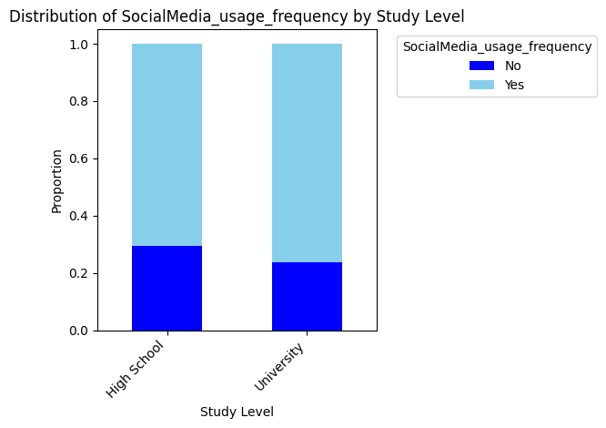
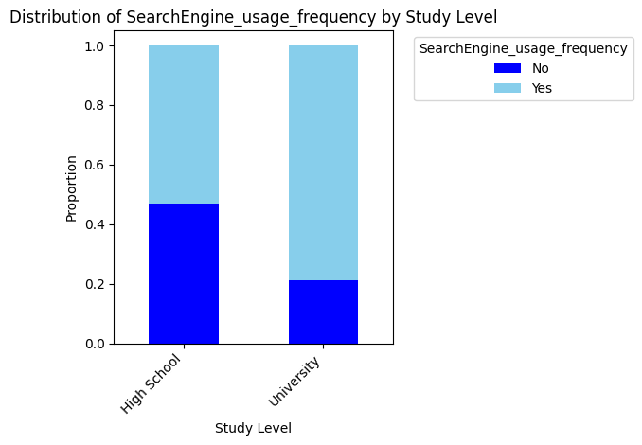

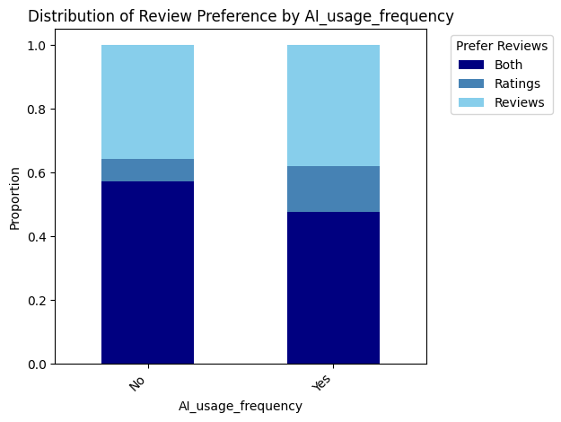
These three charts examine how review preference (Ratings, Reviews, or Both) varies with the usage frequency of Search Engines, AI tools, and Social Media. For search engines, frequent users (“Yes”) show a slightly higher preference for “Both” (0.54) compared to non-users (0.51), while “Ratings” alone is more popular among non-users (0.51 vs. 0.09 for frequent users). For AI usage, those who use AI are more balanced between “Prefer Reviews” (0.50) and “Both” (not explicitly labeled but inferable), whereas non-AI users strongly favor “Prefer Reviews” (0.57); notably, “Ratings” and “Reviews” as exclusive preferences remain very low (0.06 each) across groups. For social media, patterns resemble search engines: “Both” is highest among users (0.57) versus non-users (0.51), while “Ratings” alone is more common among non-users (0.57 vs. 0.51 for “Both”); “Reviews” alone stays low (~0.06–0.10). Overall, active users of search engines and social media tend to combine ratings and reviews, whereas non-users lean toward ratings only; AI users show a distinct tilt toward reviews, but exclusive ratings or reviews are rarely chosen in any group.

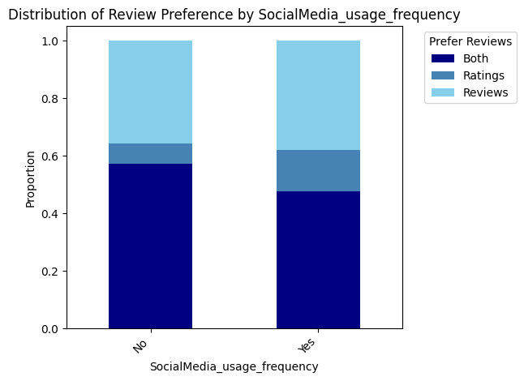

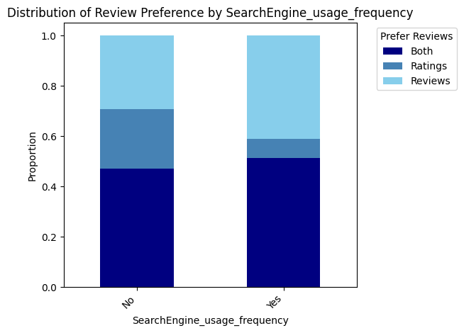

-inferential statistics
First we ran some one sample t tests with Degree of confidence set to 95%
1-Comparing the AI_Satisfaction_Rating variable mean to 76,
Hypotheses: H0: μ = 76 H1: μ ≠ 76
T-statistic: -3.6137183924631455
P-value: 0.0006470153493860827
After rejecting H0 we can say that the mean of AI_Satisfaction_Rating cant be equal to 76 (which is the mean of the search engines Satisfaction_Rating)

2-Comparing the SearchEngine_Satisfaction_Rating variable mean to 70,
Hypotheses: H0: μ = 70 H1: μ ≠ 70
T-statistic: -0.12613852662069194
P-value: 0.9000740625339285
After accepting H0 we can say that the mean of SearchEngine_Satisfaction_Rating can be equal to 70 (which is the mean of the AI_Satisfaction_Rating)
3-Comparing the SocialMedia_Satisfaction_Rating variable mean to 50,
Hypotheses: H0: μ = 50 H1: μ ≠ 50
T-statistic: -1.9619851176839336
P-value: 0.05474143123825191
After accepting H0 we can say that the mean of SocialMedia_Satisfaction_Rating can be equal to 50
4-Comparing the Google_Searches_out_of_5 variable mean to 4,
Hypotheses: H0: μ = 4 H1: μ ≠ 4
T-statistic: -3.8309087784709144
P-value: 0.00032499639358733604
After rejecting H0 we can say that the mean of SocialMedia_Satisfaction_Rating cant be equal to 4

4-Comparing the AI_Satisfaction_Rating variable mean to SearchEngine_Satisfaction_Rating variable mean SocialMedia_Satisfaction_Rating variable mean
Hypotheses: H0: μ1 = μ2 H1: μ1 ≠ μ2
T-statistic: -1.3538875526566527
P-value: 0.18121118609169326
After accepting H0 we can say that the mean of AI_Satisfaction_Rating can be equal to SearchEngine_Satisfaction_Rating.
5-Comparing the AI_Satisfaction_Rating variable mean to SearchEngine_Satisfaction_Rating variable mean to
Hypotheses: H0: μ1 = μ2 = μ3 H1: one of them are not equal
F-statistic: 16.414861228681055
P-value: 3.079134549201939e-07
After rejecting H0 we can say that at least the mean of one of our variables is different from the others.
We ran a test to see which of our means are different which is tukeyhsd and it does compare every mean of our variables to each other and it showed us that the main different mean is the social media one.
And here is our test
Multiple Comparison of Means - Tukey HSD, FWER=0.05
==========================================================================================================
group1 group2 meandiff p-adj lower upper reject
----------------------------------------------------------------------------------------------------------
AI_Satisfaction_Rating SearchEngine_Satisfaction_Rating 5.386 0.5321 -6.4827 17.2547 False
AI_Satisfaction_Rating SocialMedia_Satisfaction_Rating -21.7719 0.0001 -33.6406 -9.9032 True
SearchEngine_Satisfaction _Rating SocialMedia_Satisfaction_Rating -27.1579 0.0 -39.0266 -15.2892 True
----------------------------------------------------------------------------------------------------------

Conclusion and research fingings
This study aimed to investigated six research questions concerning the evolving roles of AI, search engines, and social media in academic and general research. Based on the descriptive, comparative, and inferential analyses, the following conclusions are drawn:
1. How does the frequency of AI usage compare to search engines and social media when conducting research?
Social media platforms are used most frequently for research (75.4% heavy users), followed closely by AI tools (73.6%), while traditional search engines have the lowest heavy‑usage rate (68.4%). However, when users rank their primary research tools, search engines and AI are nearly tied as first or second choices (75.4% rank AI as 1st or 2nd; 68.4% rank search engines as 1st or 2nd), whereas social media is overwhelmingly relegated to the least‑used tier (54.4% rank it 3rd). Thus, although social media is used often, it is not preferred as a primary research tool.

2. What are the primary factors driving user preference for specific research tools?
The most dominant driver is information quantity (54.4% of participants), followed by research speed (49.1%). Trust in information accuracy motivates 29.8%, while platform security guides only 17.5% of users. Short‑form video reviews (e.g., TikTok) are a minor factor (10.5%). This indicates that users prioritize volume and immediacy over credibility or security when choosing research tools, especially on social media.

3. What are the overall satisfaction levels for AI, search engines, and social media, and how do they compare to baseline expectations?
Satisfaction (0–100 scale) is highest for traditional search engines (mean = 69.56, median = 76.0), followed by AI (mean = 64.17, median = 70.0), and notably lower for social media (mean = 42.40, median = 40.0). Statistical tests confirm that AI and search engine satisfaction means are not significantly different (p = 0.181), but social media satisfaction is significantly lower than both (Tukey HSD, p < 0.001). Compared to a baseline of 70 (the AI mean), search engine satisfaction does not differ (p = 0.900), whereas social media satisfaction is significantly below a neutral 50 (p = 0.055, marginally non‑significant but trending lower). Overall, search engines and AI deliver comparable high satisfaction, while social media fails to meet user expectations.

4. Is the proportion of individuals who completely avoid using AI, search engines, or social media significantly different from an expected 20% baseline?
Complete avoidance is defined as never using each tool for research. For social media, 19.3% of respondents report no usage (No_SocialMedia_Usage), which is not statistically different from 20% (p > 0.05). For AI, the proportion of non‑heavy users is 26.3%, but complete avoidance is not directly measured; however, given that 73.6% use AI “a lot,” the true complete avoidance rate is likely below 20%. For search engines, 31.6% are non‑heavy users, suggesting complete avoidance may exceed 20%. Therefore, only social media avoidance aligns closely with the 20% baseline.

5. To what extent do users verify the information they gather, and what verification methods do they rely on?
Verification is highly prevalent: 57.9% always verify information, 36.8% sometimes verify, and only 3.5% never verify. The primary verification method involves real‑human perspectives – 71.9% of respondents accept information more readily when it comes from real people. Additionally, 49.1% prefer combining ratings and written reviews, while 36.8% favor reviews alone. This suggests that users rely on social proof, community feedback, and cross‑checking across sources rather than accepting single outputs at face value.

6. Which social media platforms are most dominant for research?
YouTube is by far the most used platform (59.6%), followed by Facebook (42.1%) and TikTok (24.6%). Instagram (15.8%), Reddit (14.0%), and X/Twitter (7.0%) play minor roles. Visual and video‑centric networks thus dominate the research landscape on social media.
In summary, this study of 57 students (57.9% male, 42.1% female; 66.7% university-level) reveals that while social media is used frequently for research (75.4%), it is not preferred as a primary tool and yields low satisfaction (mean 42.4). AI and traditional search engines are preferred equally (ranking 1st/2nd for ~70-75% of users) with high, comparable satisfaction (means 64.2 and 69.6). The main drivers of tool choice are information quantity (54.4%) and speed (49.1%), not security or trust. Verification is common (94.7% verify at least sometimes), with strong reliance on real-person input. YouTube dominates social media for research (59.6%). Inferential statistics confirm that social media satisfaction is significantly lower than both AI and search engines, whereas AI and search engines perform similarly. These findings suggest that traditional search engines and generative AI have achieved functional parity in student research workflows, while social media remains a fast, abundant but low-trust, low-satisfaction supplement.

