King Saud University.

College of Computer and Information Sciences.

Department of Computer Science.

CSC 453 introduction to parallel processing.

Instructor: Dr. Mohammed A. Al-Abdulkareem.

Fall 2020.

**Self-Report**

**Student Name: Hassan Jaafar.**

**Student ID: 438105959**.

|  |  |
| --- | --- |
| ID# | Name |
| 438104708 | Majed Al-khraiji |
| 438102142 | Faisal Al-dhuwayhi |
| 438103307 | Ahmad Al-Mosallam |
| 438100439 | Fahad Al-deham |

**Team Members:**

In this short report, I am going to write my own findings and important notes after working in the project with my team

**Findings:**

|  |  |  |  |  |  |  |
| --- | --- | --- | --- | --- | --- | --- |
| RUN# | p | M | T1 | Tp | Speedup | Efficiency |
| 1 | 1 | 100 | 0.0018 | 0.0018 | 1 | 1 |
| 2 | 2 | 100 | 0.0018 | 0.001 | 1.8 | 0.9 |
| 3 | 3 | 100 | 0.0018 | 0.001 | 1.8 | 0.6 |
| 4 | 4 | 100 | 0.0018 | 0.001 | 1.8 | 0.45 |
| 5 | 1 | 200 | 0.0114 | 0.0114 | 1 | 1 |
| 6 | 2 | 200 | 0.0114 | 0.0058 | 1.965517241 | 0.982758621 |
| 7 | 3 | 200 | 0.0114 | 0.0042 | 2.714285714 | 0.904761905 |
| 8 | 4 | 200 | 0.0114 | 0.0036 | 3.166666667 | 0.791666667 |

small sample

**First of all, it is clear that the parallel code was very efficient for solving the matrix multiplication as it gives a good speedup and efficiency except when the matrix is small in size where whenever we increase the number of processing units (2,3,4) the speedup still the same and of course with decreasing in the efficiency since it is a small problem and all different processing units will result in almost the same time.**

Also, I tried to increase the number of processing units from 4 to 8 on size 2000 and see if there is a difference or not and this what I found

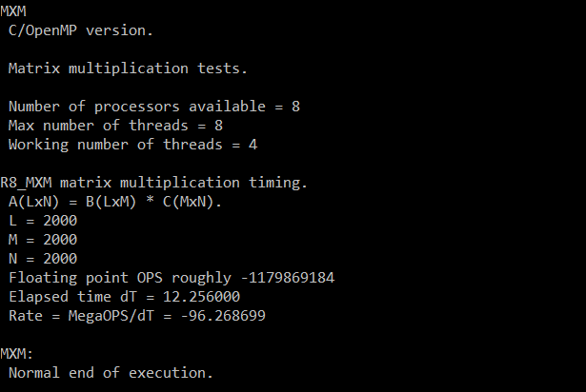

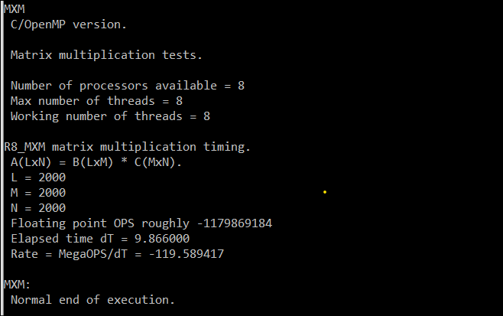

As shown above running on 4 gives us a speedup of 3.13 and efficiency of 0.78 on the other hand running it on 8 gives us 3.89 with efficiency equal to 0.49 which is clearly implies that we don’t utilize the power of increasing the processing units, because there is a limitation that can’t be exceeded after a certain number of processors and this limitation could happen for some reasons for example, the nature of the algorithm or limited computational resources.

**Potential enhancements:**

There are different ways I want to try to see if it can improve the code:

1- using padding solution to make sure that the elements for one processing unit is in one cache for preventing false sharing

2- optimizing the memory could help significantly in increasing the parallel algorithm performance for example, Cache friendly algorithm implementation.