APPENDICES

Appendix A: Engineering Drawings (Mechanical)

• A.1. General Assembly (GA) Drawing: The full machine with a Bill of Materials (BOM).
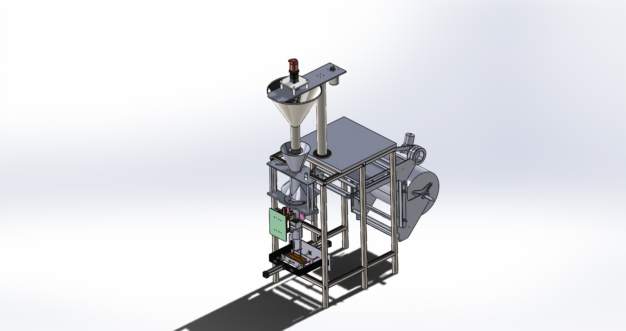

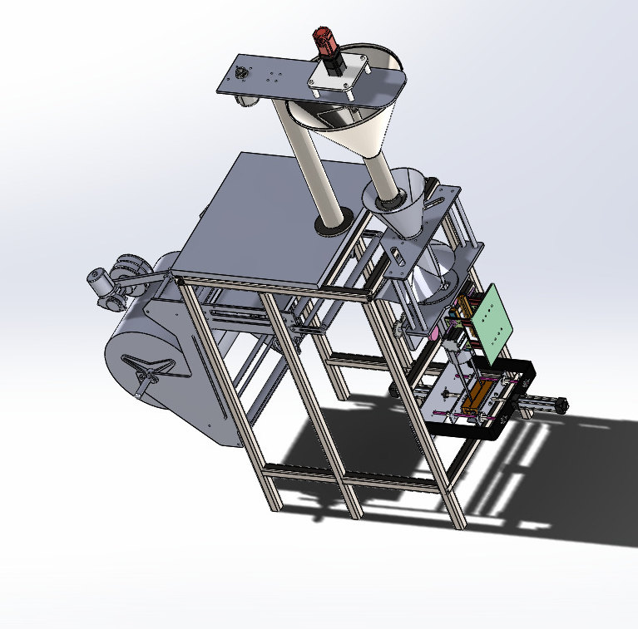
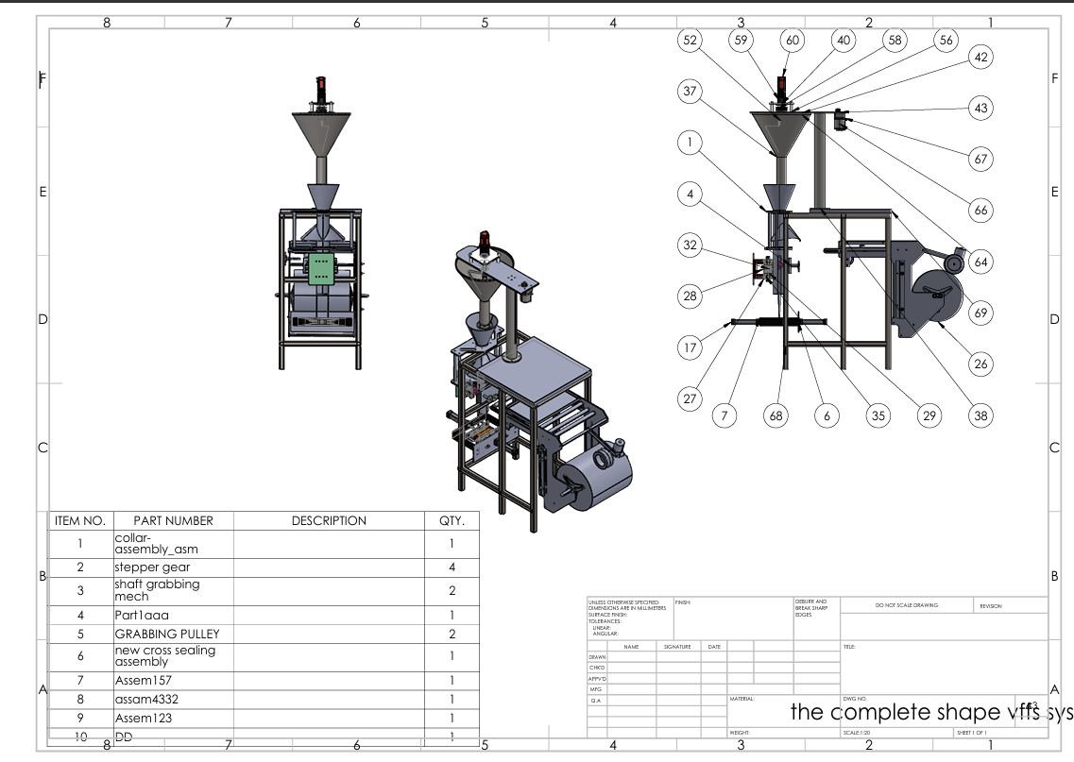

Materials (BOM).

A.2. Sub-Assembly Drawings: Detailed views of the Hopper-Agitator unit and the Drive Train.
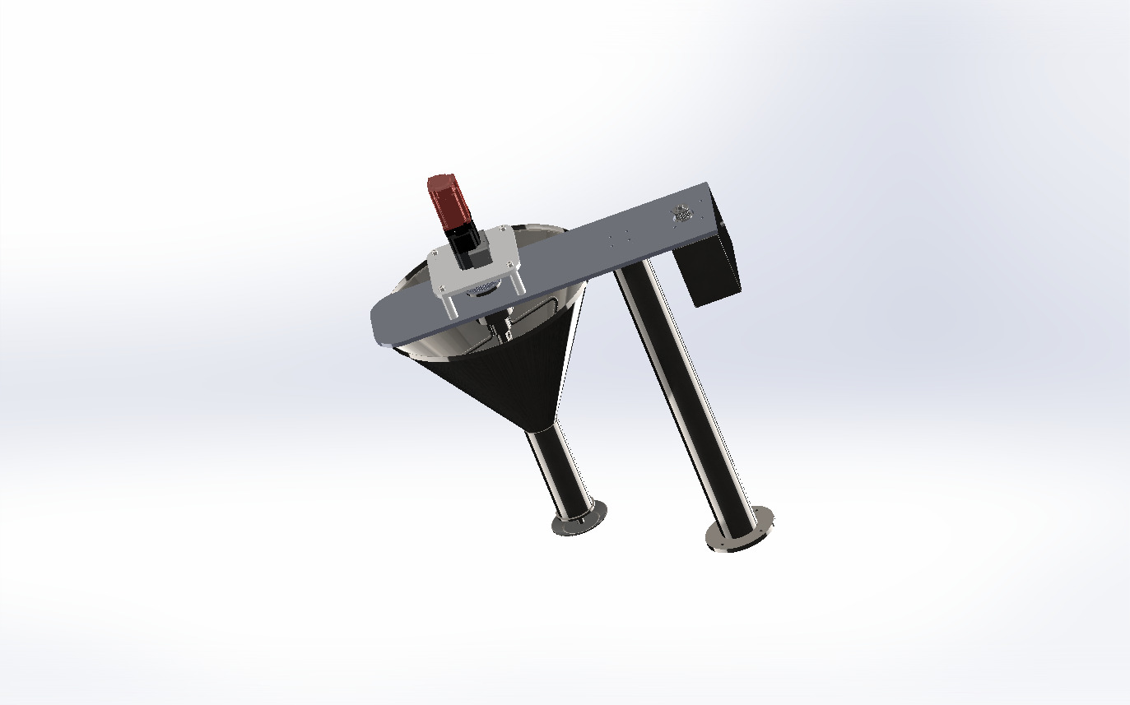
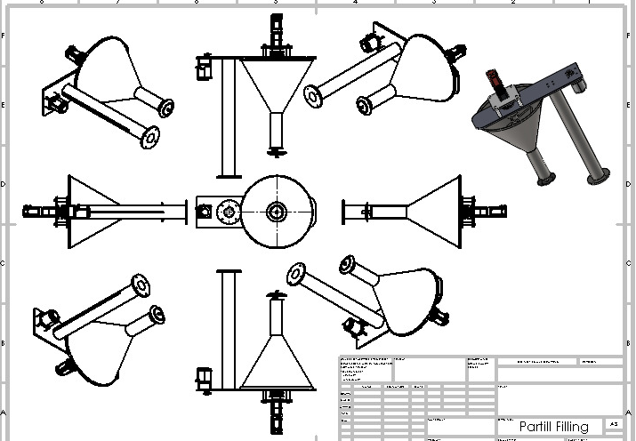

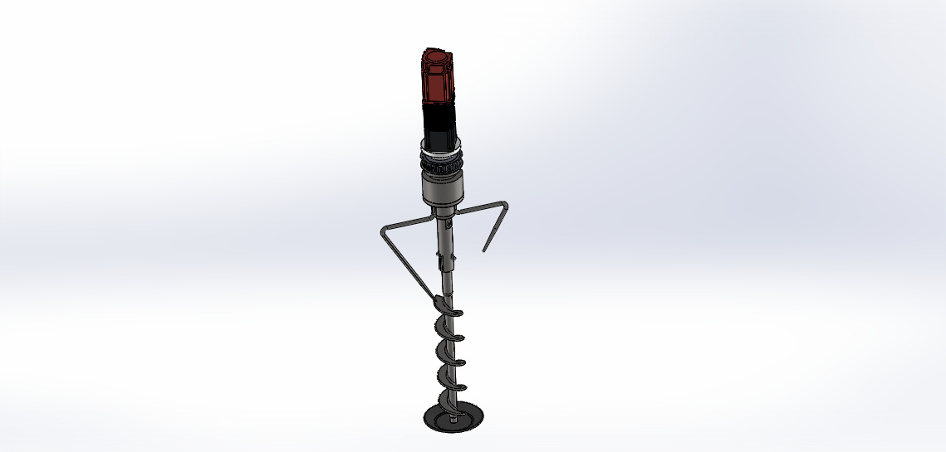

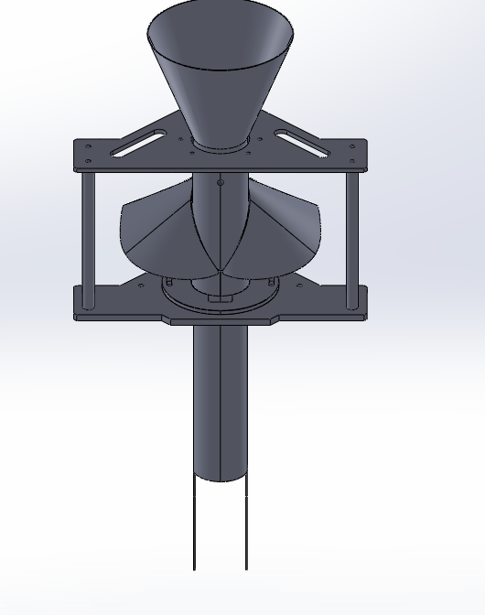

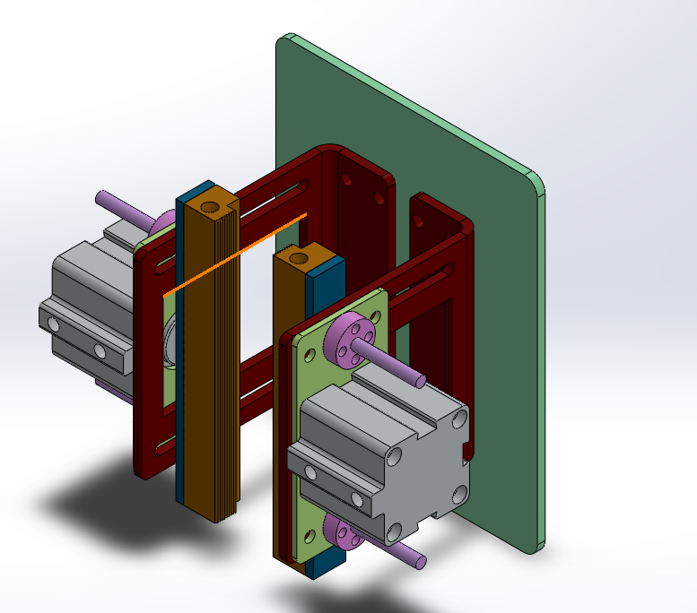

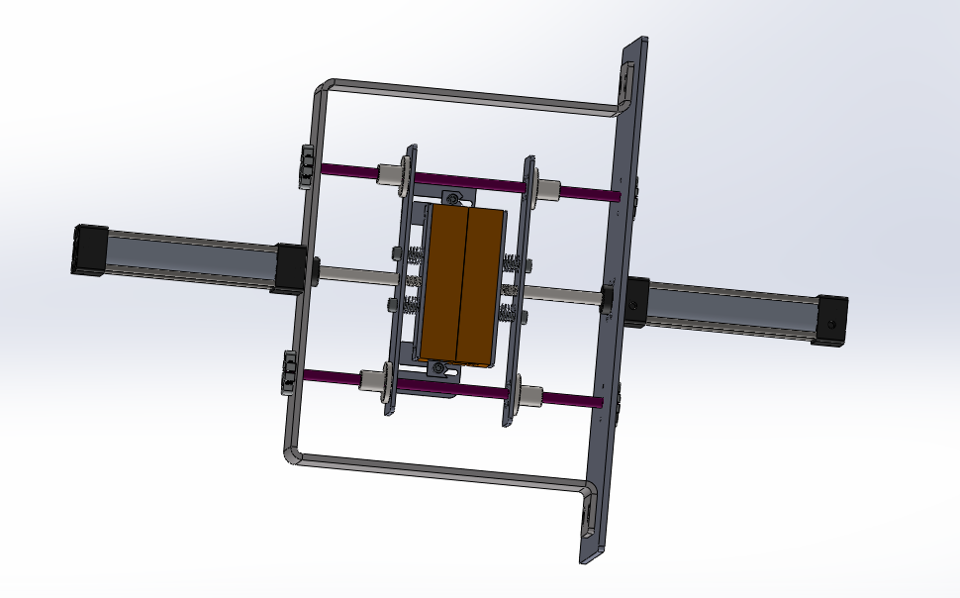

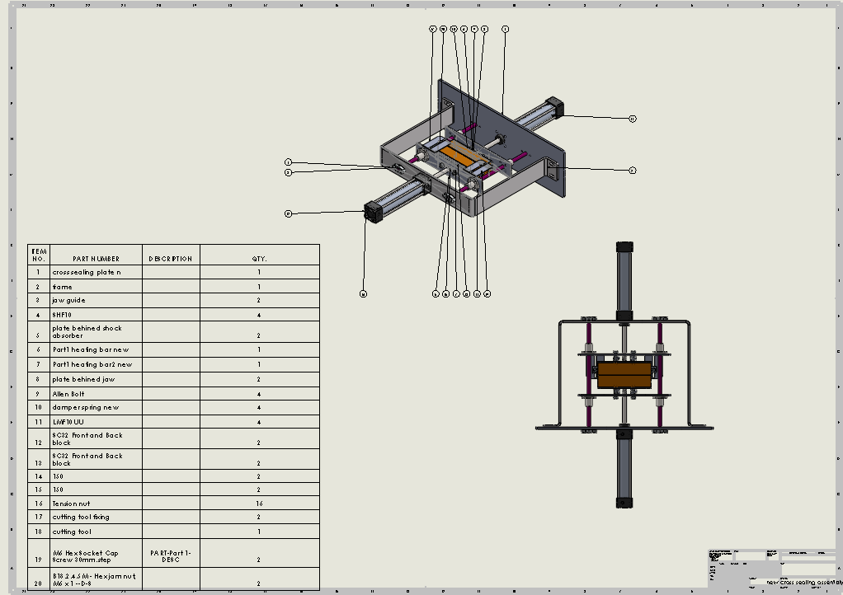

• A.3. Detailed Component Drawings: 2D dimensioned drawings of the Auger Screw (showing pitch and flight details), the Shaft, and the Discharge Nozzle.
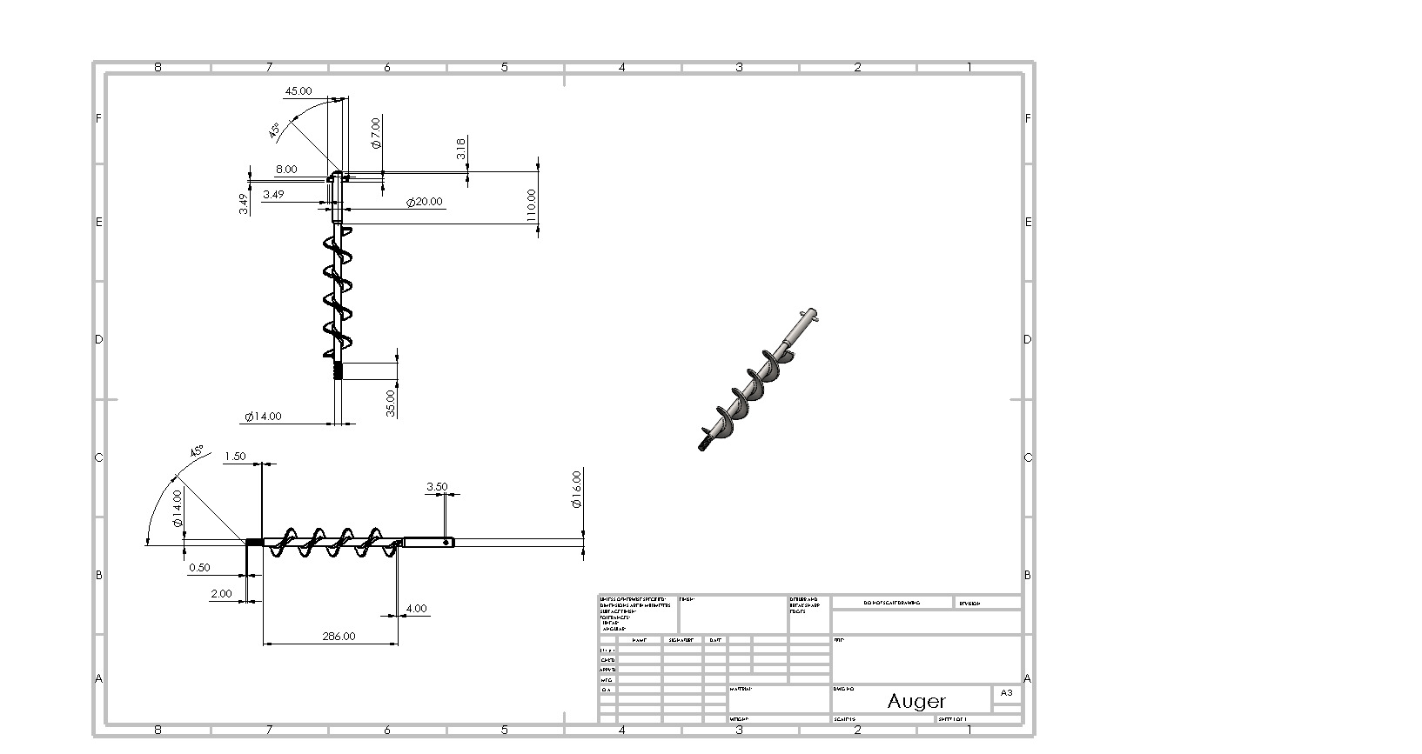
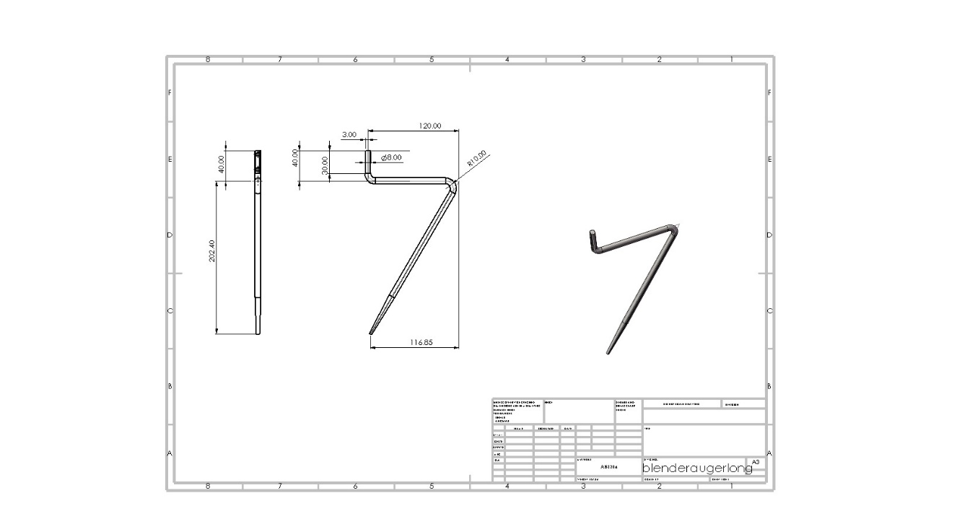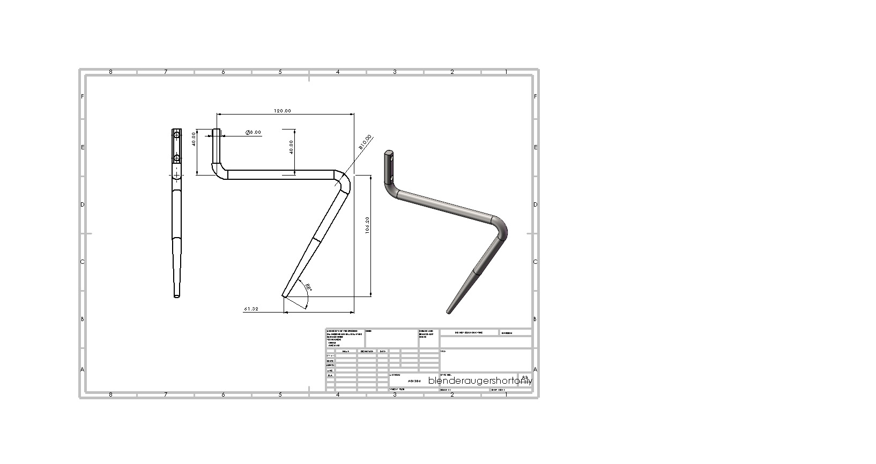
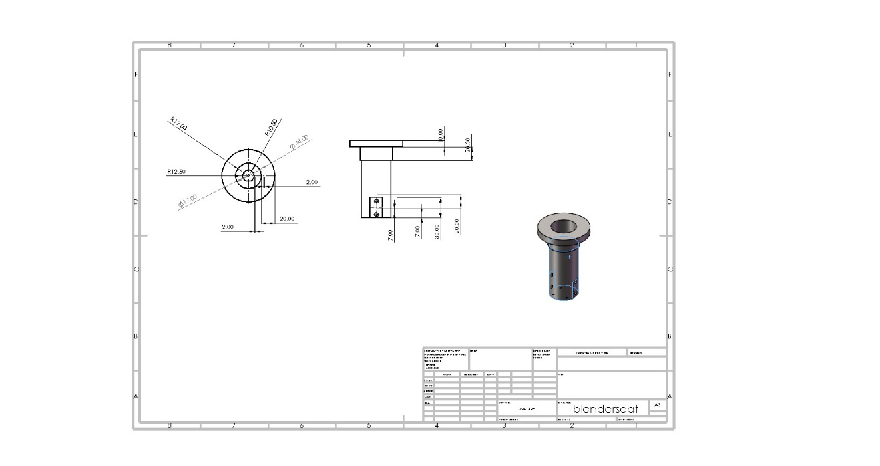
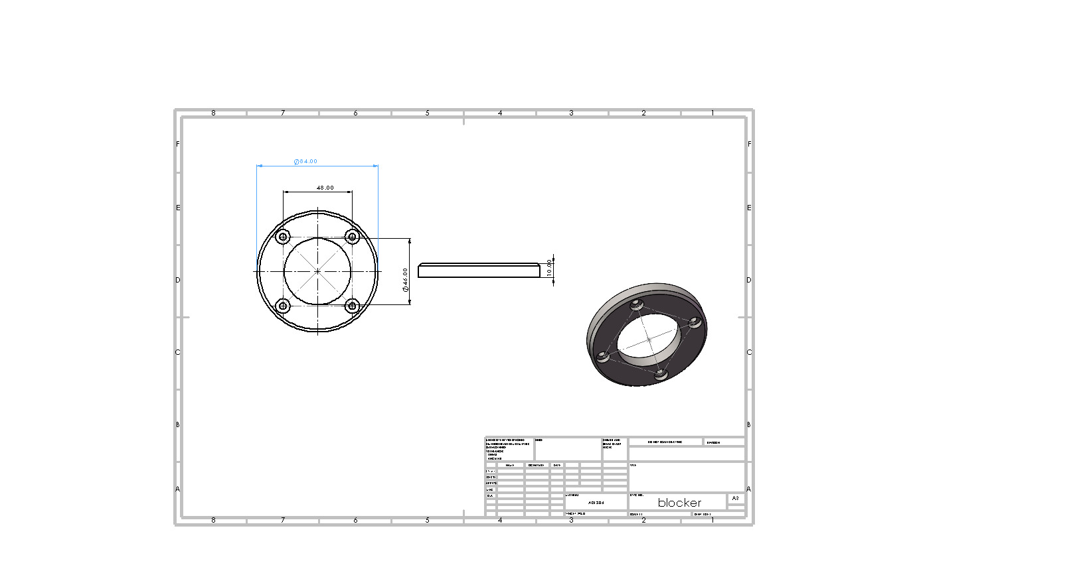

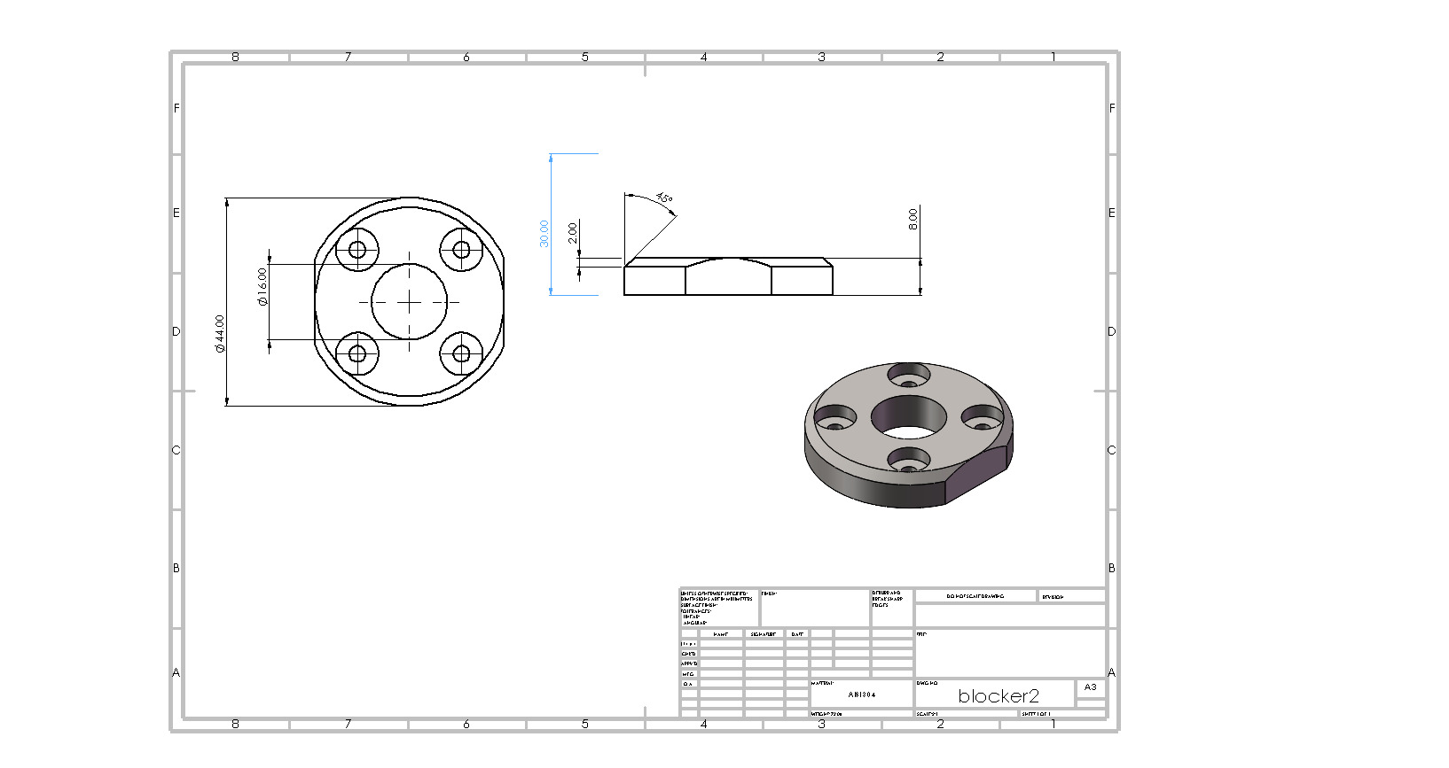
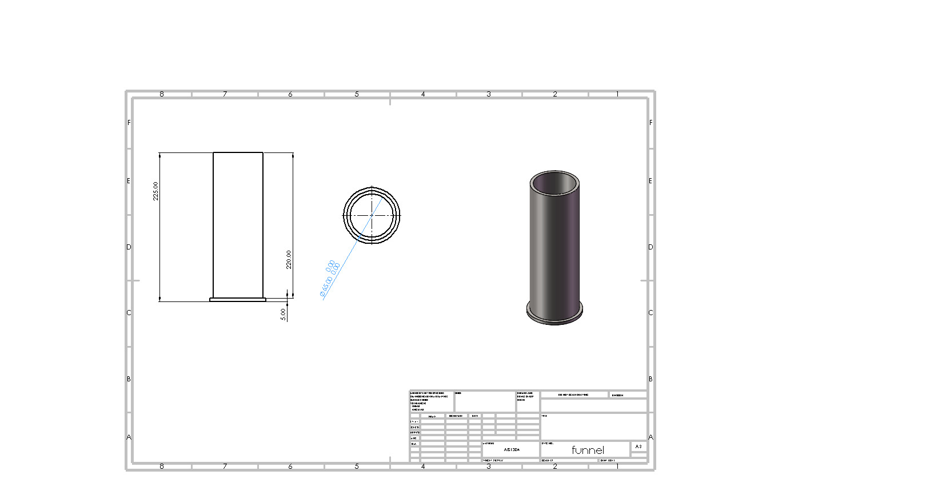
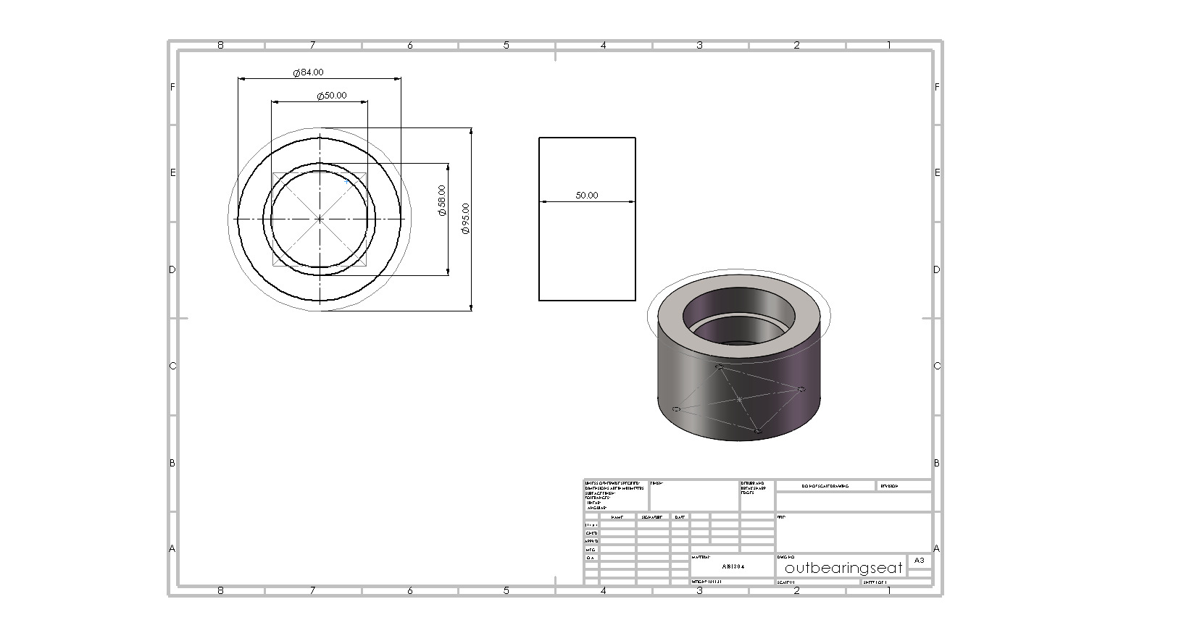
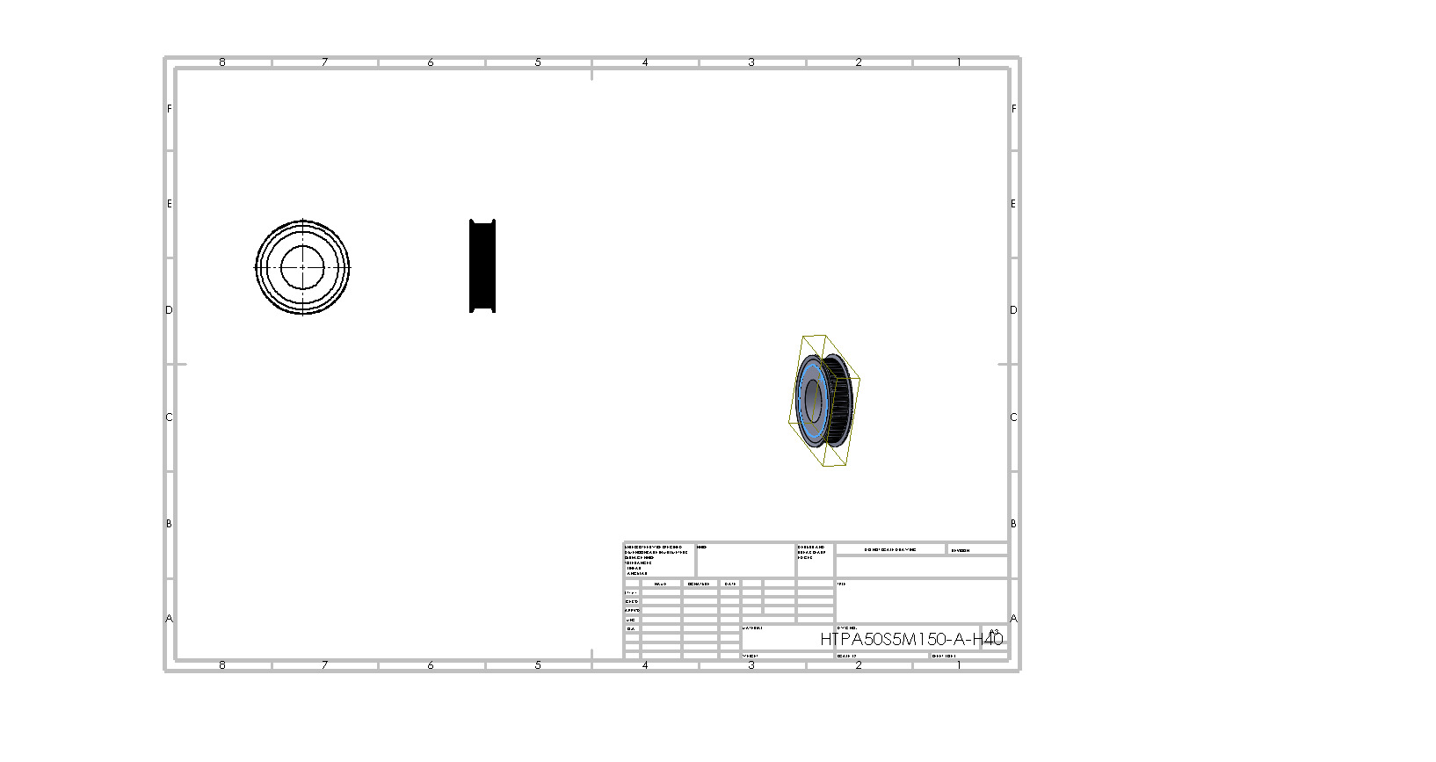
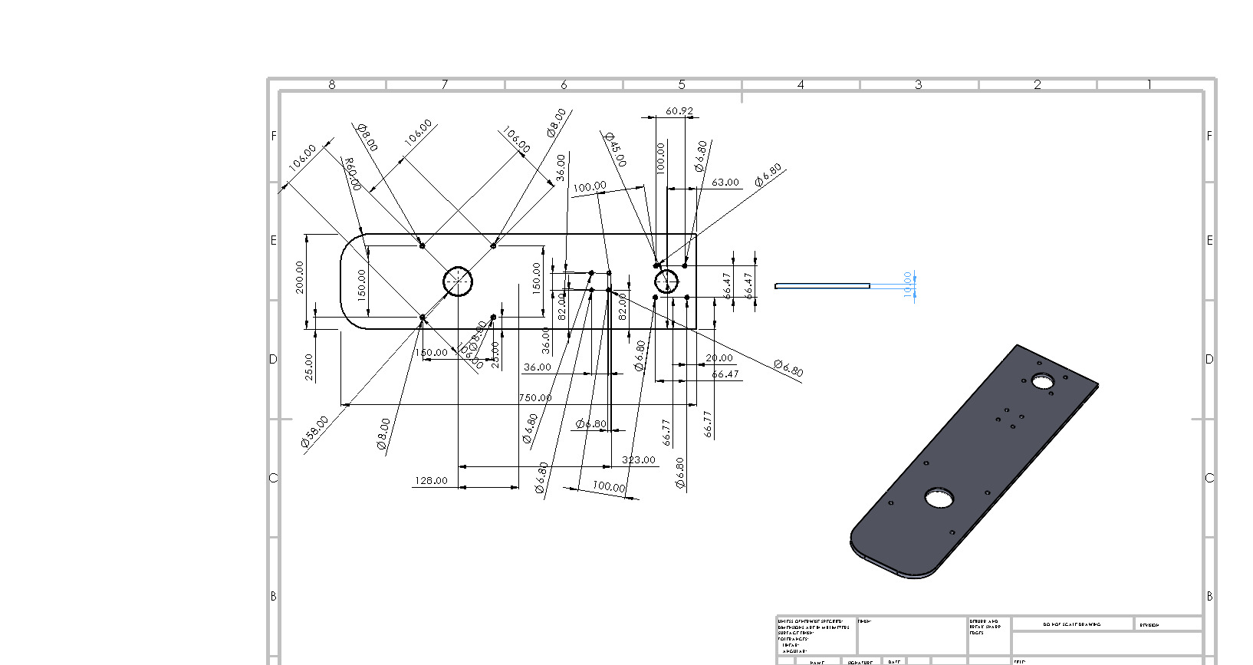
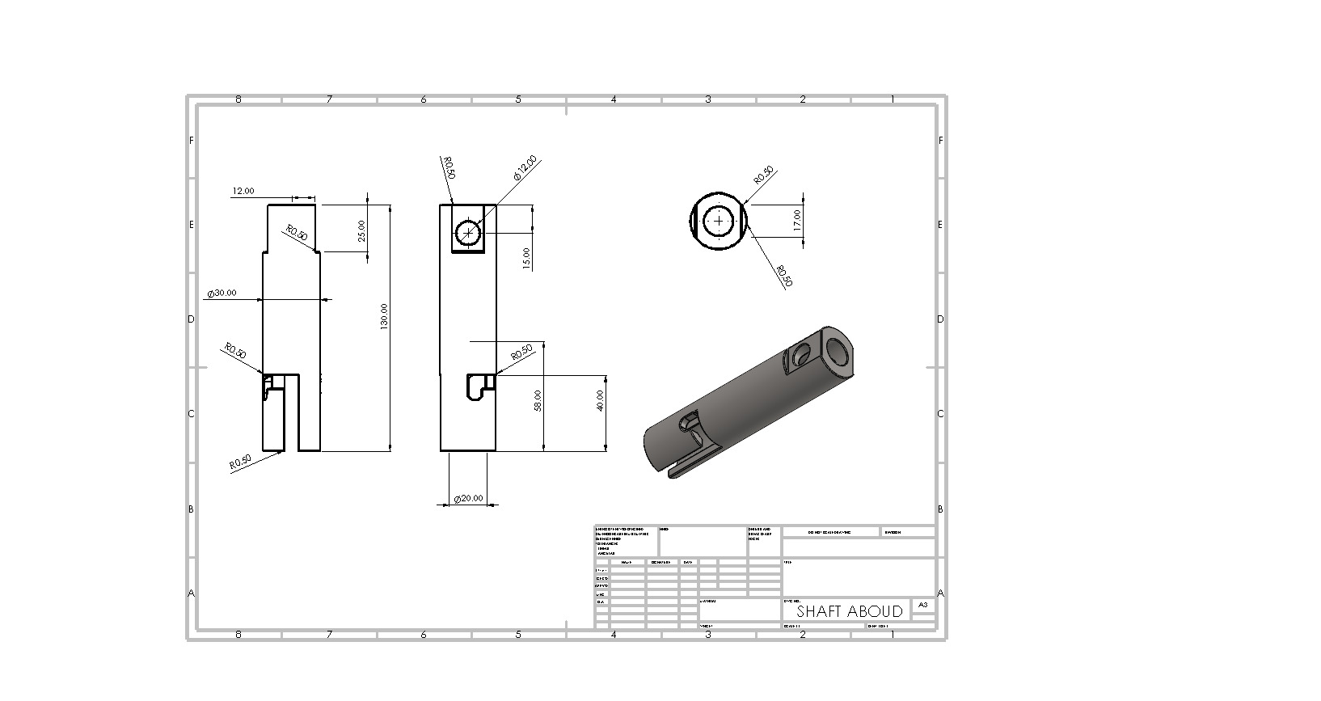
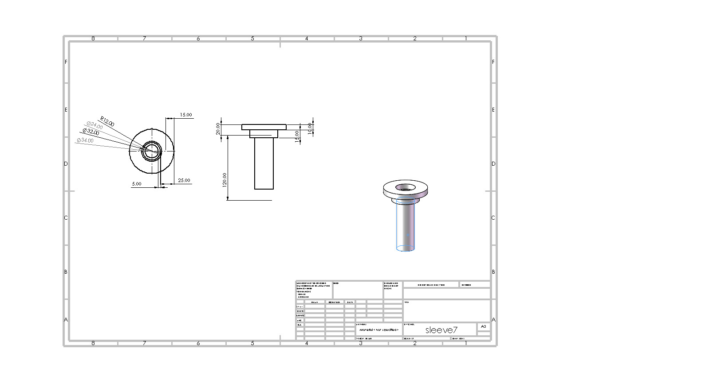
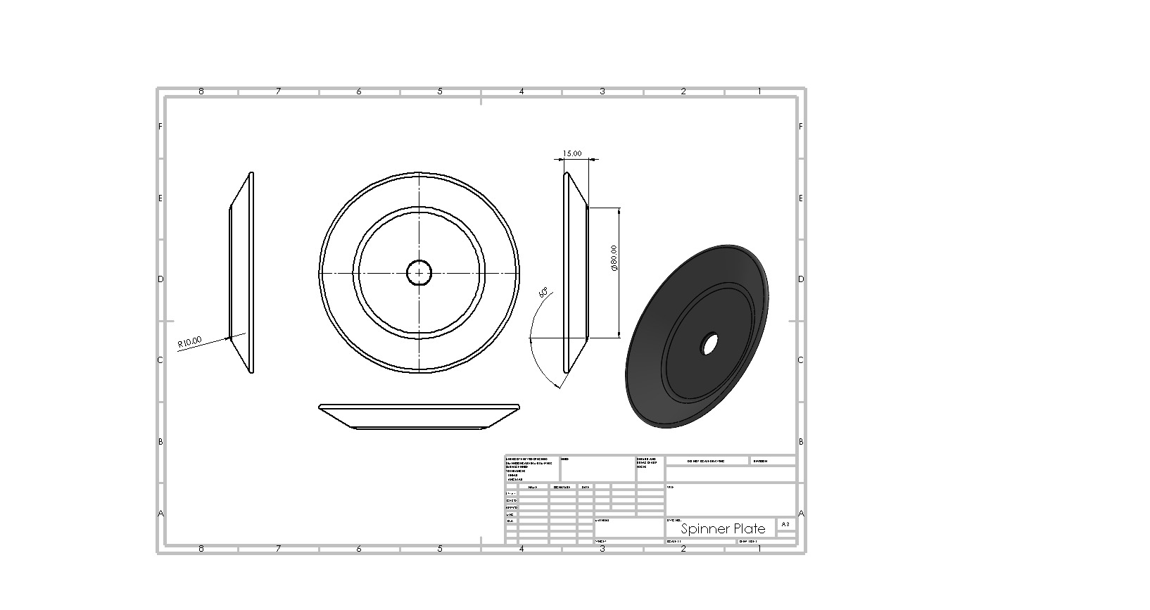
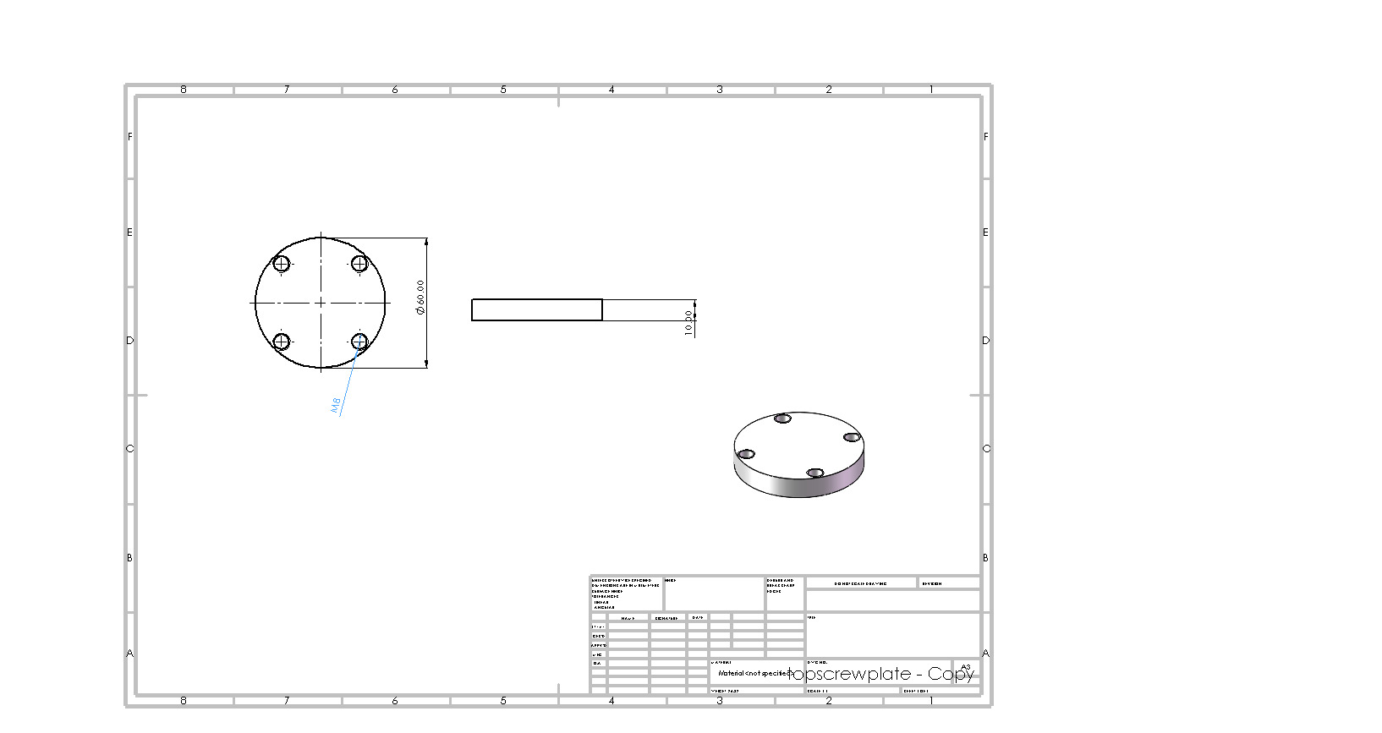
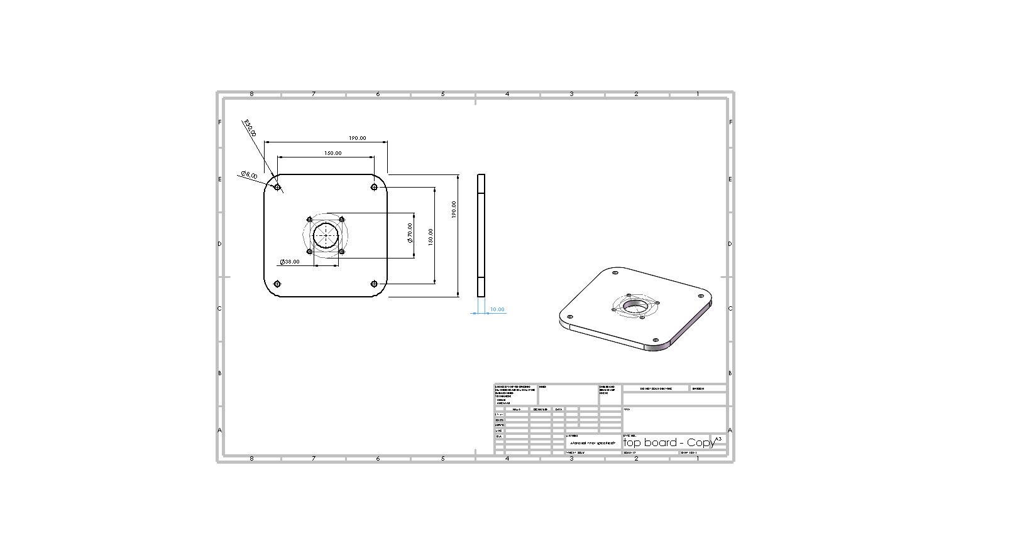
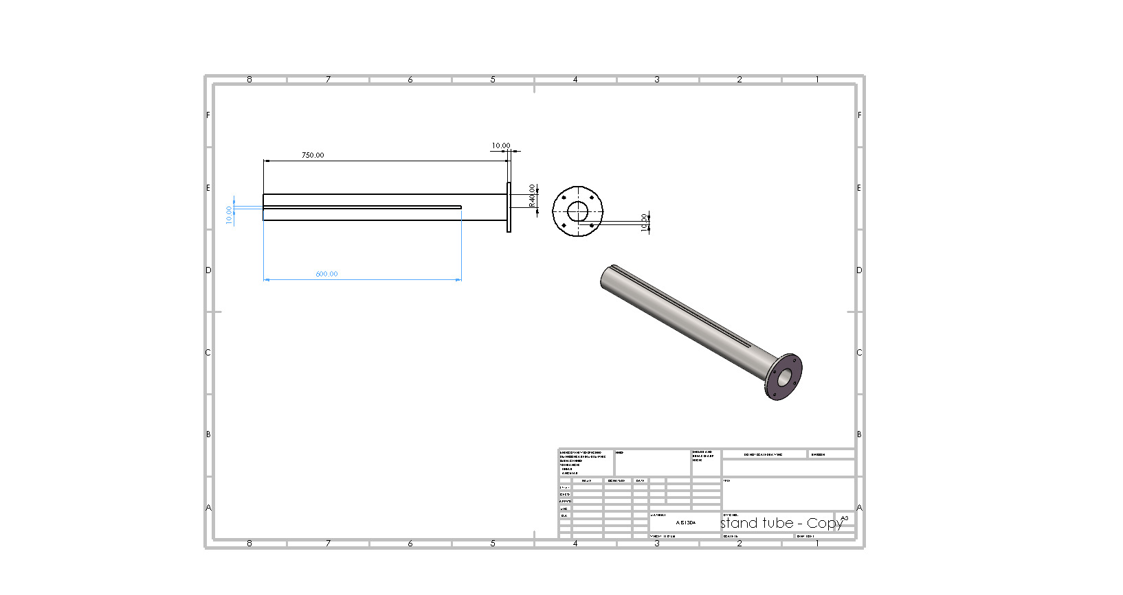
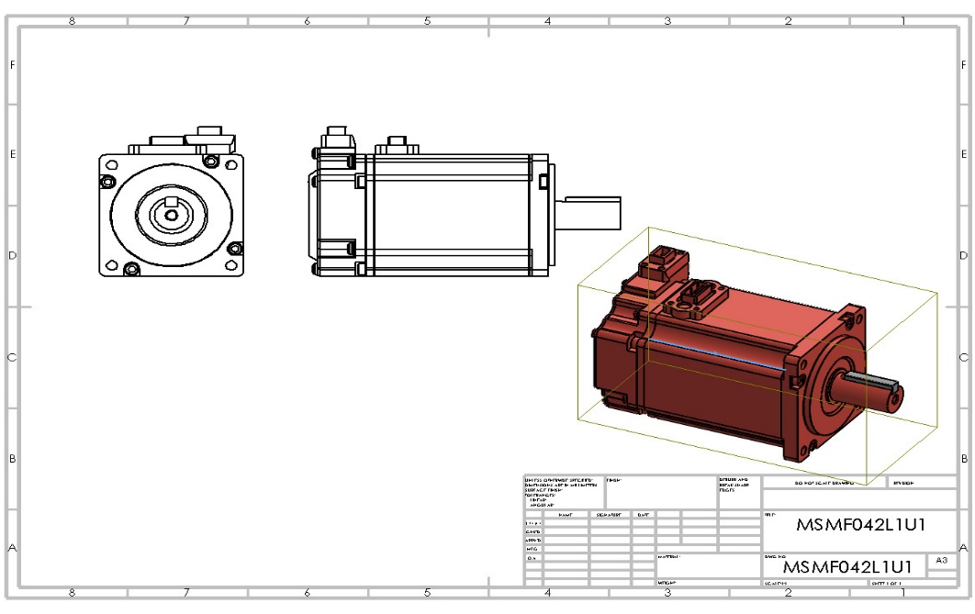
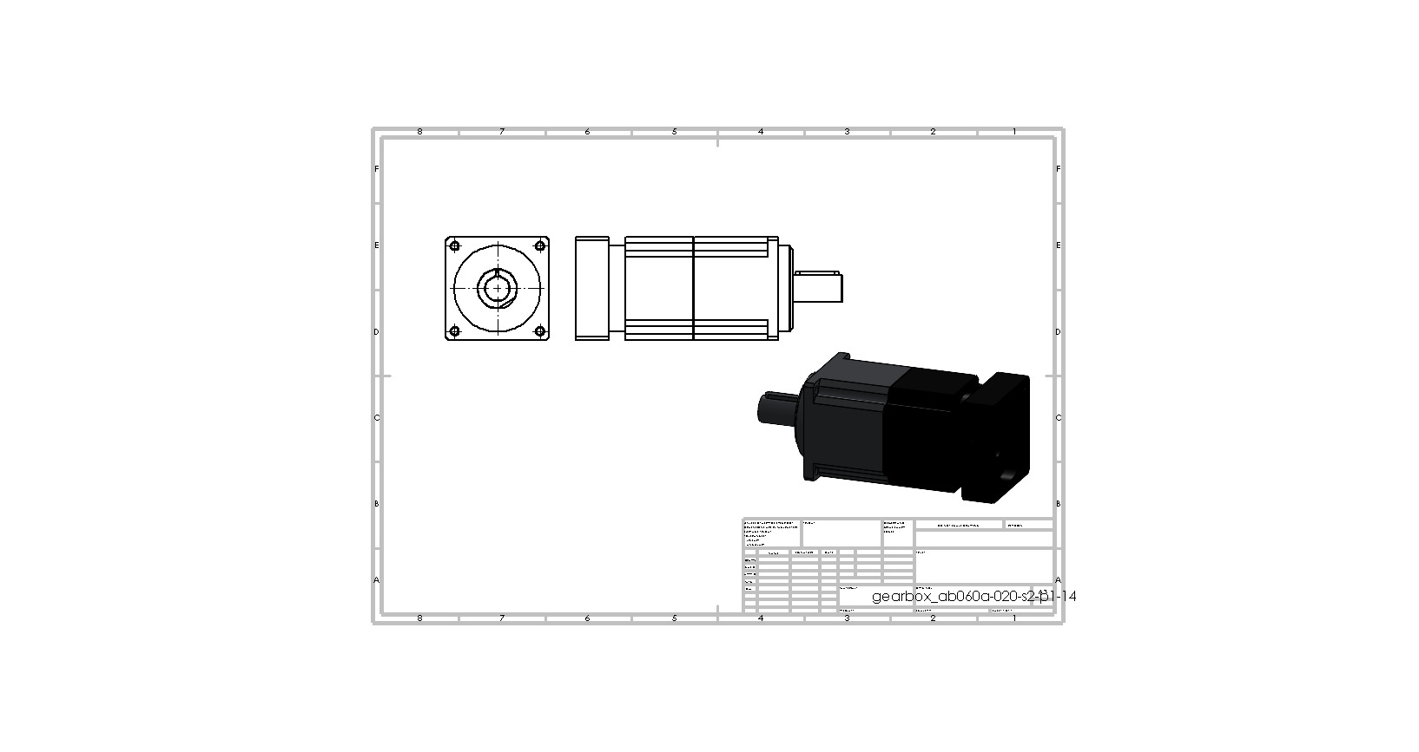
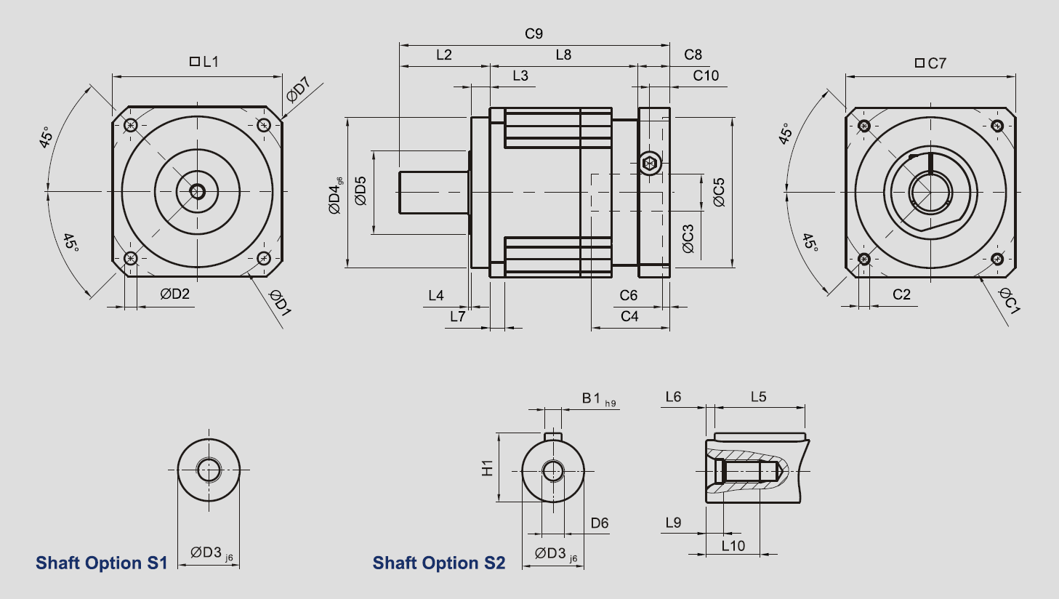
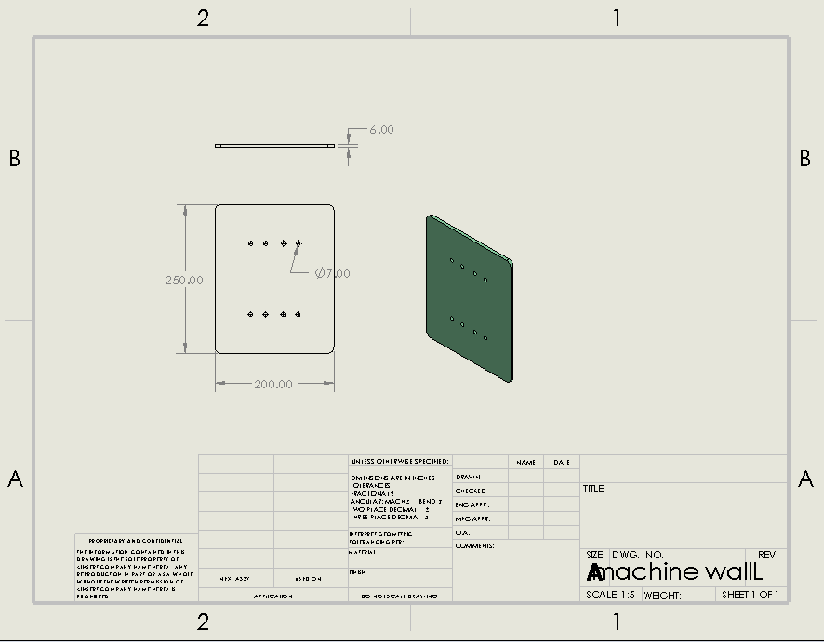
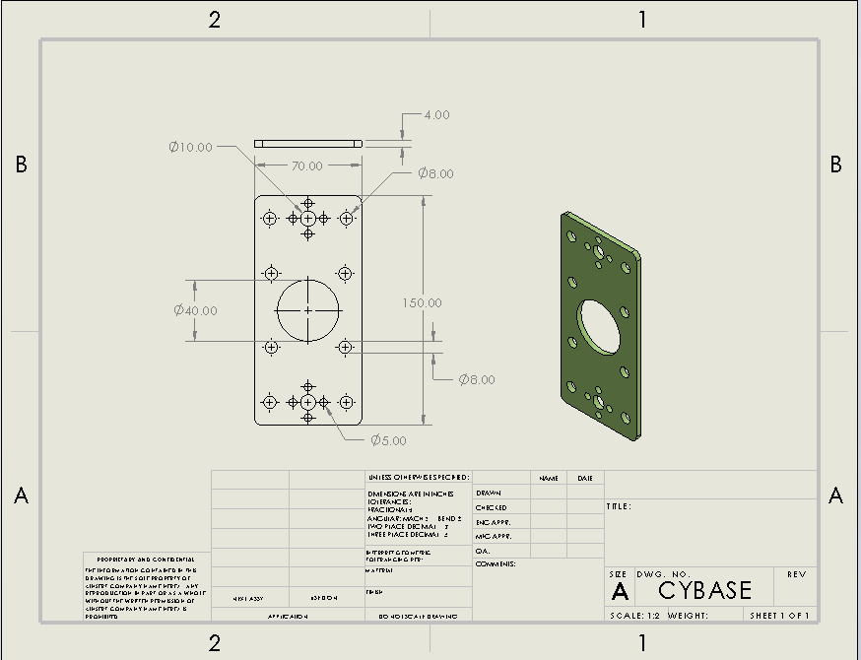
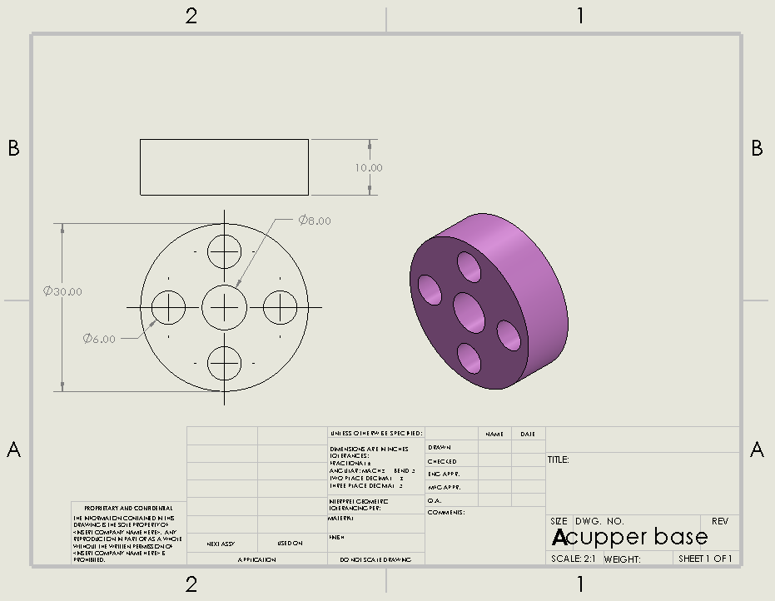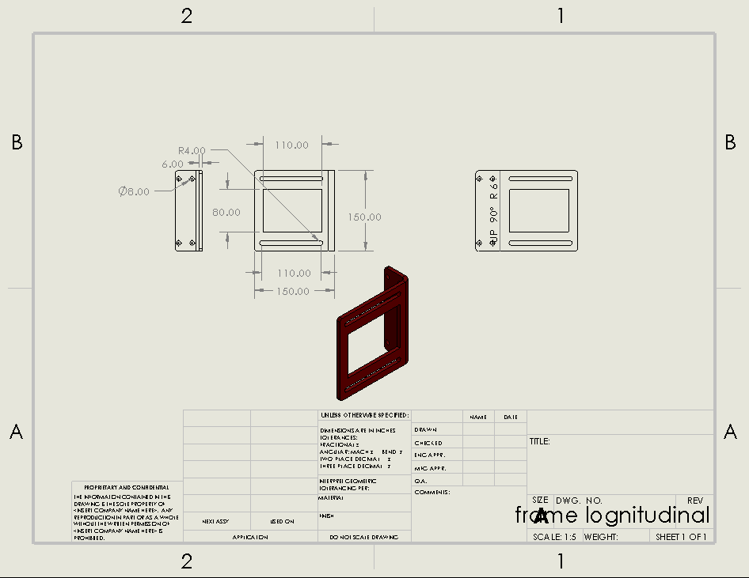
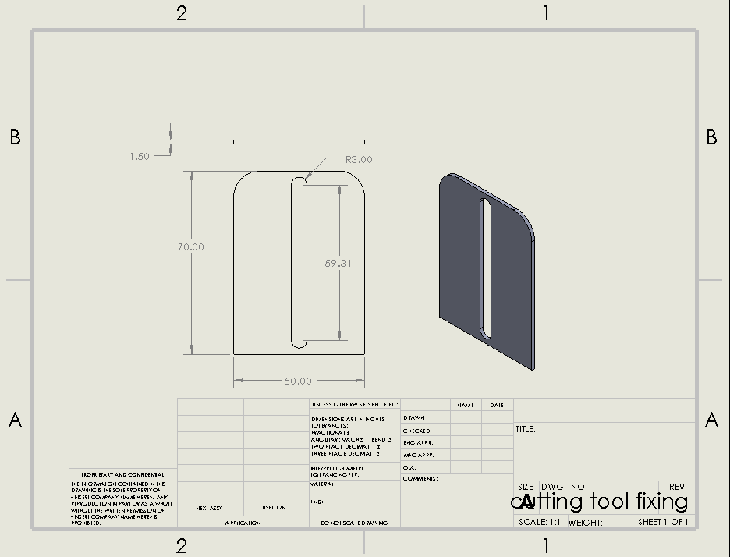
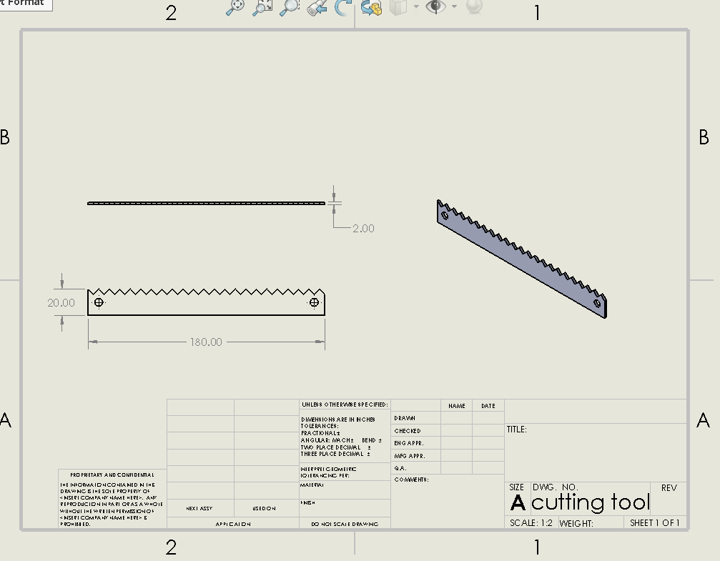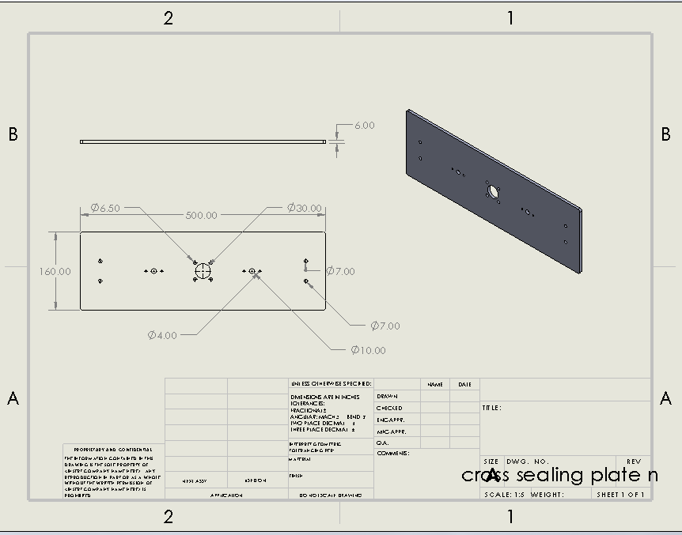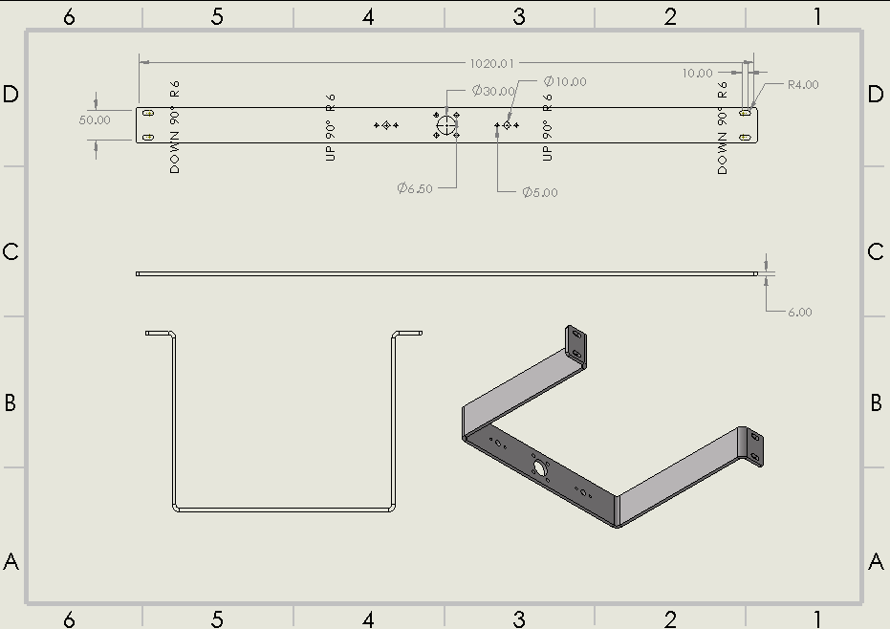

A.4. Exploded View: To show the assembly sequence and maintenance access points.
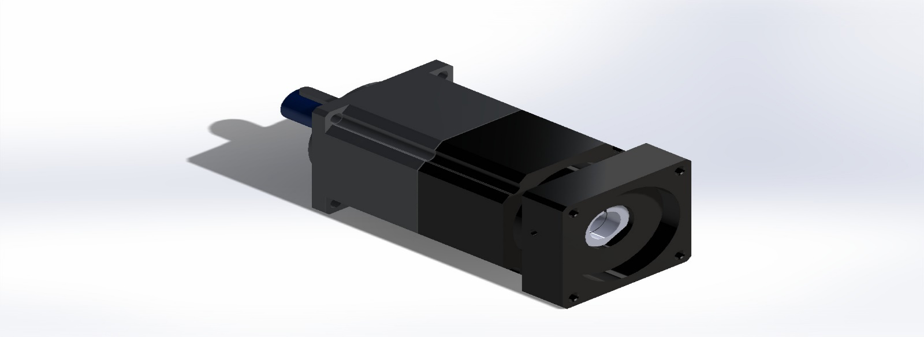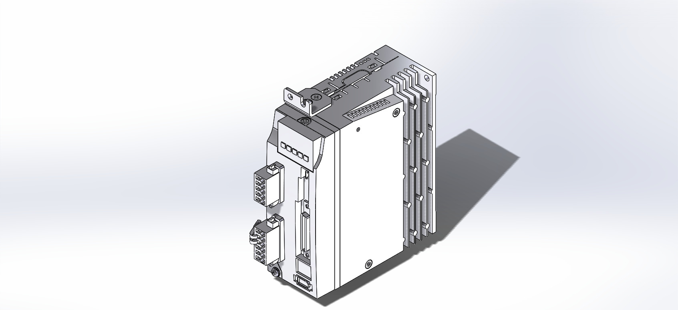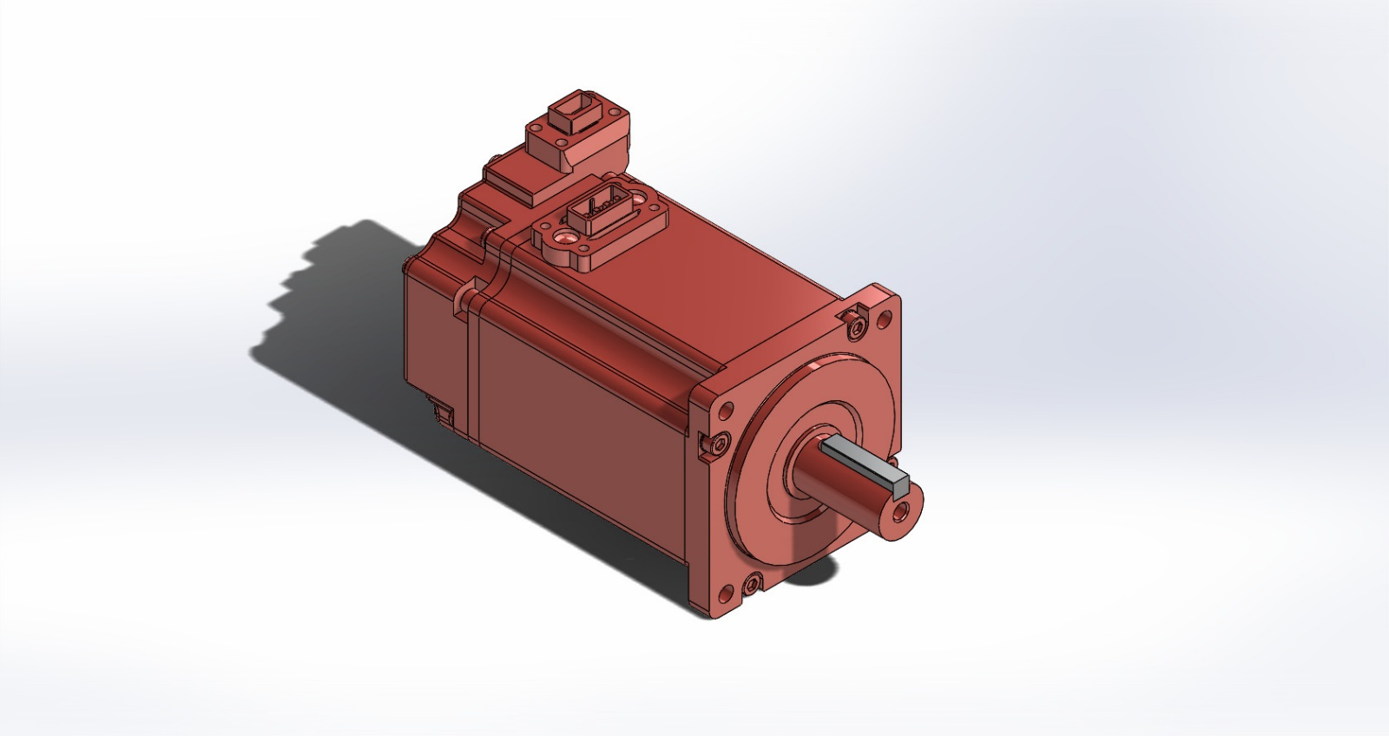
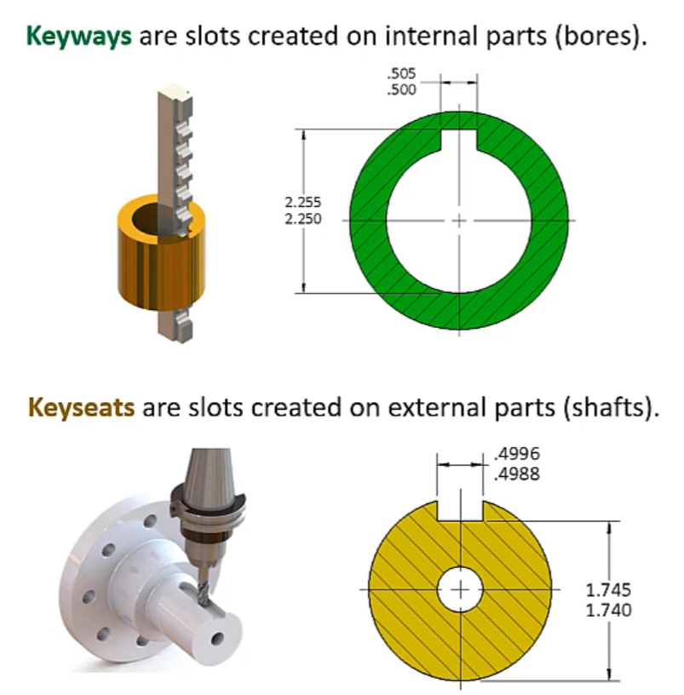
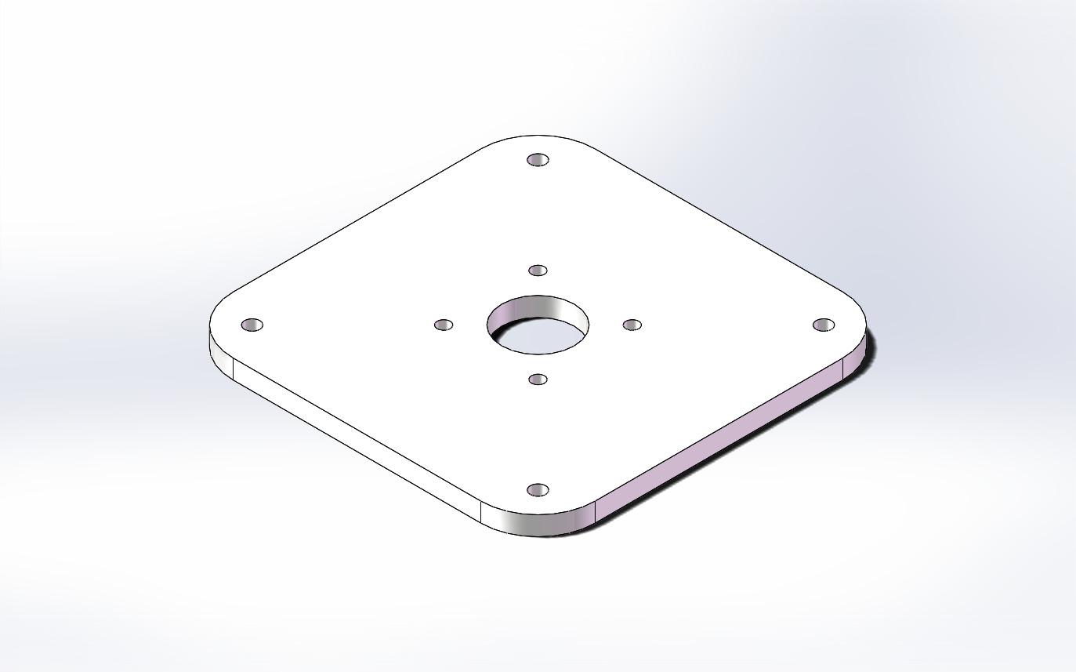
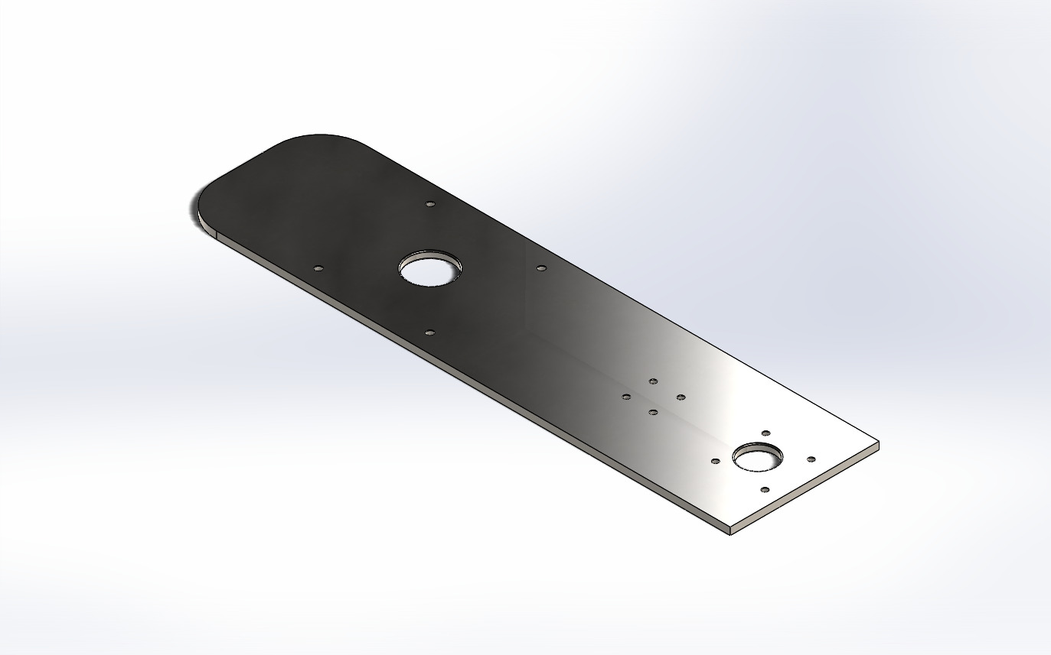
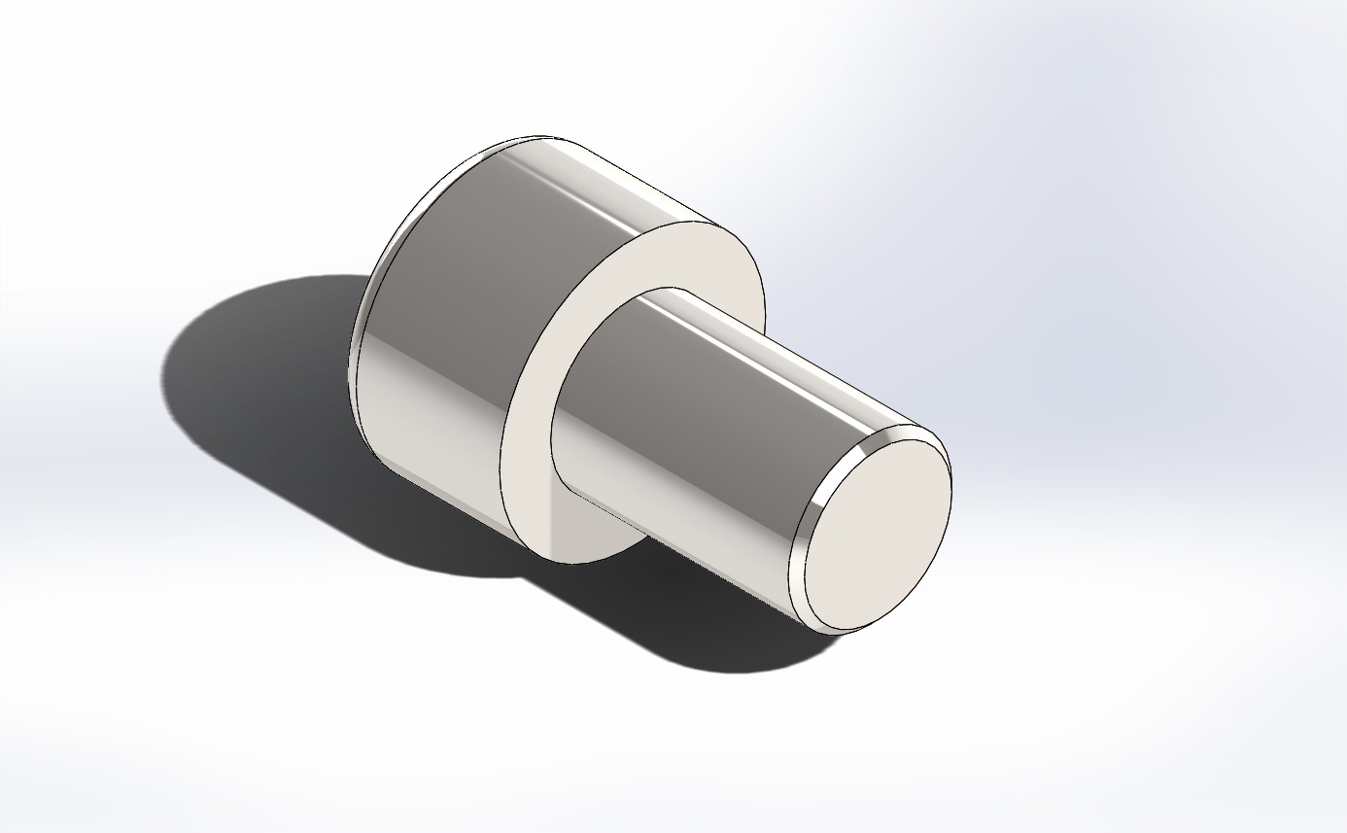
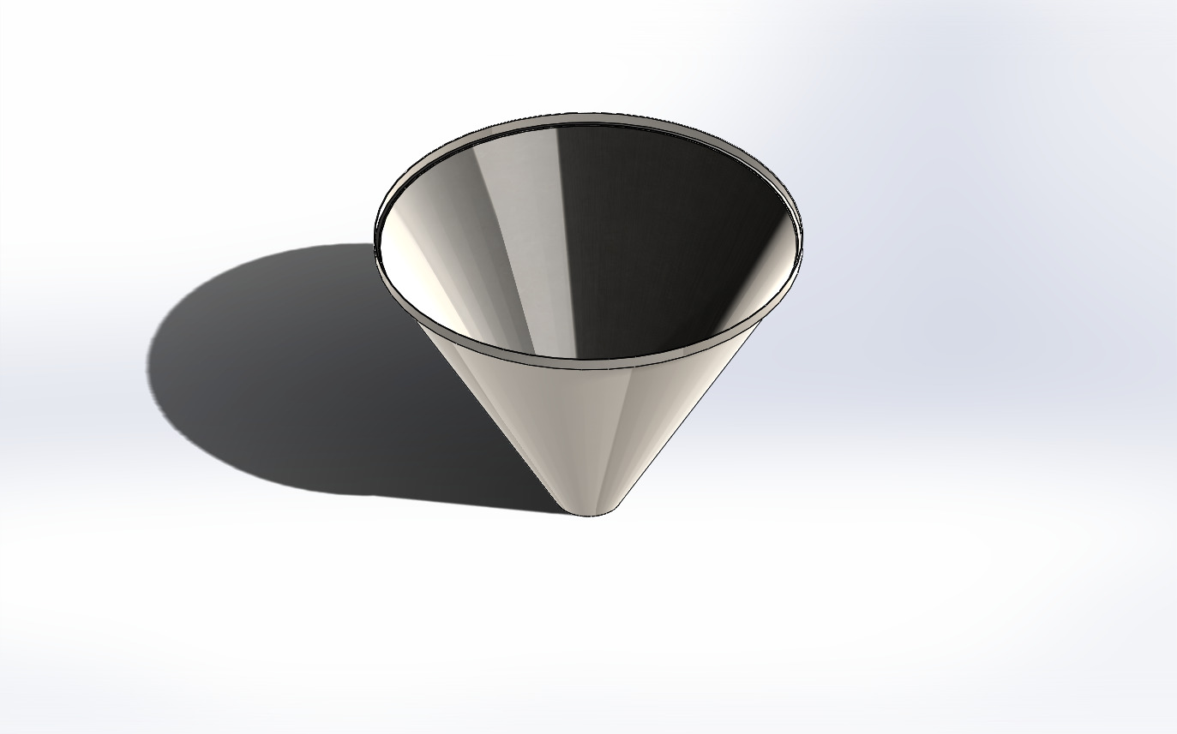
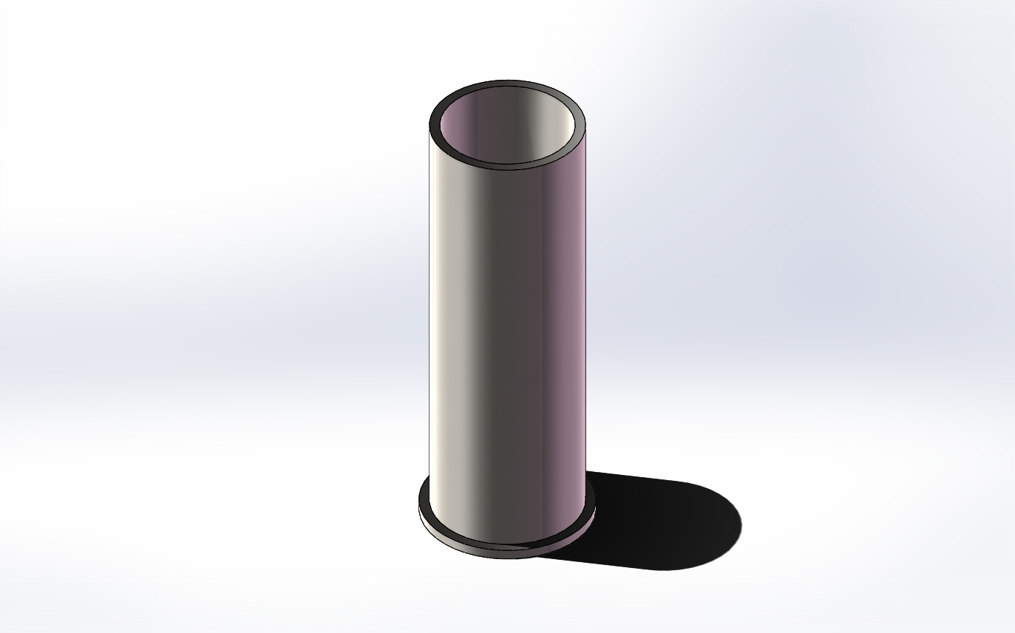
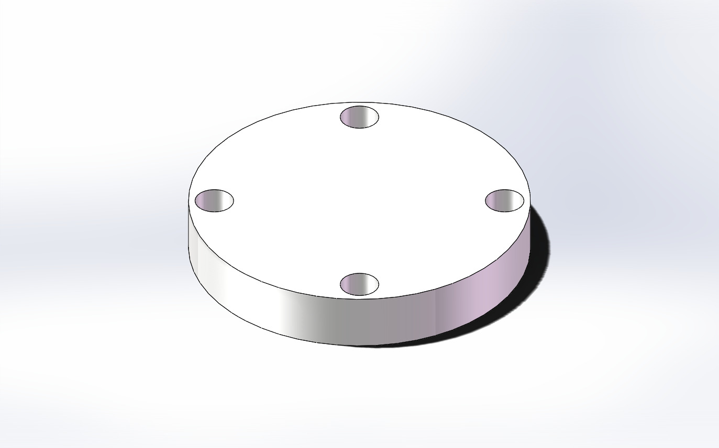
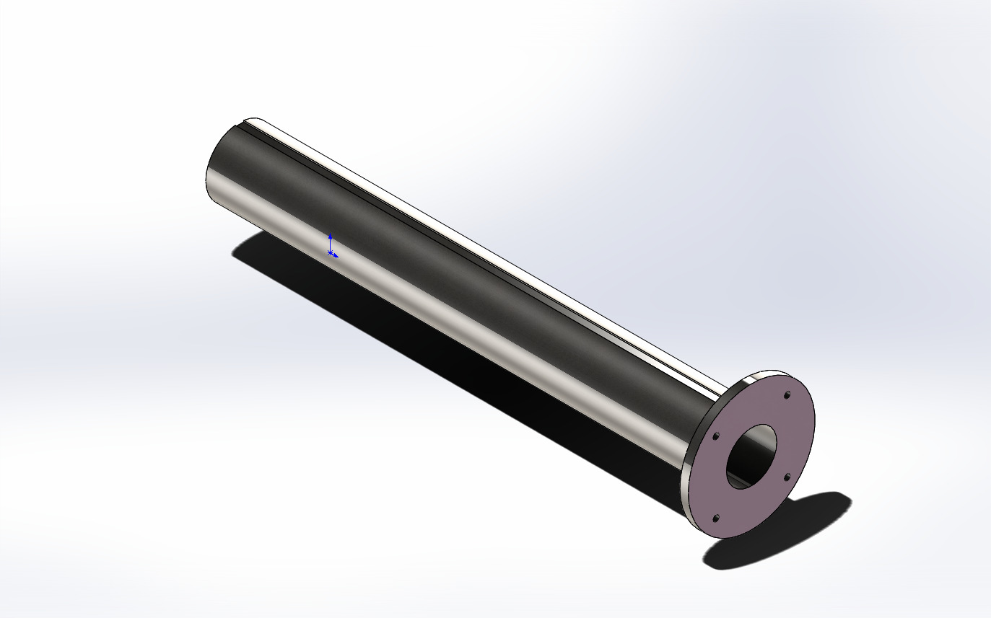
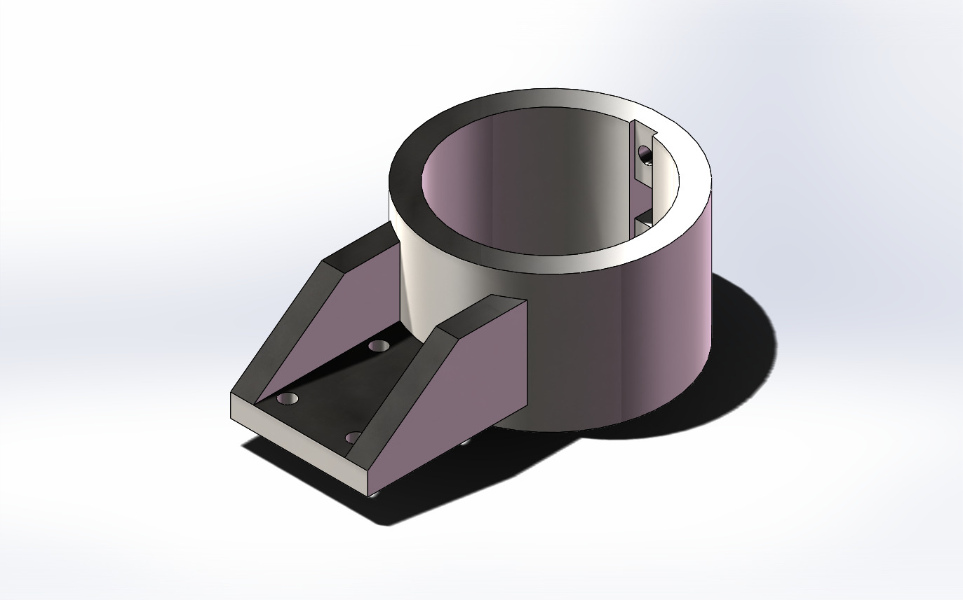
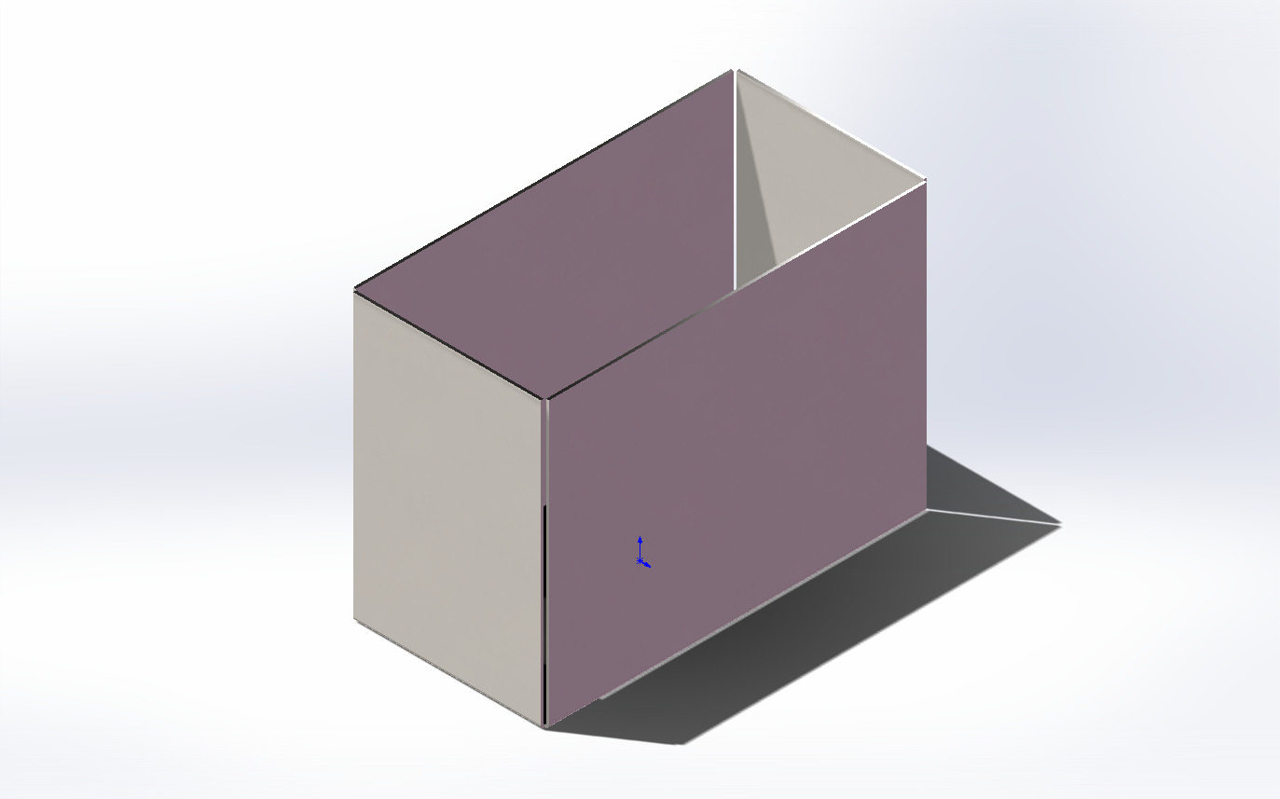
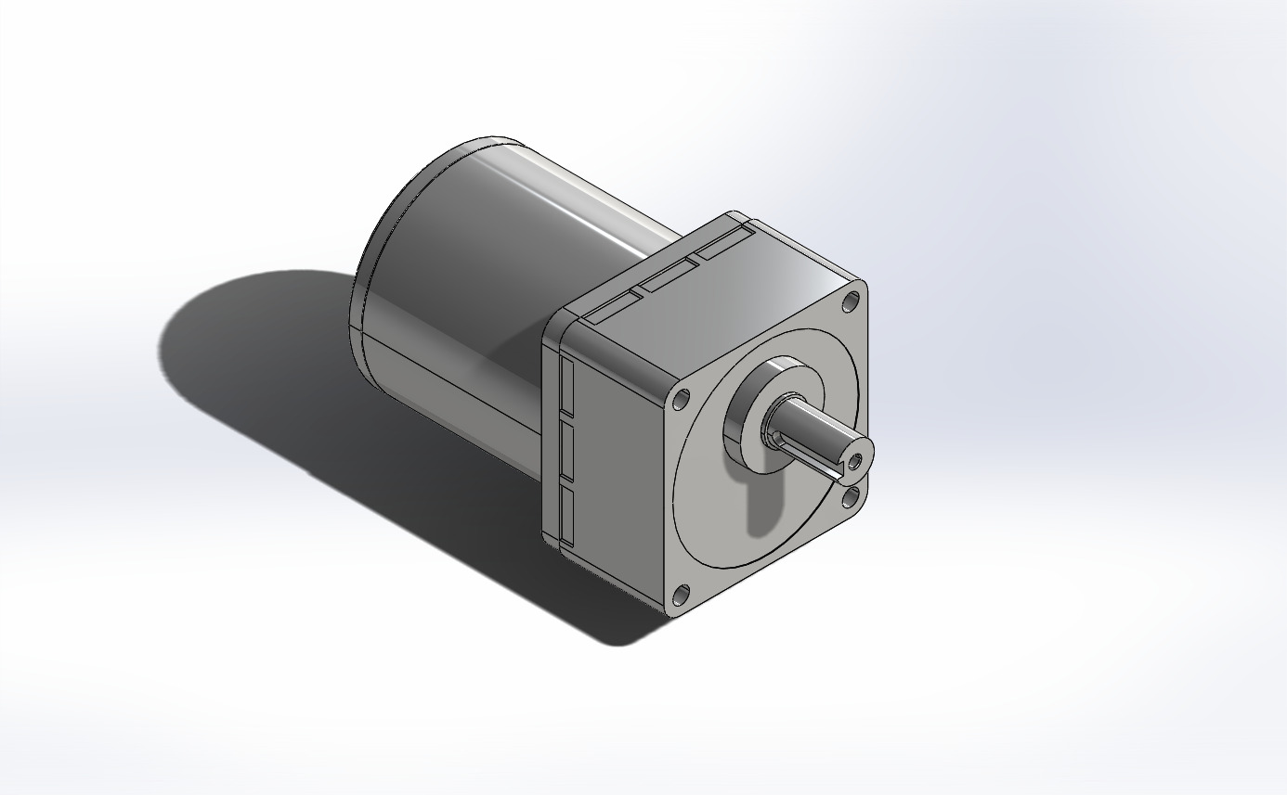
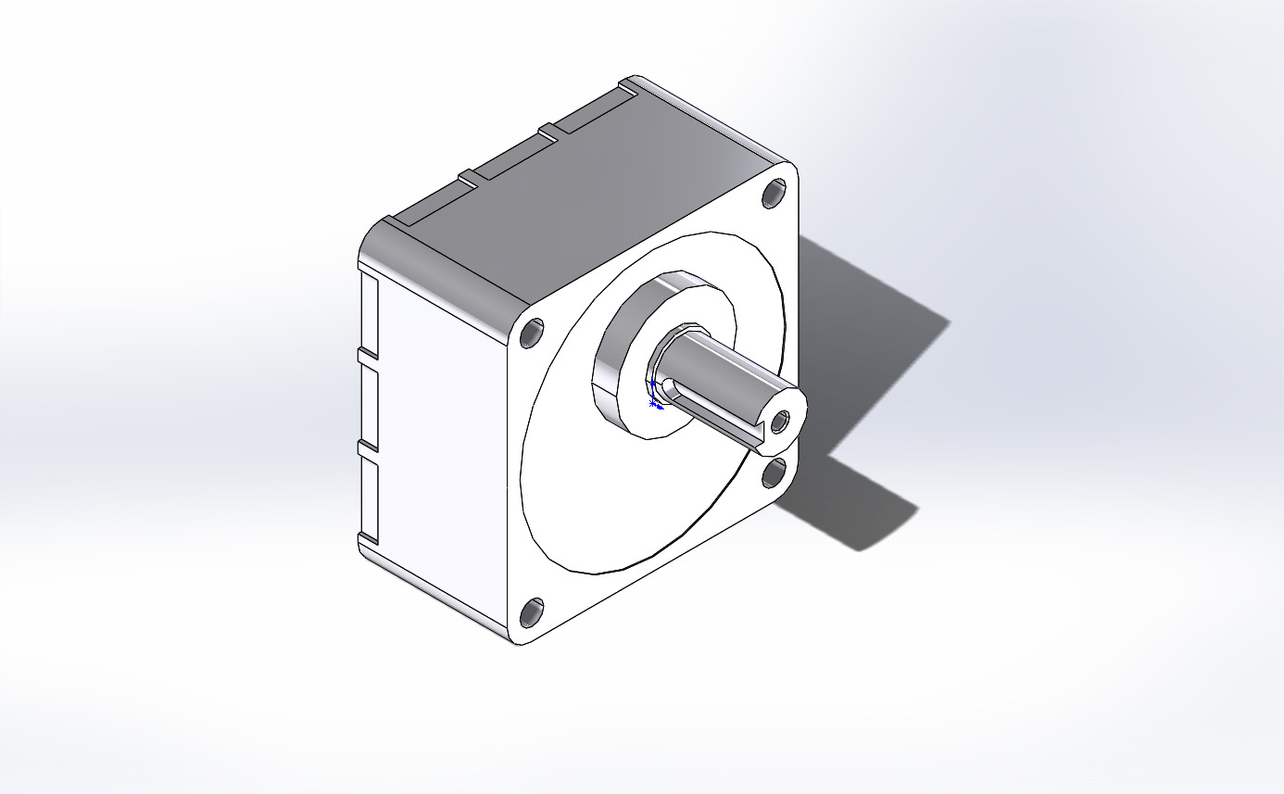
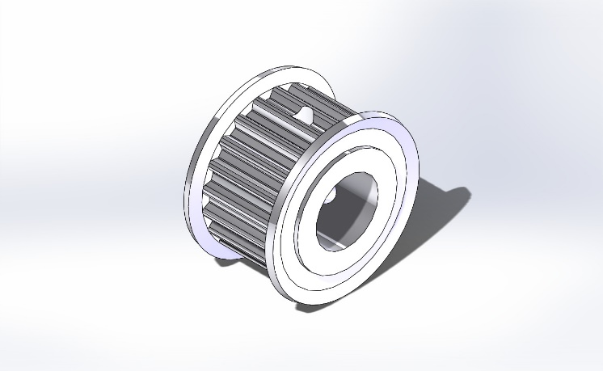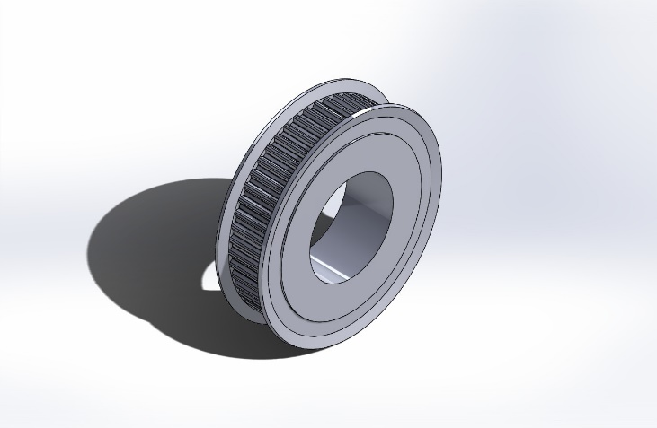

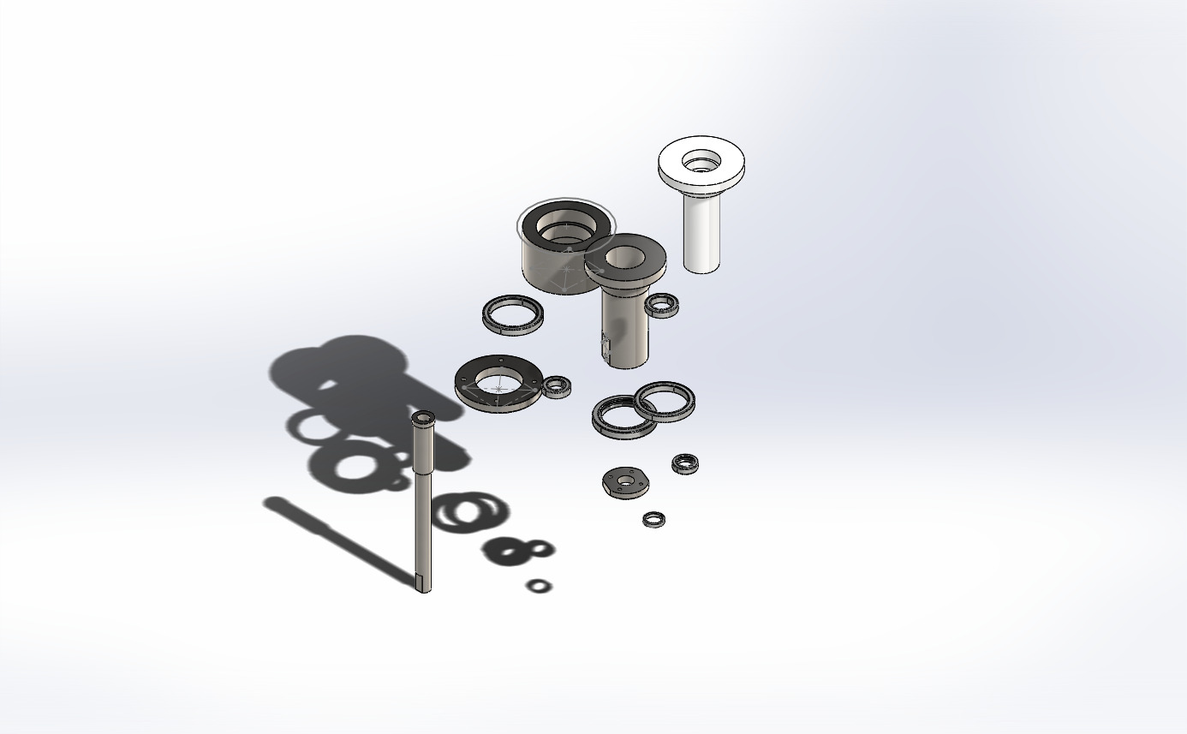
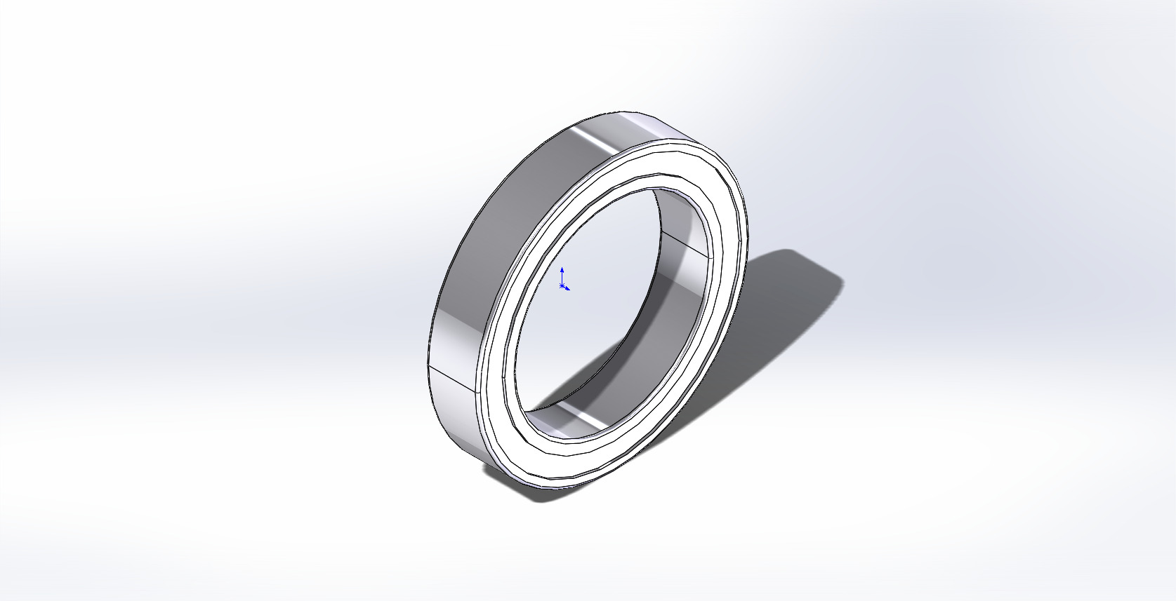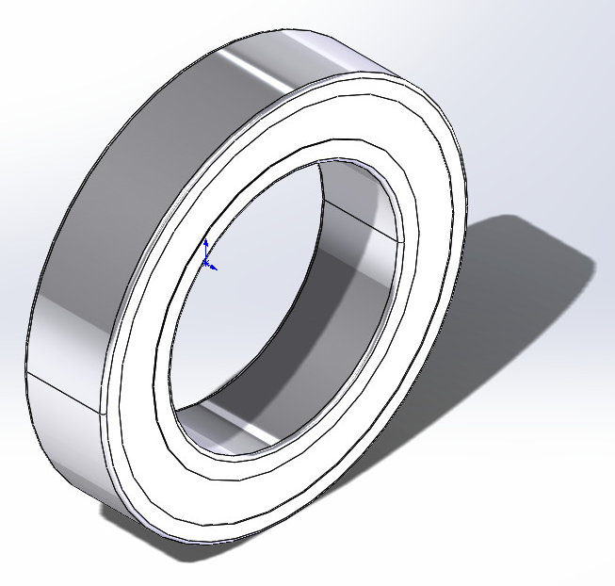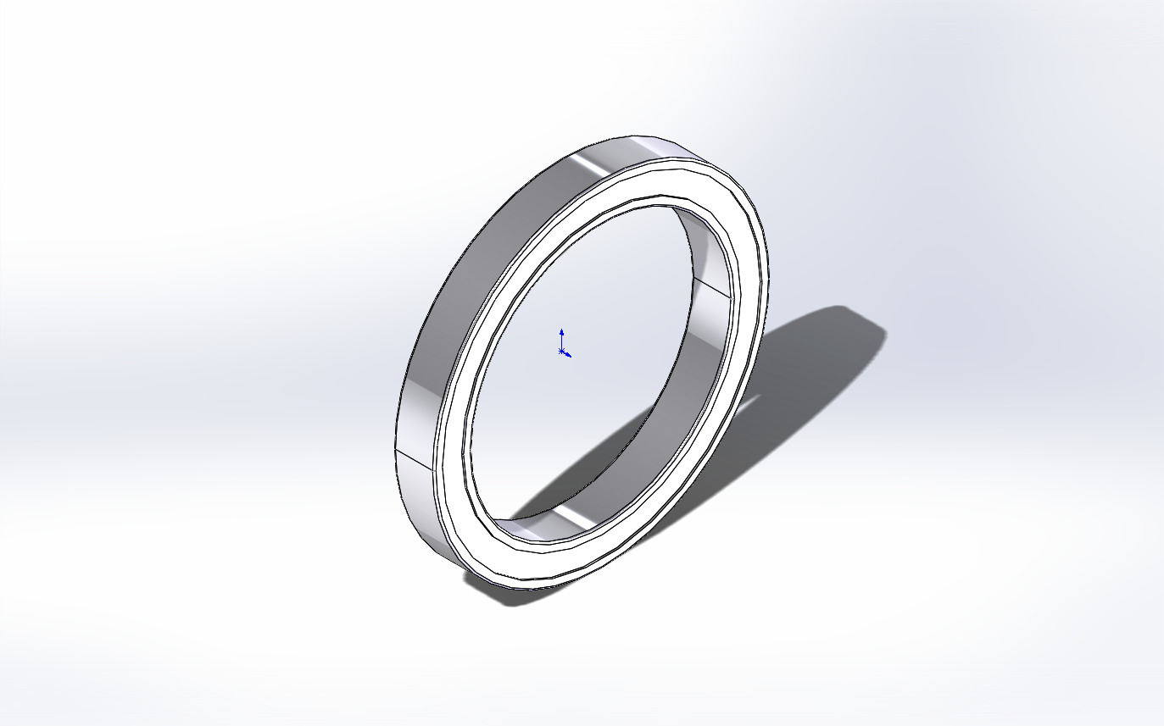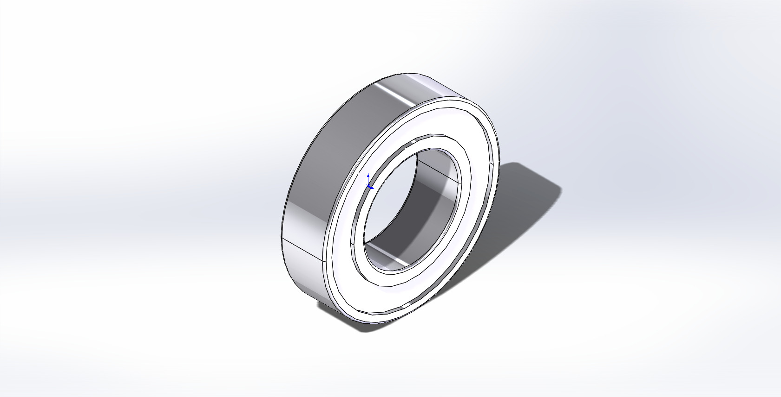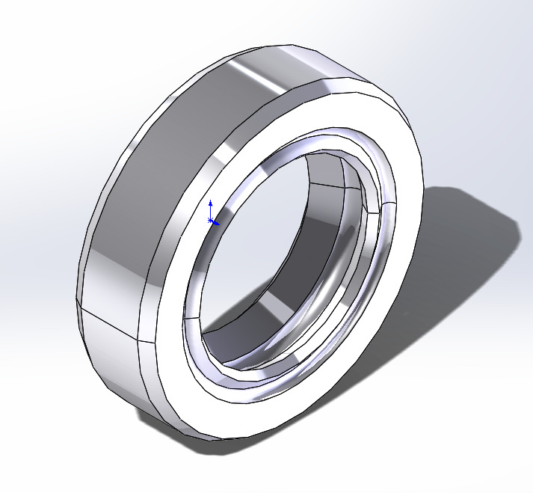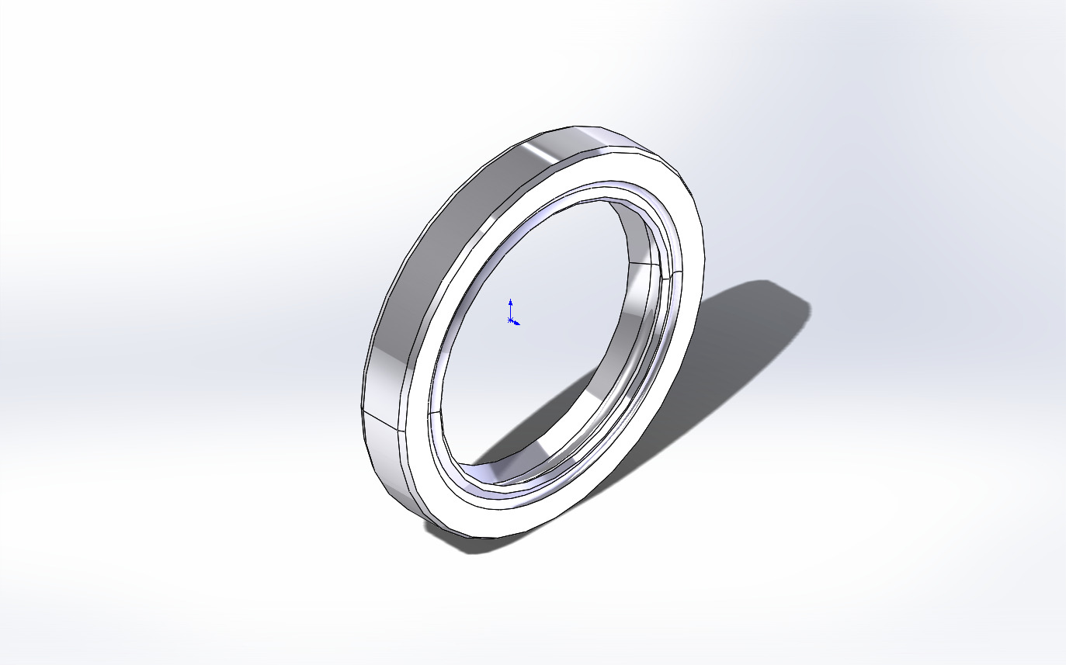

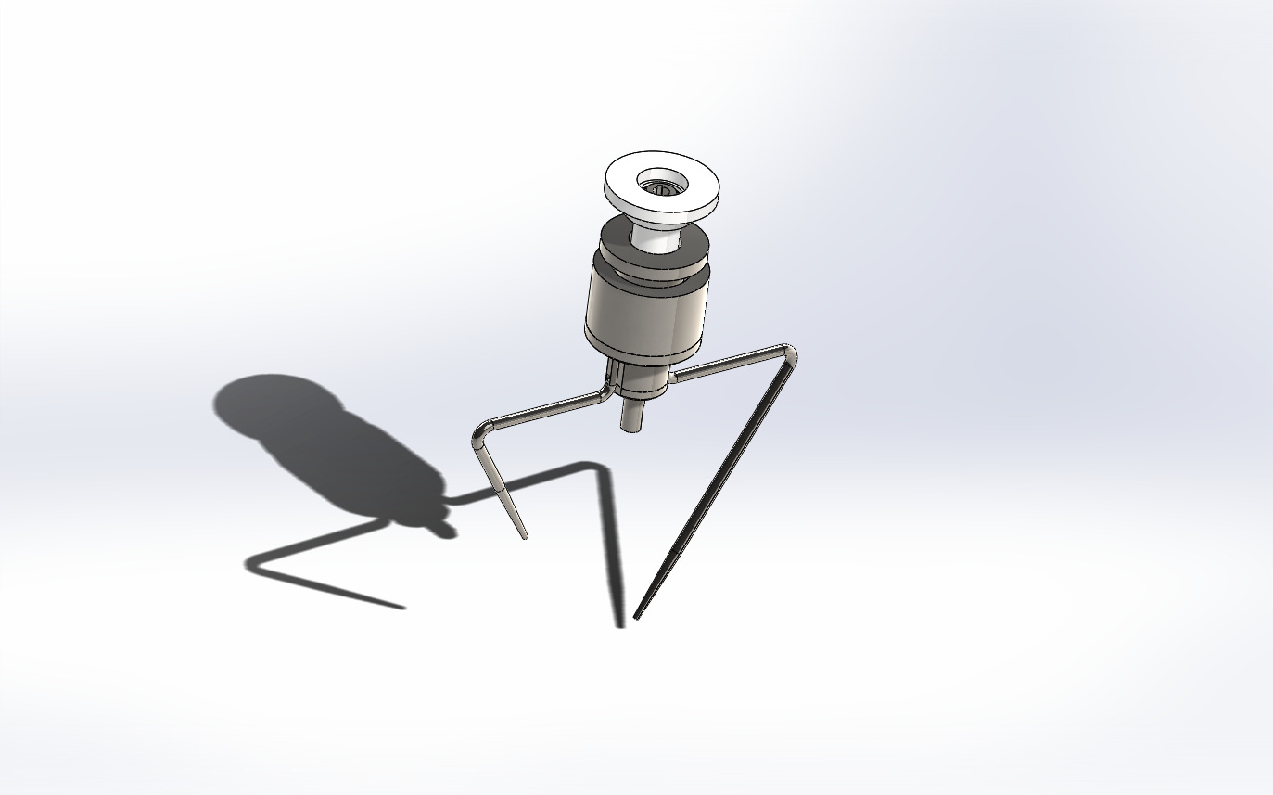

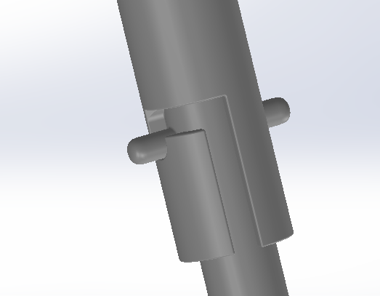
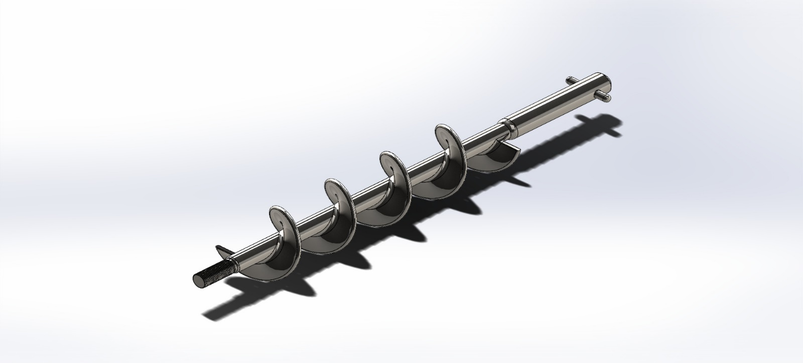

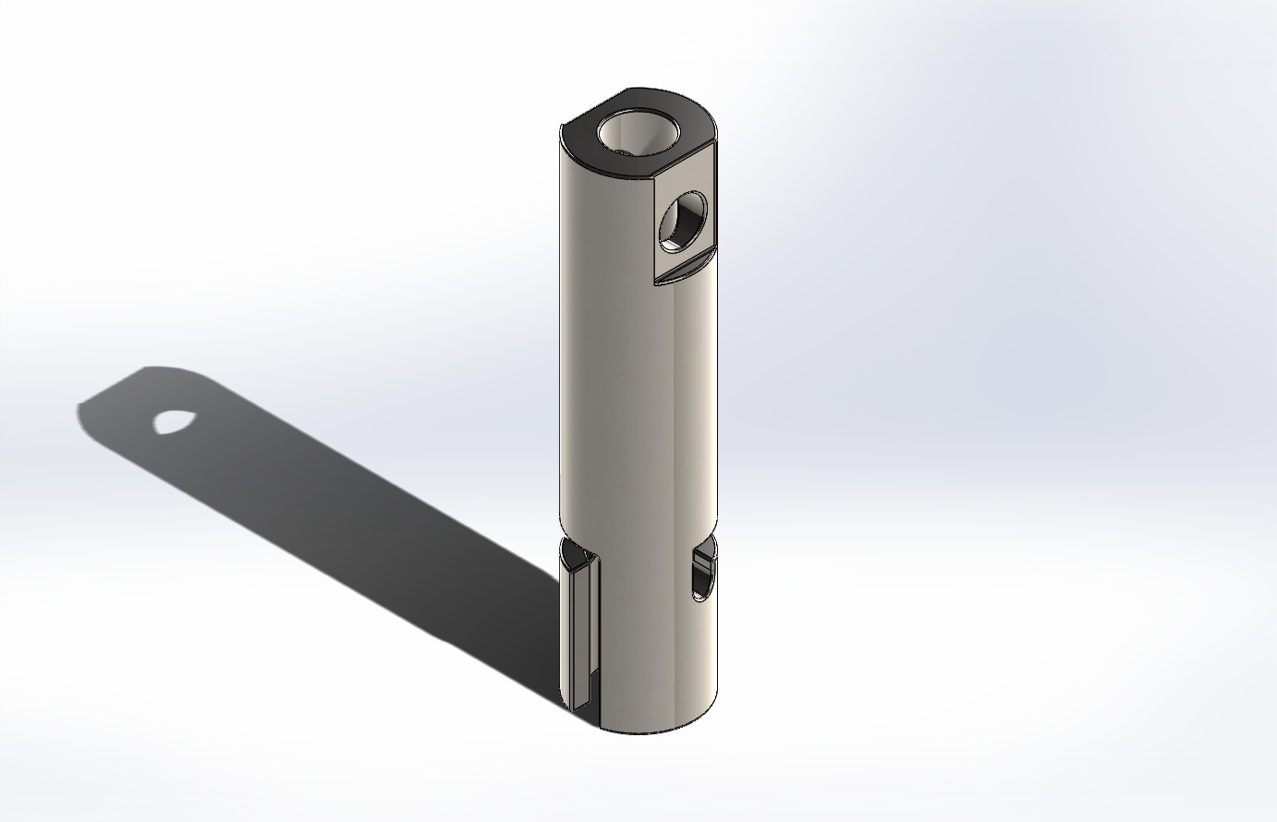
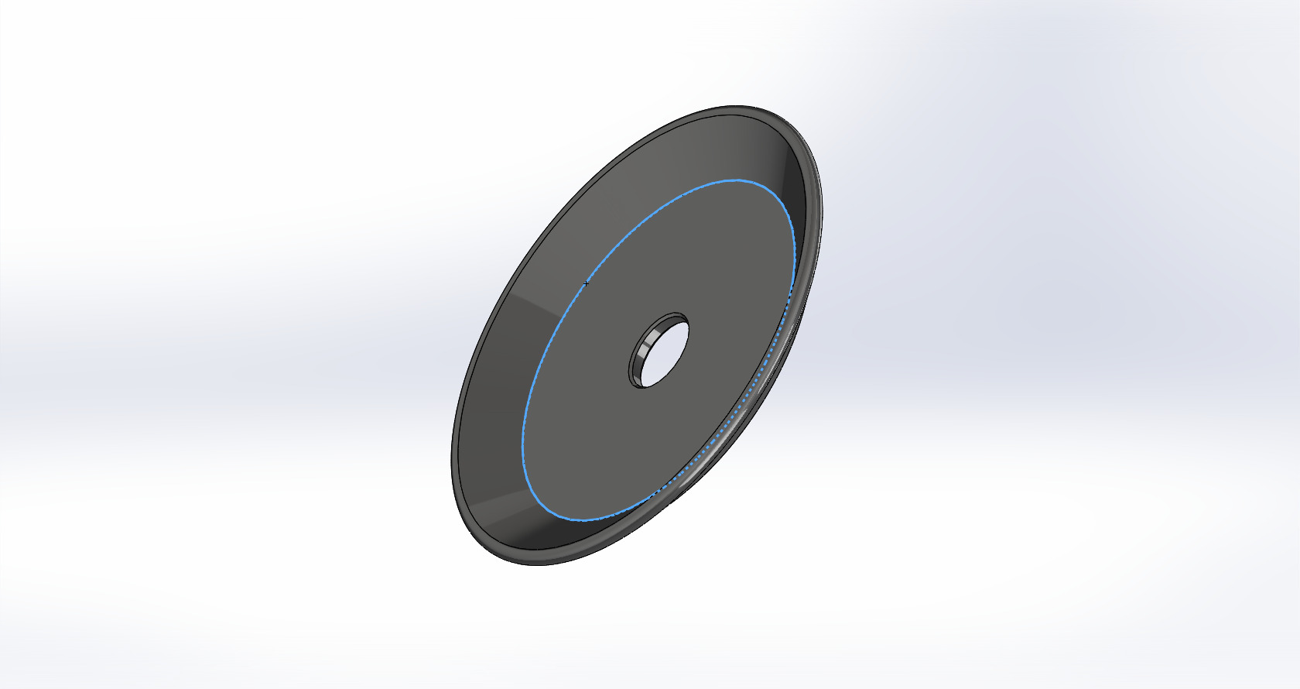

Appendix B: Control and Mechatronics Documentation

B.1. Wiring Diagram: Electrical schematic showing the PLC/Microcontroller, Driver, and Motor connections.

B.2. Control Logic Flowchart: The algorithmic sequence for the "Fill-Stop-Seal" cycle.
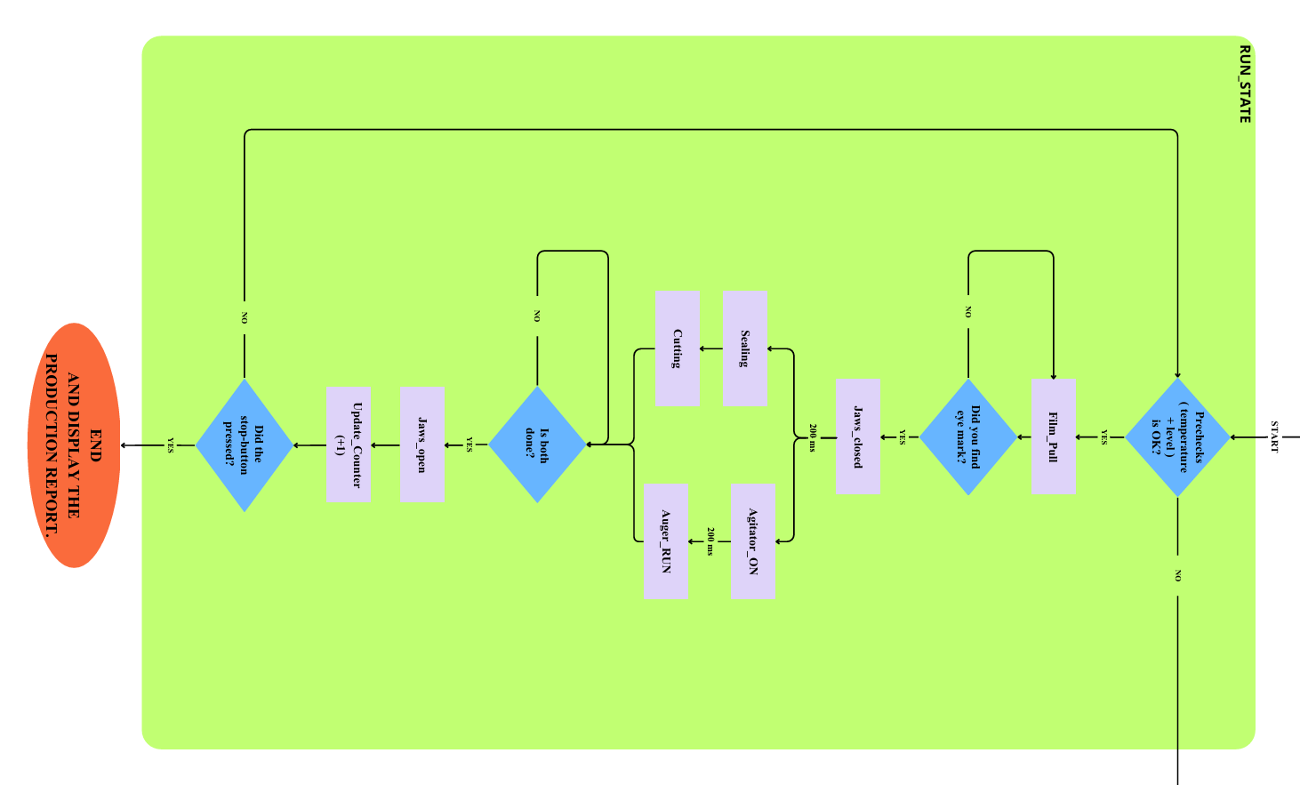

B.3. HMI Screen Mockups: User interface design for entering target weight and speed.
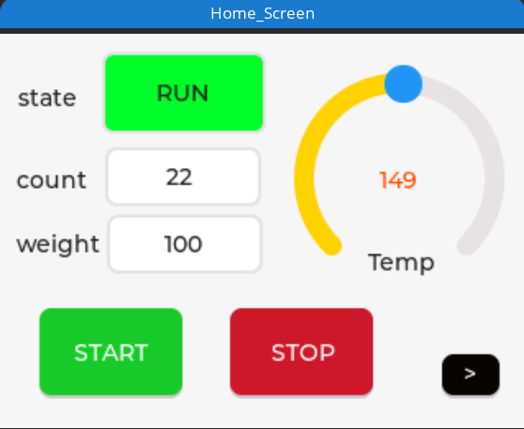

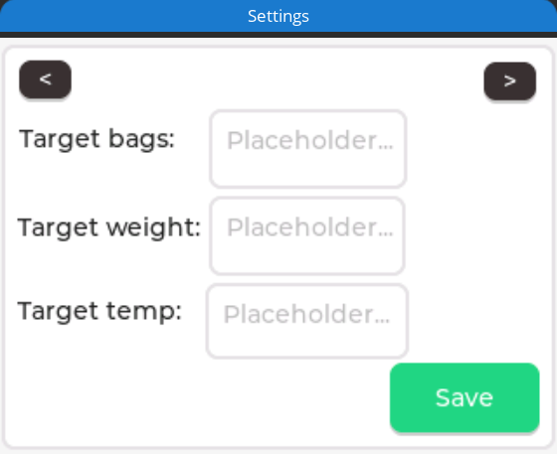

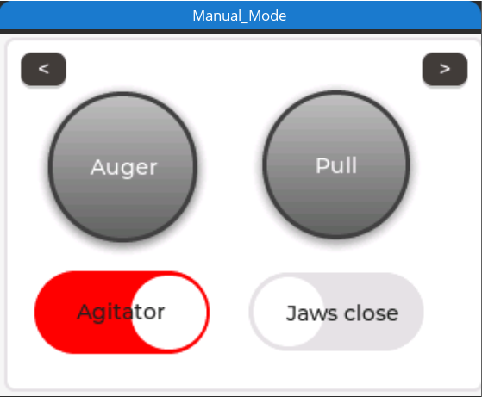

B.4. Pseudo-code/Source Code: The core logic used for the motion control profile.
/*
* VFFS Machine Controller - Graduation Project
* * Features:
* 1. RMT Driver: Generates stepper pulses via Hardware (Non-blocking).
* 2. Hybrid Motion: RMT for speed (Blind Zone) + Manual for precision (Sensor Search).
* 3. Robust E-Stop: Kills RMT channels instantly via Fault Handler.
* 4. Optimized Core Usage: CPU 0 is free for precise PID calculations.
*/
#include <stdio.h>
#include <string.h>
#include <stdlib.h>
#include "freertos/FreeRTOS.h"
#include "freertos/task.h"
#include "freertos/queue.h"
#include "freertos/semphr.h"
#include "freertos/event_groups.h"
#include "driver/gpio.h"
#include "driver/rmt.h" //
#include "esp_timer.h"
#include "esp_log.h"
#include "esp_rom_sys.h"
#include "esp_adc/adc_oneshot.h"
#include "mock_sensor.h"
// =========================================================
// ********** USER CONFIGURATION AREA **********
// =========================================================
#define SIMULATION_MODE 1
// PID & TEMP
#define HEATER_SETPOINT 150.0
#define PID_KP 20.0
#define PID_KI 0.5
#define PID_KD 0.0
#define PID_WINDOW_SIZE_MS 1000
#define TEMP_TOLERANCE 5.0
// HOPPER
#define HOPPER_EMPTY_THRESH 10
#define HOPPER_LOW_THRESH 30
// BAG & MOTION
#define BAG_LENGTH_STEPS 700
#define BLIND_ZONE_STEPS 500
#define MAX_SEARCH_STEPS 1000
#define AUGER_STEPS 800
// SPEED (RMT tick is usually 1us)
#define SPEED_FILM_US 1000
#define SPEED_AUGER_US 1000
// DELAYS
#define DELAY_JAWS_CLOSE 200
#define DELAY_FILL 200
#define DELAY_CUT 200
#define DELAY_OPEN 200
#define DELAY_CYCLE_END 200
// =========================================================
// PINS & DEFINITIONS
// =========================================================
// RMT CHANNELS
#define RMT_CH_AUGER RMT_CHANNEL_0
#define RMT_CH_FILM RMT_CHANNEL_1
// SPI
#define SPI_PIN_SCK 18
#define SPI_PIN_MISO 19
#define SPI_PIN_CS_1 21

// GPIOs
#define PIN_ESTOP 15
#define PIN_START_BTN 34
#define PIN_STOP_BTN 2
#define PIN_EYE_MARK 39
// Motors
#define PIN_AUGER_STEP 25
#define PIN_AUGER_DIR 26
#define PIN_AUGER_EN 27
#define PIN_FILM_STEP 32
#define PIN_FILM_DIR 33
#define PIN_FILM_EN 14
// Actuators
#define PIN_AGITATOR 13
#define PIN_HEATER_SSR 23
#define PIN_VALVE_HORIZ 4
#define PIN_VALVE_VERT 5
#define PIN_VALVE_CUTTER 12
// ADC
#define ADC_UNIT_ID ADC_UNIT_1
#define ADC_CHAN_LEVEL ADC_CHANNEL_7
// Logic
#define VALVE_ON 0
#define VALVE_OFF 1
#define AGIT_ON 1
#define AGIT_OFF 0
#define MOTOR_ENABLE 0
#define MOTOR_DISABLE 1
#define MOTOR_AUGER_ID 1
#define MOTOR_FILM_ID 2

// Events
#define BIT_SYSTEM_READY (1 << 0)
#define BIT_AUTO_RUNNING (1 << 1)
#define BIT_ESTOP_ACTIVE (1 << 2)
#define BIT_TEMP_OK (1 << 3)
// =========================================================
// HANDLES
// =========================================================
typedef struct {
uint8_t motor_id;
uint32_t steps;
uint32_t interval_us;
uint8_t direction;
bool use_sensor;
} MotionCommand_t;
EventGroupHandle_t sys_evt_group;
QueueHandle_t motion_queue;
SemaphoreHandle_t motion_done_sem;
SemaphoreHandle_t mutex_vars;
TaskHandle_t th_ControlLoop = NULL;
TaskHandle_t th_PID = NULL;
TaskHandle_t th_HMI = NULL;
TaskHandle_t th_Motion = NULL;
adc_oneshot_unit_handle_t adc1_handle;
typedef struct {
double current_temp;
uint32_t bag_counter;
bool last_move_success;
} SystemData_t;

SystemData_t sys_data = { .current_temp = 25.0, .last_move_success = true };
// Forward Declarations
void Task_ControlLoop(void *pvParameters);
void Task_PID(void *pvParameters);
void Task_MotionController(void *pvParameters);
void Task_FaultHandler(void *pvParameters);
void Task_HMI(void *pvParameters);
// =========================================================
// RMT & HARDWARE SETUP
// =========================================================
void Init_RMT() {
rmt_config_t config = RMT_DEFAULT_CONFIG_TX(PIN_AUGER_STEP, RMT_CH_AUGER);
config.clk_div = 80; // 80MHz / 80 = 1MHz (1 tick = 1us) -> دقة ممتازة
rmt_config(&config);
rmt_driver_install(config.channel, 0, 0);
rmt_config_t config2 = RMT_DEFAULT_CONFIG_TX(PIN_FILM_STEP, RMT_CH_FILM);
config2.clk_div = 80;
rmt_config(&config2);
rmt_driver_install(config2.channel, 0, 0);
}
double Read_Temperature_Sensor() {
#if SIMULATION_MODE
return Read_Fake_Thermocouple(SPI_PIN_CS_1);
#else
// SPI Real Code
int v = 0;
gpio_set_level(SPI_PIN_CS_1, 0);
esp_rom_delay_us(10);
for (int i = 15; i >= 0; i--) {
gpio_set_level(SPI_PIN_SCK, 1); esp_rom_delay_us(10);
if (gpio_get_level(SPI_PIN_MISO)) v |= (1 << i);
gpio_set_level(SPI_PIN_SCK, 0); esp_rom_delay_us(10);
}
gpio_set_level(SPI_PIN_CS_1, 1);
if (v & 0x4) return -1.0;
return (v >> 3) * 0.25;
#endif
}
// =========================================================
// HELPERS
// =========================================================
void IRAM_ATTR isr_estop_handler(void* arg) {
BaseType_t xHigherPriorityTaskWoken = pdFALSE;
xEventGroupSetBitsFromISR(sys_evt_group, BIT_ESTOP_ACTIVE, &xHigherPriorityTaskWoken);
portYIELD_FROM_ISR(xHigherPriorityTaskWoken);
}
int get_hopper_level() {
int raw_val = 0;
if (adc_oneshot_read(adc1_handle, ADC_CHAN_LEVEL, &raw_val) == ESP_OK) {
return (raw_val * 100) / 4095;
}
return 0;
}
void SendMotionCommand(uint8_t id, uint32_t steps, uint32_t speed_us, uint8_t dir, bool use_sensor) {
MotionCommand_t cmd = { .motor_id = id, .steps = steps, .interval_us = speed_us, .direction = dir, .use_sensor = use_sensor };
xQueueSend(motion_queue, &cmd, portMAX_DELAY);
}
bool WaitForMotionResult() {
while(xSemaphoreTake(motion_done_sem, pdMS_TO_TICKS(100)) == pdFALSE) {
if (xEventGroupGetBits(sys_evt_group) & BIT_ESTOP_ACTIVE) return false;
}
bool success = true;
if (xSemaphoreTake(mutex_vars, pdMS_TO_TICKS(10))) {
success = sys_data.last_move_success;
xSemaphoreGive(mutex_vars);
}
return success;
}
// =========================================================
// TASKS
// =========================================================
// --- MOTION TASK (RMT ENABLED) ---
void Task_MotionController(void *pvParameters) {
MotionCommand_t cmd;
int dir_pin, en_pin;
rmt_channel_t rmt_chan;

for (;;) {
if (xQueueReceive(motion_queue, &cmd, portMAX_DELAY)) {
// 1. Setup
if (cmd.motor_id == MOTOR_AUGER_ID) {
dir_pin = PIN_AUGER_DIR; en_pin = PIN_AUGER_EN; rmt_chan = RMT_CH_AUGER;
} else {
dir_pin = PIN_FILM_DIR; en_pin = PIN_FILM_EN; rmt_chan = RMT_CH_FILM;
}
gpio_set_level(dir_pin, cmd.direction);
gpio_set_level(en_pin, MOTOR_ENABLE);
esp_rom_delay_us(50);
bool move_ok = true;
// 2. Execution Logic
if (cmd.use_sensor) {
// === HYBRID MODE: RMT for Blind Zone + Manual for Search ===
printf("[MOTION] Hybrid Pull: RMT (Blind) -> Manual (Search)\n");
// A) RMT Phase: Blind Zone (Fast & CPU Free)
if (BLIND_ZONE_STEPS > 0) {
// Create RMT items buffer
size_t size = BLIND_ZONE_STEPS * sizeof(rmt_item32_t);
rmt_item32_t* items = (rmt_item32_t*) malloc(size);
if (items) {
for (int i = 0; i < BLIND_ZONE_STEPS; i++) {
// High/Low duration = half interval
items[i] = (rmt_item32_t){{{cmd.interval_us/2, 1, cmd.interval_us/2, 0}}};
}
// Send and Wait
rmt_write_items(rmt_chan, items, BLIND_ZONE_STEPS, true);
rmt_wait_tx_done(rmt_chan, portMAX_DELAY); // Wait for HW to finish
free(items);
}
}
// Check Safety after RMT
if (xEventGroupGetBits(sys_evt_group) & BIT_ESTOP_ACTIVE) move_ok = false;
// B) Manual Phase: Search Zone (Precise)
if (move_ok) {
bool mark_found = false;
int step_pin = (cmd.motor_id == MOTOR_AUGER_ID) ? PIN_AUGER_STEP : PIN_FILM_STEP;
uint32_t remaining_search = MAX_SEARCH_STEPS - BLIND_ZONE_STEPS;
for (uint32_t i = 0; i < remaining_search; i++) {
if (xEventGroupGetBits(sys_evt_group) & BIT_ESTOP_ACTIVE) { move_ok = false; break; }

gpio_set_level(step_pin, 1); esp_rom_delay_us(cmd.interval_us / 2);
gpio_set_level(step_pin, 0); esp_rom_delay_us(cmd.interval_us / 2);
if (gpio_get_level(PIN_EYE_MARK) == 0) { // Found!
mark_found = true;
printf("[MOTION] Mark Found in Search Zone.\n");
break;
}
}
if (!mark_found && move_ok) {
printf("[MOTION] Error: Mark Missed!\n");
move_ok = false;
}
}
} else {
// === PURE RMT MODE (Auger) ===
// Generate all pulses via hardware
size_t size = cmd.steps * sizeof(rmt_item32_t);
rmt_item32_t* items = (rmt_item32_t*) malloc(size);
if (items) {
for (int i = 0; i < cmd.steps; i++) {
items[i] = (rmt_item32_t){{{cmd.interval_us/2, 1, cmd.interval_us/2, 0}}};
}
rmt_write_items(rmt_chan, items, cmd.steps, true);

// While RMT works, we wait. If E-Stop happens, FaultHandler kills RMT.
// We just need to wait for completion or abort.
while (rmt_wait_tx_done(rmt_chan, 10 / portTICK_PERIOD_MS) != ESP_OK) {
if (xEventGroupGetBits(sys_evt_group) & BIT_ESTOP_ACTIVE) {
move_ok = false; break;
}
}
free(items);
}
}
gpio_set_level(en_pin, MOTOR_DISABLE);
if (xSemaphoreTake(mutex_vars, pdMS_TO_TICKS(10))) {
sys_data.last_move_success = move_ok;
xSemaphoreGive(mutex_vars);
}
xSemaphoreGive(motion_done_sem);
}
}
}

// --- PID TASK (Precise due to RMT) ---
void Task_PID(void *pvParameters) {
// Setup SPI
gpio_set_direction(SPI_PIN_CS_1, GPIO_MODE_OUTPUT);
gpio_set_direction(SPI_PIN_SCK, GPIO_MODE_OUTPUT);
gpio_set_direction(SPI_PIN_MISO, GPIO_MODE_INPUT);
gpio_set_level(SPI_PIN_CS_1, 1);

double temp_current = 0.0, pid_output = 0.0;
double error = 0.0, last_error = 0.0, integral = 0.0;
int64_t window_start = esp_timer_get_time() / 1000;

for (;;) {
int64_t now_ms = esp_timer_get_time() / 1000;
int64_t in_window = (now_ms - window_start);

if (in_window >= PID_WINDOW_SIZE_MS) {
window_start = now_ms;
in_window = 0;

temp_current = Read_Temperature_Sensor();
if (temp_current == -1.0) temp_current = sys_data.current_temp; // Fallback

if (xSemaphoreTake(mutex_vars, pdMS_TO_TICKS(10))) {
sys_data.current_temp = temp_current;
xSemaphoreGive(mutex_vars);
}
printf("[PID] T:%.1f C | Pwr:%.0f%%\n", temp_current, (pid_output/PID_WINDOW_SIZE_MS)*100.0);
error = HEATER_SETPOINT - temp_current;
integral += error;
if (integral > 100.0) integral = 100.0;
if (integral < -100.0) integral = -100.0;
double output_val = (PID_KP * error) + (PID_KI * integral) + (PID_KD * (error - last_error));
last_error = error;
if (output_val > PID_WINDOW_SIZE_MS) output_val = PID_WINDOW_SIZE_MS;
if (output_val < 0) output_val = 0;
pid_output = output_val;
if (temp_current > (HEATER_SETPOINT - TEMP_TOLERANCE)) xEventGroupSetBits(sys_evt_group, BIT_TEMP_OK);
else xEventGroupClearBits(sys_evt_group, BIT_TEMP_OK);
}
if (in_window < pid_output) gpio_set_level(PIN_HEATER_SSR, 1);
else gpio_set_level(PIN_HEATER_SSR, 0);

vTaskDelay(pdMS_TO_TICKS(20));
}
}
// --- LOGIC & HMI TASKS (UNCHANGED) ---
void Task_ControlLoop(void *pvParameters) {
vTaskDelay(pdMS_TO_TICKS(1000));
xEventGroupSetBits(sys_evt_group, BIT_SYSTEM_READY);

for (;;) {
EventBits_t bits = xEventGroupWaitBits(sys_evt_group, BIT_AUTO_RUNNING, pdFALSE, pdTRUE, pdMS_TO_TICKS(500));

if (bits & BIT_AUTO_RUNNING) {
if (!(xEventGroupGetBits(sys_evt_group) & BIT_TEMP_OK)) {
printf("[SYS] Paused: Waiting for Temp...\n");
vTaskDelay(pdMS_TO_TICKS(1000)); continue;
}
int level = get_hopper_level();
if (level < HOPPER_EMPTY_THRESH) {
printf("[ALARM] Hopper EMPTY!\n");
xEventGroupClearBits(sys_evt_group, BIT_AUTO_RUNNING); continue;
} else if (level < HOPPER_LOW_THRESH) {
printf("[WARNING] Low Material (%d%%).\n", level);
}
printf("[CYCLE] 1. Pulling Film...\n");
SendMotionCommand(MOTOR_FILM_ID, 0, SPEED_FILM_US, 1, true);
if (!WaitForMotionResult()) {
printf("[FAULT] Film Error.\n");
xEventGroupClearBits(sys_evt_group, BIT_AUTO_RUNNING); continue;
}
printf("[CYCLE] 2. Jaws Closing...\n");
gpio_set_level(PIN_VALVE_HORIZ, VALVE_ON);
gpio_set_level(PIN_VALVE_VERT, VALVE_ON);
vTaskDelay(pdMS_TO_TICKS(DELAY_JAWS_CLOSE));

printf("[CYCLE] 3. Filling...\n");
gpio_set_level(PIN_AGITATOR, AGIT_ON);
vTaskDelay(pdMS_TO_TICKS(DELAY_FILL));
SendMotionCommand(MOTOR_AUGER_ID, AUGER_STEPS, SPEED_AUGER_US, 1, false);
WaitForMotionResult();

printf("[CYCLE] >> CUT\n");
gpio_set_level(PIN_VALVE_CUTTER, VALVE_ON);
vTaskDelay(pdMS_TO_TICKS(DELAY_CUT));
gpio_set_level(PIN_VALVE_CUTTER, VALVE_OFF);
printf("[CYCLE] 4. Open Jaws\n");
gpio_set_level(PIN_VALVE_VERT, VALVE_OFF);
gpio_set_level(PIN_AGITATOR, AGIT_OFF);
printf("[CYCLE] 6. Release Horizontal\n");
gpio_set_level(PIN_VALVE_HORIZ, VALVE_OFF);
vTaskDelay(pdMS_TO_TICKS(DELAY_OPEN));
if (xSemaphoreTake(mutex_vars, pdMS_TO_TICKS(10))) {
sys_data.bag_counter++;
printf("[DATA] Bags: %lu\n", sys_data.bag_counter);
xSemaphoreGive(mutex_vars);
}
vTaskDelay(pdMS_TO_TICKS(DELAY_CYCLE_END));

} else {
vTaskDelay(pdMS_TO_TICKS(500));
}
}
}
void Task_HMI(void *pvParameters) {
int last_start = 0, last_stop = 0;
for (;;) {
int start = gpio_get_level(PIN_START_BTN);
if (start == 1 && last_start == 0) {
EventBits_t status = xEventGroupGetBits(sys_evt_group);
if (status & BIT_ESTOP_ACTIVE) {
printf("[HMI] REJECTED: E-STOP Active!\n");
} else if ((status & BIT_TEMP_OK) == 0) {
printf("[HMI] REJECTED: Warming Up... (Wait for %.1f C)\n", HEATER_SETPOINT);
} else {
printf("[HMI] Start Accepted\n");
xEventGroupSetBits(sys_evt_group, BIT_AUTO_RUNNING);
}
}
last_start = start;
int stop = gpio_get_level(PIN_STOP_BTN);
if (stop == 1 && last_stop == 0) {
printf("[HMI] Stop Received\n");
xEventGroupClearBits(sys_evt_group, BIT_AUTO_RUNNING);
}
last_stop = stop;
vTaskDelay(pdMS_TO_TICKS(50));
}
}
// --- FAULT HANDLER (CRITICAL: RMT STOP) ---
void Task_FaultHandler(void *pvParameters) {
EventBits_t bits;
for (;;) {
bits = xEventGroupWaitBits(sys_evt_group, BIT_ESTOP_ACTIVE, pdFALSE, pdFALSE, portMAX_DELAY);
if (bits & BIT_ESTOP_ACTIVE) {
printf("\n!!! E-STOP TRIGGERED !!!\n");
// 1. Kill RMT Immediately (Hardware Stop)
rmt_tx_stop(RMT_CH_AUGER);
rmt_tx_stop(RMT_CH_FILM);

// 2. Suspend Tasks
if (th_ControlLoop) vTaskSuspend(th_ControlLoop);
if (th_PID) vTaskSuspend(th_PID);
if (th_Motion) vTaskSuspend(th_Motion);
// 3. Kill Outputs
gpio_set_level(PIN_AUGER_EN, MOTOR_DISABLE);
gpio_set_level(PIN_FILM_EN, MOTOR_DISABLE);
gpio_set_level(PIN_HEATER_SSR, 0);
gpio_set_level(PIN_VALVE_HORIZ, VALVE_OFF);
gpio_set_level(PIN_VALVE_VERT, VALVE_OFF);
gpio_set_level(PIN_VALVE_CUTTER, VALVE_OFF);
gpio_set_level(PIN_AGITATOR, AGIT_OFF);
xEventGroupClearBits(sys_evt_group, BIT_AUTO_RUNNING);
while(gpio_get_level(PIN_ESTOP) == 0) vTaskDelay(pdMS_TO_TICKS(50));
printf("[SYS] E-STOP Released. Resetting...\n");
// Respawn
if (th_Motion) { vTaskDelete(th_Motion); th_Motion = NULL; }
xTaskCreatePinnedToCore(Task_MotionController, "MotionTask", 4096, NULL, 5, &th_Motion, 0);
if (th_ControlLoop) { vTaskDelete(th_ControlLoop); th_ControlLoop = NULL; }
xTaskCreatePinnedToCore(Task_ControlLoop, "ControlTask", 4096, NULL, 2, &th_ControlLoop, 1);
if (th_PID) { vTaskDelete(th_PID); th_PID = NULL; }
xTaskCreatePinnedToCore(Task_PID, "PIDTask", 2048, NULL, 3, &th_PID, 0);
xEventGroupClearBits(sys_evt_group, BIT_ESTOP_ACTIVE);
}
}
}
void app_main() {
sys_evt_group = xEventGroupCreate();
mutex_vars = xSemaphoreCreateMutex();
motion_queue = xQueueCreate(5, sizeof(MotionCommand_t));
motion_done_sem = xSemaphoreCreateBinary();
adc_oneshot_unit_init_cfg_t init_config1 = { .unit_id = ADC_UNIT_ID };
adc_oneshot_new_unit(&init_config1, &adc1_handle);
adc_oneshot_chan_cfg_t config = { .bitwidth = ADC_BITWIDTH_DEFAULT, .atten = ADC_ATTEN_DB_12 };
adc_oneshot_config_channel(adc1_handle, ADC_CHAN_LEVEL, &config);
gpio_config_t io_conf = {};
io_conf.intr_type = GPIO_INTR_DISABLE;
// Heater
io_conf.mode = GPIO_MODE_INPUT_OUTPUT;
io_conf.pin_bit_mask = (1ULL<<PIN_HEATER_SSR);
io_conf.pull_down_en = 0; io_conf.pull_up_en = 0;
gpio_config(&io_conf);
// Outputs
io_conf.mode = GPIO_MODE_OUTPUT;
gpio_set_level(PIN_VALVE_HORIZ, VALVE_OFF);
gpio_set_level(PIN_VALVE_VERT, VALVE_OFF);
gpio_set_level(PIN_VALVE_CUTTER, VALVE_OFF);
gpio_set_level(PIN_AGITATOR, AGIT_OFF);
io_conf.pin_bit_mask = (1ULL<<PIN_AUGER_EN) | (1ULL<<PIN_AUGER_DIR) | // No STEP here (RMT handles it)
(1ULL<<PIN_FILM_EN) | (1ULL<<PIN_FILM_DIR) |
(1ULL<<PIN_AGITATOR) |
(1ULL<<PIN_VALVE_HORIZ) | (1ULL<<PIN_VALVE_VERT) | (1ULL<<PIN_VALVE_CUTTER) |
(1ULL<<SPI_PIN_CS_1) | (1ULL<<SPI_PIN_SCK);
gpio_config(&io_conf);
// Buttons
io_conf.mode = GPIO_MODE_INPUT;
io_conf.pin_bit_mask = (1ULL<<PIN_START_BTN) | (1ULL<<PIN_STOP_BTN);
io_conf.pull_up_en = 0; io_conf.pull_down_en = 0;
gpio_config(&io_conf);
// Sensors
io_conf.pin_bit_mask = (1ULL<<PIN_EYE_MARK) | (1ULL<<SPI_PIN_MISO);
io_conf.pull_up_en = 1; io_conf.pull_down_en = 0;
gpio_config(&io_conf);

// E-Stop
io_conf.intr_type = GPIO_INTR_NEGEDGE;
io_conf.pin_bit_mask = (1ULL<<PIN_ESTOP);
io_conf.pull_up_en = 0;
gpio_config(&io_conf);
gpio_install_isr_service(0);
gpio_isr_handler_add(PIN_ESTOP, isr_estop_handler, NULL);
//
Init_RMT(); // تهيئة RMT
#if SIMULATION_MODE
Start_Mock_Engine();
#endif
// Core Distribution
xTaskCreatePinnedToCore(Task_FaultHandler, "FaultTask", 2048, NULL, 5, NULL, 0);
xTaskCreatePinnedToCore(Task_MotionController, "MotionTask", 4096, NULL, 4, &th_Motion, 0);
xTaskCreatePinnedToCore(Task_PID, "PIDTask", 2048, NULL, 3, &th_PID, 0);
xTaskCreatePinnedToCore(Task_ControlLoop, "ControlTask", 4096, NULL, 2, &th_ControlLoop, 1);
xTaskCreatePinnedToCore(Task_HMI, "HMITask", 2048, NULL, 1, &th_HMI, 1);
printf("System Ready (RMT Accelerated).\n");
}

Appendix C: Simulation and Data Reports

C.1. Mesh Sensitivity Analysis Data: Tables showing how results converged with different mesh sizes.
Platform | Mesh Type | Element Size | Elements | Max Stress (MPa)
SOLIDWORKS | Coarse | - | 19779 | 21.3
SOLIDWORKS | Medium | - | 50377 | 85.37
SOLIDWORKS | Fine | - | 351350 | 127.3
ANSYS | Coarse | 10 mm | 52340 | 62.1
ANSYS | Medium | 5 mm | 118450 | 85.92
ANSYS | Fine | 2.5 mm | 554032 | 86.39

C.2. Material Datasheets: Technical properties of the powder used (e.g., Flour, Milk Powder) and the Stainless Steel grade.
Table C.2 presents the bulk density values and flow properties for the target powders in this study:
Material | Bulk Density (kg/m³) | AoR (°) | Cohesion (Pa) | Flow Function
Coffee Powder | 250-400 | 30-40 | 150-300 | Cohesive
Granulated Sugar | 700-880 | 30-36 | 50-100 | Easy-flowing
Wheat Flour | 560-600 | 38-45 | 300-500 | Very cohesive
Fine Table Salt | 1200-1400 | 32-35 | 100-200 | Easy-flowing
Powdered Detergent | 300-600 | 30-45 | 200-400 | Cohesive
Milk Powder | 200-720 | 35-44 | 250-450 | Cohesive
Table C.2: Bulk Density and Flow Properties of Target Powders

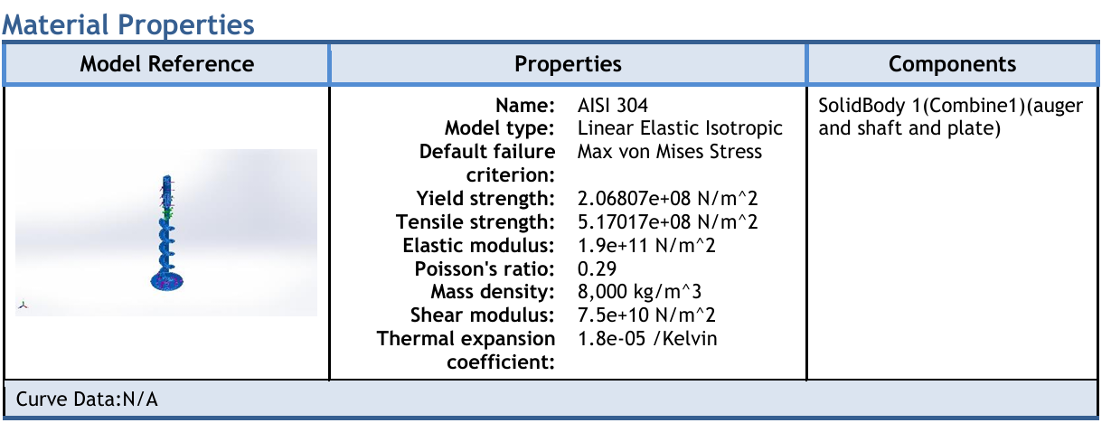
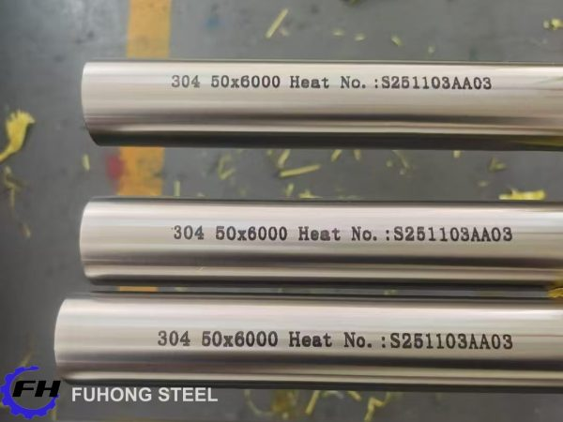

C.3. Extended Simulation Plots: High-resolution color contours of von Mises stress, total deformation, and thermal gradients.
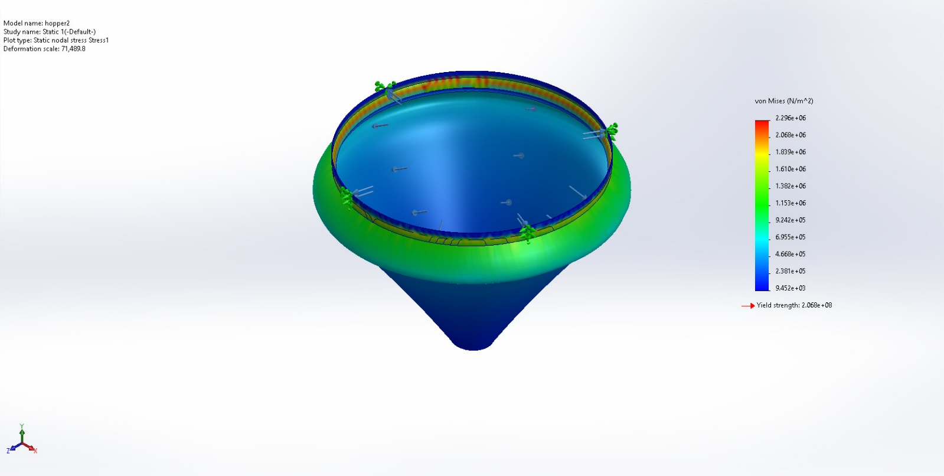
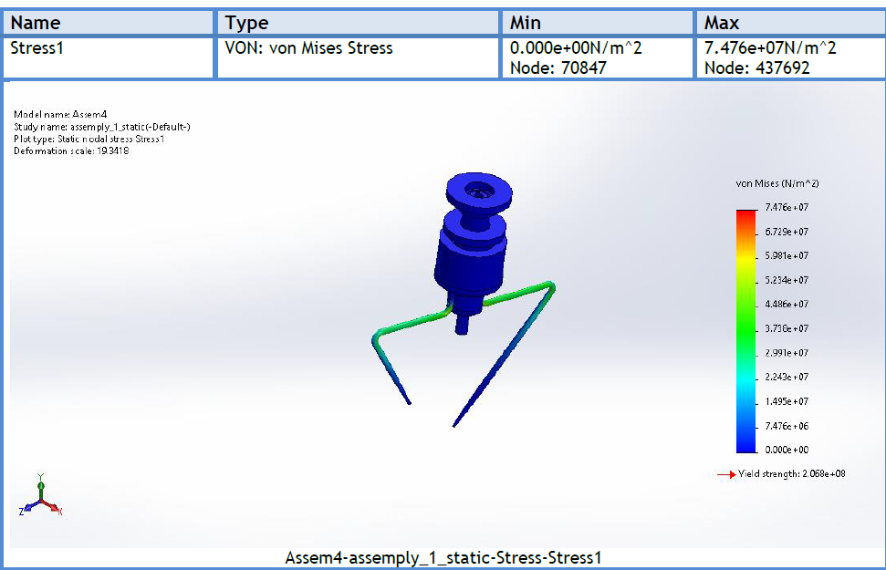’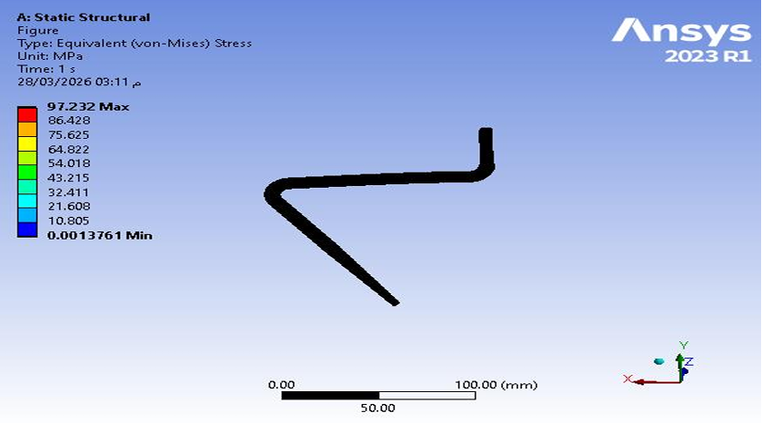

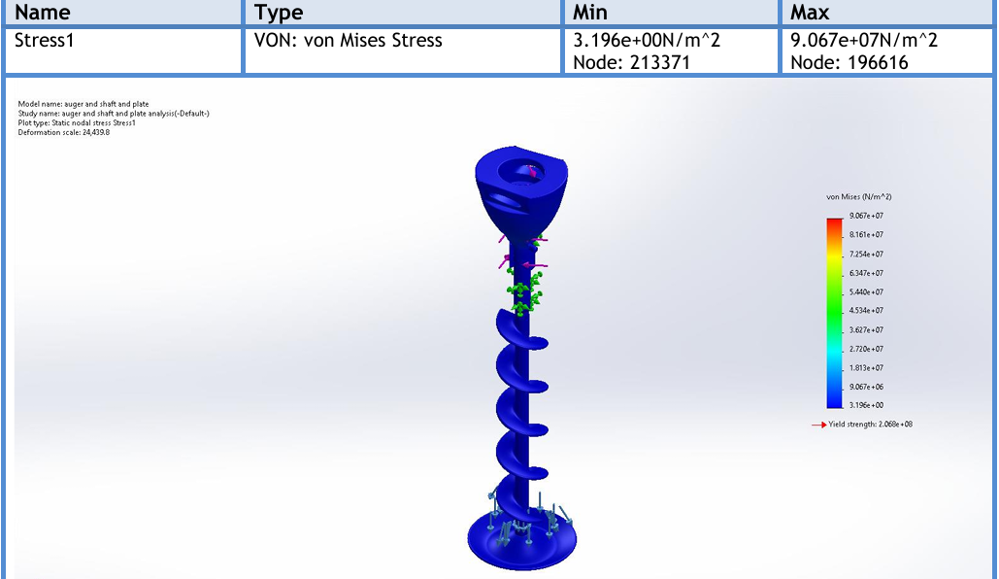

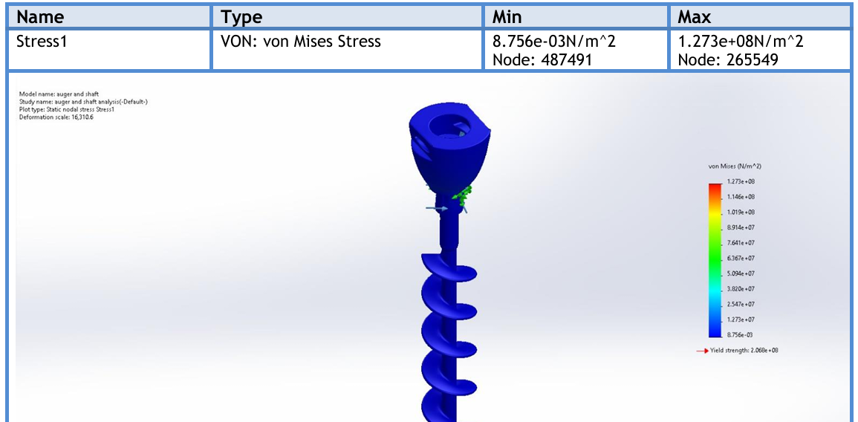

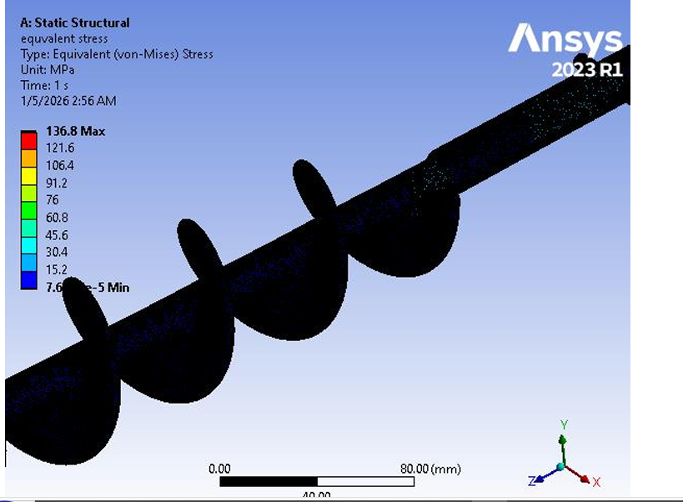

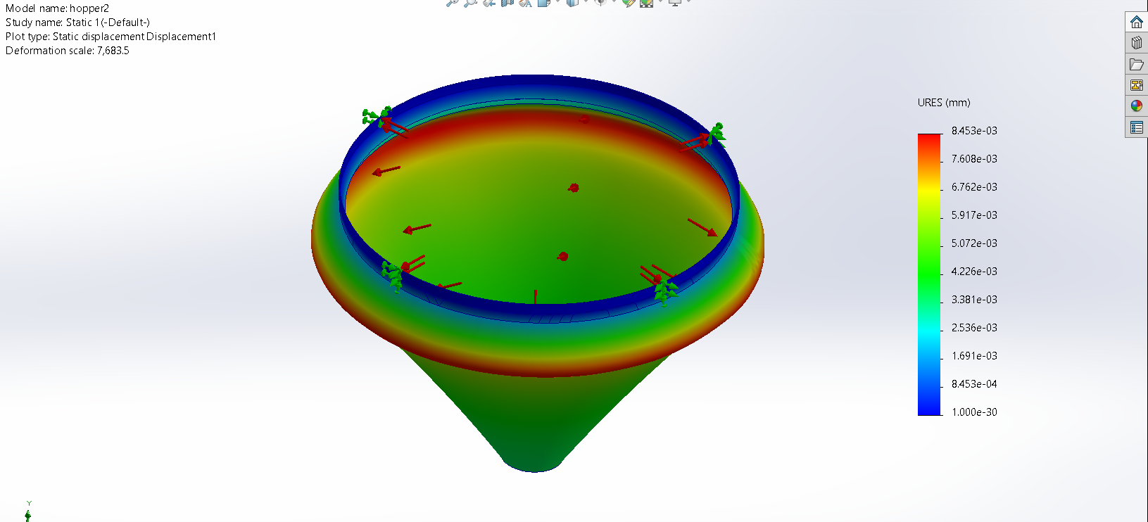
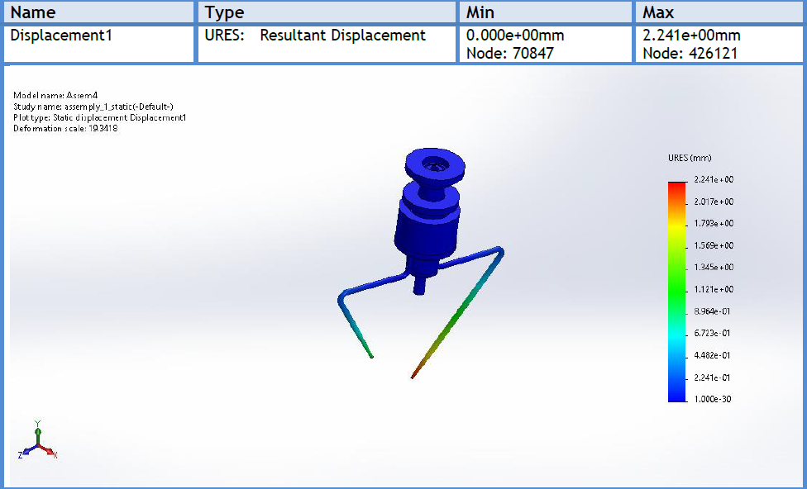
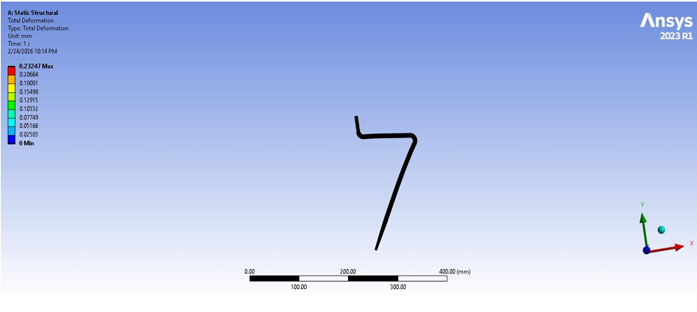
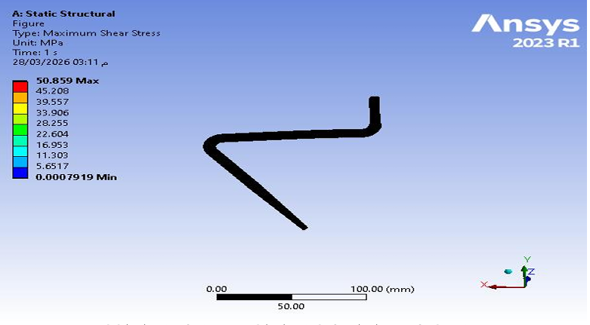

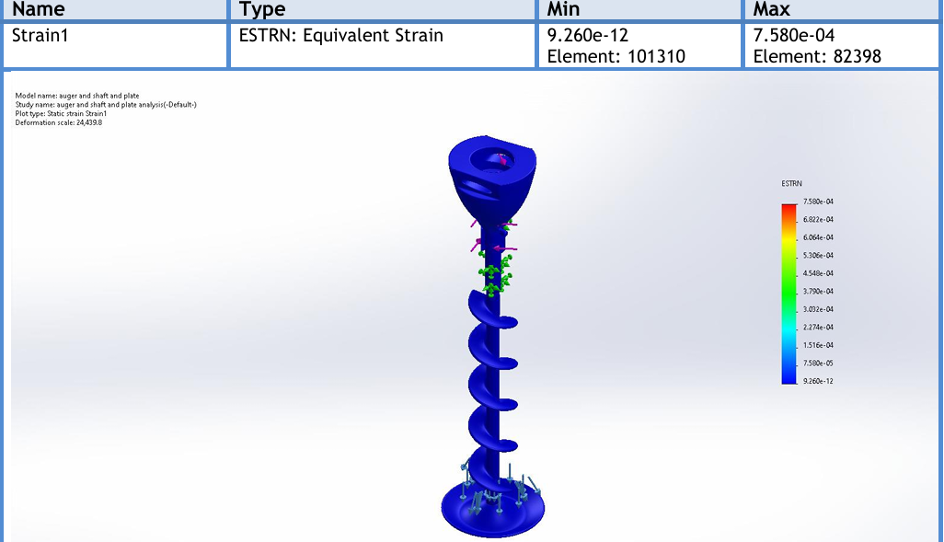

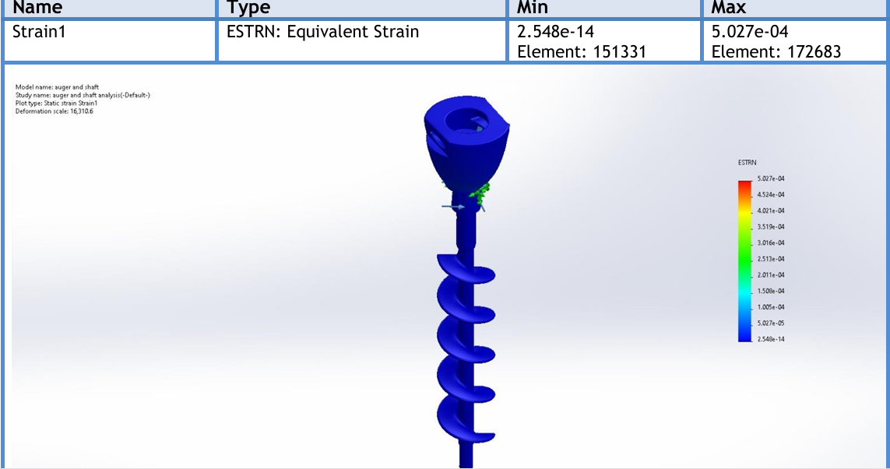
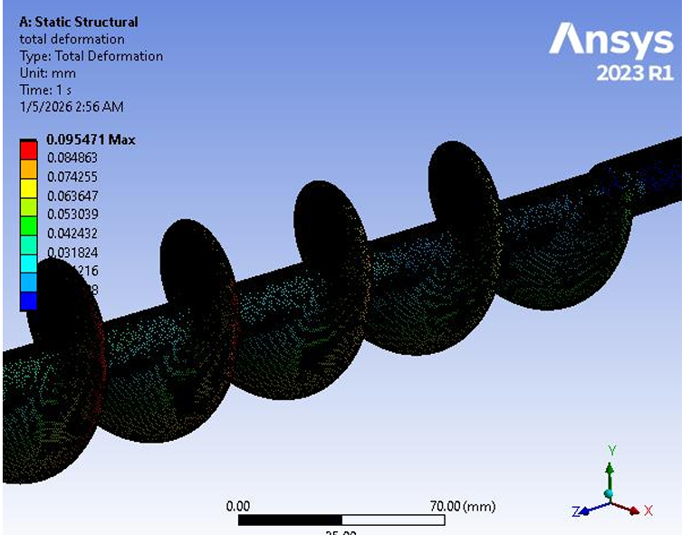

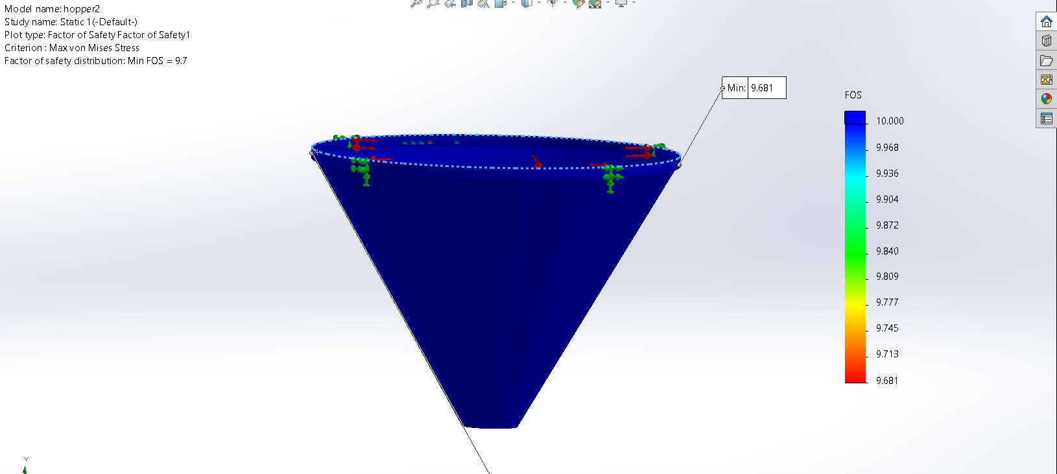

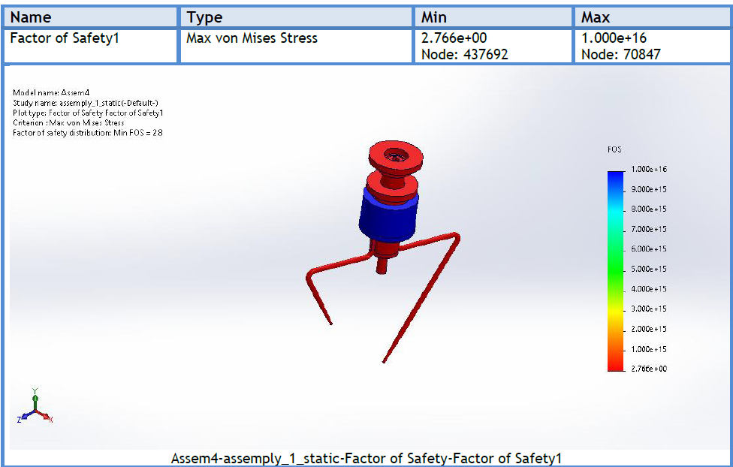
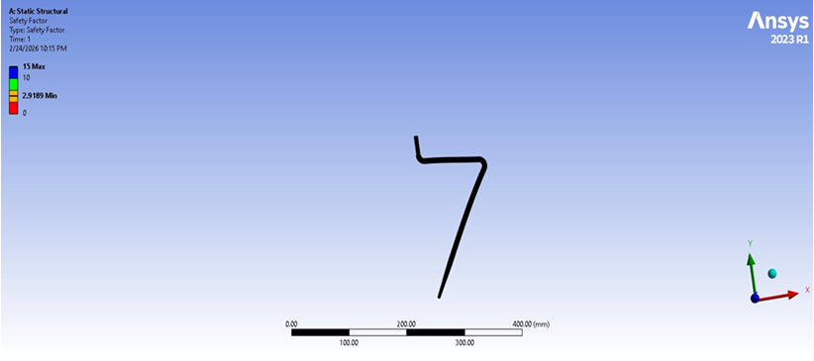
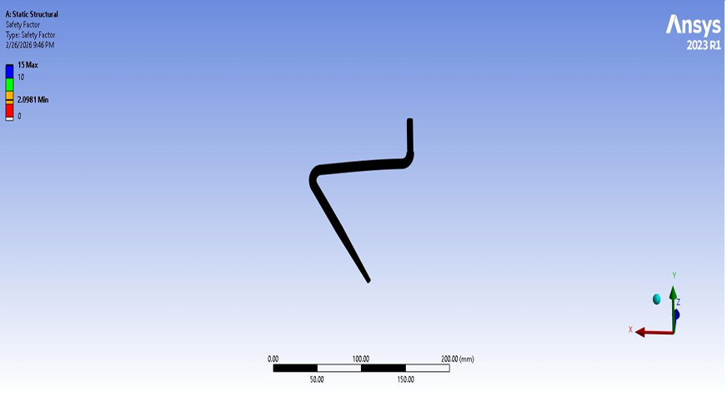
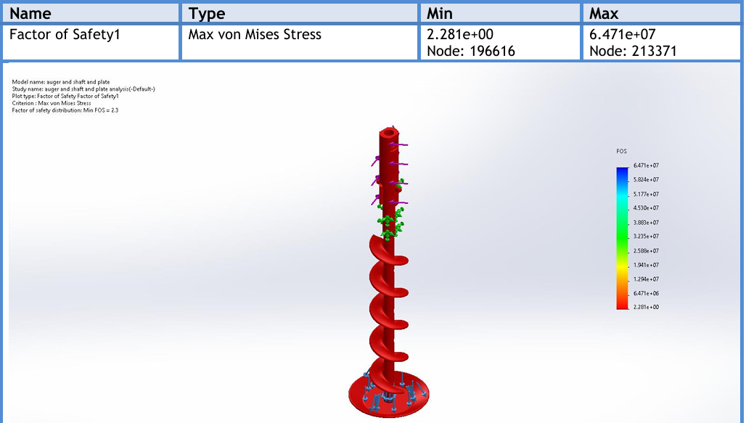

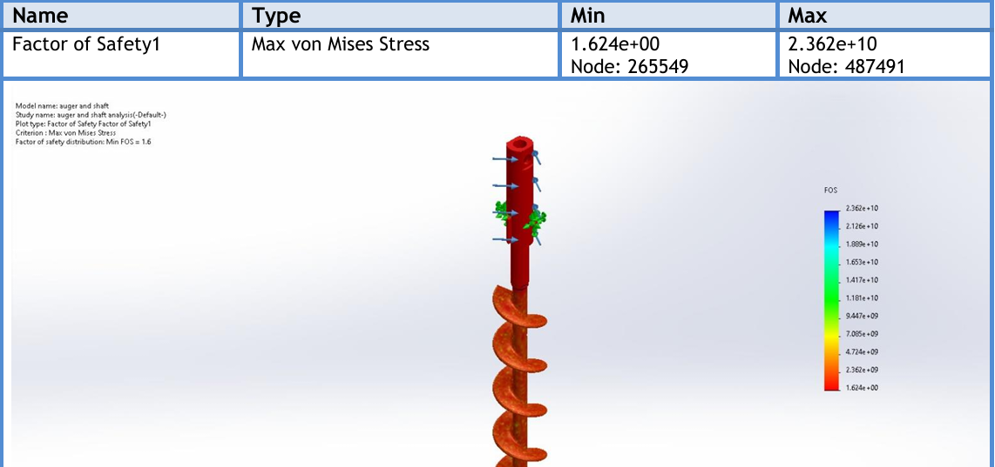
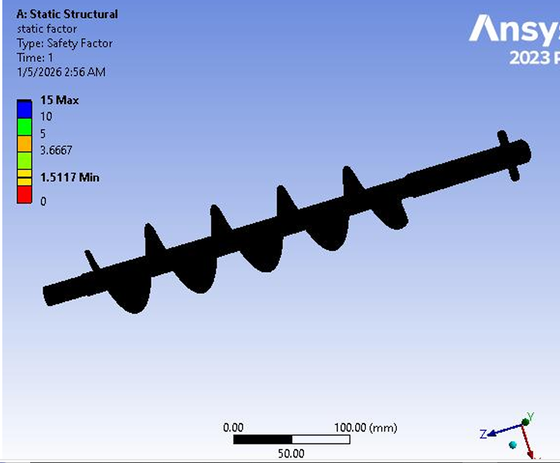

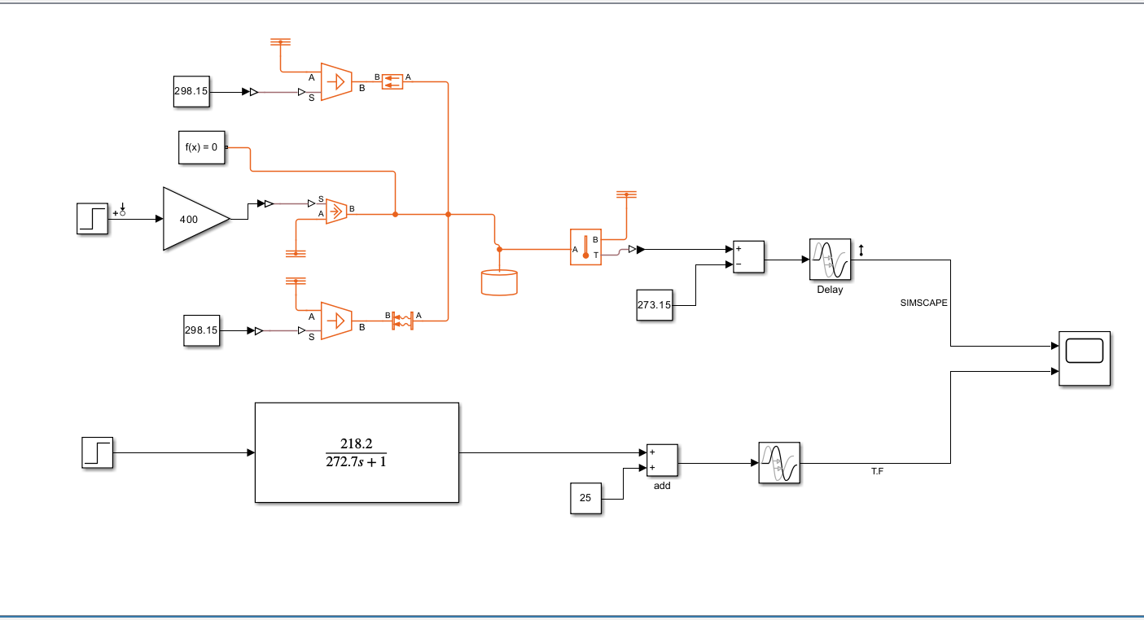
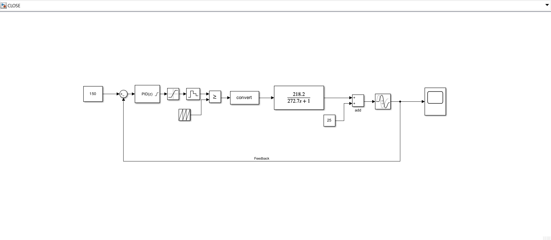
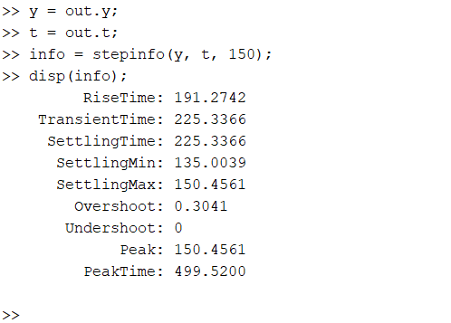
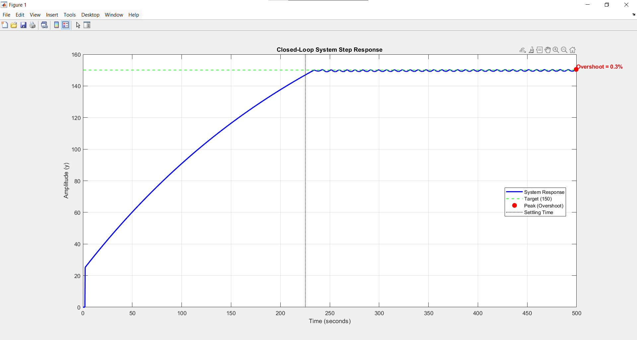
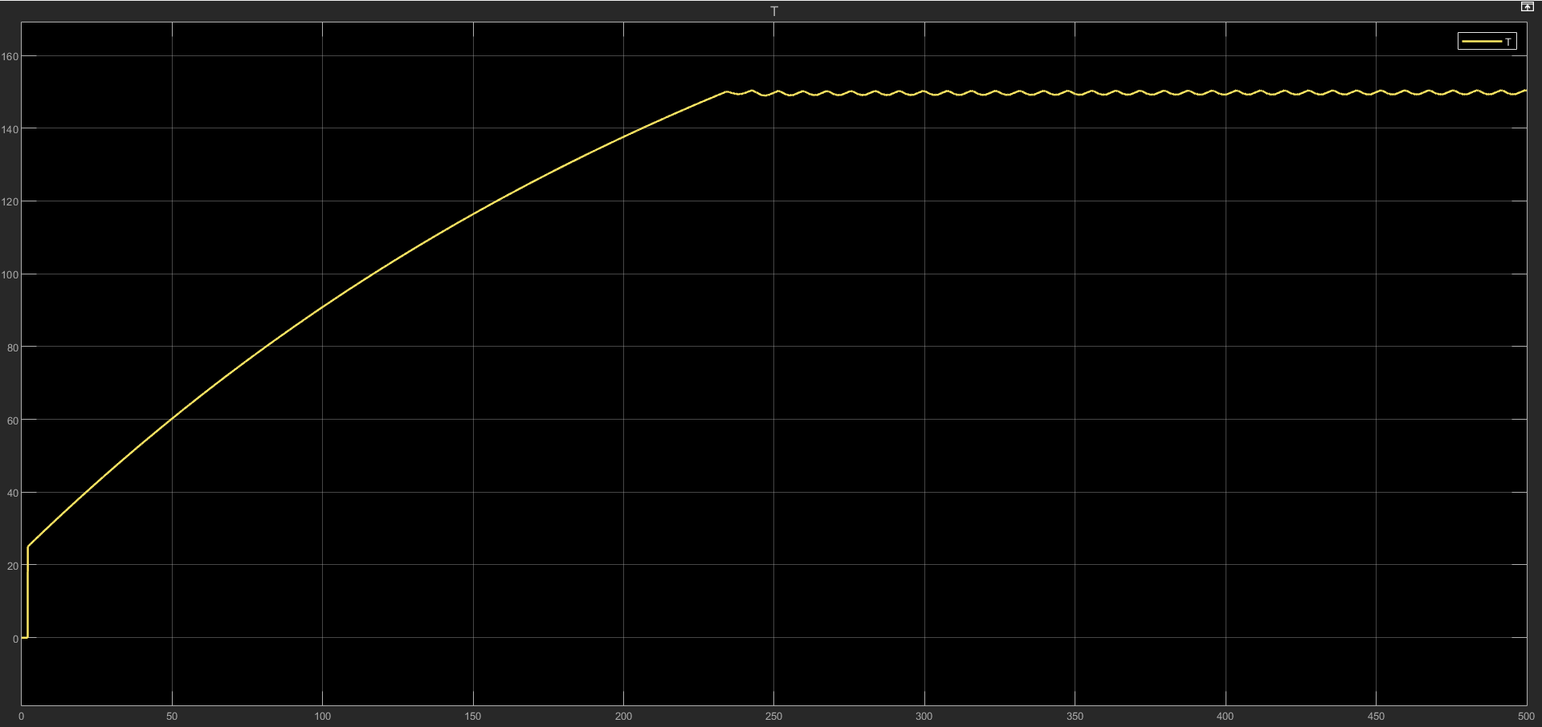

Appendix D: Calculations and Tables

D.1. Motor Sizing Spreadsheet: Detailed torque-speed calculations.
Optimal Motor Selection Table - VFFS Auger Filler
I. Basic Design Requirements
Item | Value | Unit | Notes
Required Design Torque ($T_{design}$) | 1.14 | $$N·m$$ | With SF = 3.0
Design Torque with Reserve ($T_{design,total}$) | 1.332 | $$N·m$$ | $×1.2$ for unexpected conditions
Required Speed at Auger | 150 | RPM | For filling in 0.6 seconds
Maximum Angular Acceleration | 300 | $$rad/s²$$ | For rapid response

II. Comparative Motor Options
Specification | Non Acceptable Option | Acceptable Option | Current Option
Model | MSMF012L1U1 | MSMF022L1U1 | MSMF042L1U1
Manufacturer | Panasonic | Panasonic | Panasonic
Power | 100 W | 200 W | 400 W
Rated Torque ($T_{rated}$) | $$0.32 N·m$$ | $$0.64 N·m$$ | $$1.27 N·m$$
Peak Torque ($T_{peak}$) | $$0.95 N·m$$ | $$1.91 N·m$$ | $$3.82 N·m$$
Rated Speed | 3000 RPM | 3000 RPM | 3000 RPM
Maximum Speed | 6000 RPM | 6000 RPM | 6000 RPM
Rotor Inertia ($J_{rotor}$) | $$0.051 ×{10}^{-4} kg·m²$$ | $$0.14 ×{10}^{-4} kg·m²$$ | $$0.27 ×{10}^{-4} kg·m²$$
Weight | 0.47 kg | 0.78 kg | 1.2 kg
Flange Dimensions | 40 mm | 60 mm | 60 mm
Protection Rating | IP67 | IP67 | IP67
Approximate Price | $150 | $220 | $400

III. Gearbox Compatibility
Item | Non Acceptable Option | Acceptable Option | Current Option
Proposed Gear Ratio ($i$) | 5:1 | 10:1 | 20:1 (Current)
Required Servo Torque | $$1.48 N·m$$ | $$0.74 N·m$$ | $$0.37 N·m$$
Available Servo Torque | $$0.32 N·m$$ | $$0.64 N·m$$ | $$1.27 N·m$$
Safety Margin (${SF}_{actual}$) | 0.216 | 1 | 3.5
Evaluation | Not safe | Weak | Very safe
Speed at Auger | 600 RPM | 300 RPM | 150 RPM
Required Modification | Electronic speed reduction | None | None

IV. Practical Application Compatibility
Criterion | Non Acceptable Option | Acceptable Option | Current Option (MSMF042L1U1)
Stopping Precision | High | High | Very High
Acceleration Response | Very Fast | Fast | Relatively Slow
Power Consumption | Low (30W) | Medium (60W) | High (120W)
Cooling Requirement | Natural | Natural | Additional Fan
Lifespan | Long (10+ years) | Very Long | Very Long
Maintenance Ease | Easy | Easy | Easy
Spare Parts Availability | Bad | Not good | Excellent

Comprehensive Torque Equations Table - VFFS Auger Filler
I. Fundamental Material Torques
No. | Torque Name | Equation | Symbols & Meanings | Calculated Value | Unit | Engineering Notes
1 | Material Weight Torque | $$T_{w}=m×g×r_{m}$$ | m = Material mass (0.5 kg)  g = Gravity acceleration (9.81 m/s²)  $r_{m}= Mean radius =\frac{r_{o}+r_{i}}{2}$ | 0.093 | $$N·m$$ | Basic torque required to lift the material.
2 | Axial Friction Torque | $$T_{f}=μ×m×g×r_{m}$$ | $μ$ = Friction coefficient (0.3 for fine salt) | 0.028 | $$N·m$$ | Material resistance to movement.
3 | Wall Friction Torque | $$T_{wall}=μ_{w}×f_{n}×r_{o}$$ | $μ_{w}$ = Wall friction coefficient (0.2-0.4)  $$F_{n}= Normal force =m×g×cos⁡(α)$$  $r_{o}$ = Outer radius (0.03 m) | 0.015 | $$N·m$$ | Friction of the auger flight against the tube wall.
4 | Internal Shear Torque | $$T_{s}=τ×A×r_{m}$$ | $τ$ = Material shear stress (100-500 Pa for salt)  $$A = Shear area =π×D_{s}×L_{f}$$ | 0.05 | $$N·m$$ | Material resistance to deformation.

II. Dynamic Torques
No. | Torque Name | Equation | Symbols & Meanings | Calculated Value | Unit | Engineering Notes
5 | Auger Inertia Torque | $$T_{j,auger}=J_{auger}×α$$ | $$J_{auger}=\frac{1}{2}×m_{auger}×(r_{o}^{2}+r_{i}^{2})$$  $α$ = Angular acceleration = $\frac{∆ω}{∆t}$ | 0.008 | $$N·m$$ | Impactful during startup and stopping.
6 | Material Inertia Torque | $$T_{j,material}=J_{material}×α$$ | $$J_{material}=\frac{1}{2}×m×(r_{o}^{2}+r_{i}^{2})$$ | 0.004 | $$N·m$$ | Accounts for the mass of the accelerating material.
7 | Centrifugal Torque | $$T_{c}=m×w^{2}×r_{m}×μ×r_{o}$$ | $ω$ = Angular velocity (rad/s)  $$ω=\frac{2π×N}{60}$$ | 0.012 | $$N·m$$ | Increases significantly at high speeds.
8 | Vibration Torque | $$T_{v}=m_{v}×A_{V}×R_{m}$$ | $m_{v}$ = Vibrator mass (0.1 kg)  $a_{v}$ = Vibration acceleration (2-5 m/s²) | 0.006 | $$N·m$$ | Applicable if a vibration motor is utilized.

III. Mechanical Torques
No. | Torque Name | Equation | Symbols & Meanings | Calculated Value | Unit | Engineering Notes
9 | Bearing Friction Torque | $$T_{bearing}=\frac{1}{2}×μ_{b}×F_{r}×d_{b}$$ | $μ_{b}$ = Bearing friction coefficient (0.001-0.005)  $F_{r }$= Radial load (N)  $d_{b}$ = Bearing diameter (0.02 m) | 0.0002 | N·m | Very small but critical for precision.
10 | Gear Loss Torque | $$T_{gear,loss}=T_{in}×(1-n)$$ | $T_{in}$ = Input torque  $n$ = Gear efficiency (0.94) | Variable | N·m | Represents roughly 6% of lost power.
11 | Coupling Loss Torque | $$T_{coupling}=μ_{c}×F_{c}×r_{c}$$ | $μ_{c}$= Coupling friction coefficient (0.1)  $F_{c}$= Coupling compression force  $r_{c}$ = Coupling radius | 0.003 | N·m | Minor losses occurring at the connections.
12 | Air Resistance Torque | $$T_{air}=\frac{1}{2}×ρ_{air}×c_{d}×A×v^{2}×r_{o}$$ | $ρ_{air}$ = Air density (1.225 kg/m³)  $c_{d}$ = Drag coefficient (0.5-1.0)  $A$ = Exposed area  $v$ = Linear velocity | 0.001 | $$N·m$$ | Extremely negligible, typically ignored.

IV. Final Design Torques
No. | Torque Name | Equation | Symbols & Meanings | Calculated Value | Unit | Engineering Notes
13 | Total Raw Torque | $$T_{raw}=T_{w}+T_{f}+T_{wall}+T_{s}+T_{j,total}+T_{C}+T_{bearing}+T_{coupling}$$ | Sum of all preceding torques | 0.37 | $$N·m$$ | Value before applying any safety factors.
14 | Required Design Torque | $$T_{design}=T_{raw}×SF$$ | $SF$ = Safety Factor (3.0 as specified) | 1.14 | $$N·m$$ | The primary value used for design.
15 | Design Torque with Reserve | $$T_{design,total }=T_{design}×1.2$$ | 1.2 = Reserve factor for unexpected operational conditions | 1.37 | $$N·m$$ | Ensures components are never overstressed.

V. Servo Conversion Equations
No. | Torque Name | Equation | Symbols & Meanings | Calculated Value | Unit | Engineering Notes
16 | Required Servo Torque | $$T_{servo}=\frac{T_{design,total}}{i×n}$$ | $i$ = Gear ratio (20)  $n$ = Gear efficiency (0.94) | 0.033 | N·m | Torque required directly at the servo shaft.
17 | Servo Peak Torque (Acceleration) | $$T_{servo,peak}=T_{servo}+\frac{J_{total,}×α_{max}}{i×n}$$ | $J_{total}$ = Total system inertia  $α_{max}$ = Maximum acceleration | 0.045 | $$N·m$$ | Torque spike during maximum acceleration.
18 | Actual Safety Margin | $${SF}_{actual}=\frac{T_{servo,rated}}{T_{servo}}$$ | $T_{servo,rated}$= Servo rated torque (1.27 $N·m$) | 38.5 | - | Excessively high (confirms the motor is oversized).
19 | Gear Output Torque | $$T_{output}=T_{ servo,rate}×i×n$$ | - | 23.9 | $$N·m$$ | Total available torque at the auger shaft.

Comprehensive Volumetric Equations Table - Auger Filler VFFS
First: Basic Auger Geometry Equations
No. | Equation Name | Equation | Symbols & Meanings | Calculated Value | Unit | Engineering Notes
1 | Annular Cross-Sectional Area | $$A=\frac{π}{4}​×(D^{2}-D_{s}^{2})$$ | D = Outer auger diameter (0.06 m)  $D_{s}$ = Central shaft diameter (0.016 m) | 0.00267 | m² | Effective area for material transfer
2 | Outer Radius | $$ro​=\frac{D}{2}​$$ | D = Outer diameter | 0.03 | m | For circular calculations
3 | Inner Radius | $$r_{i}=\frac{D_{s}}{2}$$ | $D_{s}$= Shaft diameter | 0.008 | m | For circular calculations
4 | Mean Radius | $$r_{m}=\frac{r_{o}+r_{i}}{2}$$ | - | 0.019 | m | For torque and force calculations
5 | Radial Flight Height | $$h_{f}=r_{o}-r_{i}=\frac{D-D_{s}}{3}$$ | - | 0.022 | m = 22 mm | Helical chamber depth
6 | Outer Circumference | $$C_{o}=π×D$$ | - | 0.1885 | m | For linear speed calculations
7 | Inner Circumference | $$C_{i}=π×D_{s}$$ | - | 0.0503 | m | For inner speed calculations

Second: Auger Volume Calculations Equations
No. | Equation Name | Equation | Symbols & Meanings | Calculated Value | Unit | Engineering Notes
8 | Theoretical Volume per Pitch | $$V_{pitch,theory}=A×p=\frac{π}{4}(D^{2}-D_{s}^{2})×p$$ | $p = Pitch =$ Distance between flights (0.06 m) | 0.000160 | m³ = 160 cm³ | Without considering voids
9 | Effective Volume per Pitch | $$V_{pitch,eff}=η_{v}×V_{pitch,theory}$$  $$=η_{v}×A×p$$ | $η_{v}$= Volumetric filling efficiency (0.6 for fine salt) | 0.000096 | m³ = 96 cm³ | Considering voids between material particles
10 | Total Auger Volume | $$V_{auger,total} = V_{pitch,eff}×n=η_{v}×A×p×n$$ | n = Number of effective pitches (4.5) | 0.000432 | m³ = 432 cm³ | Volume of material inside the auger
11 | Volume per Complete Revolution | $$V_{rev} = V_{pitch,eff}=η_{v}×A×p$$ | - | 0.000096 | m³ | Same as Equation 9
12 | Volume per Degree of Rotation | $$V_{deg} = \frac{V_{pitch,eff}}{{360}^{°}}=\frac{η_{v}×A×p}{360}$$ | - | 2.67 × 10⁻⁷ | m³/° | For precise Servo control
13 | Volume per Pulse | $$V_{pulse} = \frac{V_{pitch,eff}}{PPR}=\frac{η_{v}×A×p}{8,388,608}$$ | PPR = Encoder resolution (23-bit = 8,388,608) | 1.14 × 10⁻¹¹ | m³/pulse | Ultra-high precision control

Third: Mass & Flow Calculations Equations
No. | Equation Name | Equation | Symbols & Meanings | Calculated Value | Unit | Engineering Notes
14 | Mass per Pitch | $$m_{pitch} =V_{ pitch,eff}×ρ_{b}$$  $$=η_{v}×A×p×ρ_{b}$$ | $ρ_{b}$= Bulk density of material (1300 kg/m³ for salt) | 0.125 | kg = 125 g | Theoretical mass per pitch
15 | Mass per Revolution | $$m_{rev}{=m}_{pitch}$$  $$=η_{v}×A×p×ρ_{b}$$ | - | 0.125 | kg | Same as Equation 14
16 | Total Auger Mass | $$m_{auger,total} = V_{auger,total}×ρ_{b}=η_{v}×A×p×n×ρ_{b}$$ | - | 0.562 | kg = 562 g | Maximum mass inside the auger
17 | Volumetric Flow Rate | $$Q_{v} = V_{pitch,eff}×N$$  $$=η_{v}×A×p×N$$ | N = Angular speed (rev/sec) | Variable | m³/s | Material volume/time
18 | Mass Flow Rate | $$\dot{m=Q_{v} ×ρ_{b}}$$  $$=η_{v}×A×p×N×ρ_{b}$$ | - | Variable | kg/s | Material mass/time
19 | Target Dose Mass | $$m_{dose,target} = 1.0$$ | Determined from customer requirements | 1.0 | kg = 1000 g | Target to be achieved
20 | Required Revolutions per Dose | $$N_{dose}=\frac{m_{dose,target}}{m_{rev}} =\frac{m_{dose,target}}{η_{v}×A×p×ρ_{b}}$$ | - | 8.0 | rev | To obtain 1000 g
21 | Required Pitches per Dose | $$n_{dose}=\frac{m_{dose,target}}{m_{pitch}} =\frac{m_{dose,target}}{η_{v}×A×p×ρ_{b}}$$ | - | 8.0 | pitch | Same as Equation 20
22 | Required Rotation Angle | $$θ_{dose}=N_{dose}×360=\frac{m_{dose,target}×360}{η_{v}×A×p×ρ_{b}}$$ | - | 2880 | degree | For Servo Position Control
23 | Required Filling Time | $$\frac{N_{dose}}{N_{auger}}=\frac{m_{dose,target}×360}{η_{v}×A×p×ρ_{b}×N_{auger}}$$ | $N_{auger}$= Auger speed (rev/sec) | 0.6 | s | For synchronization with bag cycle

Fourth: Spinner Plate Volume Equations
No. | Equation Name | Equation | Symbols & Meanings | Calculated Value | Unit | Engineering Notes
24 | Circular Plate Area | $$A_{disc}=\frac{π}{4}×D_{disc}^{2}$$ | $D_{disc}$ = Plate diameter (0.10 m) | 0.00785 | m² | Total area of the plate
25 | Sloped Area | $$A_{slop}=$$  $$π×(r_{disc}^{2}-r_{flat}^{2})$$ | $r_{disc}$ = Plate radius (0.05 m)  $r_{flat}$ = Flat area radius (0.034775 m) | 0.00415 | m² | Effective sliding area
26 | Material Volume on Plate | $$V_{disc}=A_{disc}×h_{layer}=$$  $$\frac{π}{4}×D_{disc}^{2}×h_{layer}$$ | $h_{layer}$= Material layer thickness (0.01-0.02 m) | 0.0000785 | m³ = 78.5 cm³ | For continuous feeding
27 | Material Mass on Plate | $$m_{disc}=V_{disc}×ρ_{b}=$$  $$A_{disc}×h_{layer}×ρ_{b}$$ | - | 0.102 | kg = 102 g | Reserve above the auger
28 | Effective Slope Angle | $$α_{eff}=$$  $$arctan⁡(\frac{h_{disc}}{r_{disc}-r_{flat}})$$ | $h_{disc}$= Plate edge height (0.01 m) | 55 | degree | Affects flow speed

Fifth: Hopper Volume Equations
No. | Equation Name | Equation | Symbols & Meanings | Calculated Value | Unit | Engineering Notes
29 | Cylindrical Hopper Volume | $$V_{hopper,cyl}=\frac{π}{4}×D_{h}^{2}×H_{h}$$ | $D_{h}$ = Hopper diameter (0.3 m)  $H_{h}$= Hopper height (0.4 m) | 0.0283 | m³ = 28.3 L | For temporary storage
30 | Conical Hopper Volume | $$V_{hopper,cyl}=\frac{π}{12}×H_{c}×(D_{t}^{2}+D_{t}×D_{b}+D_{b}^{2})$$ | $H_{c}$ = Cone height  $D_{t}$ = Top diameter  $D_{b}$ = Bottom diameter | Variable | m³ | For smooth feeding
31 | Material Volume in Hopper | $$V_{material,hopper} =$$  $$η_{fill}×V_{hopper}$$ | $η_{fill}$ = Hopper fill factor (0.8-0.9) | Variable | m³ | Less than geometric volume
32 | Material Mass in Hopper | $${m_{hopper}=V}_{material,hopper} ×ρ_{b}$$ | - | Variable | kg | For production planning
33 | Complete Emptying Time | $$t_{empty}= \frac{{ m}_{hopper}}{\dot{m}}=\frac{V_{material,hopper}}{Q_{v}}$$ | - | Variable | s | Between two hopper refills

Sixth: Bag Volume Equations
No. | Equation Name | Equation | Symbols & Meanings | Calculated Value | Unit | Engineering Notes
34 | Rectangular Bag Volume | $$V_{bag}=ω×h×t$$ | $ω$ = Width (0.15 m)  $h$= Height (0.20 m)  $t$= Thickness/Depth (0.08 m) | 0.0024 | m³ = 2.4 L | Internal bag volume
35 | Available Product Volume | $$V_{product}=$$  $$V_{bag}×η_{fill,bag}=ω×h×t×η_{fill,bag}$$ | $η_{fill,bag}$= Bag fill factor (0.7-0.8) | 0.0018 | m³ = 1.8 L | Considering air
36 | Maximum Bag Mass | $$m_{bag,max}=ρ_{b}×V_{product}$$ | - | 2.34 | kg | For safety verification
37 | Required Film Length | $$L_{film}=$$  $$2×\left(ω+t\right)+L_{seal}$$ | $L_{seal}$= Seal margin (0.02 m) | 0.48 | m = 480 mm | Per bag
38 | Required Film Width | $$w_{film} =$$  $$h + L_{seal,top}\} +L_{seal,bottom}$$ | $L_{seal,bottom}$= Top/bottom seal margin | 0.24 | m = 240 mm | Roll width

Seventh: Pressure & Stress Equations
No. | Equation Name | Equation | Symbols & Meanings | Calculated Value | Unit | Engineering Notes
39 | Hydrostatic Column Pressure | $$P_{h}=$$  $$ρ_{b}×g×h_{column}$$ | $h_{coulmn}$= Material column height above auger (0.2 m) | 2550 | Pa = 2.55 kPa | Pressure on the auger
40 | Vertical Force from Pressure | $$F_{h}=P_{h}×A=ρ_{b}×g×h_{column}×\frac{π}{4}×D_{disc}^{2}$$ | - | 20.0 | N | Needed for structural design
41 | Shear Stress in Material | $$τ=\frac{F_{shear}}{A_{shear}}=\frac{T}{2π×r_{m}^{2}×h_{f}}$$ | T = Applied torque | Variable | Pa | For viscous materials
42 | Compressibility Factor | $$K =\frac{∆P}{\frac{∆V}{V_{o}}}$$ | $∆P$ = Pressure change  $∆V$= Volume change | Variable | Pa | For compressible materials

Eighth: Speed & Time Equations
No. | Equation Name | Equation | Symbols & Meanings | Calculated Value | Unit | Engineering Notes
43 | Angular Velocity | $$ω=2π×N=\frac{2π×n_{RPM}}{60}$$ | N = Speed (rev/sec)  $n_{RPM}$ = Speed (rev/min) | 15.7 | $$rad/s$$ | For unit conversion
44 | Linear Material Velocity | $$v_{material}=ω×r_{m}×tan⁡(∅)$$ | $∅$= Internal friction angle (25-35°) | Variable | $$m/s$$ | Actual transfer speed
45 | Complete Filling Cycle Time | $$T_{cycle}=t_{fill}+t_{settle}+t_{seal}+t_{cut}+t_{frad}$$ | $t_{settle}$= Settling time  $t_{seal}$ = Sealing time  $t_{cut}$ = Cutting time  $t_{frad}$= Feeding time | 1.71 | s | For total productivity
46 | Productivity | $$\dot{n}=\frac{60}{T_{cycle}}$$ | - | 35 | $$bag/min$$ | Production target

Ninth: Correction & Calibration Equations
No. | Equation Name | Equation | Symbols & Meanings | Calculated Value | Unit | Engineering Notes
47 | Volumetric Correction Factor | $$C_{v}=\frac{m_{actual}}{m_{theory}}=\frac{m_{actual}}{η_{v}×A×p×ρ_{b}×n}$$ | $m_{actual}$= Measured actual mass | Variable | - | Determined experimentally
48 | Actual Bulk Density | $$ρ_{actual}=\frac{m_{actual}}{V_{auger,total}}=\frac{m_{actual}}{η_{v}×A×p×n}$$ | - | Variable | $$kg/m³$$ | May differ from 1300
49 | Actual Filling Efficiency | $$η_{actual}=\frac{m_{actual}}{ρ_{b}×A×p×n}$$ | - | Variable | - | For precise calibration
50 | Corrected Number of Revolutions | $$N_{corrected}=N_{theory}×\frac{1}{C_{v}}=\frac{m_{target}}{m_{actual}}×N_{theory}$$ | - | Variable | rev | For precise control

Summary of Key Values
Item | Value | Unit | Main Equation
Annular Area (A) | 0.00267 | $$m²$$ | $$A=\frac{π}{4}​⋅(D^{2}-D_{s}^{2})$$
Effective Volume per Pitch | 96 | $$cm³$$ | $$η_{v}×A×p$$
Total Auger Volume | 432 | $$cm³$$ | $$η_{v}×A×p×n$$
Mass per Pitch | 125 | $$g$$ | $$η_{v}×A×p×ρ_{b}$$
Total Auger Mass | 562 | g | $$η_{v}×A×p×ρ_{b}×n$$
Required Revolutions for 1000g | 8.0 | rev | $$\frac{m_{target}}{η_{v}×A×p×ρ_{b}}$$
Rotation Angle for 1000g | 2880 | degree | $$N_{dose}× 360$$
Filling Time | 0.6 | s | $$\frac{N_{dose}}{N_{auger}}$$

Required Design Torque ($T_{design}$) | 1.14 | $$N·m$$ | With SF = 3.0
Design Torque with Reserve ($T_{design,total}$) | 1.332 | $$N·m$$ | $×1.2$ for unexpected conditions
Required Speed at Auger | 150 | RPM | For filling in 0.6 seconds
Maximum Angular Acceleration | 300 | $$rad/s²$$ | For rapid response

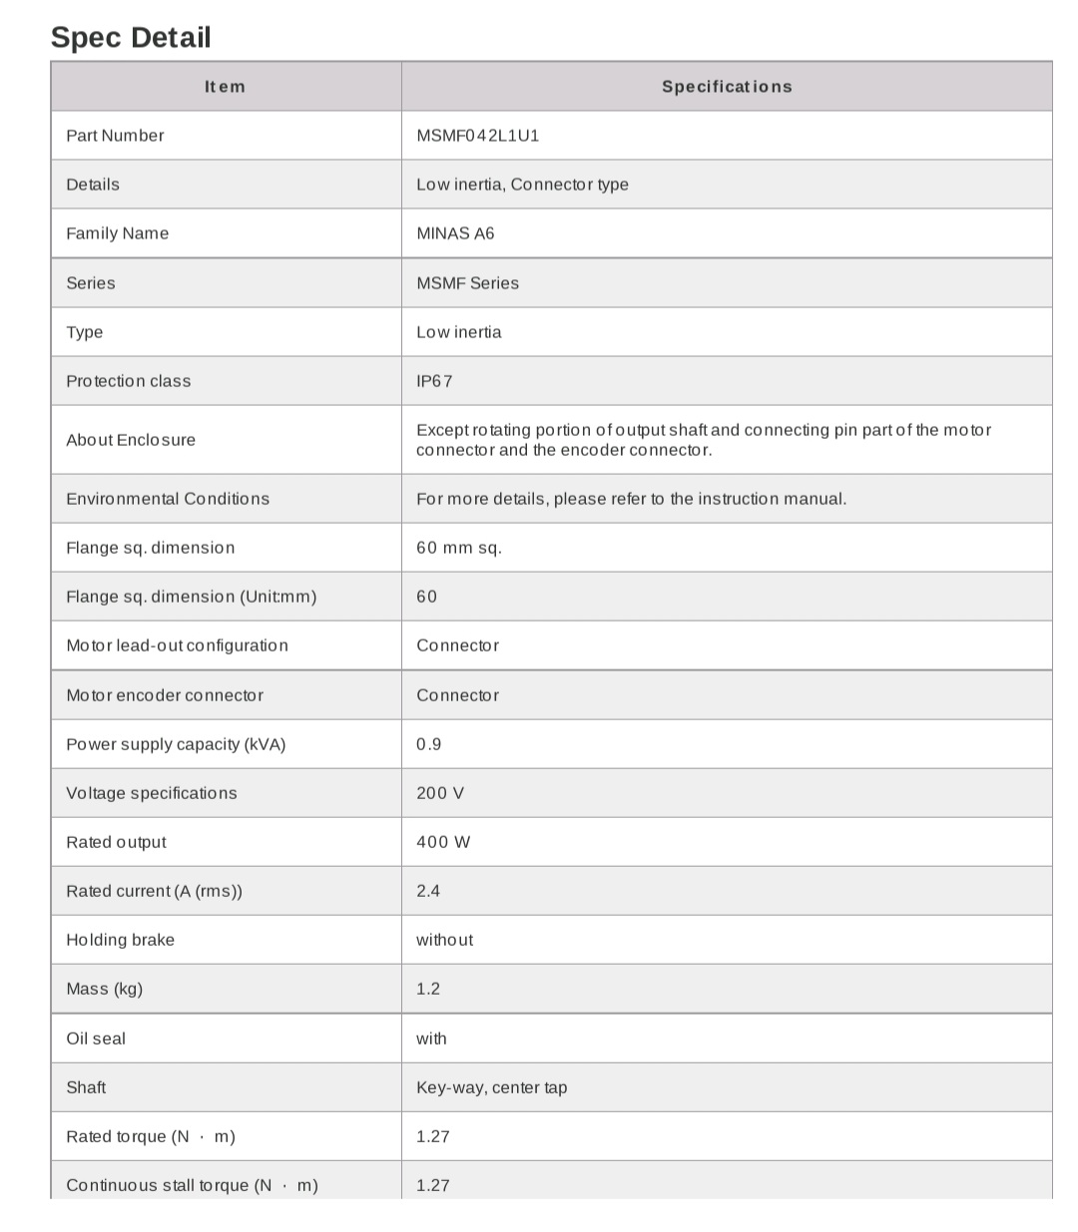
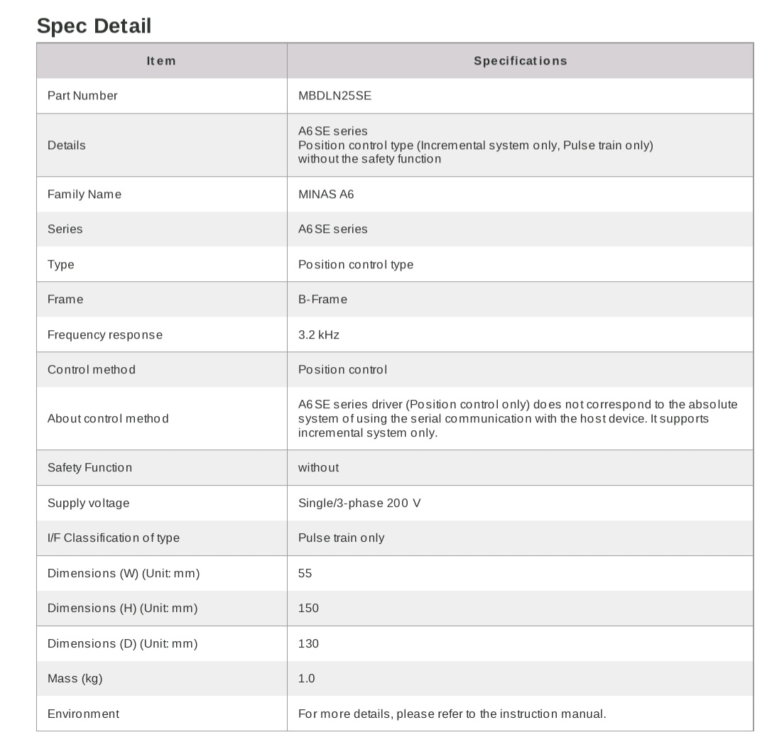
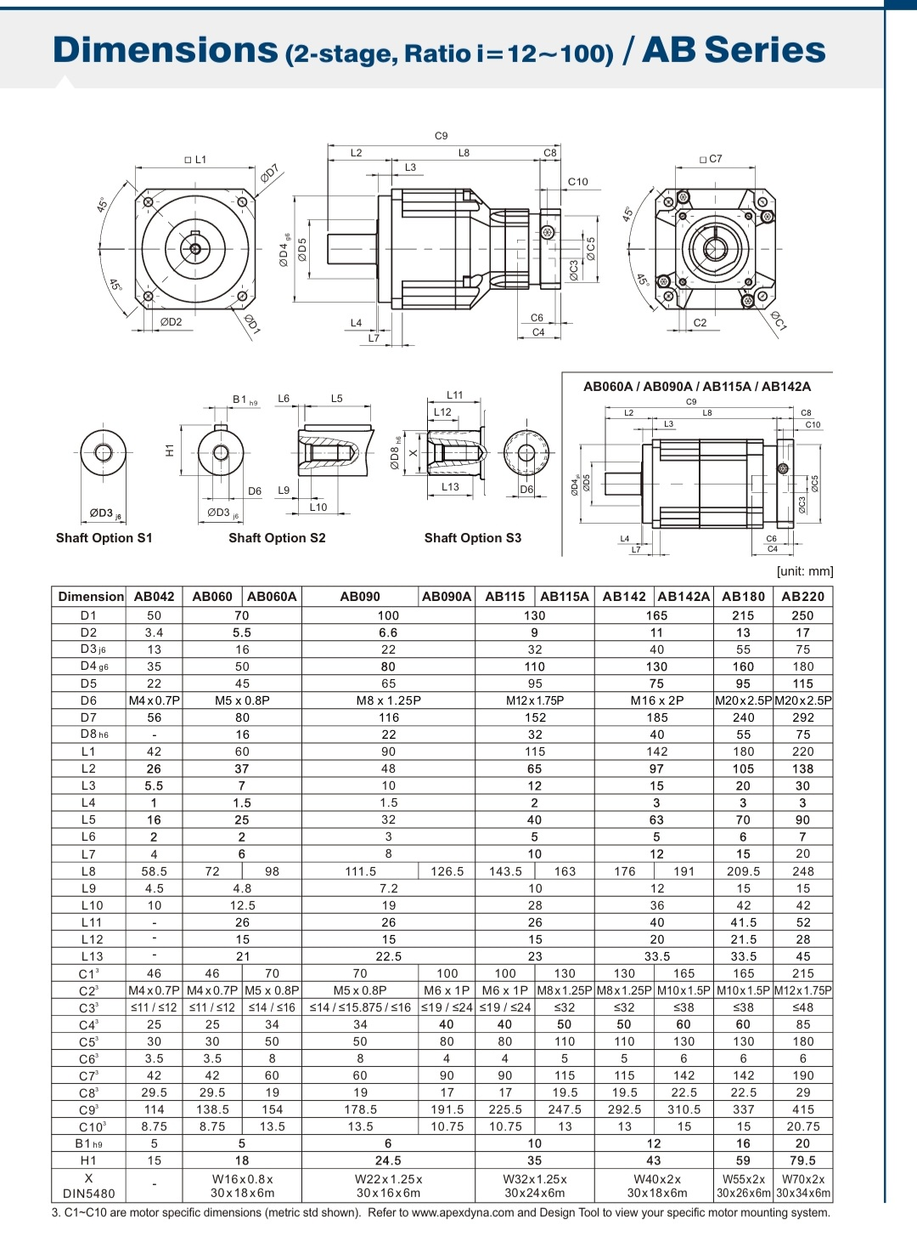
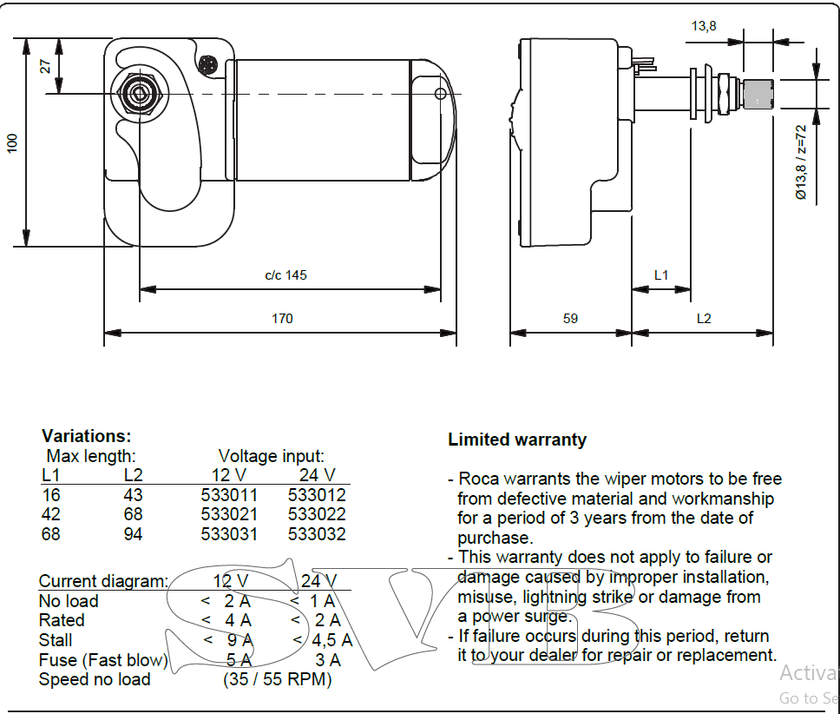

D.2. Bearing and Fastener Selection Tables: Reference data used to justify the selection of specific industrial parts.
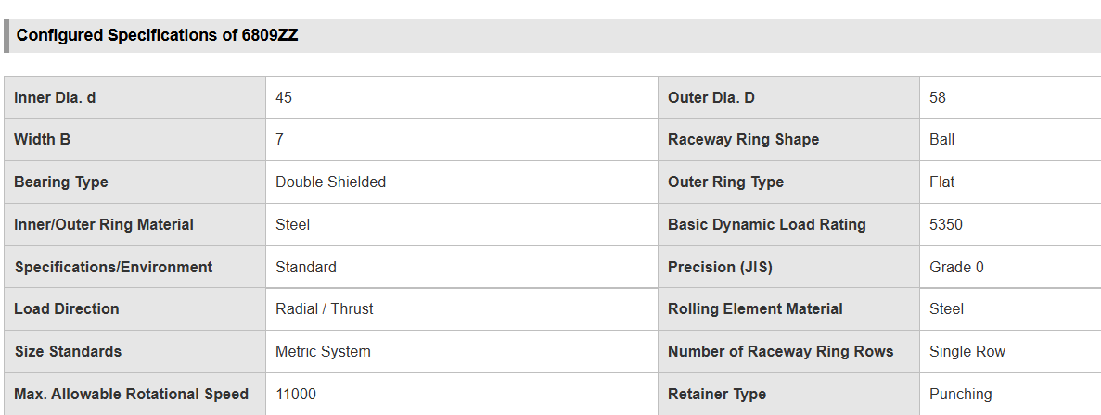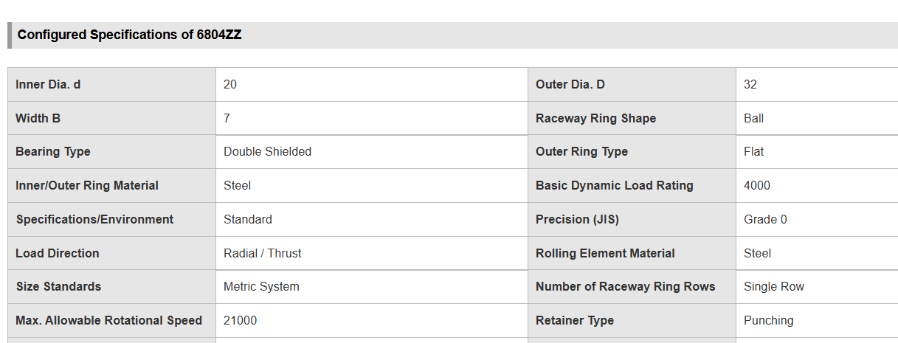
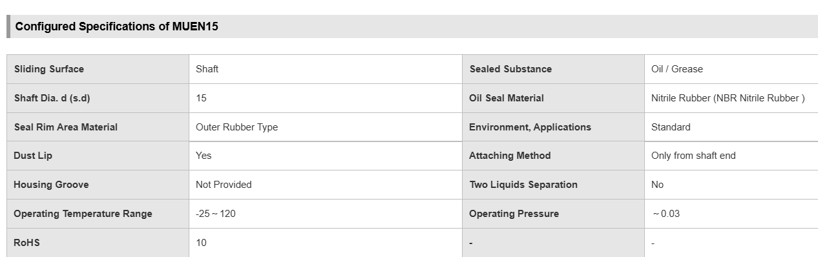
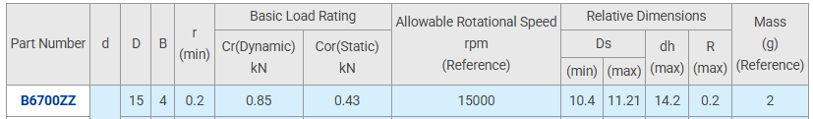
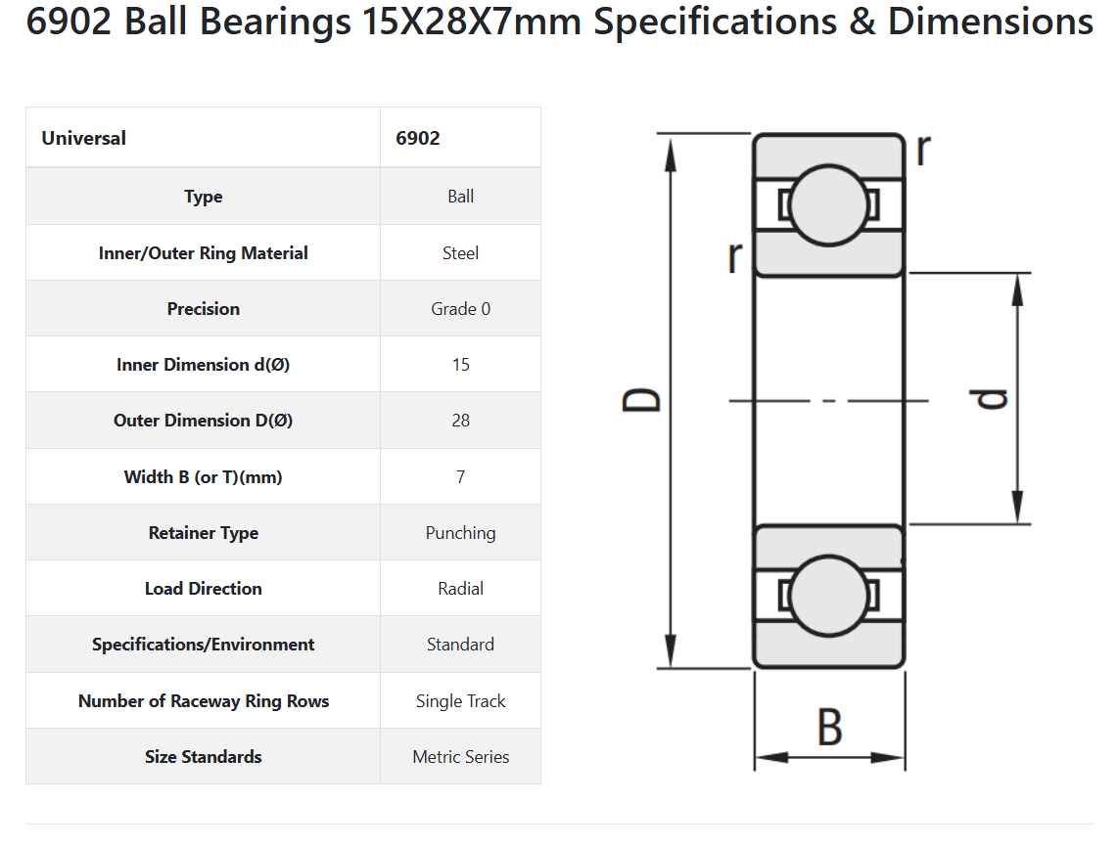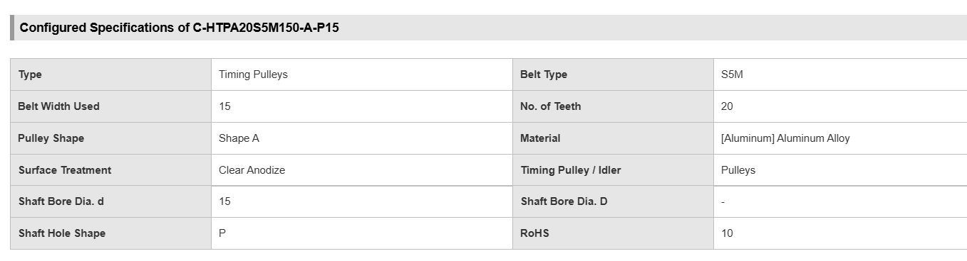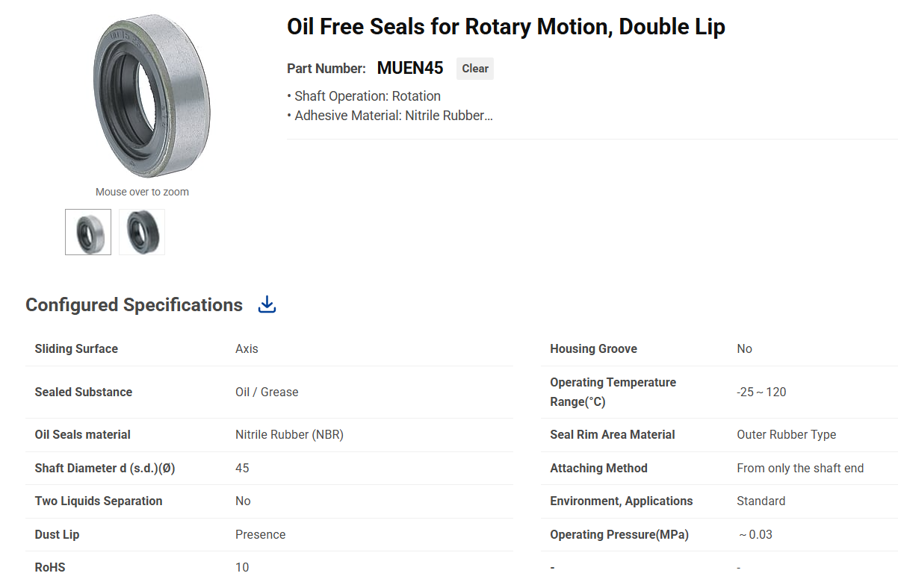
II. Controller Selection (ESP32 vs. PLC)
Feature | Custom ESP32 Architecture | Traditional Industrial PLC
Processing Power | Dual-Core 240 MHz (Parallel) | Single-Core 50-100 MHz (Cyclic)
Motion Control | Native RMT (Hardware-level) | Needs High-Speed IO Modules
Cost Efficiency | Highly Cost-Effective | High License & Hardware Costs
Connectivity | Native WiFi/UART (Industry 4.0) | Requires Communication Gateways

Industrial Hardware Specifications
Component | Part Number/Type | Technical Justification
Thermal Sensor | K-Type + MAX6675 | High range (up to $1024^\circ\text{C}$) & SPI Digital interface.
Eye-mark Sensor | KS-C2 (NPN) | High-speed contrast detection for registration.
Heater Relay | Zero-Crossing SSR 40A | Eliminates EMI noise during PID switching.
Logic Isolation | Optocoupler Relay Module | Protects ESP32 (3.3V) from 24V industrial spikes.
Power Supply | MeanWell 24V, 14.6A | Provides stable power for motors and actuators.

D.3. Error Analysis Calculations: The statistical math used to compare analytical vs. simulation results
II. Simulation vs. Requirement Analysis
Metric | Design Requirement | Simscape Result | Percentage Error / Status
Setpoint | $150^\circ\text{C}$ | $150^\circ\text{C}$ | 0% (Exact match)
Settling Time | $< 300\text{ s}$ | $225.3\text{ s}$ | Within Bounds (PASSED)
Max Overshoot | $< 1\%$ | $0.304\%$ | Highly Stable (PASSED)
Steady-State Error | $\pm 1^\circ\text{C}$ | $\pm 0.45^\circ\text{C}$ | Improved precision
Derivative Filter ($N$) | Stable ($ | 1-NT_s | <1$)

