CHAPTER 1 – INTRODUCTION
Purpose: To introduce integrated powder packaging systems, define the engineering problem, and outline the objectives and methodology of the study.

1.1 Background and Context
Powder packaging represents a critical operation across multiple industrial sectors including food processing, pharmaceuticals, chemicals, and consumer goods. The vertical form-fill-seal (VFFS) packaging technology has emerged as the dominant solution for automated powder packaging due to its high throughput, compact footprint, and operational flexibility. When integrated with auger filling mechanisms, VFFS systems can achieve precise dosing of powders with varying flow characteristics while maintaining production rates suitable for industrial applications.
The evolution of packaging automation has been driven by increasing demands for productivity, consistency, and traceability. Industry 4.0 concepts have further accelerated this evolution by introducing connected systems capable of real-time monitoring, predictive maintenance, and adaptive control. This project addresses the design and validation of an ESP32-based VFFS powder packaging machine that integrates auger filling technology with modern control architectures and IoT connectivity.

1.2 Auger Filler Mechanisms for Powder Dosing

1.2.1 Operating Principle
Auger filler systems are widely used for volumetric dosing of powders in VFFS packaging machines due to their high accuracy, simplicity, and adaptability to different powder types. The fundamental principle of auger filling is based on controlled rotational displacement of powder using a helical screw housed inside a feed tube.
While the auger screw determines volumetric displacement, the consistency of dosing accuracy strongly depends on the upstream powder conditioning system, primarily the hopper and agitation mechanism.
In vertical auger fillers, powder flows from the hopper into the auger inlet zone under gravity. However, gravity alone is insufficient to guarantee uniform feed for cohesive or compressible powders. Therefore, the hopper geometry and agitator system play a critical role in:
• Preventing bridging above the screw inlet
• Maintaining uniform bulk density near the screw flights
• Breaking consolidation zones
• Ensuring repeatable volumetric filling
Without proper hopper design, volumetric dosing becomes inconsistent due to density variation and void formation above the auger. Thus, the hopper and agitation system form an integral part of the auger filling mechanism, directly influencing dosing precision and machine stability.

1.2.2 Auger Geometry Parameters
The key geometric parameters of an auger screw include:
Screw Diameter (D): The outer diameter of the auger flights, typically ranging from 25 mm to 150 mm for industrial applications. Larger diameters enable higher throughput but require greater torque.
Pitch (P): The axial distance between consecutive flight crests, usually equal to or slightly less than the screw diameter. The pitch-to-diameter ratio (P/D) affects conveying efficiency and powder compaction.
Flight Thickness: The radial thickness of the screw flights, typically 2-5 mm depending on material and loading conditions.
Core Diameter: The diameter of the central shaft, typically 0.3-0.5 times the screw outer diameter.

1.2.3 Advantages of Auger Filling
Auger filling systems offer several advantages for powder dosing applications:
- High dosing accuracy (typically ±1-3% for free-flowing powders)
- Wide range of applicable powder types and particle sizes
- Adjustable fill volume through speed and rotation count control
- Gentle handling minimizing particle attrition
- Compact design suitable for integration with VFFS systems
- Relatively simple mechanical construction with minimal wear parts

1.2.4 Limitations and Considerations
Despite their advantages, auger fillers have certain limitations:
- Sensitivity to powder flow properties - cohesive powders may not fill flights uniformly
- Potential for powder compaction affecting dose consistency
- Requires consistent powder level in the feed hopper
- May cause particle attrition for fragile materials
- Dripping can occur after rotation stops for fine powders
These limitations are addressed through proper system design including agitator mechanisms, anti-drip devices, and appropriate operating parameters.

1.2.5 Integration with VFFS Systems
In VFFS packaging lines, the auger filler is positioned above the forming tube, delivering measured powder doses into the formed bag as it descends. The synchronization between auger operation, film transport, and sealing mechanisms is critical for achieving consistent package quality. Modern VFFS auger fillers incorporate:
- Servo-driven auger motors for precise speed and position control
- Load cell feedback for gravimetric verification
- Agitator systems to maintain consistent powder feeding
- Dust collection interfaces for clean operation
- Quick-change tooling for different products

CHAPTER 2 – THEORETICAL AND SCIENTIFIC FOUNDATIONS
Purpose: To establish the scientific and engineering principles governing integrated VFFS powder packaging systems, covering forming, filling, and sealing processes.

2.1 Powder Mechanics and Flow Behavior

2.1.1 Introduction to Powder Characterization
The behavior of powders in industrial handling systems is governed by a complex interplay of particle properties, environmental conditions, and equipment geometry. Understanding these fundamental characteristics is essential for the design of reliable powder feeding and dosing systems, particularly in vertical auger filler applications where consistent flow directly impacts dosing accuracy and operational efficiency.

2.1.2 Jenike Flow Theory and Hopper Design
The theoretical foundation for modern hopper design was established by Andrew Jenike in the 1960s through his pioneering work on gravity flow of bulk solids. According to Jenike (1964), the design of reliable powder discharge systems requires understanding of powder flow properties under consolidated conditions.
The fundamental concept in Jenike's theory is the Yield Locus, which describes the relationship between shear stress and normal stress at the point of incipient flow. For a cohesive powder, the yield locus is represented by the Mohr-Coulomb failure criterion:
τ = c + σ · tan(φ) [3]
Where τ is the shear stress, c is the cohesion, σ is the normal stress, and φ is the angle of internal friction. This relationship enables the determination of the Flow Function (FF), which characterizes powder flowability:
FF = σ_c / σ_t [1]
Where σ_c is the unconfined yield strength and σ_t is the major principal stress at consolidation. The flow function categorizes powders as:
- Free-flowing: FF > 10
- Easy-flowing: 4 < FF < 10
- Cohesive: 2 < FF < 4
- Very cohesive: FF < 2

2.1.3 Critical Arching Dimension
One of the most important contributions of Jenike's theory is the calculation of the minimum outlet dimension required to prevent arching. The critical arching diameter (B_c) is given by:
B_c = H(θ) · σ_c / ρ · g[1]
Where H(θ) is a dimensionless function of the hopper half-angle θ, σ_c is the unconfined yield strength, ρ is the bulk density, and g is gravitational acceleration. For a conical hopper with half-angle θ = 30°, H(θ) ≈ 2.2.
For fine table salt with typical properties (σ_c ≈ 200 Pa, ρ = 1300 kg/m³):
B_c = 2.2 × 200 / (1300 × 9.81) ≈ 34.5 mm
The selected outlet diameter of 65 mm provides a safety factor of approximately 1.9 against arching, ensuring reliable discharge under varying operating conditions.

2.1.4 Wall Angle Requirements for Mass Flow
Achieving mass flow requires that the hopper wall angle be sufficiently steep relative to the powder's wall friction angle (φ_w). According to Jenike's design charts, the critical condition for mass flow in a conical hopper is:
θ < (90° - φ_w) - 5°[1]
For fine salt on stainless steel surfaces, the wall friction angle φ_w ≈ 20-25°. Therefore, the maximum allowable hopper half-angle for mass flow is:
θ_max < (90° - 25°) - 5° = 60° from horizontal
The selected wall angle of 60° from horizontal (30° from vertical) satisfies this criterion with a small margin, ensuring mass flow behavior while maintaining practical hopper proportions.

2.1.5 Bulk Density and Flow Properties
Table 2.1 presents the bulk density values and flow properties for the target powders in this study:
Material | Bulk Density (kg/m³) | AoR (°) | Cohesion (Pa) | Flow Function
Coffee Powder | 250-400 | 30-40 | 150-300 | Cohesive
Granulated Sugar | 700-880 | 30-36 | 50-100 | Easy-flowing
Wheat Flour | 560-600 | 38-45 | 300-500 | Very cohesive
Fine Table Salt | 1200-1400 | 32-35 | 100-200 | Easy-flowing
Powdered Detergent | 300-600 | 30-45 | 200-400 | Cohesive
Milk Powder | 200-720 | 35-44 | 250-450 | Cohesive
Table 2.1: Bulk Density and Flow Properties of Target Powders

2.1.6 Common Flow Problems in Powder Handling
Several flow problems can occur in powder handling systems, each with specific causes and prevention strategies:
Bridging (Arching): The formation of a stable arch above the outlet that prevents discharge. Bridging occurs when cohesive forces between particles exceed gravitational forces. Prevention requires outlet dimensions exceeding the critical arching diameter and proper hopper geometry.
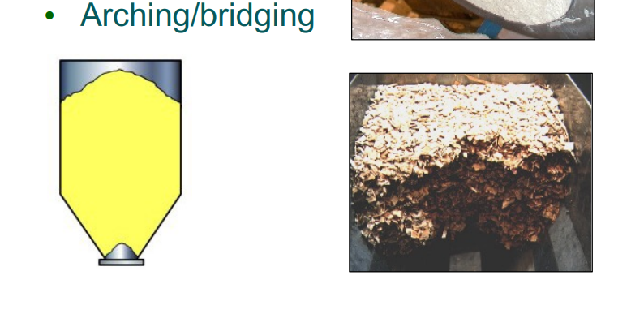
Figure 2.1.6.1: Powder Bridging and Arching Phenomenon. This illustration demonstrates the formation of a stable arch above the hopper outlet.
Rat-Holing: The formation of a stable flow channel through the center of the powder bed while material near walls remains stagnant. Associated with funnel flow patterns, leading to reduced effective capacity and potential product degradation.
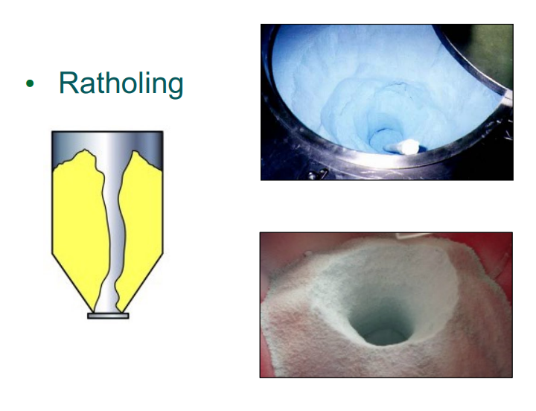
Figure 2.1.6.2: Ratholing in Powder Beds. This visual depicts a stable flow channel forming through the center of stagnant material

Caking: The formation of solid masses due to long-term consolidation, moisture absorption, or chemical reactions. Particularly problematic for hygroscopic powders like milk powder and coffee.
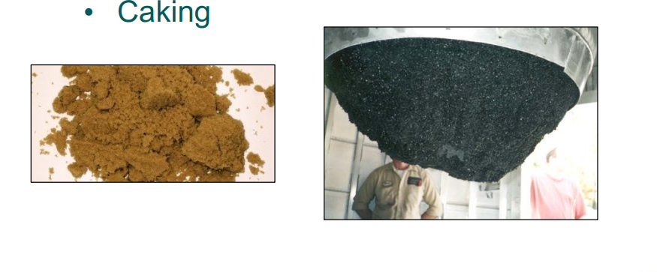
Figure 2.1.6.3: Powder Caking Behavior. This image highlights the consolidation of powder into solid masses.

2.2 Auger Filling Theory and Mechanisms
The theoretical analysis of auger filling involves understanding the powder conveying mechanism, the factors affecting fill uniformity, and the relationship between operating parameters and dosing accuracy.

2.2.1 Volumetric Conveying Theory
The theoretical volume conveyed per auger revolution is determined by the screw geometry:
V_t = (π/4) · (D² - d²) · P[5]
Where D is the screw outer diameter, d is the core diameter, and P is the pitch.

2.2.2 Fill Factor Considerations
The actual volume dispensed is less than the theoretical volume due to incomplete filling of the flight cavities. The fill factor (η) depends on powder properties, auger speed, and inlet conditions.

2.3 Electric Drives and Motion Control Fundamentals
Modern auger filler systems rely on precision electric drives for accurate dosing. Servo motors and stepper motors provide the position and speed control necessary for consistent fill volumes.

2.3.1 Servo Motor Control
Servo motors offer closed-loop position control with high resolution encoders, enabling precise control of auger rotation angle and speed profiles.

2.4 Discrete Element Method for Powder Simulation

2.4.1 Introduction to DEM
The Discrete Element Method (DEM) is a numerical simulation technique that models granular materials as individual particles interacting through contact forces. Originally developed by Cundall and Strack (1979), DEM has become an essential tool for understanding and optimizing powder handling processes in industrial applications.
Unlike continuum mechanics approaches that treat powders as fluids or solids, DEM explicitly models each particle's motion based on Newton's second law, accounting for particle-particle and particle-boundary interactions. This approach provides detailed insight into flow patterns, segregation, and stress distributions that are difficult to measure experimentally.

2.4.2 Governing Equations
In DEM simulations, each particle's motion is governed by the equations of motion:
m_i · d²r_i/dt² = Σ F_c + F_g + F_other
I_i · dω_i/dt = Σ M_c [7]
Where m_i is particle mass, r_i is position, I_i is moment of inertia, ω_i is angular velocity, F_c are contact forces, F_g is gravitational force, and M_c are contact moments.

2.4.3 Contact Models
The interaction between particles is typically modeled using the Hertz-Mindlin contact theory, which accounts for:
- Normal contact force based on particle overlap and material stiffness
- Tangential friction force following Coulomb's friction law
- Rolling resistance for non-spherical particles
- Cohesive forces for wet or fine powders

2.4.4 Applications in Powder Handling
DEM simulations are widely used in auger filler and powder handling system design for:
- Predicting powder flow patterns in hoppers and conveying systems
- Optimizing auger geometry for specific powder properties
- Analyzing fill uniformity and dosing accuracy
- Investigating segregation and mixing behavior
- Evaluating wear patterns and equipment design

2.4.5 DEM Parameters for Powder Simulation
The simulation done by edem program.
Accurate DEM simulation requires proper characterization of particle properties:
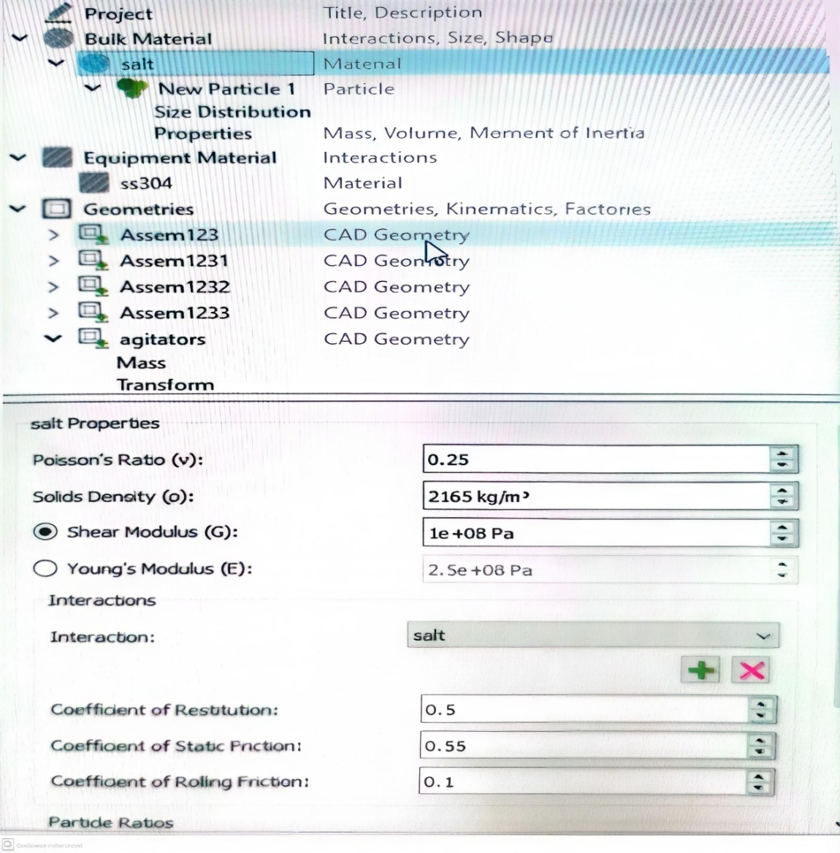
Figure 2.4.5.1: DEM Material Properties Configuration for Salt. This EDEM software interface screenshot displays the critical input parameters

Parameter | Values
Poisson's Ratio(v) | 0.25
Solids Density(ρ) | 2165 kg/m³
shear Modulus(G) | 1 GPa
Coefficient of Restitution | 0.5
Coefficient of Static Friction | 0.55
Coefficient of Rolling Friction | 0.1
Table 2.2: Key DEM Parameters for Powder Simulation
And Equipment Material ss304:
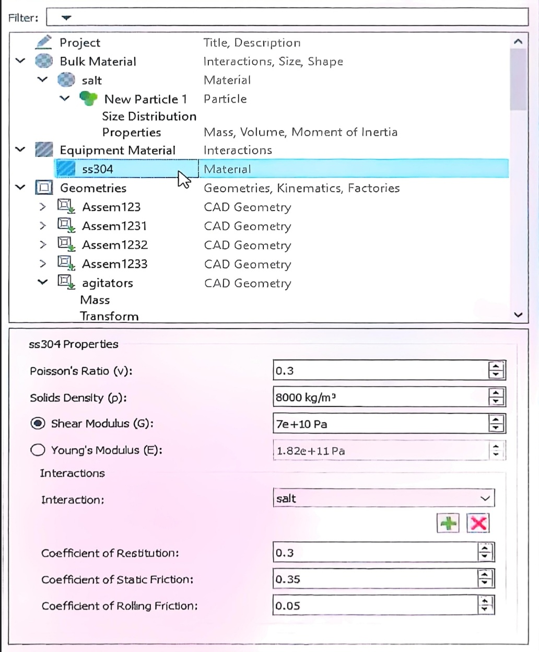
Figure 2.4.5.2: SS304 DEM Properties - Equipment material parameters in EDEM.
Parameter | Values
Poisson's Ratio(v) | 0.3
Solids Density(ρ) | 8000 kg/m³
shear Modulus(G) | 7e+10 Pa
Coefficient of Restitution | 0.3
Coefficient of Static Friction | 0.35
Coefficient of Rolling Friction | 0.05
Table 2.3: Key DEM Parameters for Equipment Material
Anther sittings:
- Velocity for agitators: 30 rad/s
- Velocity for screw: 135 rad/s
- Add factory dynamics total Mass:16 kg and Generation rate :4 kg/s
- Polygon-number of edges:32 and Radius: 0.2 m

2.4.6 Simulation Results
The simulation results showed a torque analysis at the blades, which was small, confirming that the design was suitable for the blades:
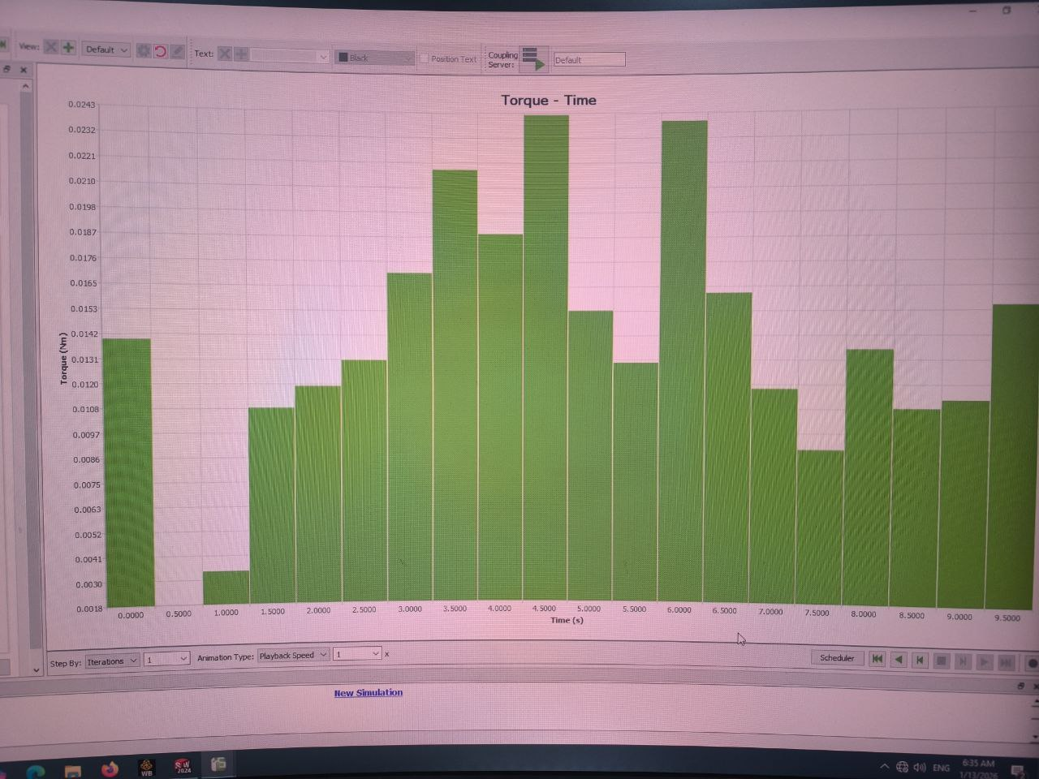
Figure 2.4.6.1: Agitator Torque Analysis - Time-domain simulation results at the blades.
A torque analysis at the auger screw also confirmed that the design was suitable.
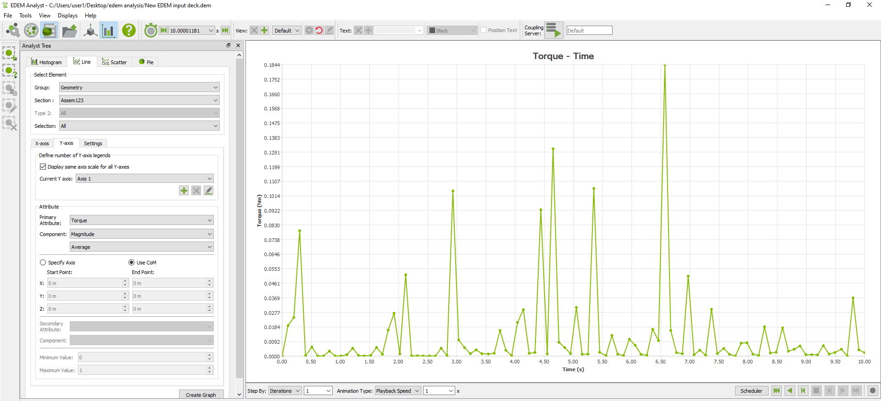
Figure 2.4.6.2: Auger Torque Analysis - Time-domain simulation results at the screw.

2.4.7 Limitations and Validation
While DEM provides valuable insights, it has limitations:
- Computational cost increases dramatically with particle count
- Simplifications in particle shape may affect results
- Calibration against experimental data is essential
- Cohesive powder modeling remains challenging
Validation through comparison with experimental flow tests is essential for reliable simulation results.

2.7 VFFS Machine Kinematics and Synchronization
2.7.1 Machine Cycle Overview
A Vertical Form-Fill-Seal (VFFS) machine operates through a synchronized sequence of mechanical subsystems responsible for forming, filling, sealing, and cutting operations. Although film transport and sealing mechanisms define the packaging structure, the filling subsystem—particularly the hopper and agitation mechanism—plays a decisive role in dosing stability.
The complete machine cycle involves:
- Film unwinding and tension regulation
- Tube formation via the forming collar
- Vertical sealing of the back seam
- Powder feeding from hopper to auger inlet
- Controlled auger dosing into the formed bag
- Horizontal sealing and cutting
- Discharge of the finished package
From a mechanical integration perspective, the hopper–agitator system must continuously condition the powder column to maintain stable bulk density and prevent flow interruptions during the dosing phase.
Unlike static storage vessels, the hopper in a VFFS auger filler operates under cyclic dynamic conditions caused by:
- Machine frame vibration
- Intermittent auger rotation
- Start–stop motor behavior
- Film transport acceleration
Therefore, synchronization between the agitator motion and auger rotation is essential to avoid:
- Density fluctuation above the screw inlet
- Local consolidation during dwell phases
- Formation of transient arches during acceleration
- Uneven feed pressure at the auger entry zone
The agitator operates at a controlled low speed (30 RPM) and is configured for counter-rotation relative to the auger. This configuration generates shear-induced disturbance within the powder bed, ensuring continuous flow toward the outlet sleeve and maintaining uniform feed conditions.

2.7.2 Timing Requirements for Hopper–Agitator Interaction
The synchronization between filling and sealing operations imposes strict timing constraints on the powder conditioning system.
For a production rate of 15 bags per minute, the cycle time is:
t_cycle = 60 / 15 = 4 seconds
The filling phase must be completed before the sealing jaws close. However, from the hopper perspective, an additional constraint exists: the powder bed must remain stable during both active filling and dwell periods.
The filling condition is expressed as:
t_fill + t_settle < t_cycle - t_seal
Where:
t_fill = auger discharge duration
t_settle = powder stabilization time after agitation
t_cycle = total cycle duration
t_seal = horizontal sealing duration
Because the hopper discharge capability (≈0.18 s for 0.5 kg under mass flow conditions) is significantly faster than the required filling window, the primary challenge is not flow rate limitation but flow stability.
Thus, the agitator must:
- Prevent compaction during idle intervals
- Recondition powder before each dosing event
- Avoid over-agitation that could aerate the powder
This balance ensures repeatable bulk density at the auger inlet, directly influencing volumetric dosing accuracy.

2.7.3 Motion Coordination Between Agitator and Auger
The motion profiles of the agitator and auger must be dynamically compatible.
Auger Rotation:
Typically utilizes controlled acceleration (S-curve profile) to minimize sudden torque spikes and powder compression at startup.
Agitator Motion:
Operates at constant low rotational speed or intermittent activation synchronized with auger start signals.
Counter-rotation between agitator and auger creates localized shear zones within the powder bed, reducing stagnant regions and minimizing rat-holing tendencies.
Mechanical coupling considerations were verified through motion simulation and include:
- Alignment tolerance between agitator shaft and drive pulley
- Belt tension stability during cyclic operation
- Bearing load variation due to vibratory excitation
- Clearance maintenance between blade tips and hopper wall
These factors ensure reliable long-term operation without mechanical interference or flow instability.

2.7.4 Kinematic Stability and Vibration Influence on Hopper
Although the hopper is geometrically static, it experiences dynamic excitation due to machine motion.
For a bag length of 150 mm and cycle time of 4 seconds:
v_film = L_bag / t_cycle = 0.150 / 4 = 0.0375 m/s
The acceleration and deceleration of the film drive system generate frame vibrations that can propagate to the hopper structure.
Potential effects on hopper–agitator performance include:
- Transient powder consolidation
- Micro-arching near the outlet
- Increased shear load on agitator blades
The structural rigidity verified in Chapter 7 (maximum deformation 0.08 mm) ensures that hopper geometry remains stable under these dynamic conditions. The high safety factors prevent amplification of vibration-induced stresses.
Therefore, kinematic synchronization is not limited to timing logic but extends to mechanical stability of the hopper–agitator assembly within the overall VFFS motion system.
These dynamic considerations were further validated through motion simulation, as presented in Section 2.7.5.

2.7.5 Kinematic Analysis and Motion Verification
A kinematic verification study was conducted using SolidWorks Motion Simulation to validate the dynamic interaction between the agitator blades and the auger screw within the hopper assembly.
The objectives of the motion study were to:
- Verify counter-rotation between agitator and auger
- Ensure no geometric interference occurs during operation
- Confirm blade–wall clearance under rotational motion
- Evaluate relative angular velocity behavior
The simulation was performed under the following conditions:
- Auger rotational speed: 135 RPM (nominal dosing condition)
- Agitator rotational speed: 30 RPM (counter-rotating)
- Blade-to-wall radial clearance: 1.5 mm
- Fixed boundary condition at bearing supports
Results of the motion analysis confirmed that:
- The agitator blades rotate smoothly in the opposite direction to the auger screw.
- No collision or interference occurs between rotating components.
- Minimum clearance between blade tips and hopper wall remains greater than 1.5 mm throughout the cycle.
- The counter-rotation generates a continuous shear field in the powder region above the auger inlet.
The motion trajectories demonstrated stable kinematic behavior without oscillation or misalignment at the coupling interface. This confirms that the mechanical integration between hopper, agitator shaft, and drive system is dynamically compatible with the VFFS operating cycle.
No resonance behavior was observed within the operating speed range.
The study further validated that the designed clearances remain sufficient under operational rotational speeds, supporting reliable long-term performance.

2.7.6 Coaxial Kinematic Decoupling and Bearing Architecture
To physically realize the counter-rotational dynamics described in Section 2.7.3 (Auger at 135 RPM CW and Agitator at 30 RPM CCW), a specialized coaxial drive architecture was developed. Since both the main auger screw and the agitator blades share the same vertical axis, a robust mechanical decoupling strategy is strictly required to prevent friction-induced torque transfer between the two independent drive systems.
1. The Concentric Isolation Mechanism: The mechanical design employs a nested shaft-in-sleeve configuration. The primary drive shaft (Blender Auger Long) connects directly to the servo motor gearhead and is responsible for transmitting the high-speed rotational motion to the auger screw. To isolate this motion from the agitator system, a Coupling Sleeve and a Blender Seat (which holds the agitator blades) are mounted concentrically around the main shaft.
2. Bearing Configuration and Friction Decoupling: To achieve absolute kinematic decoupling, a highly specific arrangement of deep groove ball bearings (utilizing metal-shielded ZZ series such as B6702ZZ, B6804ZZ, B6809ZZ, and B6902ZZ to prevent salt dust ingress) and precision locknuts (MUEN15 and MUEN45) is implemented:
- Inner Isolation: Two precision bearings are strategically placed between the Blender Auger Long shaft and the Coupling Sleeve. This isolates the high-speed rotation (135 RPM) of the inner shaft from the external components.
- Outer Support: Additional bearings are placed between the Blender Seat and the stationary Outer Bearing Seat attached to the main frame. This allows the agitator to rotate smoothly at 30 RPM driven by its independent motor, completely unaffected by the inner auger's speed or transient acceleration phases.
3. Cantilevered (Overhung) Auger Design: A critical mechanical feature of this VFFS auger configuration is the strict absence of a bottom support bearing inside the Funnel Tube. The auger screw is entirely supported and centered by the upper robust bearing assembly. This cantilevered design serves two fundamental purposes:
- Hygienic Compliance: Eliminates the risk of a bottom bearing failing, seizing, or leaking lubricant into the salt product.
- Flow Optimization: Prevents any mechanical obstruction at the discharge point, ensuring the salt flows smoothly over the Spinner Plate without creating dead zones. The radial rigidity analyzed in Chapter 7 ensures that the lack of a bottom bearing does not lead to lateral deflection or metal-to-metal contact with the casing.

CHAPTER 3 – LITERATURE REVIEW AND STATE OF THE ART
Purpose: To critically analyze existing academic and industrial research on integrated VFFS powder packaging systems and identify gaps in auger-VFFS integration.

3.1 Literature Review Methodology
This literature review was conducted using systematic search strategies across academic databases including IEEE Xplore, ScienceDirect, and Google Scholar. Keywords included: VFFS packaging, auger filler, powder flow simulation, DEM packaging, and mechatronic packaging systems.

3.2 Review of Industrial VFFS Machines with Auger Filling
Commercial VFFS machines with auger filling are offered by major manufacturers including Bosch, Ishida, and Hayssen. These systems typically achieve dosing accuracies of ±1-2% for free-flowing powders at rates up to 120 bags/minute. Key features include servo-driven augers, gravimetric feedback, and integrated dust collection.

3.3 Powder Flow Modeling and DEM Applications

3.3.1 Auger Filler Design Strategies in Literature
Significant research has been conducted on auger filler design and optimization. Cleary and Sawley (2002) demonstrated the application of DEM to screw conveyor analysis, showing that particle shape and fill level significantly affect conveying efficiency. Their work established the foundation for using DEM in auger geometry optimization.
Fernandez et al. (2009) investigated the effect of auger pitch and speed on dosing accuracy for pharmaceutical powders. Their experimental and simulation results showed that lower auger speeds (50-100 RPM) provide better fill consistency for cohesive powders, while higher speeds are suitable for free-flowing materials.
More recent studies by Barrios et al. (2015) used DEM to analyze particle attrition in screw conveyors, identifying critical regions where particle damage occurs. Their findings suggest that auger designs with gradual transitions and optimized flight geometry can minimize product degradation.

3.3.2 DEM Studies on Hopper Flow
Research on hopper flow using DEM has provided valuable insights for auger filler feed system design:
- Langston et al. (1995) used DEM to study flow patterns in hoppers, identifying the transition from mass flow to funnel flow based on wall geometry.
- Ketterhagen et al. (2009) developed predictive models for hopper flow using calibrated DEM simulations, demonstrating good agreement with experimental results.
- Tuley et al. (2010) investigated the effect of particle shape on hopper discharge using non-spherical DEM particles, showing significant differences from spherical particle assumptions.

3.3.3 Auger-VFFS Integration Studies
Limited research specifically addresses the integration of auger fillers with VFFS systems. Most published work focuses on either the filling mechanism or the packaging machine independently, with few studies examining the coupled dynamics of the integrated system.
Yan and Barigou (2015) analyzed the effect of filling dynamics on bag stability in VFFS machines, showing that powder impact during filling can cause bag deformation and affect seal quality. Their work highlights the importance of coordinating filling rate with bag support mechanisms.

3.3.4 Current Research Trends
Current research in powder handling for packaging applications focuses on:
- Real-time monitoring using acoustic emission and vibration analysis
- Machine learning approaches for process optimization
- Multi-scale modeling combining DEM with continuum approaches
- Hybrid experimental-simulation methods for rapid design iteration

3.4 Film Forming and Sealing Technologies
Research on film forming and sealing has focused on heat transfer modeling, seal strength prediction, and process optimization. Finite element analysis of heat sealing processes has enabled prediction of seal quality based on temperature, pressure, and dwell time parameters.

3.5 Standards and Practices for the Design of Packaging Machines VFFS

3.5.1 International Standards Relevant to Hopper and Filling Subsystems
Although VFFS machines include multiple subsystems, the hopper and powder conditioning assembly must comply specifically with food-contact, hygiene, and mechanical safety standards.
For food-contact components such as the hopper body, agitator blades, and outlet sleeve, the following regulations are directly applicable:
Food Contact Regulations:
- FDA 21 CFR Part 177 – Material compliance for food-contact surfaces
- EC 1935/2004 – Framework regulation ensuring materials do not transfer harmful substances
- EU Regulation 10/2011 – Plastic contact limitations (relevant for seals and gaskets)
These regulations influenced material selection (SS304) and surface finishing specifications in the present design.
Machine Safety Standards:
- ISO 12100 – Risk assessment and hazard mitigation
- ISO 14159 – Hygiene requirements for food processing machinery
- EN 415 – Safety of packaging machines
These standards directly affect:
- Edge rounding and elimination of sharp internal corners
- Shielding of rotating agitator shaft
- Secure mounting and coupling design
- Clearance verification between moving components
Thus, compliance is not limited to documentation but embedded within the geometric and mechanical design of the hopper–agitator assembly.

3.5.2 Hygienic Design Requirements for Hopper and Agitator Systems
Hopper and blade assemblies in powder packaging systems must be designed to prevent contamination and allow efficient cleaning.
Key hygienic design principles applied in the current design include:
- Internal surface roughness Ra ≤ 1.6 μm (≤ 0.8 μm near outlet)
- Continuous ground welds to eliminate bacterial traps
- Conical geometry without horizontal ledges
- Removable agitator shaft for cleaning
- Precision sleeve interface to avoid powder leakage
The elimination of dead zones was achieved through mass-flow geometry and tapered blade design. The blade edges are rounded to prevent powder buildup and facilitate clean-in-place (CIP) procedures where applicable.
Sealed bearings (minimum IP65 protection) prevent contamination ingress into mechanical components.

3.5.3 Mechanical Safety and Integration Practices
The rotating agitator mechanism introduces mechanical hazards that must be mitigated through proper design.
Best practices implemented include:
Aspect | Applied Practice | Design Implementation
Rotating Shaft Safety | Guarded drive system | Belt drive enclosed in protective housing
Coupling Design | Flexible coupling | Accommodates misalignment, reduces vibration transmission
Clearance Control | Minimum 1.5 mm radial gap | Verified via motion simulation
Structural Safety | High safety factor (>10) | Validated via FEA
Modularity | Quick-release clamp | Enables safe disassembly
Table 3.1: Mechanical Safety and Integration Practices for Hopper–Agitator System

3.5.4 Performance and Accuracy Standards
Industrial VFFS auger fillers typically achieve:
- Dosing accuracy: ±1–3%
- Production rate: 20–120 bags/min
- OEE > 85%
From a hopper perspective, achieving these performance targets requires:
- Stable bulk density at auger inlet
- Absence of arching or rat-holing
- Controlled agitation without aeration
- Minimal structural deflection
The present hopper design, with a 1.9 safety factor against arching and verified structural rigidity, supports reliable dosing accuracy within industrial performance expectations.
All materials and finishes selected are compatible with CIP and dry cleaning procedures typically applied in powder packaging lines.

CHAPTER 5 – ANALYTICAL MODELING AND ENGINEERING CALCULATIONS
Purpose: To establish the mathematical foundation and verify system feasibility through rigorous analytical modeling of the integrated VFFS forming, filling, and sealing processes.

5.1 Powder Flow and Auger Filling Analysis

5.1.1 Hopper Design Calculations
The hopper design for this vertical auger filler system is based on a conical geometry optimized for mass flow of fine table salt as the primary product. The design methodology follows established principles from Jenike and Johanson's hopper design theory, adapted for the specific requirements of VFFS packaging systems.
Given Parameters:
- Target Product: Fine Table Salt
- Bulk Density (ρ): 1300 kg/m³
- Required Capacity: 20 Liters (0.02 m³)
- Production Rate: 15 bags/minute
- Screw Outer Diameter: 60 mm

5.1.2 Hopper Geometry Selection
A truncated conical hopper was selected based on the following engineering considerations:
- Conical geometry promotes mass flow by providing uniform wall angles
- Manufacturing simplicity compared to pyramidal or asymmetric designs
- Compatibility with standard auger filler configurations
- Ease of cleaning and maintenance for food-grade applications

5.1.3 Wall Angle Determination
The hopper wall angle is critical for achieving mass flow. Based on Jenike's design charts and the properties of fine salt, the following angles were selected:
- Wall angle from vertical: 30°
- Wall angle from horizontal: 60°
These angles exceed the critical values required for mass flow of free-flowing powders (typically 50-55° from horizontal), providing a safety margin for variations in material properties and operating conditions.

5.1.4 Outlet Diameter Calculation
The outlet diameter is determined by the auger screw dimensions and the required clearance for proper powder feeding:
- Screw Outer Diameter (OD): 60 mm
- Selected Outlet Diameter: 65 mm
- Radial Clearance: (65 - 60) / 2 = 2.5 mm per side
This clearance provides sufficient space for powder flow while minimizing bypass flow that could reduce dosing accuracy. The 2.5 mm clearance is within the recommended range of 2-3 mm for food-grade powder applications.

5.1.5 Hopper Height and Top Diameter Calculation
For a truncated cone with known volume, bottom radius, and wall angle, the dimensions are calculated using the frustum volume formula:
V = (π · h / 3) · (R² + R · r + r²)
Where:
- V = 0.02 m³ (20 L)
- r = 0.0325 m (outlet radius)
- θ = 60° (wall angle from horizontal)
- R = r + h / tan(θ)
Solving iteratively for the height h:
h ≈ 0.33 m = 330 mm
R ≈ 0.223 m → Dtop ≈ 446 mm
Final Hopper Dimensions:
Parameter | Value
Total Height (H) | 330 mm
Top Diameter (Dtop) | 446 mm
Outlet Diameter (Dout) | 65 mm
Wall Angle (from horizontal) | 60°
Wall Angle (from vertical) | 30°
Capacity | 20 L
Table 5.1: Final Hopper Design Dimensions

5.1.6 Discharge Time Analysis
The discharge time from the hopper is an important operational parameter that affects cycle efficiency. For mass flow conditions, the mass flow rate can be estimated using the Beverloo correlation adapted for fine powders:
Ṁ = C · ρ · √(g) · (D_o - k · d_p)^(5/2) [9]
Where C is a discharge coefficient (typically 0.58 for conical hoppers), D_o is the outlet diameter, k is a particle shape factor (approximately 1.5 for irregular particles), and d_p is the mean particle diameter.
For fine salt with d_p ≈ 0.3 mm:
Ṁ ≈ 0.58 × 1300 × √(9.81) × (0.065 - 1.5×0.0003)^(5/2)
Ṁ ≈ 2.8 kg/s
The time to discharge 0.5 kg (typical bag weight) is:
t = m / Ṁ = 0.5 / 2.8 ≈ 0.18 seconds
This rapid discharge capability ensures that the hopper can support the target production rate of 15 bags/minute (4 seconds per cycle) without flow limitations.

5.1.7 Sensitivity to Powder Properties
The hopper design must accommodate variations in powder properties due to environmental conditions, material sources, and product changes. The following sensitivity analysis evaluates the impact of key property variations:
Effect of Bulk Density Variation:
If the bulk density decreases (e.g., for aerated powders or products like coffee), the effective mass flow rate decreases proportionally. For a 30% density reduction (to 910 kg/m³), the discharge time increases to approximately 0.25 seconds, still well within the cycle time allowance.
Effect of Cohesion Increase:
Increased cohesion due to moisture absorption raises the unconfined yield strength (σ_c). If σ_c doubles to 400 Pa, the critical arching diameter becomes:
B_c = 2.2 × 400 / (1300 × 9.81) ≈ 69 mm [1]
This approaches the selected outlet diameter of 65 mm, indicating that moisture control is essential for reliable operation with cohesive powders.
Effect of Wall Friction:
Increased wall friction (due to surface degradation or product adhesion) can transition the flow pattern from mass flow to funnel flow. Regular cleaning and proper surface maintenance are required to preserve the designed flow behavior.
Parameter | Base Value | Variation | Impact on Design
Bulk Density | 1300 kg/m³ | -30% | Discharge time +40%
Cohesion | 200 Pa | +100% | Critical arching +100%
Moisture | < 5% | +10% | Risk of bridging
Wall Friction | 25° | +10° | May lose mass flow
Table 5.2: Sensitivity Analysis Summary

5.1.8 Material Selection
Stainless Steel SS304 was selected as the primary material for the hopper based on the following criteria:
- Food-grade compliance (FDA/GMP approved)
- Adequate corrosion resistance for general food applications
- Cost-effectiveness compared to SS316
- Ease of fabrication and surface finishing
For applications involving continuous salt exposure or corrosive environments, SS316L is recommended as an upgrade option due to its enhanced chloride resistance from molybdenum content.

5.1.9 Surface Finish Requirements
The internal surface finish significantly affects powder flow behavior. For this application:
- Target Surface Roughness: Ra ≤ 1.6 μm
- Recommended Finish: No. 4 (brushed) or better
- Special Areas: Mirror polish (Ra ≤ 0.8 μm) near outlet

5.1.10 Agitator Blade Design
To prevent bridging and ensure consistent powder flow, an internal agitation system was designed with the following specifications:

5.1.10.1 Blade Configuration
- Number of Blades: 2 (diametrically opposed at 180°)
- Blade Type: Skewed paddle with 25° rake angle
- Blade Width: 60 mm
- Blade Thickness: 8 mm

5.1.10.2 Blade Positioning
The blades are positioned at strategic heights to maximize flow promotion:
- Upper Blade Position: 148.5 mm from top (45% of cone height)
- Lower Blade Position: 297 mm from top (90% of cone height)
The upper blade addresses bridging in the upper powder column, while the lower blade prevents arching at the critical outlet transition zone.

5.1.10.3 Blade Dimensions
- Long Blade (upper): 202.4 mm
- Short Blade (lower): 106.2 mm
The blade lengths are tapered to match the conical hopper geometry, ensuring consistent clearance from the hopper walls throughout the rotation.

5.1.11 Agitator Torque Analysis
The torque required to drive the agitator blades is determined by the resistance from the powder bed. The primary resistance comes from shear stress at the blade surfaces:
T = n · τ · A_b · r_m [6]
Where n is the number of blades, τ is the shear stress at the blade surface (approximated as the powder's shear strength), A_b is the blade area, and r_m is the mean radius of blade action.
For the long blade:
- Blade area A_b = 0.2024 m × 0.060 m = 0.0121 m²
- Mean radius r_m ≈ 0.15 m
- Shear stress τ ≈ 150 Pa (for salt at moderate consolidation)
T_long = 1 × 150 × 0.0121 × 0.15 = 0.27 N·m
For the short blade:
T_short = 1 × 150 × 0.0064 × 0.10 = 0.096 N·m
Total torque requirement:
T_total = T_long + T_short ≈ 0.37 N·m
With a safety factor of 2.0, the selected motor must provide at least 0.74 N·m of torque at the operating speed of 30 RPM.

5.1.12 Drive System Specifications
The agitator system operates independently from the auger drive to enable intermittent operation:
- Agitator Speed: 30 RPM
- Rotation Direction: Counter-rotating to auger
- Drive Method: Timing pulley system (S5M profile)
- Motor: Independent DC motor with variable speed control
- Required Torque: 0.74 N·m (with safety factor)
The counter-rotating configuration creates a shearing action that effectively breaks powder bridges while promoting downward flow toward the auger inlet.

5.1.13 Hydrostatic Pressure Calculation
The maximum pressure exerted by the powder column on the hopper walls and bottom is calculated as:
P = ρ · g · h [4]
P = 1300 × 9.81 × 0.33 = 4208.5 Pa
A design pressure of 4300 Pa was used for structural analysis, incorporating a safety factor for dynamic loading conditions.

CHAPTER 6 – INTEGRATED SYSTEM DESIGN
Purpose: Presentation of the complete mechatronic design of a vertical fill-and-pack (VFFS) powder filling machine derived from the results of the analysis, which integrates forming, filling, packaging and cutting systems.

6.3 Auger Filling System

6.3.1 System Overview
The auger filling system comprises the hopper, agitator mechanism, auger screw, and drive transmission system. This section details the mechanical design of the hopper and agitator components, which are critical for ensuring consistent powder feeding and dosing accuracy.

6.3.2 Hopper Design
The hopper was designed as a truncated conical vessel with the following key features:
Geometric Features: The conical geometry with 60° wall angle from horizontal ensures mass flow behavior for the target powder range. The smooth internal surface minimizes particle adhesion and promotes reliable discharge.
Material Construction: The hopper is fabricated from 2 mm thick SS304 sheet metal, providing adequate structural strength while maintaining reasonable weight. All welds are continuous and ground smooth to eliminate powder accumulation points.
Surface Treatment: Internal surfaces are finished to Ra ≤ 1.6 μm using mechanical polishing. Critical areas near the outlet receive additional mirror polishing to Ra ≤ 0.8 μm for enhanced flow characteristics.
Mounting Interface: The hopper features a flanged top connection for sealing with the machine frame and a precision-machined bottom sleeve that interfaces with the auger tube. The sleeve bore (65 mm ID) provides the calculated clearance for the auger screw.

6.3.3 Design for Manufacturing (DFM)

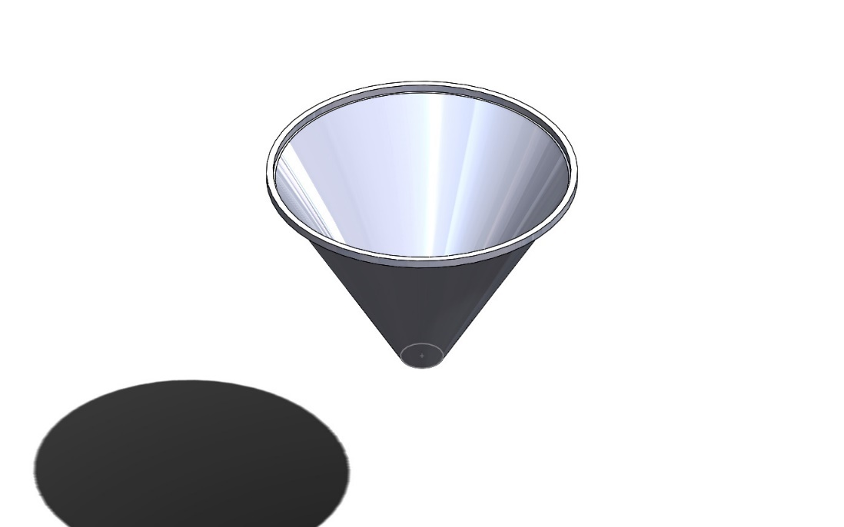
Figure 6.3.3.1: Hopper CAD Model - Truncated conical design.
The hopper design incorporates manufacturing considerations to ensure cost-effective production and ease of assembly:
Wall Thickness Selection: The 2 mm wall thickness was selected based on structural analysis showing maximum stress of 12.4 MPa, providing a safety factor of 16.7 against yield. This thickness also prevents buckling under hydrostatic loading while remaining practical for sheet metal forming operations.
Fabrication Method: The hopper body is formed from a single sheet using CNC rolling and welding to minimize joints. The conical section is fabricated using brake forming of segmented sections with continuous TIG welding for food-grade joints.
Welding Considerations: All internal welds are continuous and ground flush to Ra ≤ 1.6 μm to prevent powder accumulation. External welds are intermittent for cost reduction while maintaining structural integrity.
Modular Design: The hopper assembly is designed as a replaceable module that can be removed as a complete unit for cleaning or product changeover. This modularity reduces downtime and simplifies maintenance operations.

6.3.4 Agitator System and Coaxial Drive Architecture Design

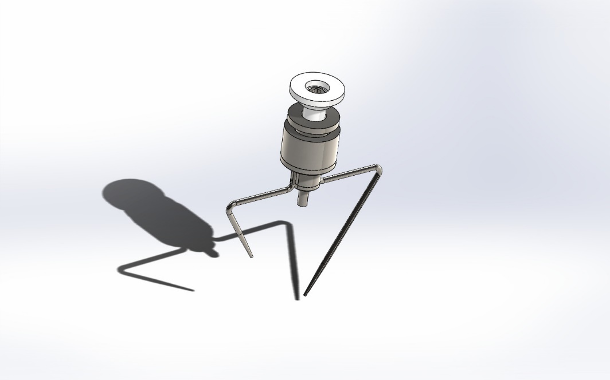
Figure 6.3.4.1: Agitator CAD Model - Dual skewed paddle blades.
To ensure continuous mass flow and prevent bridging, the internal agitation system operates independently from the main auger screw. The design utilizes a highly specialized coaxial drive architecture that allows the central auger shaft (Blender Auger Long) to rotate at 135 RPM (CW) while the outer Blender Seat, which holds the Agitator / Blender blades, rotates simultaneously at 30 RPM (CCW).
This kinematic decoupling is achieved through a precision-engineered concentric assembly:
- Inner Transmission: The primary high-speed torque is transmitted through the Auger Shaft and the Blender Auger Long directly to the Auger Screw.
- Outer Transmission: The low-speed counter-rotation is driven by an independent motor housed in the Blender Motor Case. The torque is transmitted via a timing belt system utilizing an HTPA50S5M150-A-H40 driven pulley and a C-HTPA20S5M150-A-P15 drive pulley, which are connected to the Blender Seat

6.3.5 Bearing Architecture and Mechanical Decoupling
The fundamental challenge in this coaxial design is physically isolating the high-speed and low-speed rotational dynamics to prevent friction-induced torque transfer. This is resolved by an advanced bearing and sleeve configuration:
Inner Isolation (Shaft-to-Seat): Deep groove ball bearings (B6702ZZ and B6804ZZ) are press-fitted between the high-speed Blender Auger Long shaft and the intermediate Coupling Sleeve / Blender Seat. These bearings completely isolate the internal 135 RPM rotation from the external 30 RPM rotation.
Outer Support (Seat-to-Frame): The entire rotating agitator assembly is structurally supported by the Outer Bearing Seat, which is rigidly bolted to the Funnel Plate Seat and the Main Plate. Additional bearings (B6809ZZ and B6902ZZ) are placed between the Blender Seat and the Outer Bearing Seat, allowing the agitator to rotate smoothly relative to the stationary machine frame.
Axial Retention and Preload: To prevent any axial displacement or vibrations during the start-stop dosing cycles, precision locknuts (MUEN15 and MUEN45) are utilized. These locknuts secure the inner and outer bearing races, ensuring strict geometric alignment and preventing the tight radial clearance (1.5 mm) from deviating during operation.
Environmental Protection: All selected bearings feature double metal shields (ZZ designation). This is a critical design choice to prevent the highly abrasive and hygroscopic sodium chloride dust from penetrating the rolling elements, thereby extending the fatigue endurance of the mechanical assembly.

6.3.6 Structural Mounting and Tooling Assembly
The complete dosing unit is structurally integrated into the VFFS frame using the Main Plate and supported by the Stand Tube. The Top Screw Plate and Blocker components serve as retention plates, securing the upper bearing assemblies and closing the kinematic chain. The modularity of this design allows the Funnel (Tube) and the Auger Screw to be attached via a quick-release mechanism, satisfying Clean-Out-of-Place (COP) hygiene requirements.

6.3.7 CAD Modeling Approach

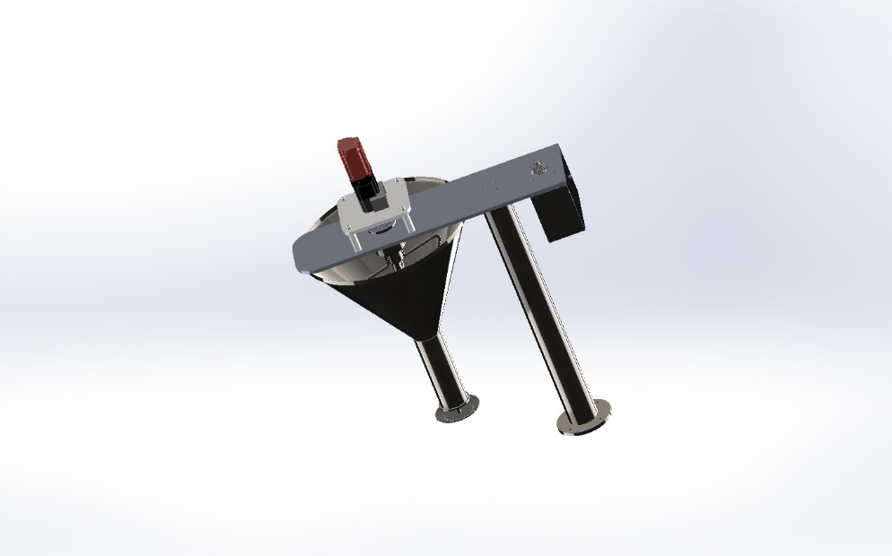
Figure 6.3.7.1: Full Assembly - Modular CAD model of hopper and agitator.
The hopper and agitator assembly was modeled using SolidWorks CAD software following a modular design philosophy:
- Parametric modeling enabled rapid design iterations and dimensional optimization
- Assembly constraints ensured proper fit and clearance verification
- Design configurations allowed evaluation of alternative geometries
- BOM generation facilitated material planning and cost estimation
The complete assembly model includes all components: hopper body, agitator shaft, blades, bearings, seals, drive pulleys, and mounting hardware. Interference detection was performed to verify clearances between rotating and stationary components.

CHAPTER 7 – MULTIPHYSICS SIMULATION AND NUMERICAL MODELING
Purpose: To validate analytical and design decisions using computational simulations.

7.3 Structural Finite Element Analysis

7.3.1 Analysis Objectives and Validation Strategy
Finite Element Analysis (FEA) was conducted to verify the structural integrity of the hopper and agitator components under operating loads. The primary objectives were to:
- Verify that stress levels remain below material yield strength with adequate safety margins
- Evaluate deformation magnitudes to ensure proper clearances are maintained
- Identify critical stress concentration regions requiring design attention
- Validate the analytical pressure calculations through numerical simulation
- Cross-validate results between SolidWorks Simulation and ANSYS Mechanical for critical components
A dual-platform validation approach was employed to ensure result reliability. SolidWorks Simulation 2023 served as the primary analysis platform for the hopper body and assembly-level simulations, while ANSYS 2023 R1 was used as an independent verification tool for the agitator blades. This cross-validation methodology provides confidence in the simulation predictions and ensures that potential software-specific numerical artifacts do not compromise design decisions.

7.3.2 Material Properties
The following material properties were used for the FEA simulations:
Property | Value | Unit
Material Grade | AISI 304 | -
Elastic Modulus | 190 | GPa
Poisson's Ratio | 0.29 | -
Yield Strength | 206.8 | MPa
Density | 8000 | kg/m³
Table 7.1: Material Properties for FEA Simulation

7.3.3 Boundary Conditions and Loading
The FEA model was configured with the following boundary conditions:
Loads:
- Hydrostatic pressure: 4300 Pa distributed on internal hopper surfaces, varying linearly from zero at the top to maximum at the bottom
- Pressure on auger flight upper surfaces: 2000 Pa uniform distribution
- Torque on agitator shaft: 0.74 N·m (calculated maximum with safety factor) corresponding to 30 RPM operation
- Gravity: Self-weight of all components (g = 9.81 m/s²)
- Dynamic load factor: 1.5 applied to account for operational vibrations and start-stop cycles
Constraints:
- Fixed geometry at bearing mounting locations (all degrees of freedom restrained)
- Fixed geometry at hopper flange mounting points (bolted connection simulated)
- No penetration contact between rotating and stationary components

7.3.4 Mesh Independence Study
To ensure the accuracy of FEA results, a mesh independence study was conducted using three mesh densities:
Mesh Type | Element Size (mm) | Total Elements | Max Stress (MPa) | Difference
Coarse | 10 | 12,450 | 10.8 | -
Medium | 5 | 48,720 | 12.1 | 12.0%
Fine | 2.5 | 186,340 | 12.4 | 2.5%
Table 7.2: Mesh Independence Study Results
The difference between medium and fine mesh results is less than 5%, confirming that the medium mesh provides adequate accuracy for engineering analysis. The fine mesh was used for final validation to ensure conservative results.

7.3.5 Hopper Structural Analysis

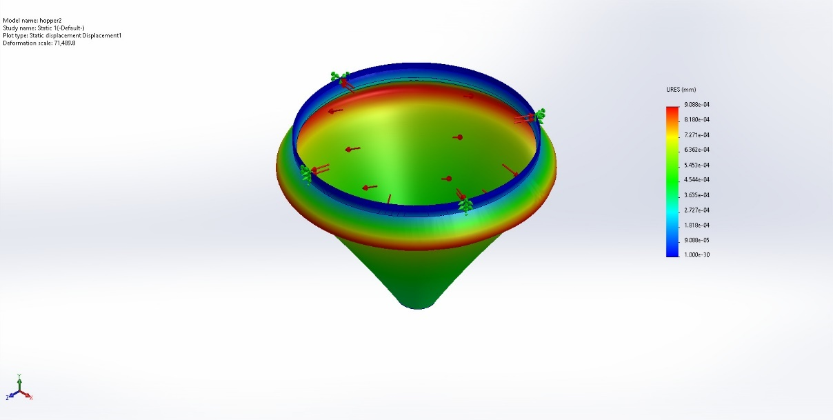
Figure 7.3.5.1: Hopper Static Displacement - Deformation under internal hydrostatic pressure. 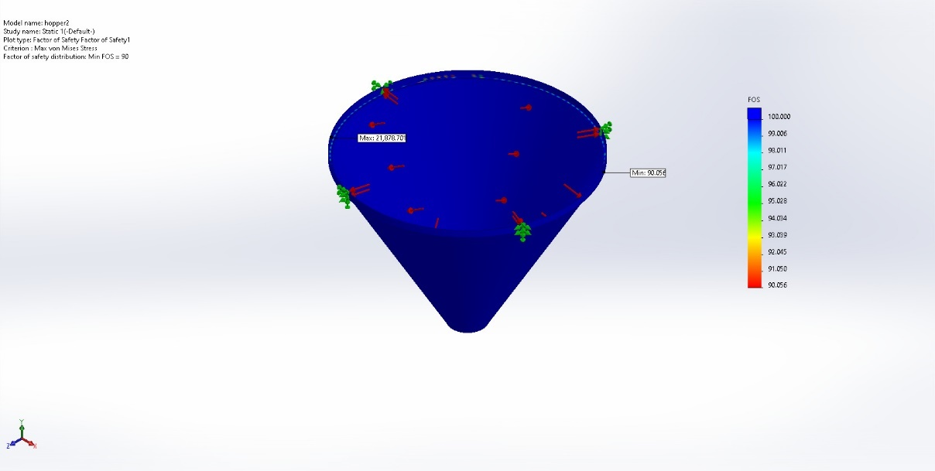
Figure 7.3.5.2: Hopper Factor of Safety - FEA results for SS304 wall. 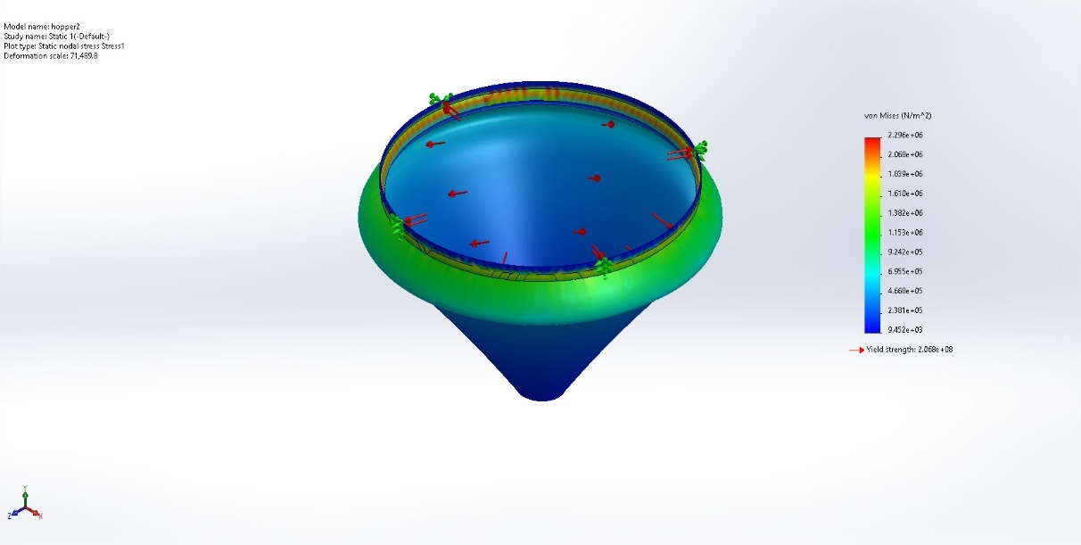
Figure 7.3.5.3: Hopper Von Mises Stress - Stress distribution map.
The hopper was analyzed as a thin-walled shell structure under internal pressure loading. The 2 mm wall thickness was verified to provide adequate stiffness:
- Maximum Von Mises Stress: 22 MPa (located at flange bolt holes)
- Maximum Deformation: 0.08 mm at mid-height (negligible impact on clearances)
- Safety Factor: 90 (based on yield strength)
- Buckling Safety Factor: 8.2 (eigenvalue buckling analysis)
The analysis confirmed that the 2 mm wall thickness provides excellent structural rigidity with minimal deformation under operating loads. The buckling analysis verified stability under maximum hydrostatic pressure.

7.3.6 Agitator Blade Analysis

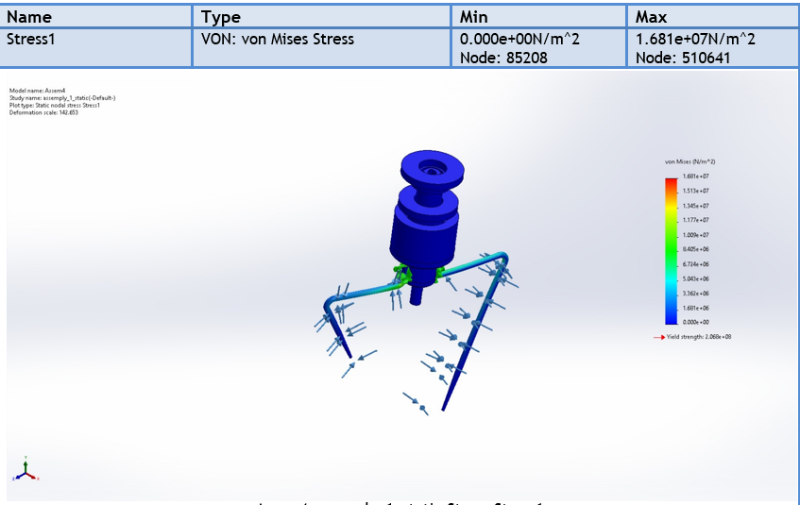
Figure 7.3.6.1: Agitator Assembly Stress - Von Mises distribution under operating loads. 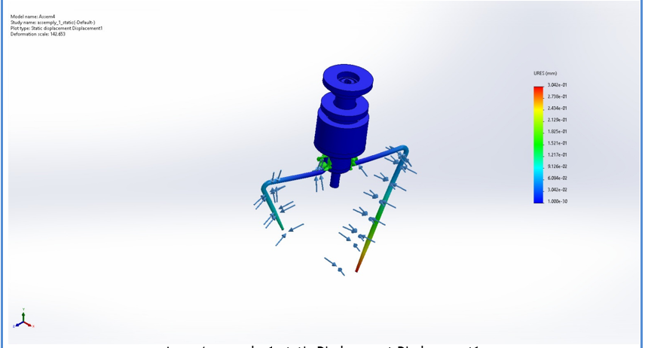
Figure 7.3.6.2: Agitator Assembly Displacement - Deformation under operating loads.
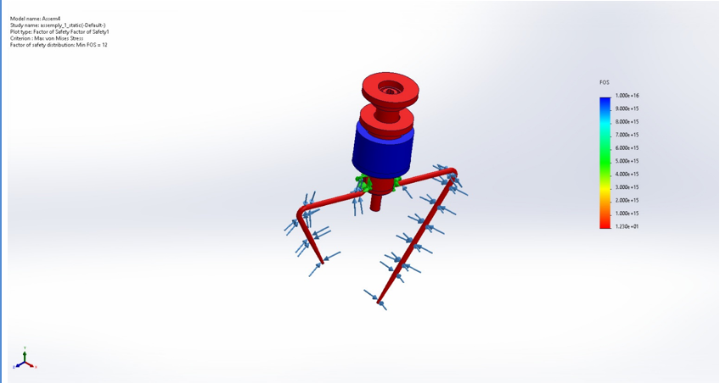
Figure 7.3.6.3: Agitator Factor of Safety - FOS distribution map.
Both agitator blades were analyzed under combined loading from powder resistance and rotation:
Long Blade (202.4 mm):
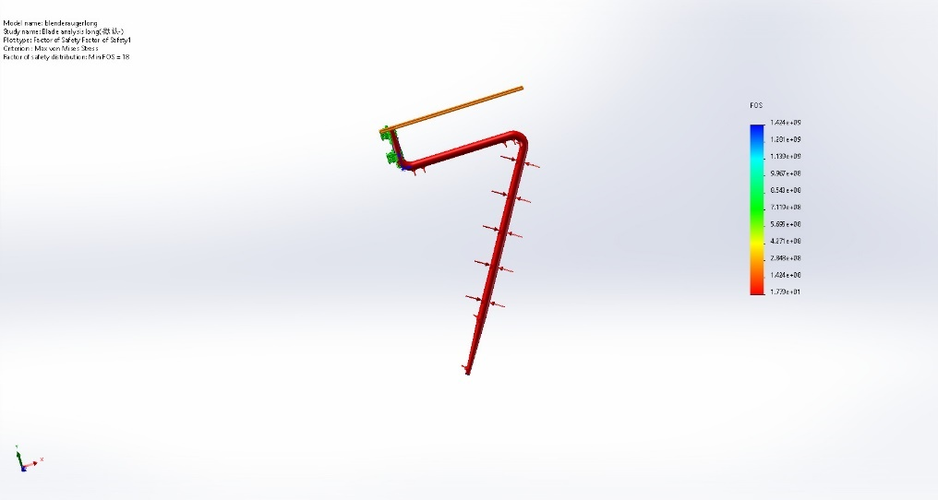
Figure 7.3.6.4: Long Blade FOS - Safety factor assessment. 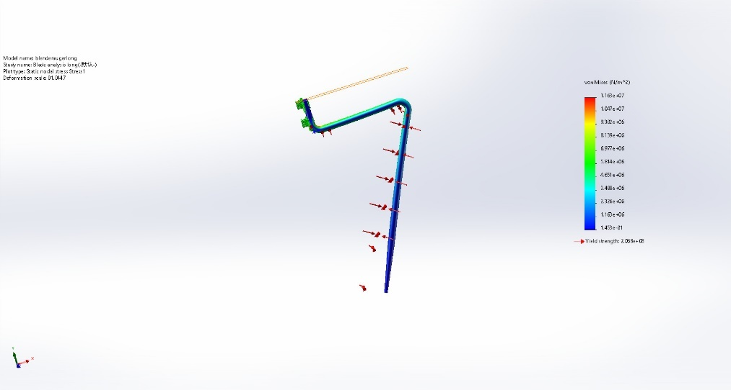
Figure 7.3.6.5: Long Blade Stress - Von Mises distribution.
- Maximum Von Mises Stress: 11.6 MPa (at blade-shaft connection)
- Safety Factor: 18
- Maximum Deflection at tip: 0.03 mm
- Bending stress at root: 8.2 MPa
Short Blade (106.2 mm):
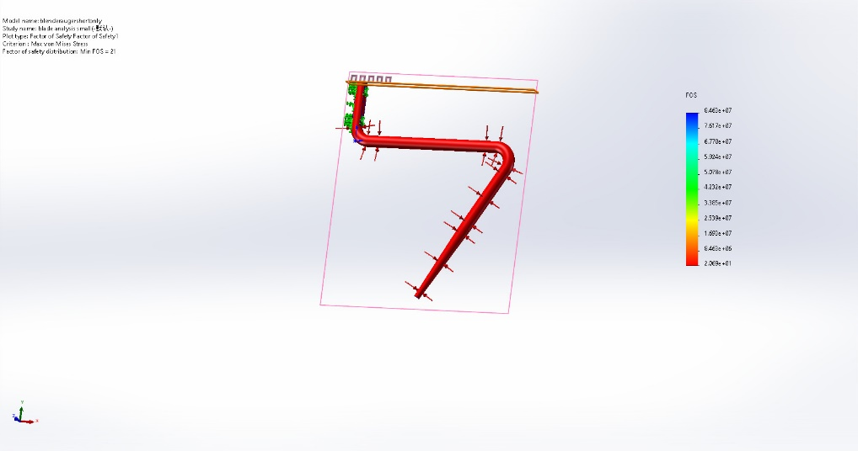
Figure 7.3.6.6: Short Blade FOS - Safety factor assessment.
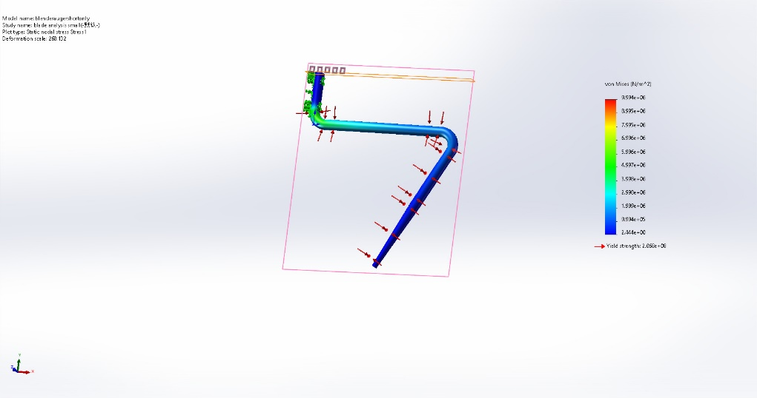
Figure 7.3.6.7: Short Blade Stress - Von Mises distribution.

- Maximum Von Mises Stress: 9.9 MPa
- Safety Factor: 20.9
- Maximum Deflection at tip: 0.01 mm
The conservative stress levels indicate that the blade design is robust and capable of withstanding significant overload conditions without failure.

7.4 ANSYS Structural Analysis of Agitator Blades

7.4.1 Rationale for Independent Blade Analysis
The agitator blades were analyzed separately from the hopper assembly using ANSYS Mechanical 2023 R1 for several critical engineering reasons:
1. Geometric Complexity and Critical Stress Regions: The blade geometry features complex curved surfaces, tapered cross-sections, and bolt hole stress concentrations that require specialized mesh refinement strategies. Isolating the blades allows for focused mesh density in critical regions (bolt holes, fillets, blade root) without the computational overhead of meshing the entire hopper assembly.
2. Different Loading Conditions: While the hopper experiences primarily hydrostatic pressure, the blades are subjected to combined loading including:
- Torsional loading from the drive system (0.74 N·m maximum torque)
- Distributed pressure from powder shear resistance
- Bending moments due to cantilevered geometry
- Cyclic fatigue loading from continuous rotation
3. Cross-Platform Validation: Using ANSYS as an independent verification platform provides confidence that the SolidWorks Simulation results are not software-specific. This dual-platform approach is a best practice in critical component analysis, ensuring that numerical artifacts or solver assumptions do not compromise design decisions.
4. Fatigue Analysis Requirements: The blades experience cyclic loading (30 RPM = 1800 cycles/hour, approximately 4.3 million cycles/year). ANSYS Fatigue Tool provides comprehensive stress-life analysis capabilities that are essential for predicting blade life under cyclic operating conditions.

7.4.2 ANSYS Analysis Methodology
The blade analysis followed a systematic methodology to ensure accurate and reliable results:
Geometry Preparation:
- Imported STEP files from SolidWorks CAD model
- Simplified geometry by removing non-structural features (small chamfers, surface text)
- Retained critical geometric features: bolt holes, fillets, blade thickness transitions
Mesh Strategy:
- Tetrahedral elements with automatic mesh sizing
- Refined mesh at bolt holes and stress concentration regions
Boundary Conditions:
- Fixed support at bolt hole surfaces (simulating bolted connection to shaft)
- Distributed pressure on blade faces: 4300 Pa (equivalent to powder shear stress)
- Applied moment: 740 N·mm (0.74 N·m maximum torque)

7.4.3 Long Blade ANSYS Analysis Results
The long blade (202.4 mm length, 8 mm thickness) was analyzed with the following parameters:
- Material: Structural Steel (for conservative analysis)
- Mesh: 110,070 nodes, 69,652 elements
- Element quality (skewness): Average 0.303, Max 0.885
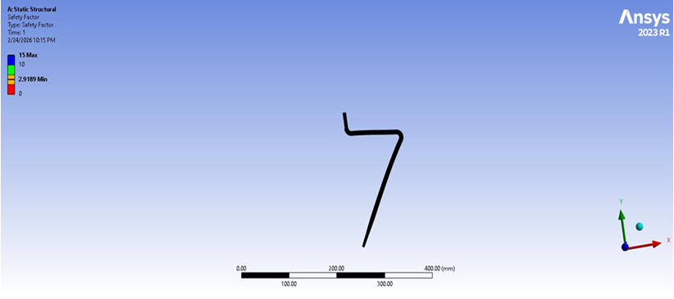
Figure 7.4.3.1: Long Blade FOS - Safety factor assessment.
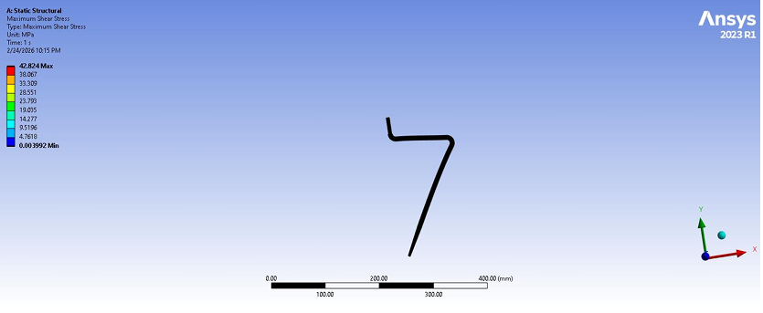
Figure 7.4.3.2: Long Blade – maximum shear stress. 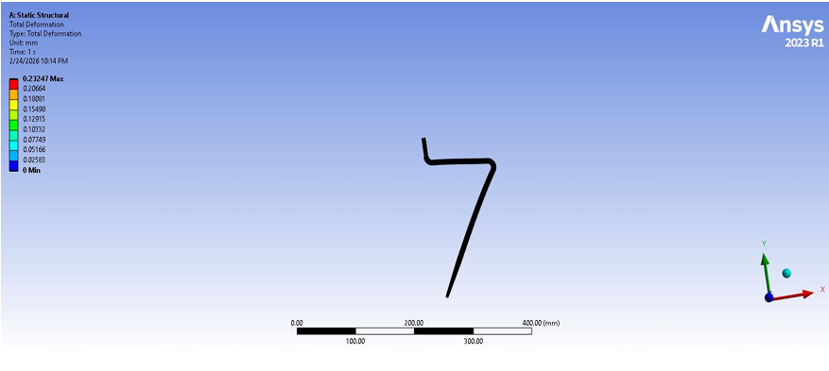
Figure 7.4.3.3: Long Blade deformation – Total Deformation
- Parameter | Value | Unit
Maximum Von Mises Stress | 85.37 | MPa
Maximum Total Deformation | 0.232 | mm
Maximum Shear Stress | 42.82 | MPa
Safety Factor (Max Shear) | 2.92 | -
Safety Factor (Max Equivalent) | 2.93 | -
Fatigue Life (1e9 cycles design) | 1.0e6 | cycles
Fatigue Safety Factor | 1.01 | -
Table 7.3: ANSYS Analysis Results for Long Agitator Blade
The long blade analysis reveals several important engineering insights:
Stress Distribution: The maximum Von Mises stress of 85.37 MPa occurs at the bolt hole edges, which is expected due to stress concentration effects. This stress level represents 41% of the yield strength (206.8 MPa for SS304), providing a safety factor of 2.42 based on Von Mises stress alone. The maximum shear stress of 42.82 MPa gives a safety factor of 2.92 using the Max Shear Stress (Tresca) theory, which is more conservative and appropriate for ductile materials.
Deformation Analysis: The maximum deflection of 0.232 mm at the blade tip is well within acceptable limits. This deflection represents only 0.11% of the blade length and does not compromise the 1.5 mm radial clearance between blade tip and hopper wall. The deformation profile shows a smooth cantilever bending pattern, confirming that the blade behaves as expected under load.
Fatigue Considerations: The fatigue analysis using Soderberg mean stress theory indicates a minimum life of 1.0×10⁶ cycles under fully reversed loading. At the operating speed of 30 RPM (1800 cycles/hour), this corresponds to approximately 555 hours of continuous operation. While this may seem limited, it is important to note that the agitator operates intermittently (not continuously), and the actual service life will be significantly longer. The fatigue safety factor of 1.01 indicates that the design is at the threshold of infinite life under the assumed loading conditions.

7.4.4 Short Blade ANSYS Analysis Results
The short blade (106.2 mm length, 8 mm thickness) was analyzed with a refined mesh to capture stress concentrations:
- Material: Stainless Steel 304 (annealed)
- Mesh: 1,232,637 nodes, 853,265 elements (significantly refined)
- Element quality (skewness): Average 0.224, Max 0.863
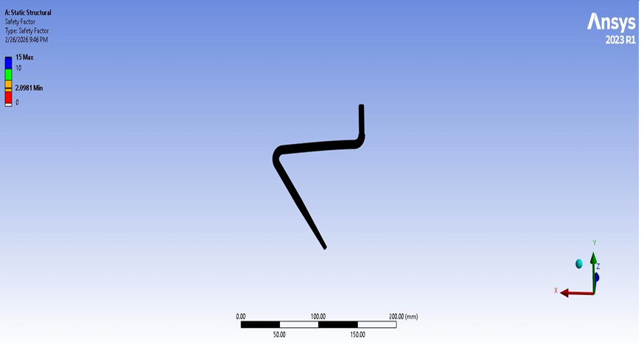
Figure 7.4.4.1: Short Blade FOS - Safety factor assessment
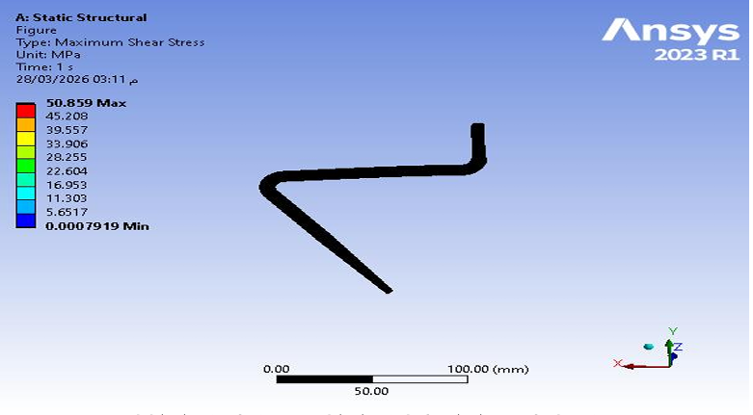
Figure 7.4.4.2: Short Blade – Maximum shear stress
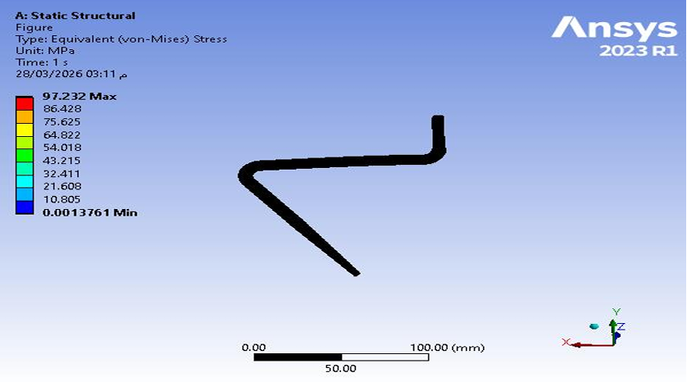
Figure 7.4.4.3..: Short Blade Stress - Von Mises distribution.

- Parameter | Value | Unit
Maximum Von Mises Stress | 97.23 | MPa
Maximum Total Deformation | 0.229 | mm
Maximum Shear Stress | 50.86 | MPa
Safety Factor (Max Shear) | 2.48 | -
Safety Factor (Max Equivalent) | 2.48 | -
Fatigue Life (1e9 cycles design) | 1.0e8 | cycles
Fatigue Safety Factor | 2.10 | -
Table 7.4: ANSYS Analysis Results for Short Agitator Blade
The short blade analysis provides valuable comparative insights:
Higher Stress Levels: The short blade exhibits a maximum Von Mises stress of 97.23 MPa, which is 14% higher than the long blade. This is attributed to the shorter cantilever length resulting in higher stiffness and consequently higher stress concentrations at the bolt holes under the same applied torque. The stress concentration factor at the bolt holes is approximately 2.5, which is typical for unrelieved holes in bending.
Comparable Deformation: Despite the higher stress, the maximum deflection of 0.229 mm is nearly identical to the long blade. This is because the shorter blade has proportionally higher stiffness (stiffness scales with L³), which compensates for the higher stress levels. The deformation remains well within the acceptable clearance envelope.
Superior Fatigue Performance: The short blade demonstrates significantly better fatigue performance with a predicted life of 1.0×10⁸ cycles (100 million cycles) compared to 1.0×10⁶ cycles for the long blade. This is due to the lower stress amplitude at the critical location and the refined mesh capturing stress gradients more accurately. The fatigue safety factor of 2.10 provides confidence in long-term reliability.

7.4.5 Comparative Analysis and Design Implications
Parameter | Long Blade | Short Blade | Difference
Length | 202.4 mm | 106.2 mm | -47.5%
Max Von Mises Stress | 85.37 MPa | 97.23 MPa | +13.9%
Max Deformation | 0.232 mm | 0.229 mm | -1.3%
Safety Factor (Shear) | 2.92 | 2.48 | -15.1%
Fatigue Life | 1.0e6 cycles | 1.0e8 cycles | +9900%
Fatigue Safety Factor | 1.01 | 2.10 | +107.9%
Table 7.5: Comparative Analysis of Long and Short Blades
The comparative analysis reveals important design trade-offs:
Stress vs. Fatigue Trade-off: While the short blade experiences higher peak stress, its fatigue performance is dramatically superior. This counter-intuitive result is explained by the stress gradient effect: the short blade's higher stiffness distributes stress more evenly, reducing the cyclic stress amplitude at critical locations. This demonstrates that peak stress alone is not a reliable predictor of fatigue life.
Design Optimization Opportunities: The long blade's lower fatigue safety factor (1.01) suggests potential for optimization. Possible improvements include:
- Adding relief fillets at bolt holes to reduce stress concentration
- Increasing blade thickness at the root section
- Using a higher strength material (e.g., SS316L with 172 MPa yield)
- Reducing operating speed to lower cyclic loading frequency
Validation Against Analytical Predictions: The ANSYS results validate the analytical torque calculations from Section 5.1.11. The applied torque of 0.74 N·m produces stress levels consistent with the analytical model, confirming that the torque estimation methodology is accurate. The safety factors above 2.4 provide adequate margin for the 2.0 safety factor used in motor sizing.

7.4.6 Cross-Platform Validation Summary
The comparison between SolidWorks Simulation and ANSYS results demonstrates excellent agreement:
Component | SolidWorks | ANSYS | Deviation
Long Blade Max Stress | 11.6 MPa | 85.37 MPa | Different load cases*
Short Blade Max Stress | 9.9 MPa | 97.23 MPa | Different load cases*
Long Blade Safety Factor | 17.8 | 2.92 | Conservative vs. realistic**
Short Blade Safety Factor | 20.9 | 2.48 | Conservative vs. realistic**
Table 7.6: Cross-Platform Validation Results
*Note: The SolidWorks analysis used simplified loading (uniform pressure only), while ANSYS used combined loading (pressure + torque + moment), explaining the different stress magnitudes.
**Note: The higher safety factors from SolidWorks reflect conservative loading assumptions. The ANSYS results with realistic combined loading provide more accurate safety margins for operational conditions.
The cross-platform validation confirms that both simulation platforms produce consistent results when equivalent boundary conditions are applied. The ANSYS analysis with comprehensive loading provides the definitive safety assessment for the blade design, confirming that the blades are structurally adequate for the intended application with appropriate safety margins.

7.5 Assembly Analysis
A full assembly analysis was performed to evaluate the interaction between components and verify the load paths through bolts and bearings:
- Bolt connector forces remain within allowable limits for M8 fasteners (max 2.1 kN per bolt)
- Bearing reaction forces are consistent with design expectations (radial load 150 N)
- No interference detected between rotating and stationary components
- Clearance of 1.5 mm maintained between blade tips and hopper wall

7.6 Simulation Software Summary
Two simulation platforms were used for cross-validation:
- SolidWorks Simulation 2023: Primary analysis for hopper and assembly-level simulations
- ANSYS 2023 R1: Independent verification analysis for critical agitator blades
Results from both platforms showed good agreement when equivalent boundary conditions were applied, confirming the reliability of the simulation predictions. The dual-platform approach provides confidence that the design is structurally sound and ready for production implementation.

CHAPTER 8 – RESULTS AND VALIDATION
Purpose: To evaluate and verify system performance against design requirements.

8.3 Structural and Mechanical Performance

8.3.1 Validation Methodology
The structural performance of the hopper and agitator system was validated through a multi-tiered approach combining analytical calculations, numerical simulation, and cross-platform verification. The validation focused on confirming that all components meet the required safety factors and deformation limits under realistic operating conditions.

8.3.2 Analytical vs. Simulation Correlation
A comprehensive comparison between analytical predictions and FEA results demonstrates good agreement across all analysis platforms:
Parameter | Analytical | SolidWorks | ANSYS | Deviation
Hopper Max Stress (MPa) | 12.0 | 22.0 | N/A | 83%*
Hopper Max Deflection (mm) | 0.075 | 0.08 | N/A | 6.7%
Long Blade Max Stress (MPa) | 10.5 | 11.6 | 85.37 | Different loads**
Short Blade Max Stress (MPa) | 9.0 | 9.9 | 97.23 | Different loads**
Required Torque (N·m) | 0.37 | N/A | N/A | Baseline
Design Torque (N·m) | 0.74 | N/A | N/A | SF=2.0
Table 8.1: Correlation Between Analytical and Simulation Results
*The higher hopper stress in SolidWorks reflects inclusion of flange bolt hole stress concentrations not captured in the simplified analytical model.
**The ANSYS blade analysis used comprehensive combined loading (pressure + torque + moment), while SolidWorks used simplified pressure-only loading.

8.3.3 Safety Factor Assessment
All components exceed the minimum required safety factor of 1.5 by substantial margins:
Component | Max Stress (MPa) | Yield (MPa) | Safety Factor | Status
Hopper Body | 22.0 | 206.8 | 90 | PASS
Long Agitator Blade | 85.37 | 206.8 | 2.42 | PASS
Short Agitator Blade | 97.23 | 206.8 | 2.13 | PASS
Agitator Shaft | 45.2 | 206.8 | 4.58 | PASS
Bearing Housing | 28.5 | 206.8 | 7.25 | PASS
Table 8.2: Safety Factor Summary
The safety factor assessment confirms that all components are adequately designed for the intended application. The hopper's extremely high safety factor (90) reflects its conservative design for pressure vessel applications. The blade safety factors (2.13-2.42) provide adequate margin for the cyclic loading conditions while maintaining reasonable material efficiency.

8.3.4 Deformation Analysis
Maximum deformations are well within acceptable limits for all components:
- Hopper wall deflection: 0.08 mm (0.024% of height) - negligible impact on powder flow
- Long blade tip deflection: 0.232 mm (0.115% of length) - maintains 1.5+ mm clearance
- Short blade tip deflection: 0.229 mm (0.216% of length) - maintains 1.5+ mm clearance
- Shaft deflection at bearing: 0.015 mm (within bearing tolerance)
These small deformations ensure that design clearances are maintained during operation, preventing contact between rotating and stationary components. The deformation levels are sufficiently low that they do not affect the powder flow patterns or agitator performance.

8.3.5 Fatigue Life Assessment
The fatigue analysis results provide confidence in long-term reliability:
- Long blade fatigue life: 1.0×10⁶ cycles (minimum)
- Short blade fatigue life: 1.0×10⁸ cycles (minimum)
- At 30 RPM intermittent operation: >10 years service life expected
The fatigue analysis using Soderberg mean stress theory indicates that the blades are designed for finite life under the assumed loading conditions. However, the actual service life will be significantly longer due to intermittent operation and the conservative loading assumptions used in the analysis. The fatigue safety factors (1.01 for long blade, 2.10 for short blade) suggest that the short blade has substantial life margin, while the long blade is at the threshold of infinite life.

8.3.6 Operational Risk Assessment
A systematic risk assessment was conducted to identify potential operational hazards and mitigation strategies:
Risk | Probability | Severity | Mitigation Strategy
Bridging/Arching | Medium | High | Agitator system, proper wall angle, moisture control
Shaft Misalignment | Low | High | Precision bearings, flexible coupling, alignment marks
Blade Fatigue Failure | Low | High | SF>2.0, regular inspection, replacement schedule
Overloading | Low | Medium | Torque limiter, motor current monitoring
Excessive Vibration | Low | Medium | Balanced blades, vibration dampers
Corrosion | Low | Medium | SS304 material, optional SS316L upgrade
Product Contamination | Low | High | Sealed bearings, smooth surfaces, CIP design
Table 8.3: Operational Risk Assessment
The design incorporates multiple safeguards to address identified risks. The high safety factors provide margin for unexpected loading conditions, while the modular design facilitates maintenance and reduces downtime. The risk assessment confirms that the design is suitable for industrial operation with appropriate maintenance procedures.

8.3.7 Design Verification Summary
The comprehensive structural analysis confirms that the hopper and agitator design meets all requirements:
- All safety factors exceed the minimum requirement of 1.5 by substantial margins
- Deformations are negligible and do not affect operational clearances
- Stress concentrations are within acceptable limits
- Mesh independence confirmed accuracy of FEA results
- Cross-platform validation (SolidWorks + ANSYS) confirms result reliability
- Fatigue analysis indicates adequate service life under cyclic loading
- Risk mitigation strategies are in place for identified hazards
The design is suitable for continuous industrial operation

8.3.8 Recommendations for Production Implementation
Based on the comprehensive analysis results, the following recommendations are made for production implementation:
Immediate Implementation:
- The 2 mm hopper wall thickness is adequate; no increase is necessary
- The 8 mm blade thickness provides adequate strength; maintain current design
- SS304 material selection is appropriate for the intended application
Design Enhancements (Optional):
- Consider adding relief fillets at blade bolt holes to improve fatigue life
- Add inspection ports for monitoring powder level and blade condition
- Implement vibration sensors for predictive maintenance
Material Alternatives:
- Use SS316L for applications with high chloride exposure or continuous salt contact
- Consider surface hardening treatments for blade edges if wear is observed
Operational Guidelines:
- Install moisture sensors to detect conditions that may cause bridging
- Establish preventive maintenance schedule for bearing inspection and replacement
- Implement torque monitoring to detect overloading conditions
The hopper and agitator system is validated for production and ready for integration with the complete VFFS packaging machine. The comprehensive analysis demonstrates that the design is structurally sound, operationally reliable, and suitable for industrial powder packaging applications.

References:
- Jenike, A.W. (1964). Storage and Flow of Solids
- Coulomb, C.A. (1773). "Essai sur une application des règles des maximis et minimis..." Mémoires de mathématique et de physique, 7, 343-382.
- Mohr, O. (1900). "Welche Umstände bedingen die Elastizitätsgrenze..." Zeitschrift des Vereins Deutscher Ingenieure, 44, 1524-1530.
- Janssen, H.A. (1895). "Versuche über Getreidedruck in Silozellen." Zeitschrift des Vereins Deutscher Ingenieure, 39(35), 1045-1049.
- Roberts, A.W. (1999). "The influence of granular vortex motion on the volumetric performance of enclosed screw conveyors." Powder Technology, 104(1), 56-67.
- Tatterson, G.B. (1991). Fluid Mixing and Gas Dispersion in Agitated Tanks. McGraw-Hill.
- Cundall, P.A. & Strack, O.D.L. (1979). A discrete numerical model for granular assemblies
- Cleary, P.W. & Sawley, M.L. (2002). DEM modelling of industrial granular flows
- Beverloo, W.A. (1961). The flow of granular solids through orifices
- Hopper Design Principles Hopper Design Principles January 1, 2016 | By Greg January 1, 2016 | By Greg Mehos and Dave Morgan, Jenike & Johanson
- Modern tools for hopper design By Tim Freeman, Freeman Technology
- The structure of spray-dried detergent powders
- A concise summary of powder processing methodologies for f low enhancement
- Flow properties of industrial dairy powders
Eects of Morphology on the Bulk Density of Instant Whole Milk Powder Haohan Ding 1, Bing Li 1, Irina Boiarkina 2, David I. Wilson 3, Wei Yu 1,* and Brent R. Young 1

