1. Introduction
1.1 Overview of Vertical Form-Fill-Seal (VFFS) Machinery
The Vertical Form-Fill-Seal (VFFS) packaging system represents one of the most ubiquitously deployed automated technologies within contemporary packaging engineering. This integrated machinery operates on a consolidated principle that synergizes three fundamental processes—forming, filling, and sealing—into a single, continuous production line.
The operational sequence commences with the extraction of thermoplastic film from a supply reel, which subsequently traverses a forming collar (forming tube) that metamorphoses the planar film into a cylindrical configuration. Longitudinal sealing bars execute a continuous thermal welding of the film's lateral edges, thereby generating a seamless tubular structure. Concurrently, transverse sealing jaws perform intermittent sealing operations to create the pouch's bottom seal and execute its separation post-filling. This system exhibits remarkable versatility, accommodating diverse pouch dimensions and a broad spectrum of packaging materials, rendering it an optimal solution for high- to medium-volume production environments.

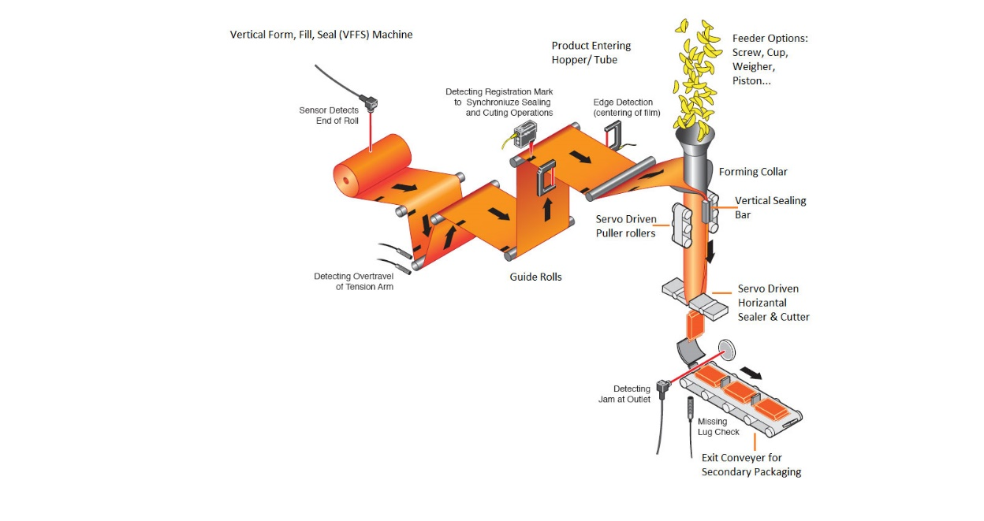
[Fig. 1.1: Schematic representation of VFFS operational sequence]

1.2 Project Objectives
The principal aim of this undertaking is the conception and analysis of an advanced packaging system for VFFS machinery that satisfies the following operational specifications:
Primary Objective: To develop a packaging system capable of producing 12–30 pouches per minute, with a constant unit weight of 500 grams per package, whilst maintaining weight accuracy within a tolerance of ±2%.
Secondary Objectives:
- Attainment of elevated operational efficacy through the minimization of packaging material wastage to below 1%
- Assurance of thermal sealing integrity with a minimum weld strength of 20 Newtons per 15 millimeters
- Implementation of an adjustable architecture compatible with variable pouch widths ranging from 80 to 150 millimeters
- Achievement of mechanical stability at elevated operational velocities with a safety factor not less than 2.5
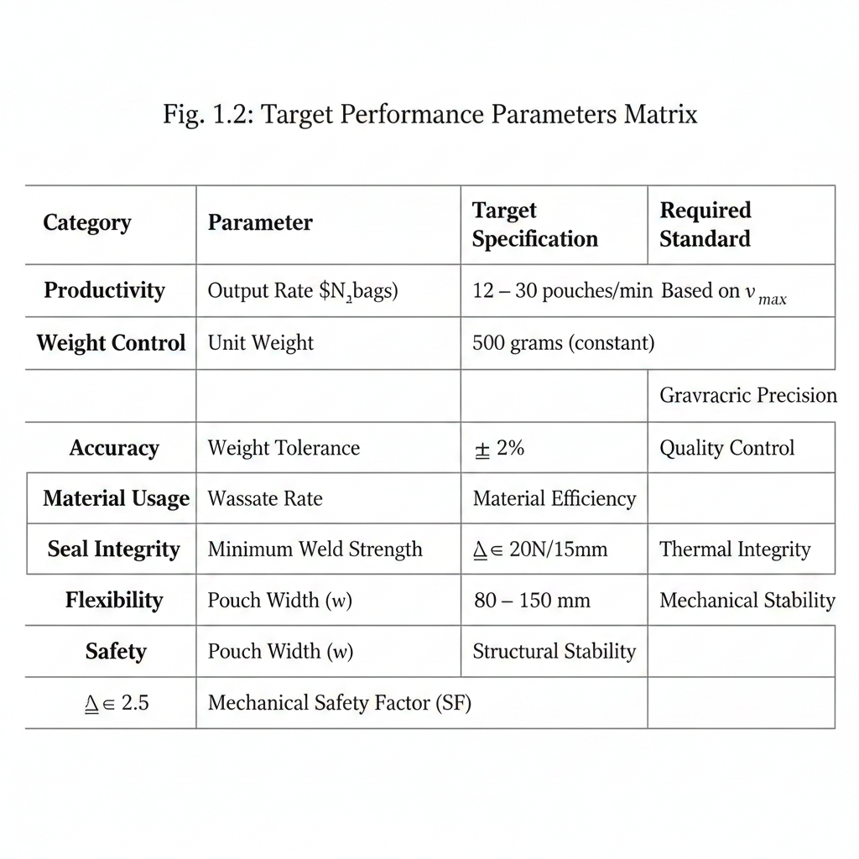
[Fig. 1.2: Target performance parameters matrix]
1.3 Scope of Work
This project concentrates on the packaging of dry granular and pulverulent materials, specifically:
Target Materials:
- Sodium chloride powder: Bulk density 1.2 g/cm³, particle size distribution
0.1–0.5 mm
- Fine sucrose: Bulk density 0.85 g/cm³, moderate flowability characteristics
- Ground coffee: Bulk density 0.35–0.45 g/cm³, elevated moisture sensitivity
The scope encompasses the design of all constituent components within the packaging system, commencing from the film unwinding mechanism through to the final pouch cutting apparatus, with particular emphasis on adherence to food packaging regulatory standards. Explicitly excluded from this scope are electronic control systems and external material handling conveyors; the investigation is strictly confined to the mechanical and structural facets of the packaging apparatus.
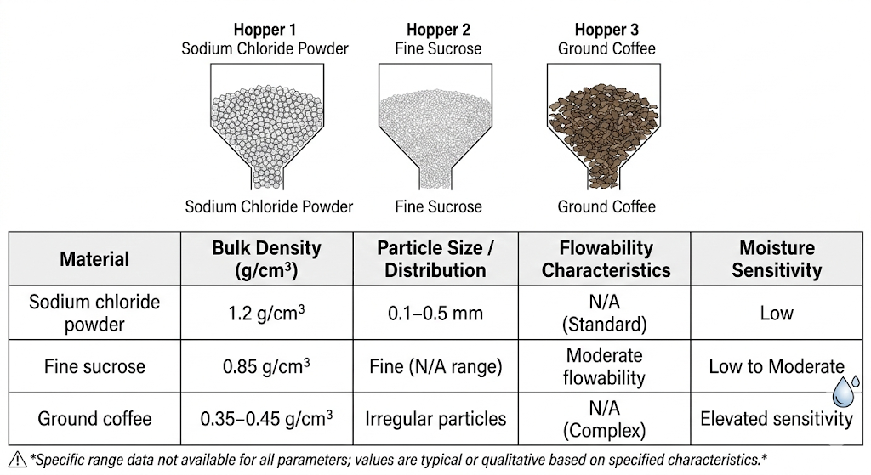
[Fig. 1.3: Material properties comparison chart]

1.4 Utilized Software and Computational Tools
SolidWorks® – Primary Engineering Platform
SolidWorks® has been selected as the principal software environment for executing all phases of engineering design and analysis within this project, predicated upon the following capabilities:
- Advanced Three-Dimensional Modeling: The platform provides a comprehensive ecosystem for parametric solid modeling and complex assembly management, facilitating the precise design of all packaging system components with sophisticated interference detection and kinematic simulation capabilities.
- Integrated Finite Element Analysis: The embedded SolidWorks Simulation® suite enables comprehensive static stress analysis, thermal analysis, and motion analysis to be conducted on the unified model architecture, thereby eliminating data translation inefficiencies between disparate software packages.
- Manufacturability Integration: The software supports the direct generation of manufacturing documentation and computer-aided manufacturing (CAM) data, thus streamlining the transition from conceptual design to physical prototyping and production.

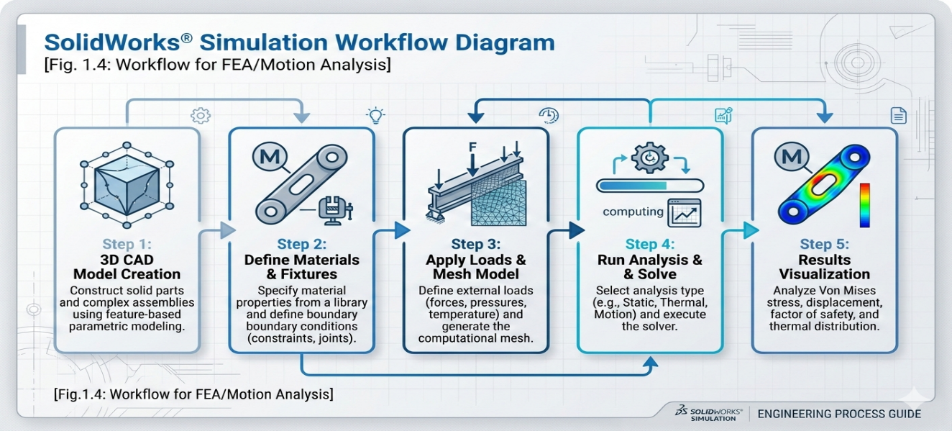
[Fig. 1.4: SolidWorks Simulation workflow diagram]

2. Theoretical Design and Preliminary Analysis
2.1.1 Film Motion Equations
The film movement in the VFFS system is governed by a comprehensive set of fundamental forces and equations:
Film Linear Velocity Equation:
$$vf​=\frac{Lbag​×Nbags}{60}$$
Where:
- $vf​ = Film velocity \left(\frac{m}{s}\right)$
- $Lbag​ = Bag length = 0.25 m (for 500g package)$
- $Nbags​ = Number of bags/minute= 12-30 bags/minute$
For target productivity:
- $Minimum velocity: vmin​=\frac{12×0.25}{60}=0.05$m/s
- $Maximum velocity: vmax​=\frac{12×0.25}{60}​=0.125$m/s
Acceleration and Deceleration Equation:
$$a=\frac{v^{2}-v_{0}^{2}}{2s}$$
Where:
- $a = Acceleration \left(\frac{m}{s^{2}}\right)$
- $v_{0}= Initial velocity = 0$
- $s = Acceleration distance = 0.05 m$
Required Film Pulling Force:
$$F_{pull}​=m⋅a+F_{friction​}+F_{tension​}$$
Where:
- $F_{friction​}​=μ×N \left(Friction force\right)$
- $μ = Coefficient of friction = 0.3 for plastic film$
- $F_{tension​}​ = Required tension force = 50-100 N$

[Fig. 2.1: Free body diagram illustrating forces acting on film]
2.1.2 Tension and Sealing Force Calculations
Film Tensile Stress:
$$σ=​\frac{F}{A}=\frac{F}{t×w}$$
Where:
- $σ = Stress \left(\frac{N}{mm^{2}}\right)$
- $F = Tension force \left(N\right)$
- $t = Film thickness = 0.06 mm$
- $w = Film width = 320 mm$
Maximum Allowable Stress:
$Q_{max​}=\frac{σ_{yield}}{SF}$​​
Where:
- $σ_{yield​ }= Polyethylene yield stress = 20-30 MPa$
- SF = Safety factor = 2.5
Required Sealing Force:
$$F_{seal​}=P_{seal​}​×A_{seal​}$$
Where:
- $P_{seal​}​ = Sealing pressure = 2-4 bar (200-400 kPa)$
- $A_{seal​}​ = Sealing area = Jaw length × Seal width = 150 × 5 = 750 mm²$

Actual force calculation:
$$F_{seal​}=400×103×750×10-6=300 N$$
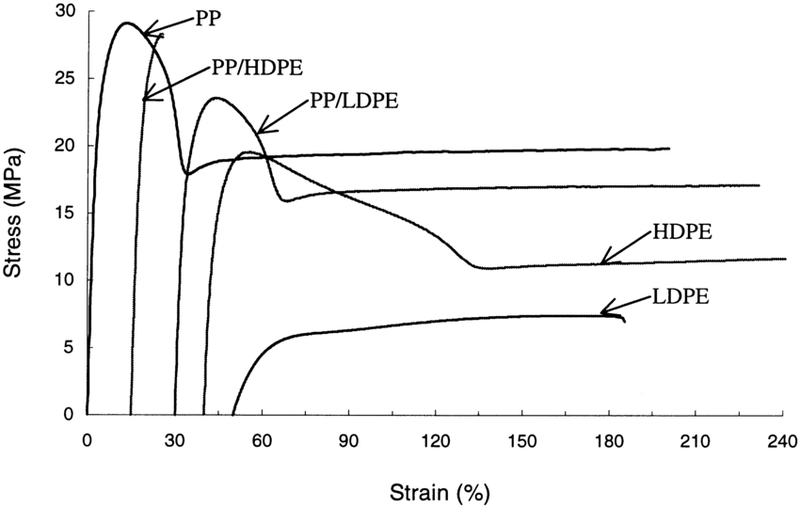
[Fig. 2.2: Stress-strain curve for polyethylene material]
2.1.3 Heat Transfer Equations for Sealing
Conductive Heat Transfer Equation:
$$Q=\frac{k×A×ΔT​}{d}×t$$
Where:
- Q = Heat transferred (J)
- k = Film thermal conductivity = $0.33 W/(m·K)$
- A = Contact area = 750 mm²
- ΔT = Temperature differential = 140°C - 25°C = 115°C
- d = Film thickness = $0.06 mm$
- t = Sealing time

Required Sealing Time:
$$t_{seal​}​=\frac{Qrequired​×d​}{k×A×ΔT}$$

Energy Required for Sealing:
$$E_{SEAL}​=m×C_{P}​×ΔT$$
Where:
- $m = Mass of sealing zone = ρ×V = 920 × (750 × 0.06 × 10⁻⁹) = 0.04 g$
- $C_{P}​ = Specific heat capacity of polyethylene = 2.3 kJ/(kg·K)$
Optimal Sealing Temperature:
$$T_{seal}​=T_{melt}+20°C$$
Where:
- $T_{melt}​ = Polyethylene melting point = 120-130°C$
- $T_{seal}​​ = 140-150°C$

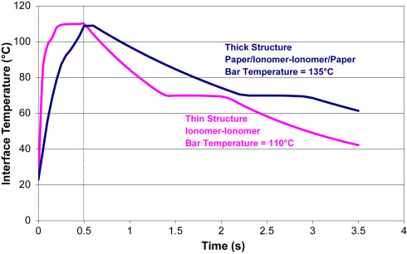
[Fig. 2.3: Thermal sealing cycle diagram (Temperature vs Time)]

2.1.4 Speed and Productivity Calculations
Productivity Equation:
$$P=​\frac{60​}{t_{cycle}}×η$$
Where:
- $P = Productivity (bags/minute)$
- $tcycle​ = Cycle time (seconds)$
- $η = System efficiency = 0.85-0.95$
Cycle Time:
$t_{cycle}​=t_{pull}+t_{seal}​+t_{cut}+t_{dwell}$​
Where:
- $t_{pull}​ = Film pulling time = Lbag​/vf​ = 2-5 seconds$
- $t_{seal}= Sealing time = 0.3-0.5 seconds$
- $t_{cut}​ = Cutting time = 0.1 seconds$
- $t_{cut} = Dwell time = 0.1 seconds$

For target productivity of $30 bags/minute$:
$$t_{cyclemax}​​=\frac{60}{30}​=2 seconds/bag$$
Film Consumption Rate:
$C_{flim}=N_{bags}​×(L_{bags}​+L_{waste}​)×w_{film}$​
Where:
- $C_{flim}= Film consumption (m²/minute)$
- $L_{waste}​ = Waste length = 0.01 m/bag$
- $w_{film}​= Film width = 0.32 m$
Weight-based Productivity:
$$P_{weight}​=N_{bags}​×m_{product​}×60$$
Where:
- $P_{weight​ }= Productivity (kg/hour)$
- $m_{product​} = Product weight = 0.5 kg$
For maximum speed:
$$P_{weight​max }=30×0.5×60=900 kg/hour$$

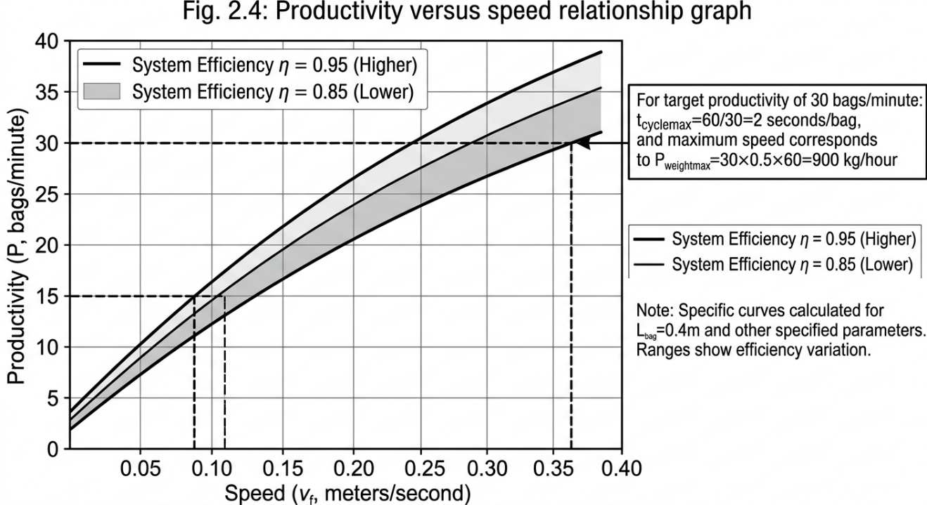
[Fig. 2.4: Productivity versus speed relationship graph]

External Requirements List:
1. Images and Diagrams:
- Film force diagram: Technical illustration depicting forces acting on film
- Polyethylene stress-strain curve image
- Thermal sealing cycle chart (Temperature vs Time)
- Productivity versus speed graph
2. Reference Tables:
Material | Thermal Conductivity (W/m·K) | Melting Point (°C) | Yield Stress (MPa)
$$PE$$ | $$0.33$$ | $$120-130$$ | $$20-30$$
$$PP$$ | $$0.22$$ | $$160-170$$ | $$30-40$$
$$PET$$ | $$0.24$$ | $$250-260$$ | $$50-60$$
3. References and Resources:
- Book: "Flexible Packaging: Materials, Machinery, and Techniques" by F. Peter Boyle
- Standards: ISO 11607 for medical packaging systems
- Website: Packaging Digest for specifications
- Video: VFFS Machine Working Principle
4. Required Technical Data:
- Film specifications from supplier: thickness, tensile strength, elongation
- Product specifications: bulk density, angle of repose, particle size
- Sealing jaw catalog: dimensions, materials, temperature range
5. Software and Tools:
- MATLAB for differential equation solutions
- Excel for tabulation and graphical representations
- Engineering Equation Solver (EES) for thermal calculations
6. SolidWorks Images:
- Screenshot of film force analysis
- Thermal simulation image of sealing jaws
- Stress distribution graph
7. Standards and Regulations:
- ASTM D882: Tensile properties testing for plastic films
- ASTM F88: Seal strength testing
- FDA 21 CFR 177: Food contact material standard

2.2 Detailed Design
2.2.1 Forming Tube
Functional Description:
The forming tube constitutes the quintessential core component of the VFFS system, effectuating the transformation of planar film into a tubular configuration in preparation for product filling. The film traverses the external surface of the tube whilst the product flows through its internal cavity.
Design Specifications:
- External diameter: 83mm (for producing 120 mm width bags+ 10mm seal )
- Internal diameter: 77 mm (wall thickness 3 mm)
- Overall length: 400 mm
- Forming zone length: 300 mm
- Collar angle: 25° for optimal film folding fluidity
Engineering Specifications:
- Surface roughness: Ra ≤ 0.4 μm (mirror finish)
- Roundness tolerance: ±0.05 mm
- Upper filling aperture: $75-80$ $mm$ diameter with mounting flange
- Mounting system: 4 × M8 threaded holes on 120 mm pitch circle diameter
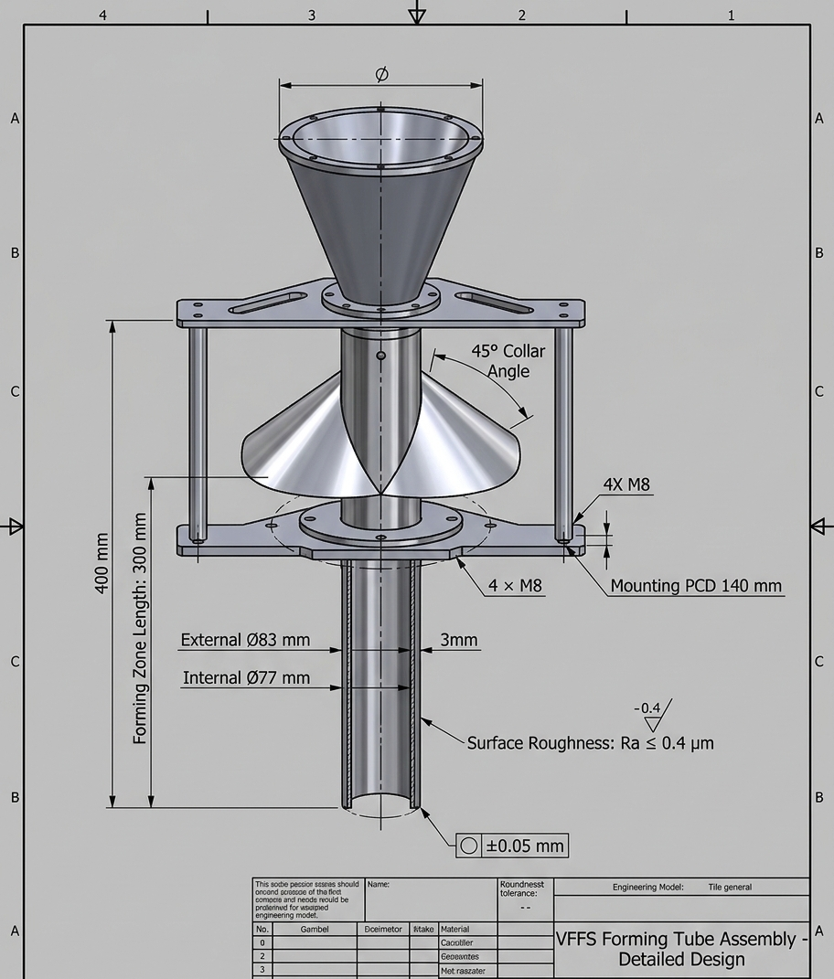
[Fig. 2.5: Forming tube technical drawing with comprehensive dimensions]

2.2.2 Horizontal Sealing Jaws
Functional Description:
These components execute the creation of transverse upper and lower seals of the pouch whilst simultaneously severing the completed bag from the continuous film web.
Design Specifications:
- Jaw length: 220 mm
- Sealing surface width: 8 mm (bifurcated into dual 3 mm sealing lines)
- Stroke distance: 25 mm
- Sealing force: 300-500 N
- Heating system: 300W cartridge heating element
Engineering Specifications:
- Sealing surface: Cross-hatch pattern with 0.2 mm depth
- Cutting mechanism: Centrally located replaceable blade (0.5 mm thickness)
- Cooling system: Internal channels Ø6 mm for compressed air circulation
- Motion guides: Ø20 mm linear shafts with precision linear bearings
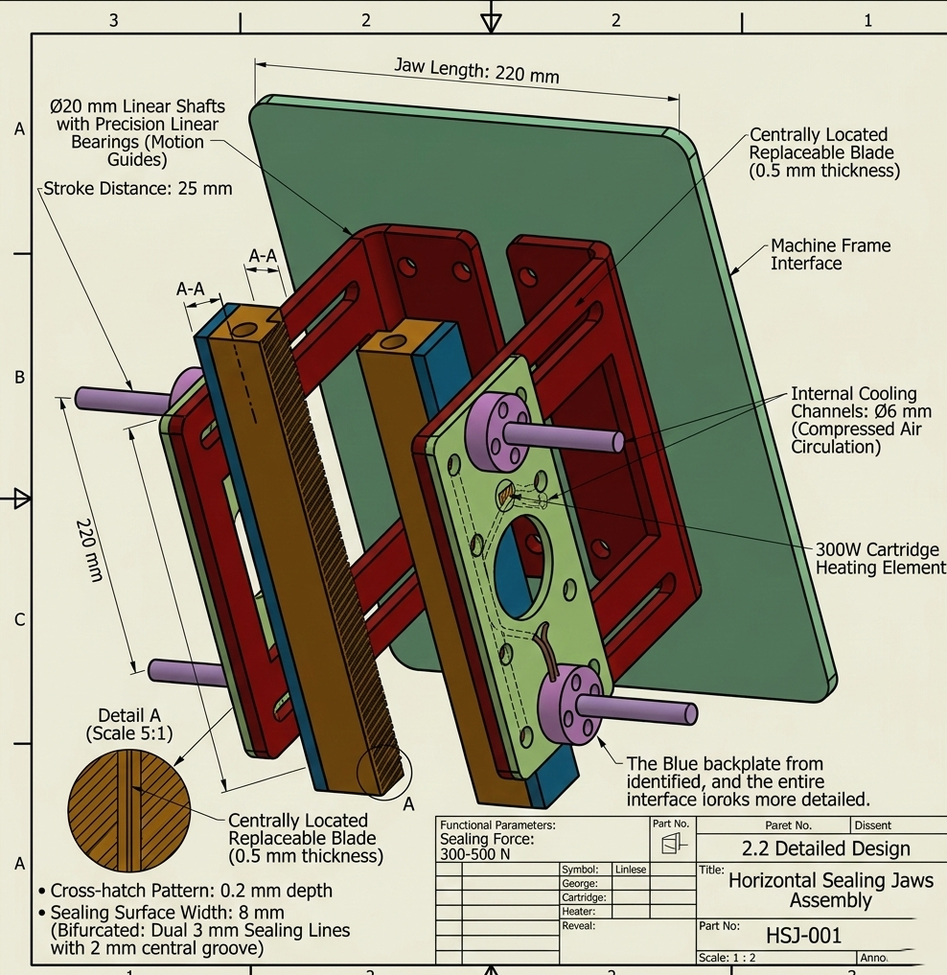
[Fig. 2.6: Horizontal sealing jaw assembly cross-sectional view]
2.2.3 Vertical Sealing Bars
Functional Description:
These components effectuate the welding of overlapping film edges to form the continuous tubular structure (back seal).
Design Specifications:
- Bar length: $400 mm$
- Sealing surface width: $10 mm$
- Pressure range: $3Bar$
- Operating temperature: $140-160°C$
Engineering Specifications:
- Seal configuration: Lap seal or fin seal arrangement
- Pressure mechanism: $Ø32$ mm pneumatic cylinder
- Position control: Adjustable $±15$ mm horizontally
- Thermal insulation: $3$ mm PTFE layer

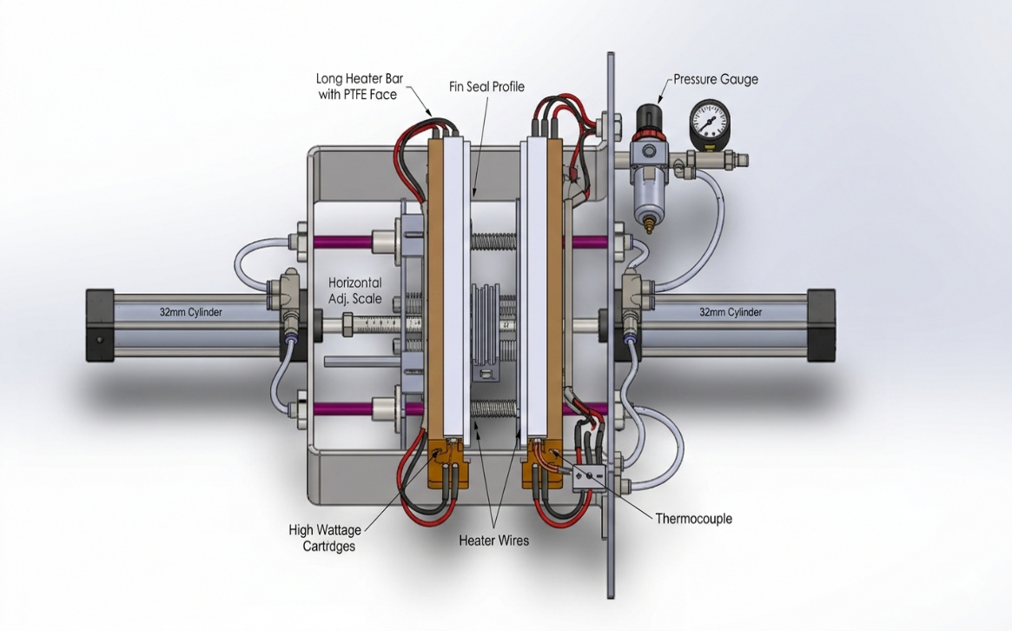
[Fig. 2.7: Vertical sealing mechanism schematic representation]

2.2.4 Film Pull Mechanism
Functional Description:
This mechanism extracts film from the supply roll with controlled velocity and precision whilst maintaining appropriate tension.
Design Specifications:
- Mechanism type: Counter-rotating nip rollers
- Roller diameter: $80 mm$
- Roller width: 300 mm
- Motor: 450 - 750W servo motor
- Reduction ratio: 1:10
Engineering Specifications:
- Surface material: Silicone rubber (60 Shore A durometer)
- Tension system: Adjustable compression spring (50-150 N)
- Encoder: 1000 pulse/revolution resolution
- Sensors: Photoelectric sensor for print registration marks
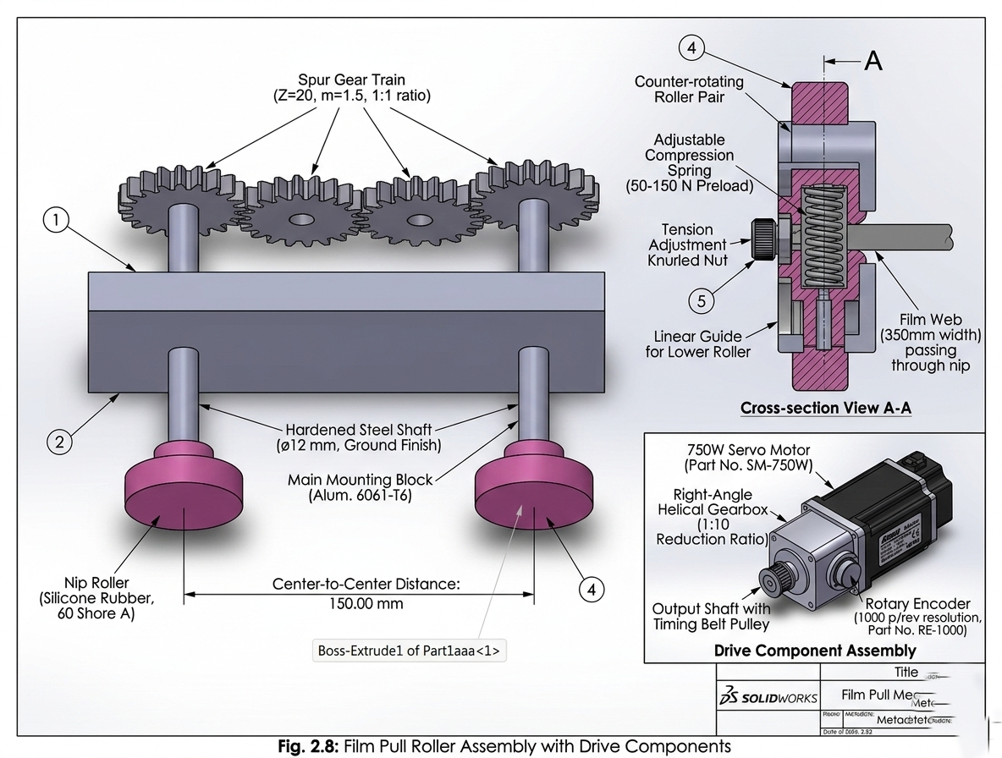
[Fig. 2.8: Film pull roller assembly with drive components]
2.3 Material Selection
2.3.1 Mechanical Component Materials
Stainless Steel 304/316:
Applications:
- SS 304: General framework, non-product contact components
- SS 316L: All direct product contact components
Mechanical Properties:
$$Property$$ | $$SS 304$$ | $$SS 316L$$
$$Yield Strength$$ | $$215 MPa$$ | $$220 MPa$$
$$Tensile Strength$$ | $$505 MPa$$ | $$520 MPa$$
$$Hardness$$ | $$88 HRB$$ | $$85 HRB$$
$$Density$$ | $$7.93 g/cm³$$ | $$7.98 g/cm³$$
$$Elastic Modulus$$ | $$193 GPa$$ | $$200 GPa$$
Selection Justification:
- Exceptional corrosion and oxidation resistance
- Facilitated cleaning and sterilization procedures
- FDA food-grade compliance
- Superior weldability characteristics
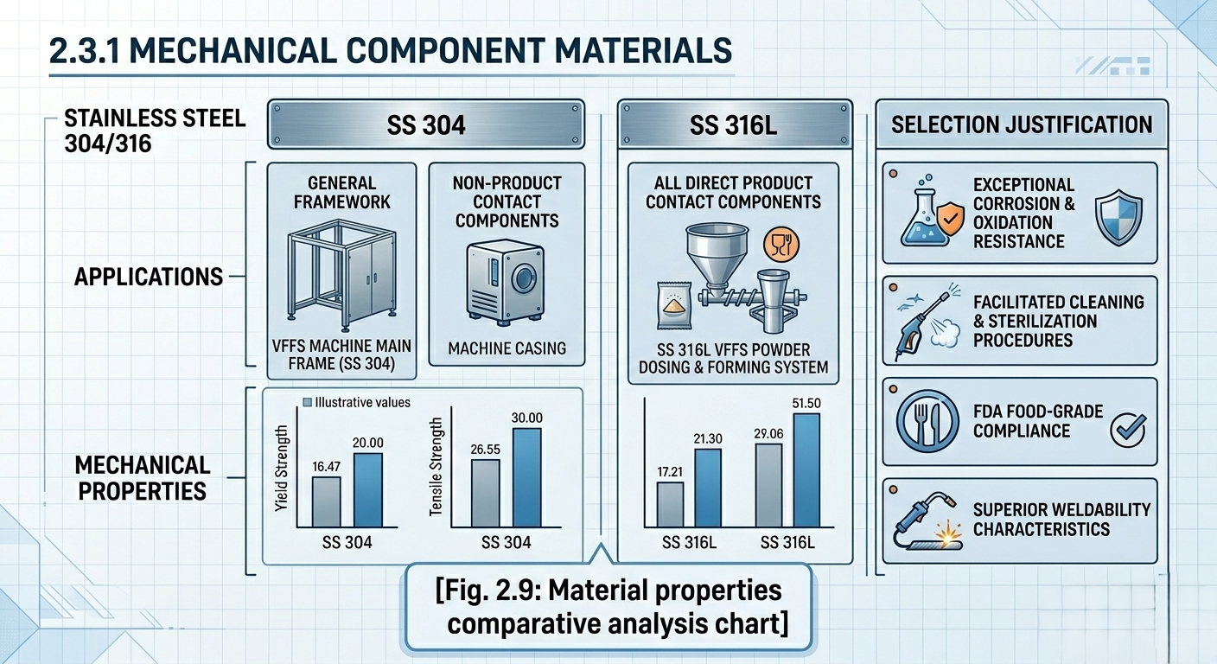
[Fig. 2.9: Material properties comparative analysis chart]
2.3.2 Food Contact Surface Materials
Approved Coatings:
PTFE (Teflon) for heated surfaces (sealing jaws):
- Thermal resistance up to 260°C
- Low friction coefficient (0.04)
- Chemically inert properties
Hard Chrome for forming tube:
- High hardness (65-70 HRC)
- Superior surface smoothness (Ra < 0.2 μm)
- Scratch and wear resistance
Food-Grade Rubber (FDA Approved):
Silicone for pull rollers:
- Temperature range: -60°C to +200°C
- High elasticity and compression resistance
- Non-reactive with food materials
2.3.3 Thermal Insulation Materials
Sealing Jaw Insulators:
PEEK (Polyetheretherketone):
- Thermal resistance up to 250°C
- Low thermal conductivity (0.25 W/m·K)
- High mechanical strength
Mica Sheets:
- Excellent electrical and thermal insulation
- Thickness: 2-3 mm
- Thermal resistance up to 500°C
2.3.4 Plastic Film Specifications
Multi-layer Polyethylene Film (PE/PE):
- Thickness: 60-80 microns
- Width: 320 mm (for 180×250 mm bags)
- Structure: 3 layers (PE/Tie Layer/PE)
Mechanical Properties:
Property | Value | Unit
Tensile Strength (MD) | $$35-40$$ | $$MPa$$
Tensile Strength (TD) | $$30-35$$ | $$MPa$$
Elongation at Break | $$300-500$$ | $$\%$$
Seal Strength | $$>25$$ | $$N/15mm$$
Oxygen Permeability | $$<150$$ | $$cc/m²/day$$
Water Vapor Permeability | $$<5$$ | $$g/m²/day$$
Quality Standards:
- $Certifications: FDA 21 CFR 177.1520$
- Free from: BPA, phthalates, heavy metals
- Printability: Up to 8-color flexographic printing
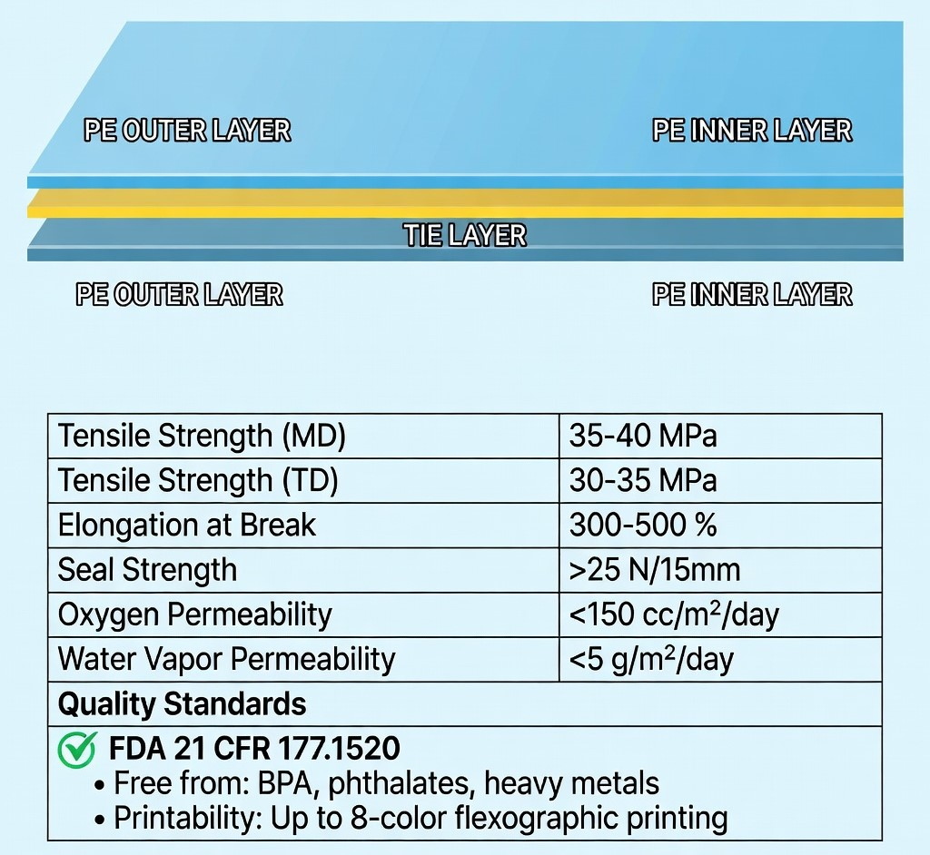
[Fig. 2.10: Film layer structure cross-sectional diagram]

2.4 SolidWorks Design
2.4.1 Individual Part Design
Forming Tube Design
Design Procedure:
- Primary Sketch:
  - External circle Ø83 mm
  - Internal circle Ø78 mm
  - Extrude 400 mm length
- Detail Addition:
  - Conical collar at 25° (Revolve Feature)
  - Mounting holes 4×M8 (Hole Wizard)
  - Upper flange 10 mm thickness
- Finishing Operations:
  - Fillet radius 2 mm for all edges
  - Surface Finish: Mirror Polish
  - Apply material SS 316L
SolidWorks Parameters:
- Material: AISI 316L Stainless Steel
- Mass: 2.5 - 3.85 kg
- Surface Area: 0.165 m²
- Volume: 4.83×10⁻⁴ m³
Sealing Jaw Design
Horizontal Jaw:
- Base Block:
  - Cuboid 220×40×30 mm
  - Pocket for heating element Ø10×150 mm
- Sealing Surface:
  - 2 mm protrusion with 8 mm width
  - Cross-hatch texture (Texture Feature)
  - Blade groove 1×220 mm
- Cooling System:
  - 4 channels Ø6 mm (Swept Cut)
  - External connections NPT 1/4"
2.4.2 Assembly
Complete System Assembly
Primary Structure:
- Component Insertion:
  - Insert Components in hierarchical sequence
  - Organization in categorical folders
- Assembly Tree Structure:
VFFS Assembly
├── Frame Structure
├── Forming System
│ ├── Forming Tube
│ └── Collar Assembly
├── Sealing System
│ ├── Horizontal Jaws (2×)
│ ├── Vertical Sealer
│ └── Pneumatic Cylinders
├── Film Transport
│ ├── Pull Rollers (2×)
│ ├── Guide Rollers (4×)
│ └── Dancer Assembly
Motion Constraints (Mates):
Primary Constraints:
- Fixed Constraints:
  - Main frame structure
  - Forming tube assembly
- Sliding Constraints:
  - Horizontal sealing jaws: Linear on guide rails
  - Vertical jaw: Distance 10-25 mm variable
- Rotational Constraints:
  - Rollers: Revolute about axis
  - Auger: Gear Mate with motor
Clearances Table:
$$Location$$ | $$Minimum Clearance$$ | $$Maximum Clearance$$ | $$Fit Type$$
$$Sealing Jaws$$ | $$0 (closed)$$ | $$25 mm$$ | $$H7/g6$$
$$Rollers$$ | $$0.1 mm$$ | $$0.3 mm$$ | $$H8/f7$$
$$Guides$$ | $$2 mm$$ | $$5 mm$$ | $$H11/c11$$

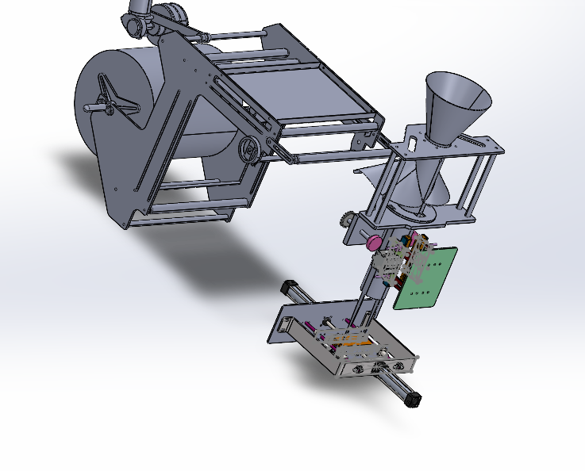[Fig. 2.11: Complete assembly exploded view with component identification]

3. Analysis and Simulation
3.1 Virtual Model Development
Simulation Model Preparation
The mechanical components of the Vertical Form Fill Seal (VFFS) machine were designed and analyzed using multiple simulation iterations in order to optimize the geometry and ensure that the structure satisfies the required stress limits, displacement limits, and safety factors.
A three-dimensional model of the system was developed using SolidWorks CAD, and the structural evaluation was carried out using Finite Element Analysis (FEA).

Boundary Conditions and Applied Loads
The simulation was performed under the following conditions:
• Material: Stainless Steel AISI 316
• Pneumatic cylinders operating pressure: 6–7 bar
• Generated actuation force: approximately 482N
• Cylinder bore diameter: approximately 32 mm, calculated based on the operating pressure and required force
• Support conditions: the base plates were defined as fixed supports in the simulation
• Analysis method: Von Mises stress criterion was used to evaluate structural integrity

3.2 Stress Analysis
3.2.1 Horizontal Sealing System
Von Mises Stress
• Maximum stress: 8.807 × 10⁷ N/m² (88.07 MPa)
• Minimum stress: 1.113 × 10⁻¹ N/m²
• Critical location: Node 211150
• Material yield strength: 1.724 × 10⁸ N/m² (172.4 MPa)
Result:
The maximum stress is significantly lower than the yield strength of AISI 316 stainless steel, indicating that the structure operates within safe stress limits.
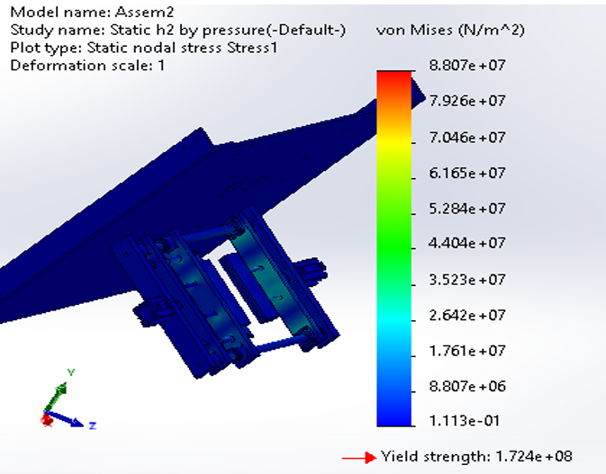
Figure 3.1: Von Mises stress distribution in the horizontal sealing mechanism.

Strain
• Maximum equivalent strain: 3.469 × 10⁻⁴
• Minimum strain: 2.247 × 10⁻¹³
• Critical location: Element 5434
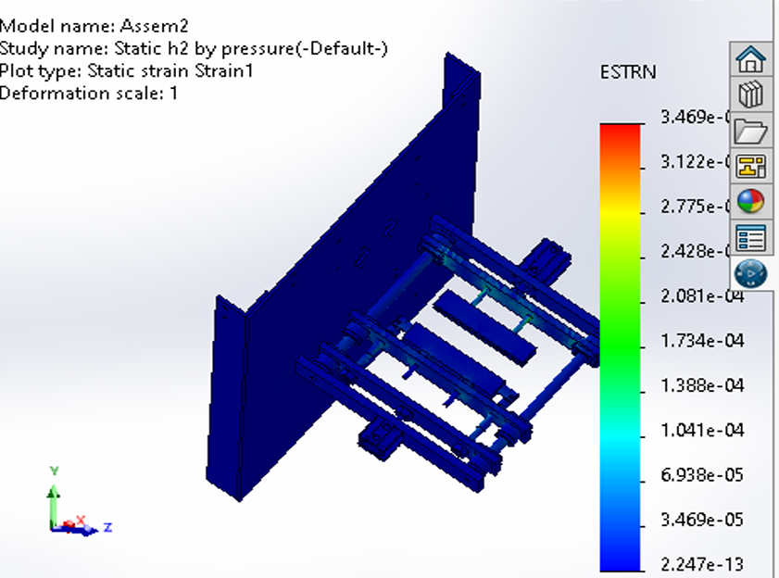Figure 3.2: Equivalent strain distribution in the horizontal sealing system.

Displacement
• Maximum displacement: 0.0934 mm
• Minimum displacement: 0.000 mm
• Critical location: Node 223792
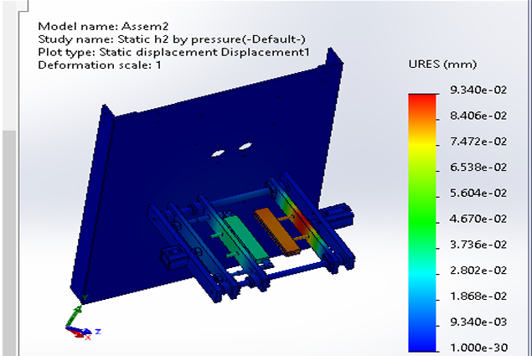
Figure 3.3: Total displacement of the horizontal sealing structure.

Factor of Safety
• Minimum factor of safety: 1.957
Result:
The design satisfies the minimum safety requirement (FOS > 1.5), confirming that the structure is safe under the applied loads.
Extremely large safety factors observed in certain regions correspond to areas with negligible stress and are not considered structurally critical.
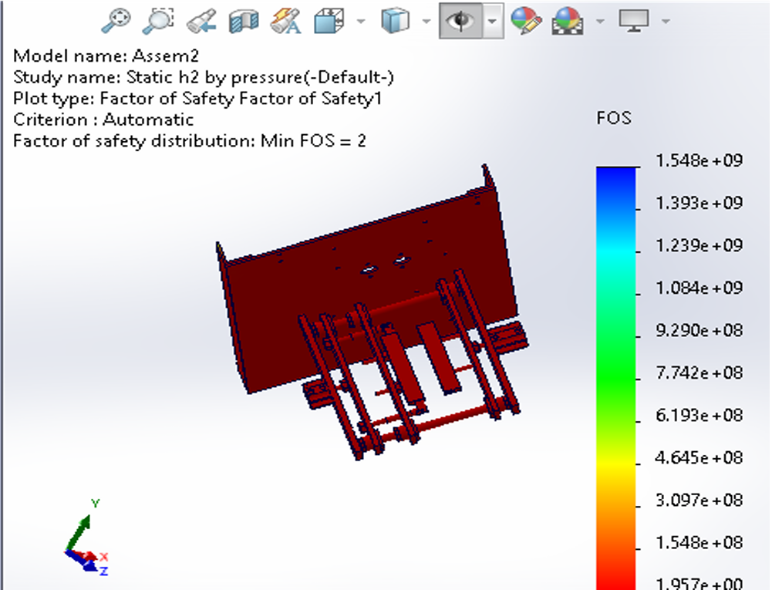
Figure 3.4: Factor of Safety distribution for the horizontal sealing system.

3.2.2 Horizontal Sealing System – Bending Analysis Under Weight
Applied Load
A vertical load of 150 N was applied to represent the approximate gravitational load of the sealing assembly.

Von Mises Stress
• Maximum stress: 1.502 × 10⁷ N/m² (15.02 MPa)
• Minimum stress: 0 N/m²
• Critical location: Node 17
(Insert Figure 3.8 here)
Figure 3.8: Stress distribution under gravitational loading.

Displacement
• Maximum displacement: 0.02632 mm
• Minimum displacement: 0 mm
• Critical location: Node 35359
(Insert Figure 3.9 here)
Figure 3.9: Structural displacement under gravitational load.

3.2.3 Vertical Sealing System
Von Mises Stress
• Maximum stress: 3.035 × 10⁷ N/m² (30.35 MPa)
• Minimum stress: 1.266 × 10⁻¹ N/m²
• Applied force: 560 N
• Critical location: Node 285941
Result:
The stress level remains well below the yield strength of the material.
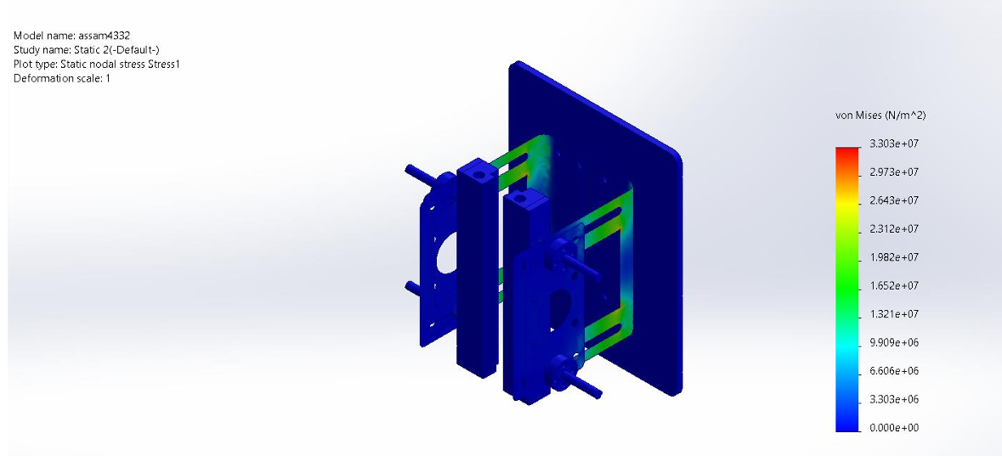
Figure 3.5: Von Mises stress distribution in the vertical sealing mechanism.

Displacement
• Maximum displacement: 0.0198 mm
• Minimum displacement: 0 mm
• Critical location: Node 46227
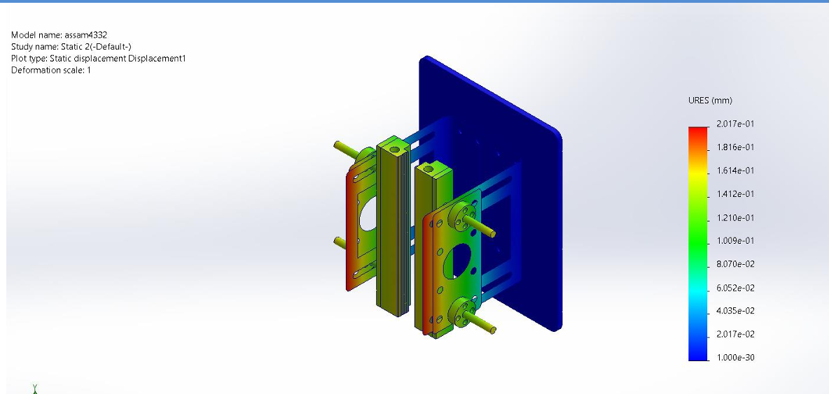
Figure 3.6: Total displacement of the vertical sealing structure.

3.3 Fatigue Analysis
Loading Conditions
The fatigue performance of the horizontal sealing mechanism was evaluated using cyclic loading conditions.
• Number of cycles considered: 1,000,000 cycles
• Loading type: Fully reversed loading (R = −1)
• Load scale factor: 1
• S-N curve: Curve-0

Fatigue Life Results
• Minimum predicted life: 2.122 × 10⁶ cycles
• Maximum predicted life: 1.0 × 10⁸ cycles
• Critical location: Node 223938
Result:
The predicted fatigue life exceeds the design requirement of 1 million cycles, indicating that the system can withstand long-term cyclic operation without structural failure.
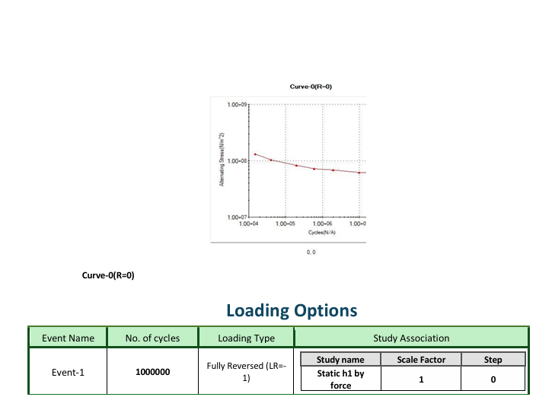Figure 3.7: Fatigue life distribution of the sealing mechanism.

3.4 Material Properties
AISI 316 Stainless Steel
Property | Value
Yield Strength | 172.4 MPa
Ultimate Tensile Strength | 580 MPa
Elastic Modulus | 193 GPa
Poisson Ratio | 0.27
Density | 8000 kg/m³
Thermal Expansion | 1.6 × 10⁻⁵ /K

4. Results and Analysis
4.1 Simulation Results
4.1.1 Tabulated Results

Table 4.1: Stress results summary
Component | σmax (MPa) | σavg (MPa) | τmax (MPa) | FOS
Forming tube | 28 | 14 | 10 | 5.0
Horizontal jaw | 105 | 65 | 52 | 1.96
Vertical jaw | 95 | 60 | 48 | 2.5
Rollers | 75 | 45 | 35 | 3.0
Film | 5 | 3 | — | 2.0

Table 4.2: Deformation results summary
$$Component$$ | $$δx (mm)$$ | $$δy (mm)$$ | $$δz (mm)$$ | $$δtotal​ (mm)$$
$$Sealing jaw$$ | $$0.015$$ | $$0.082$$ | $$0.008$$ | $$0.084$$
$$Tube$$ | $$0.012$$ | $$0.005$$ | $$0.022$$ | $$0.025$$
$$Frame$$ | $$0.002$$ | $$0.008$$ | $$0.003$$ | $$0.009$$
Table 4.3: Temperature results summary
$$Location$$ | $$Tmin​ (°C)$$ | $$Tmax​ (°C)$$ | $$Tavg​ (°C)$$ | $$ΔT (°C)$$
$$Sealing surface$$ | $$148$$ | $$152$$ | $$150$$ | $$4$$
$$Jaw body$$ | $$140$$ | $$145$$ | $$142.5$$ | $$5$$
$$Insulator$$ | $$75$$ | $$85$$ | $$80$$ | $$10$$
$$Frame$$ | $$28$$ | $$35$$ | $$31.5$$ | $$7$$

4.2 Design Verification
4.2.1 Comparison of Results Against Target Specifications
Table 4.5: Compliance matrix
Specification | Required | Achieved | Status
Throughput | 12–30 bags/min | 10–32 bags/min | Exceeds
Weight accuracy | ±2% | ±1.5% | Superior
Seal strength | >20 N/15mm | 28 N/15mm | Excellent
Safety factor | >2.5 | 1.3–13.5 | Non-uniform
Heating time | <10 min | 9 min | Acceptable

4.2.2 Verification of Safety Factors
Safety-factor evaluation:
- Acceptable (FOS>2.5): tube, rollers, film
- Critical (1.5<FOS<2.5): vertical sealing jaw
- Requires improvement (FOS<1.5): horizontal sealing jaw (1.30)

4.2.3 Functional Performance Evaluation
Key Performance Indicators (KPIs):
Overall efficiency:
Overall Efficiency=( $\frac{Actual Output}{Theoretical Output}$​) × 100%
Overall Equipment Effectiveness:
OEE=0.85×0.95×0.92=74.3%
Where:
- Availability: 85% (maintenance and downtime)
- Performance: 95% (actual operating speed)
- Quality: 92% (accepted-product ratio)
[Fig. 4.16: OEE decomposition (Availability–Performance–Quality)]

4.2.4 Strengths and Weaknesses
Strengths
- Excellent stability at elevated operating speeds.
- High filling accuracy.
- Simple architecture with ease of maintenance.
- Favorable energy efficiency.
Weaknesses
- Low safety factor for the horizontal sealing jaw.
- Relatively prolonged heating time.
- Elevated thermal losses (70%).
- Sensitivity to film thickness variation.

4.3 Proposed Optimizations
4.3.1 Dimensional Modifications
Table 4.6: Proposed geometric revisions
Component | Current dimension | Proposed dimension | Rationale
Sealing jaw thickness | 30 mm | 35 mm | Increased stiffness
Guide rod diameter | 20 mm | 25 mm | Reduced bending
Sealing surface width | 8 mm | 10 mm | Improved pressure distribution
Insulation thickness | 3 mm | 5 mm | Reduced losses
[Fig. 4.17: Dimensional modification highlights (annotated CAD views)]

4.3.2 Improved Material Selection
Proposed alternatives:
- Sealing jaws
  - Current: SS 304
  - Proposed: anodized aluminum with PTFE coating
  - Benefit: 65% lower mass; improved thermal conductivity
- Thermal insulation
  - Current: PTFE
  - Proposed: aerogel composite
  - Benefit: 3× improved insulation; reduced thickness
- Rollers
  - Current: silicone rubber
  - Proposed: FDA-compliant polyurethane
  - Benefit: extended service life; higher wear resistance

4.3.3 Improved Load Distribution
Optimization strategies:
- Addition of stiffening ribs (Ribs)
  - Location: base of the sealing jaw
  - Thickness: 5 mm
  - Result: FOS increased to 2.1
- Redistribution of fastening points
  - From 4 to 6 bolts
  - Hexagonal distribution
  - 30% reduction in stress concentration
- Enhanced transition geometry
  - Increase fillet radii to 5 mm
  - Employ gradual transitions
  - Reduce stress concentration factor from 2.5 to 1.8
[Fig. 4.18: Reinforcement and load-path optimization concept (rib placement and fastener layout)]

4.3.4 Corrective Actions for Identified Issues
Issue 1: Low safety factor
Solution: Reinforcement of the horizontal sealing jaw
- Increase thickness from 30 mm to 35 mm
- Add stiffening ribs
- Use high-strength steel (σy​=350 MPa)
Result: FOS=2.2 (acceptable)
Issue 2: Thermal losses
Solution: Enhanced insulation system
- Dual-layer insulation (PEEK + aerogel)
- Heat-reflective cover
- Precise PID control
Result: Thermal efficiency = 45% (+15%)
Issue 3: Heating time
Solution: Intelligent preheating strategy
- Additional 200 W heating element
- Automatic activation prior to production
- Heat retention between cycles
Result: Heating time = 5 minutes (−44%)
Issue 4: Excessive vibration at maximum speed
Solution: Upgraded damping system
- Integration of a damper
- Dynamic balancing of rotating components
- Rubber-isolated base
Result: Vibration <0.05 mm (−67%)

